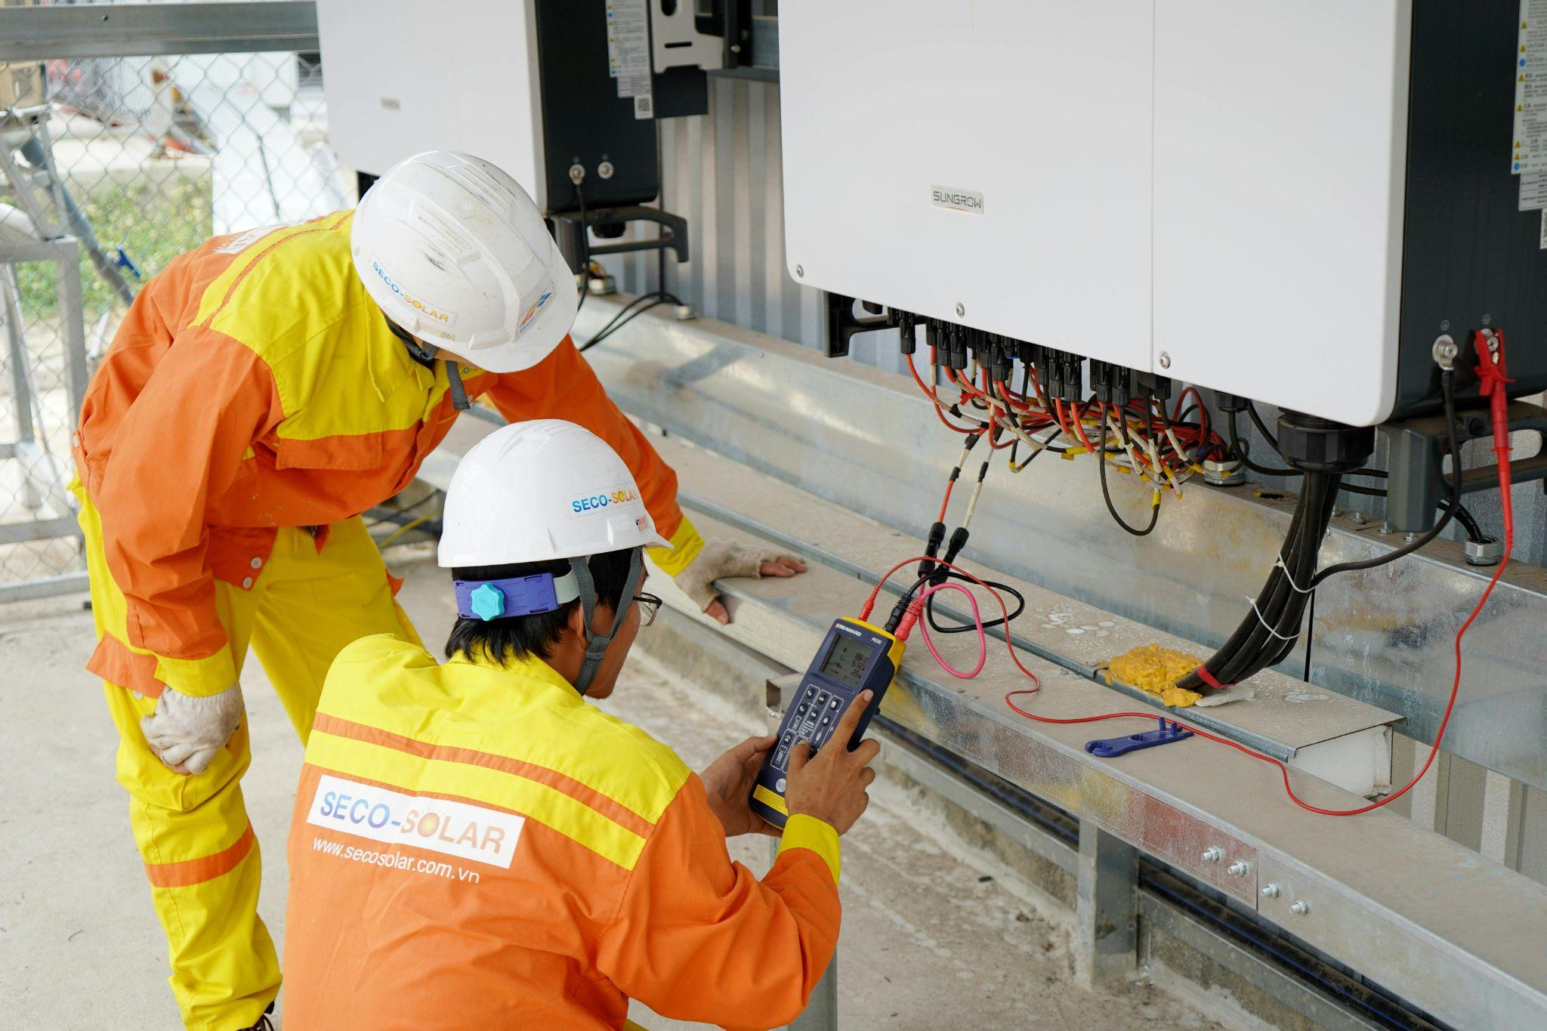

Can You Upgrade Your Solar Inverter?
Your solar inverter is the control centre of your entire system, and when it starts to fall behind, your performance, savings, and flexibility all suffer. As systems age and energy needs change, upgrading your inverter becomes less of a repair decision and more of a strategic upgrade.
This article explains when an inverter upgrade makes sense, what it involves, and how it can improve everything from efficiency to battery compatibility.
Key Takeaways
- Most solar inverters last 10–15 years, and ageing units are often the first cause of performance loss.
- Upgrading your inverter can increase efficiency, improve monitoring, and enable battery storage.
- Adding panels or expanding your system often requires a higher-capacity or hybrid inverter.
- A professionally matched inverter ensures compatibility, safety, and long-term system performance.

Why Homeowners Look At Upgrading Their Inverter
Your inverter is one of the hardest-working components in your solar panel system, and often the first to show its age. As systems evolve and household energy demands increase, many homeowners reach a point where upgrading becomes the smarter, more cost-effective option.

The Existing Inverter Is Ageing Or Failing
Most solar inverters have a lifespan of around 10 to 15 years. As they age, performance can decline, efficiency drops, and faults become more frequent.
Common signs include reduced output, intermittent faults, or complete shutdowns. Replacing an ageing inverter restores system reliability and helps recover lost performance.

Adding More Panels Requires More Capacity
If you’re planning to expand your system or add more solar panels, your current inverter may become a limiting factor. Every inverter has a maximum capacity, and once that’s reached, additional generation can’t be fully utilised.
Upgrading to a higher-capacity unit removes this bottleneck, allowing you to get the full benefit from additional panels and maximise your energy output.

Wanting To Add Battery Storage
Battery storage is becoming an increasingly popular way to improve energy independence and reduce grid reliance. However, not all inverters are compatible with modern battery systems.
Upgrading to a hybrid inverter allows you to connect a battery properly, so you can store excess energy and use it when you need it most. This gives you greater control over how and when your energy is used.

What Upgrading Your Solar Inverter Actually Means
Upgrading your inverter is an opportunity to improve how your entire solar system performs. A modern inverter can increase efficiency, unlock new features, and future-proof your setup for evolving energy needs.

Replacing Like-For-Like Vs Upgrading To A Different Type
When replacing an inverter, you can either install a like-for-like model or move to a more advanced system.
A direct replacement is often the simplest option if your current setup is performing well. However, upgrading to a different type, such as a hybrid inverter, can introduce benefits like battery compatibility, smarter monitoring, and improved system flexibility.
The right choice depends on your long-term goals, not just your current setup.

When An Upgrade Makes More Sense Than A Repair
While minor faults can sometimes be repaired, this is rarely the best long-term solution for older systems. Upgrading becomes the more practical option, especially if you’re planning to expand your solar system.
Modern inverters offer:
- Higher efficiency, meaning less energy is lost during conversion
- Improved reliability with full manufacturer warranties
- Better compatibility with batteries, smart tariffs, and future upgrades
In many cases, upgrading not only resolves the fault but also improves overall system performance.

What Changes For Your System After An Upgrade
A new inverter can transform how your system performs and how you interact with it. From improved output to better visibility of your energy usage, the benefits are immediate.
Feature | Ageing Inverter | Modern Inverter
Monitoring | Limited or none | Real-time app insights
Efficiency | Gradually declining | Typically 97%+
Warranty | Expired | 5–10 years
Beyond the technical improvements, upgrading gives you confidence that your system is operating at its full potential, delivering consistent performance and supporting your future energy plans.

The Main Inverter Types Worth Considering For An Upgrade
Choosing the right inverter directly affects how much usable energy your system delivers. The right upgrade can improve efficiency, unlock new features, and give you greater control over your energy.
Understanding the main inverter types helps you choose a solution that fits both your home and your future plans.

Standard String Inverters
String inverters remain the most common option for residential systems. They’re cost-effective, reliable, and well-suited to straightforward roof layouts with minimal shading.
If your current inverter is failing and your setup is simple, a like-for-like upgrade to a modern string inverter can restore performance quickly and affordably.

Hybrid Inverters And Why They’re Increasingly Popular
Hybrid inverters are becoming the preferred choice for homeowners looking beyond basic generation. They combine solar and battery functionality in a single system, giving you far more control over how your energy is used.
Instead of sending excess energy straight to the grid, you can store it for later, reduce peak-time costs, and increase your energy independence. For many households, this makes a hybrid upgrade a long-term investment rather than just a replacement.

Microinverters And When They Make Sense
Microinverters operate at the panel level, meaning each panel works independently. This is particularly valuable on roofs with shading, multiple orientations, or complex layouts.
Because one panel won’t affect the others, overall system performance is more stable. You also gain detailed, panel-level monitoring, making it easier to spot and resolve issues quickly.
Inverter Type | Best For | Key Benefit | Shading Handling
String Inverter | Simple systems | Cost-effective and reliable | Limited
Hybrid Inverter | Battery-ready homes | Energy control and storage | Moderate
Microinverter | Complex roofs | Panel-level optimisation | Excellent
A well-chosen inverter upgrade doesn’t just replace old hardware; it improves how your entire system performs day to day.

Is A Hybrid Inverter Worth Upgrading To?
If you’re thinking about battery storage or greater energy control, a hybrid inverter is often the most future-ready option. It doesn’t just convert energy, it manages it intelligently.

What A Hybrid Inverter Does Differently
A standard inverter simply converts solar energy into usable electricity. A hybrid inverter goes further by deciding how that energy is used in real time.
It prioritises powering your home, then charging your battery, and only exports surplus energy to the grid. This reduces waste and helps you make better use of what you generate.

How It Enables Battery Storage Without Extra Equipment
One of the biggest advantages of a hybrid inverter is its built-in battery compatibility. You don’t need a separate system to manage storage; everything is handled in one place.
This simplifies installation, reduces equipment costs, and makes it much easier to add a battery later if you’re not ready straight away.

Whether Your Panels Are Compatible With A Hybrid Inverter
Most existing solar panels can work with a hybrid inverter, provided their specifications align. Compatibility depends on factors like voltage range and system configuration.
A professional assessment will confirm this and identify whether any adjustments are needed. In most cases, upgrading the inverter is far simpler than replacing the panels themselves.
Feature | Standard Inverter | Hybrid Inverter
Battery integration | Requires extra system | Built-in compatibility
Energy management | Basic conversion | Smart energy distribution
Outage support | Not available | Available on many models
Installation complexity | Lower | Moderate
Upgrading to a hybrid inverter isn’t just about adding storage; it’s about taking control of your energy and getting more value from every unit your system produces.

Compatibility: Will A New Inverter Work With Your Existing Panels?
Upgrading your inverter is one of the most effective ways to improve system performance, but it only delivers results if everything works together properly. A well-matched system maximises output. A poorly matched one can limit performance, reduce efficiency, or create long-term reliability issues.

Voltage And Input Capacity Requirements
Every inverter is designed to operate within specific voltage and current ranges. Your existing solar panels must fall within these limits for the system to function correctly.
If the voltage is too high or too low, the inverter may struggle to operate efficiently or shut down entirely. Equally important is the inverter’s maximum DC input capacity. If your panels generate more power than they can process, excess energy is simply lost through clipping.
Matching these specifications properly is what turns theoretical generation into usable energy.

String Configuration And Panel Matching
How your panels are wired has a direct impact on how your new inverter performs. Traditional string systems rely on consistency across the array, meaning differences in panel output can affect overall performance.
When upgrading, it’s important to review:
- The voltage characteristics of your existing panels
- Whether the inverter supports your current panel configuration
- The layout and length of panel strings
- The impact of shading across different sections of the roof
If you’re combining older and newer panels, optimisers or revised string layouts may be needed to maintain performance.

When A Full System Redesign Is Needed
In some cases, upgrading the inverter highlights limitations in the original system design. This is especially common when adding more panels or integrating battery storage.
A full redesign may be required if:
- Your system exceeds the original design capacity
- Wiring or protection components no longer meet current standards
- The layout needs reconfiguring for better performance
While this adds upfront work, it creates a stronger, more efficient system that’s built for long-term reliability and future expansion.

What A Solar Inverter Upgrade Costs In The UK
Understanding the cost of an inverter upgrade helps you make a confident, informed decision. Pricing varies depending on whether you’re replacing like-for-like or investing in a more advanced system with additional capabilities.

Cost Of A Like-For-Like Replacement
A direct replacement is typically the most cost-effective option. It involves swapping your existing inverter for a modern equivalent without changing the overall system design.
This approach is ideal if your current setup still meets your needs and you simply want to restore performance. It keeps installation straightforward and avoids major electrical changes.

Cost Of Upgrading To A Hybrid Inverter
Upgrading to a hybrid inverter involves a higher upfront cost, but it adds significantly more flexibility. It allows you to integrate battery storage, improve energy management, and future-proof your system.
For many homeowners, this isn’t just a replacement; it’s a strategic upgrade that increases self-consumption and reduces reliance on grid electricity over time.

Labour And Installation Costs To Factor In
Installation costs are an important part of the overall investment. A qualified installer is required to safely remove the old inverter, install the new system, and make any necessary electrical adjustments.
Costs can vary depending on:
- Accessibility of the inverter location
- Complexity of wiring and system configuration
- Whether additional upgrades or expansion are involved
Getting a detailed quote upfront helps you understand the full scope and avoid unexpected costs. A well-planned upgrade isn’t just about cost, it’s about value. The right investment can improve efficiency, increase savings, and position your system for future energy needs.

How Upvolt Manages Solar Inverter Upgrades
A well-planned inverter upgrade can transform how your solar system performs, improving efficiency, reliability, and long-term value. Upvolt takes a structured, expert-led approach to make sure every change delivers real, measurable benefits for your home.

Assessing Your Current System And Inverter Compatibility
Every project begins with a detailed review of your existing setup. Upvolt analyses your generation data, system performance, and electrical configuration to identify limitations and opportunities for improvement.
During the assessment, we evaluate:
- The condition and performance of your current panels
- Inverter capacity and any existing bottlenecks
- Your home’s wiring and electrical infrastructure
- Suitability for battery storage or future expansion
This ensures the new inverter is properly matched to your system and designed to deliver maximum performance.

Recommending The Right Inverter For Your Setup
Once your system has been assessed, we recommend the most suitable inverter based on your energy usage, goals, and future plans.
Whether that’s a modern string inverter, a hybrid system ready for battery storage, or a more advanced configuration with enhanced monitoring, every recommendation is focused on performance, flexibility, and long-term value.
The aim is simple: more usable energy, better control, and a system that continues to meet your needs as they evolve.

MCS-Compliant Installation And Handover
All installations are carried out to strict UK standards, with full MCS compliance to protect safety, performance, and eligibility for export schemes. From installation through to final testing, every step is handled with precision.
After installation, you’ll be guided through your new system so you can confidently monitor performance and understand how to maximise your savings.

Let’s Recap
Upgrading your solar inverter is often the most impactful way to improve how your system performs. While panels generate the energy, the inverter determines how much of that energy you can actually use, store, or export. When it starts to limit performance, the entire system feels it.
For many homeowners, the trigger is clear: an ageing inverter, plans to expand, or the desire to add battery storage. In these cases, upgrading is not just a fix; it’s an opportunity to modernise your system, improve efficiency, and gain more control over your energy use.
The key is making sure the upgrade is designed around your existing setup and future goals. With the right inverter and proper planning, your system becomes more reliable, more flexible, and far better equipped to deliver long-term savings.

About Upvolt
Upvolt takes the complexity out of solar inverter upgrades by managing the entire process from assessment through to installation. Every upgrade is designed around your system, your energy usage, and your long-term goals, not just a like-for-like replacement.
Thinking about upgrading your inverter? Fill in our quick online form and get tailored advice on the best option for your home, your system, and your future energy plans.

FAQ

Can I upgrade my solar inverter without replacing my entire solar PV panel system?
Yes, in most cases, you can upgrade your inverter without replacing your existing solar PV panels. Inverters typically have a shorter lifespan of around 10–15 years, so upgrades are often part of normal system maintenance.

Why should I consider upgrading to a hybrid inverter rather than a standard string inverter?
A hybrid inverter gives you far more control over how your energy is used. Instead of simply converting electricity, it allows you to store excess energy in a battery and use it later, reducing reliance on the grid. This makes it ideal if you’re planning for battery storage, time-of-use tariffs, or greater energy independence.

Will a new inverter work with the older panels I already have installed?
Modern inverters are designed to be compatible with existing panels, provided the voltage and system configuration align. A professional installer will assess your setup to confirm compatibility and identify any adjustments needed. Only in rare cases, usually with very old or outdated systems, would a broader upgrade be required.

Is it possible to add more solar panels when I upgrade my solar inverter?
Yes, and it’s often the ideal time to do it. If you’re planning to add more solar panels, upgrading your inverter ensures your system can handle the additional capacity without limiting performance.

Does upgrading my inverter affect my feed-in tariff or SEG payments?
Yes, it can affect your SEG payments, depending on your setup and the type of upgrade. If you’re on a Feed-in Tariff or receiving SEG payments, you’ll usually need to notify your provider of any changes. As long as your system remains MCS-compliant and correctly documented, your payments should continue. Your installer will typically provide the necessary certification and guidance to keep everything in line with scheme requirements.

Meta Title: Can You Upgrade Your Solar Inverter?
Meta Description: Learn when to upgrade your solar inverter, how it improves efficiency, and what to consider for compatibility, costs, and system expansion.
Excerpt: Upgrading your solar inverter can restore performance, unlock battery storage, and support future expansion. This guide explains when it makes sense, what it costs, and how to choose the right upgrade for your system.
Sub Title: When upgrading your inverter improves efficiency, compatibility and future expansion.

