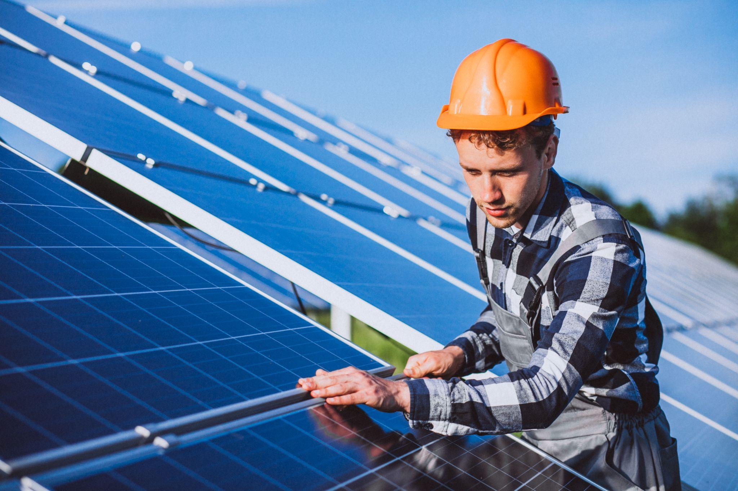

Should You Add New Solar Panels To Older Systems?
Expanding an existing solar system can be one of the smartest ways to increase energy savings, but only if it’s done correctly. What worked a few years ago may no longer meet today’s energy demands, especially with EVs, heat pumps, and rising electricity costs.
The key question isn’t just can you add more panels, it’s whether your current system is capable of supporting that upgrade efficiently. This guide breaks down when expansion makes sense, what’s involved, and how to avoid costly mistakes.
Key Takeaways
- Expanding your solar PV system can increase savings, but only if your inverter and system design can support it.
- Older systems may need upgrades (especially the inverter) to avoid limiting performance.
- Adding panels can affect SEG or FiT payments, so supplier notification is essential.
- Combining panel expansion with battery storage often delivers the best long-term return.

Why Homeowners Consider Adding Panels To An Existing System
Many UK homes are now outgrowing their original solar setup. What worked a few years ago often isn’t enough today, especially as energy use increases and electricity prices continue to rise.
Expanding your system with additional or newer solar panels is one of the simplest ways to regain control, boost savings, and move closer to true energy independence.

Growing Energy Demand At Home
Household electricity usage has changed dramatically in recent years. New technologies and lifestyle shifts mean many homes now consume far more power than when their system was first installed.
Common drivers for expansion include:
- Charging an electric vehicle (EV)
- Installing a heat pump or electric heating system
- Working from home with higher daily energy use
- Adding battery storage to store more solar energy
If your system no longer covers your usage, adding more solar panels helps close that gap and reduces how much you rely on the grid.

Getting More From An Underperforming System
Older solar systems don’t always deliver the output homeowners expect today. Panels naturally degrade over time, with energy output typically declining by around 0.5–0.8% per year, and earlier installations often used less efficient technology.
Upgrading with modern, higher-efficiency panels can significantly increase your generation without needing to replace everything.

Taking Advantage Of Lower Panel Costs
Solar technology has become far more affordable over the past decade. What once required a large upfront investment is now much more accessible, making system expansion a financially smart move.
Adding panels today allows you to:
- Increase your solar generation at a lower cost per kW
- Improve self-consumption and reduce grid reliance
- Future-proof your system as energy demand grows
For many homeowners, expanding an existing system isn’t just an upgrade, it’s a strategic way to unlock more value from their original investment.

How Old Is Too Old? Assessing Your Existing System
Expanding a solar system isn’t just about adding more panels; it’s about making sure everything works together efficiently. Mismatched components can reduce output, limit performance, or even damage your system if not handled correctly.

Panel Wattage And Brand Compatibility
New panels don’t have to match your old ones exactly, but their electrical characteristics need to align. Differences in voltage and current can reduce overall system efficiency if not managed properly.
In many cases, installers use optimisers or separate strings to safely combine old and new panels. This allows you to upgrade performance without replacing your entire system.

Inverter Capacity And Whether It Can Handle More Panels
Your inverter sets the ceiling for how much power your system can process. If you exceed its capacity, excess energy may be clipped or wasted.
Before expanding, it’s critical to:
- Check your inverter’s maximum input capacity
- Confirm whether it can handle additional panels
- Consider upgrading to a larger or hybrid inverter if needed
This is often the deciding factor between a simple expansion and a full system upgrade.

Roof Space And Structural Considerations
Physical constraints play a critical role in determining whether a system can be expanded effectively. Your roof must provide sufficient usable space, appropriate orientation, and adequate structural capacity to support additional panels.
A professional assessment will typically evaluate:
- Available roof area and layout suitability
- Structural integrity and load-bearing capacity
- Optimal panel positioning to maximise generation
Where space is limited, higher-efficiency panels, such as the panels Upvolt installs, can be used to increase output without significantly increasing the system footprint, ensuring the expansion remains both practical and effective.

What Adding Panels To An Older System Actually Involves
The expansion of an existing solar system needs to be planned correctly to protect performance, safety, and long-term value. Done well, it can significantly increase your energy generation. Done poorly, it can limit output or create costly issues.

System Assessment And Design
Every successful expansion starts with a detailed system assessment. This isn’t just about roof space; it’s about understanding how your existing panels, inverter, and wiring will interact with new components.
A professional installer will:
- Evaluate your current system performance and condition
- Assess roof structure, orientation, and usable space
- Design a layout that balances old and new panel output
Careful design is critical. Mismatched panels or poor system configuration can reduce overall efficiency rather than improve it.

Inverter Upgrade Or Replacement
Your inverter often becomes the limiting factor when expanding a system. If it can’t handle additional capacity, any extra generation may be restricted or lost.
In many cases, expansion includes:
- Upgrading to a higher-capacity inverter
- Moving to a hybrid inverter if battery storage is planned
- Improving system monitoring and control
This stage is an opportunity to modernise your system, not just expand it. A well-matched inverter ensures you fully benefit from the additional panels.

Installation And Grid Connection
Once the system is designed, installation involves integrating new panels safely into your existing setup. This includes mounting, wiring, and ensuring compliance with current electrical standards.
After installation:
- The system is tested and commissioned
- Performance is verified across the full setup
- Your installer notifies the relevant network operator and energy supplier
Proper sign-off is essential to ensure your system operates legally, safely, and efficiently within the grid.

How Adding Panels Affects Your SEG Payments
Expanding your system can also affect how you’re paid for exporting it. Understanding this upfront helps you avoid unexpected issues with tariffs or contracts.

How The Smart Export Guarantee Works
The Smart Export Guarantee (SEG) pays you for surplus electricity exported back to the grid. The more excess energy your system produces, the more you can potentially earn.
By increasing your system size, you can:
- Export more energy during peak generation
- Improve overall return on your solar investment
- Reduce reliance on grid electricity
However, payments depend on your tariff terms and system registration.

What Changes When You Add More Capacity
Adding panels increases your total generation, but it may also trigger changes to your export agreement. This is especially important if you’re on an older Feed-in Tariff (FiT).
Typical impacts include:
- FiT systems: Additional panels may not be covered and could affect eligibility if not handled correctly
- SEG systems: You may need to update your contract to reflect increased capacity
- Battery storage: Usually minimal impact, but export metering must remain accurate
Each scenario is slightly different, so checking before installation is important.

Notifying Your Energy Supplier
Any significant system change must be reported to your energy supplier. Failing to do so can lead to incorrect payments or interruptions to your export tariff.
Before expanding your system:
- Inform your supplier of planned upgrades
- Confirm how changes affect your current tariff
- Ensure your system remains properly registered
Taking this step protects your payments and ensures your upgraded system continues to deliver both energy and financial returns.

Costs And Payback Of Expanding An Existing System
Increasing your solar capacity can be one of the most cost-effective ways to reduce energy bills, but only when the financials are properly understood. The real decision comes down to how quickly the additional generation pays for itself and how well it integrates with your existing setup.

Typical Cost Of Adding Panels To An Existing System
The cost of adding panels goes beyond the modules themselves. You’re also paying for installation, mounting systems, electrical integration, and system design.
Depending on your current setup, additional upgrades may be required, including:
- A higher-capacity inverter if your existing one is already at its limit
- Power optimisers or microinverters to manage mixed panel performance
- Updated cabling and protection components
While this increases upfront cost, it ensures the system runs safely and delivers the expected performance.

How Payback Compares To A Fresh Install
Adding capacity to an existing system is often more cost-efficient than starting from scratch, particularly when core components are still in good condition. Installation is typically quicker, and the additional generation starts reducing your bills immediately.
That said, performance ultimately depends on how well the new and existing components work together. Older inverters or system limitations can restrict output, whereas a brand-new system is designed to operate at full efficiency from day one.
Feature | Expanding Existing System | New Solar Installation
Upfront Cost | Lower (partial upgrade) | Higher (full system)
Installation Time | Shorter (1–2 days typical) | Longer (3–5 days)
Performance Potential | Dependent on existing system | Fully optimised
Payback Period | Often faster (≈5–7 years)* | Standard (≈8–10 years)*
*Actual payback varies based on energy usage, tariffs, and system design.

When Adding Battery Storage Alongside Makes Financial Sense
Without storage, excess solar energy is typically exported to the grid at relatively low rates. Adding a solar battery allows you to store that energy and use it later, when electricity costs are higher.
This improves the overall value of your system by:
- Increasing self-consumption of solar energy
- Reducing reliance on peak-rate electricity
- Shortening the overall payback period
In many cases, installing a battery at the same time as adding panels is more cost-effective than retrofitting it later, as installation and integration work can be completed in a single phase.

How Upvolt Helps Homeowners Expand Their Solar Systems
Expanding a solar system isn’t just about adding more panels; it’s about making sure the entire setup continues to perform efficiently, safely, and profitably. That’s where Upvolt comes in. We turn what can be a complex upgrade into a structured, low-risk process that delivers real results.

Assessing Whether Your System Is Worth Expanding
Not every system should be expanded, and getting this wrong can limit performance or waste money. Upvolt starts with a detailed assessment of your existing setup, including panel condition, inverter capacity, and historical performance.
This allows us to determine whether:
- Your current system can support additional panels
- Key components need upgrading first
- A full replacement would deliver better long-term value
The result is a clear recommendation based on performance, not guesswork.

Designing A Compatible And Efficient Upgrade
System expansion only works when every component is properly matched. Upvolt designs upgrades that integrate seamlessly with your existing system, avoiding the common pitfalls of mismatched panels or overloaded inverters.
This includes:
- Selecting panels with compatible electrical characteristics
- Upgrading or replacing inverters where required
- Optimising layout to maximise generation from available roof space
Every design is tailored to increase output while maintaining long-term system reliability.

Managing Installation And Grid Notification
Beyond the hardware, expansion also involves compliance, paperwork, and grid approval. Upvolt manages the entire process end-to-end, so you don’t have to navigate it yourself.
We handle:
- Professional installation to UK safety standards
- System testing and commissioning
- DNO notification and energy supplier updates
This ensures your upgraded system is fully compliant, correctly registered, and continues to deliver both energy savings and export income without disruption.

Let’s Recap
Adding new panels to an older solar system can be a highly effective upgrade, but it’s not always straightforward. The success of any expansion depends on how well your existing system can integrate with new components, particularly the inverter and overall system design.
When planned correctly, expanding your system increases generation, reduces reliance on the grid, and improves long-term savings. But without proper assessment, it can lead to inefficiencies, compatibility issues, or missed financial benefits.
The bottom line: expanding your system isn’t just about adding capacity, it’s about making sure your entire setup continues to perform at its best.

About Upvolt
Upvolt specialises in helping homeowners upgrade and expand their solar systems the right way. From assessing whether your current setup is suitable, to designing a fully compatible upgrade and managing installation, every step is handled with performance and long-term value in mind.
Instead of guessing what your system can handle, Upvolt gives you a clear, data-driven recommendation, ensuring you only invest where it delivers real returns.
Get a personalised quote today to see how much more your solar setup could be doing.

FAQ

Can you add new panels to an older solar system?
Yes, in most cases, you can add new panels to an existing system, especially if your energy usage has increased. However, compatibility is key; your inverter capacity, wiring, and roof space all need to be assessed first. A professional installer will confirm whether your system can be expanded safely and efficiently, or if upgrades are required.

Should I replace old solar panels with newer ones?
It depends on the condition and performance of your old panels. If they’re still generating well, adding newer, higher-efficiency panels can be a cost-effective upgrade. However, if your existing panels are heavily degraded or outdated, a full replacement may deliver better long-term performance and value. A system assessment will help determine the most efficient option.

Will I need a new inverter?
You may need a new inverter if your current one is already at capacity or nearing the end of its lifespan. Adding panels without upgrading the inverter can limit how much additional energy you actually use. In some cases, homeowners upgrade to a hybrid inverter to support both expansion and battery storage. This ensures your system can handle increased generation efficiently.

How will adding panels affect my SEG or FiT payments?
Adding panels can affect your payments depending on your tariff. For FiT systems, additional panels are usually not covered and must be declared to avoid issues with your payments. For SEG, you can typically export more energy, but your supplier may require contract updates. Notifying your energy provider before making changes is essential to protect your income.

Is it better to add battery storage instead of more panels?
It depends on how you use your energy. If you’re already generating excess electricity during the day, a battery helps you store and use it later, increasing savings. If your system isn’t producing enough power, adding panels will have a bigger impact. Many homeowners combine both for maximum efficiency, generating more energy and using more of it on-site.

Meta Title: Should You Add New Solar Panels To Older Systems?
Meta Description: Discover whether adding solar panels to your existing system is worth it, including costs, compatibility, and potential savings.
Excerpt: Discover when adding solar panels to an existing system makes sense and how to do it without losing efficiency. Learn the key factors that impact cost, performance, and long-term savings.
Sub Title: How to expand an older solar system without reducing efficiency or compatibility.

