**Electronic part**

The electronic part was carried out by Nidhal Maghrebi and Anirban Bhattacharyya

**Introduction**

The main objective of our collective research project is to charge 4 batteries or to charge bicycles directly. In order to full fill this objective we have to use some sensors that can help us to collect data and consequently control the charging system.

Among the sensor that we are going to use in this project we can find the anemometer

(CV7-OEM TYPE V) so in this part you will find a detailed description about the anemometer sensor.

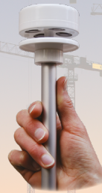**Anemometer sensor (CV7-OEM TYPE V)**

Wind speed is one of the most important external parameters of our wind turbine that is why we chose to work with an accurate sensor to measure the speed and direction of the wind as well as the temperature.

As you can see in the picture on the right side, we are going to use an anemometer which is a very accurate ultrasonic wind sensor powered with 8-30 v DC.

**Figure1 :**CV7-OEM TYPE V sensor [1]

**Data sheet of anemometer sensor**

You can find bellow a table that contains the technical Data about the chosen anemometer.

Figure 2 : Technical Data of CV7-OEM TYPE V sensor [1]

**Operating mode**

As you can see in the right-side picture this sensor contains 4 transducers (1)

Those devices communicate two by two through ultrasound signal (2) in order to determine according to two orthogonal axes, the difference in the transit time of the waves, induced by the flow of air 3.

The measurements are composed in an integrated calculator that will give the necessary information.

**Figure3:** CV7-OEM Operation mode [1]

As we mentioned before in order to control the flux power of charging system, we need Data from the anemometer sensor to take the necessary information. So, to full fill this object we have to send this Data From the sensor and display it through our computers or to our phones.

Here in after you will find a detailed description about the calibration of the anemometer sensor as well as the method that we have chose to send data even there is a long distance between transmitter and the receiver.

Before starting you can find bellow a diagram that describe all the system that we are going to use

**1) Calibration of the anemometer sensor**

At first, we tried to collect Data from our wind speed instrument used the Arduino software so you can so you can find bellows pictures of the necessary connection between the anemometer and the Arduino board after following some instructions that was taken from the data sheet.

**Figure4:** Connection of anemometer sensor

**1.a. Used instruments:**

-DC generator with 12V

-Anemometer sensor

-Arduino board

-Wires for connections

**1.b. Followed instructions.**

As shown in the picture above to make the connection between OEM CV-7 and the Arduino we had to follow the instructions bellow:

Red wire: +9v

Power supply for anemometer

Blue wire: 0V

Yellow wire: Tx (Ensure the transmission of data from the sensor to Arduino)

-We used the 13 and 14 pins to connect the anemometer with Arduino bord

**1.3. Collecting data**

Before collecting of data we should know types of data we can collect from the above Mention sensors are followed , 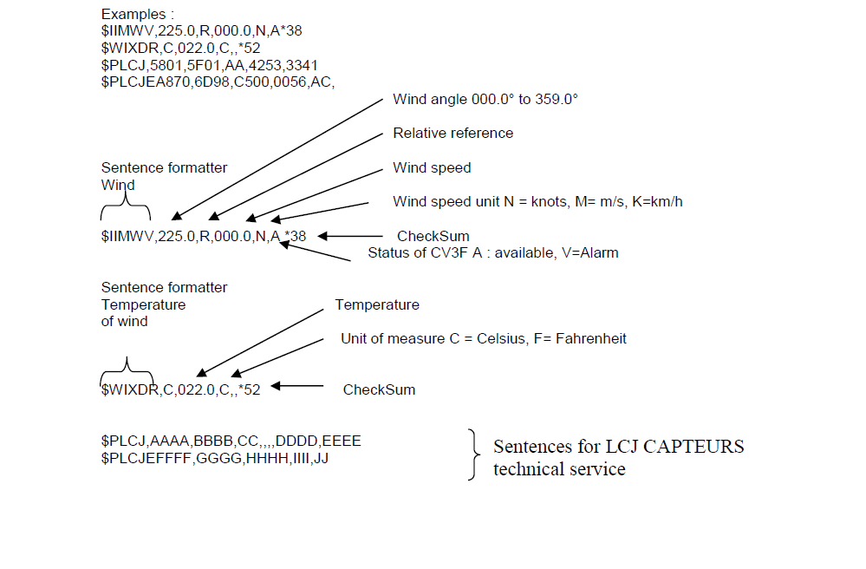

1.4

