1. **Singleton :** It returns a single bean instance per Spring IoC container.This single instance is stored in a cache of such singleton beans, and all subsequent requests and references for that named bean return the cached object.If no bean scope is specified in bean configuration file, **default** to singleton. [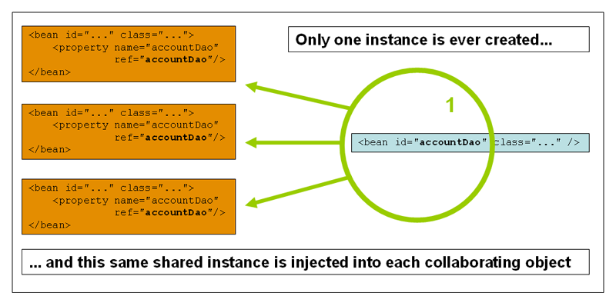](https://i.stack.imgur.com/gYMsT.png)
2. **Prototype** : It returns a new bean instance each time when requested. It does not store any cache version like singleton. [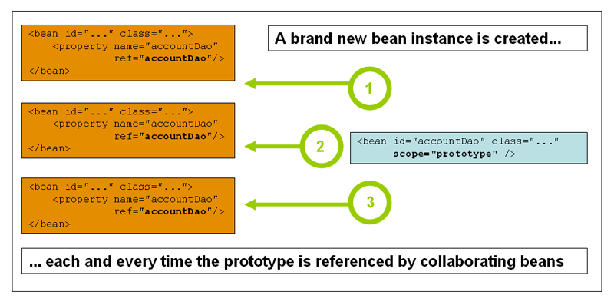](https://i.stack.imgur.com/cFt8U.png)
3. **Request** : It returns a single bean instance per HTTP request.

[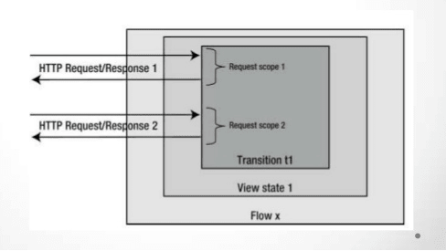](https://i.stack.imgur.com/iOcCd.png)

1. **Session** : It returns a single bean instance per HTTP session (User level session).
2. **GlobalSession** : It returns a single bean instance per global HTTP session. It is only valid in the context of a web-aware Spring ApplicationContext (Application level session).

In most cases, you may only deal with the Spring’s core scope – **singleton** and **prototype**, and the default scope is **singleton**.