---Write a SQL statement to make a list for the salesmen who either work for one or more customers or yet to join any of the customer.

--The customer, may have placed, either one or more orders on or above order amount 2000 and must have a grade,

--or he may not have placed any order to the associated supplier.

**Phase I**

--1)create a stored procedures

--2)push stored procedure data in a new table

--3)Data gather by including current time stamp in a new column

**Phase II**

4) create any primary key first on that table

5) once you get new data , upsert that data into final table using a primary key

6) Verify the upsert logic by insert and update statement by showing current time stamp column, once data get inserted it shows current time stamp.

**Phase II**

6) Create Final table

7) Verify the upsert logic using Merge statement as per current time stamp.

**Data set**

**Customer Dataset Orders Dataset**

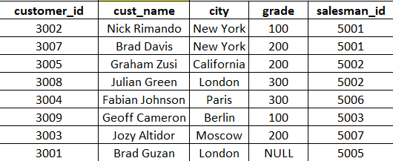 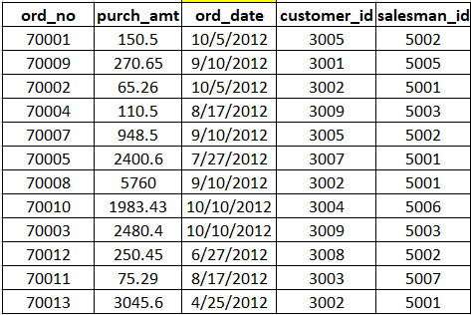

**Salesman Data set**

