🧠 Productivity Tracker
Design & Architecture Documentation

A neuroscience-backed daily protocol tracker built as a zero-build, static web application with Supabase-powered cloud sync and offline guest mode.

Part of the Zen Security Project by Trupti Shiralkar

Document Version: 1.0 • Date: July 2026

Table of Contents
Section | Title | Description
1 | Executive Summary | Project highlights, key features, and design philosophy
2 | Project Overview | Problem statement, solution, target users, design principles
2.1 | Problem Statement
2.2 | Solution
2.3 | Target Users
2.4 | Design Principles
3 | System Architecture | High-level architecture, tech stack, and file structure
3.1 | High-Level Architecture Diagram
3.2 | Technology Stack
3.3 | File Structure
4 | Component Design | UI component hierarchy, navigation, pages, and widgets
4.1 | Component Hierarchy Diagram
4.2 | Navigation System
4.3 | Page Components
4.4 | Floating Widgets
5 | Data Architecture | Data flow, Supabase schema, localStorage, dual storage
5.1 | Data Flow Diagram
5.2 | Supabase Database Schema
5.3 | Local Storage Schema
5.4 | Dual Storage Strategy
6 | Authentication & Security | Auth flows, RLS policies, guest mode architecture
6.1 | Authentication Flows
6.2 | Row Level Security (RLS)
6.3 | Guest Mode Architecture
7 | Feature Design Details | Tracker, activity cards, custom builder, samples, analytics
7.1 | Three-Phase Daily Tracker
7.2 | Rich Activity Cards
7.3 | Custom Routine Builder
7.4 | Protocol Samples
7.5 | Progress Analytics
7.6 | Pomodoro Focus Timer
7.7 | Notes & Journal System
8 | UI/UX Design System | Design tokens, theming, responsive design, animations
8.1 | Design Tokens (CSS Custom Properties)
8.2 | Theme System (Dark/Light)
8.3 | Responsive Design
8.4 | Animations & Micro-interactions
9 | Routing Architecture | Hash-based routing, page map, auth guards
10 | Testing & Quality Assurance | Built-in E2E test runner with 6 automated tests
11 | Deployment Guide | Prerequisites, configuration, local dev, production hosting
12 | Future Enhancements | Planned features and roadmap

1. Executive Summary
The Productivity Tracker is a neuroscience-based daily protocol tracking application designed to help users optimise their daily routines across three biological phases: Morning, Afternoon, and Evening. Built as a fully static, zero-build web application, it requires no bundler, framework, or npm installation — just plain HTML, CSS, and JavaScript.
The application supports two modes of operation: Registered Users with Supabase-powered cloud sync, and Anonymous Guest users with localStorage-only data persistence. This dual architecture ensures instant accessibility while providing cloud backup for committed users.
Key Highlights:
- Zero-build architecture — no bundler, no npm, just static files served over HTTP
- Dual authentication: Supabase Auth (email/password) + Anonymous Guest mode
- Three-phase daily tracking with 14 neuroscience-backed default activities
- Rich interactive activity cards with checklists, dropdowns, timers, and modals
- Drag-and-drop custom routine builder with suggested activity palette
- 6 pre-built expert protocol samples (Huberman, Attia, Walker, Goggins, Ferriss, Wim Hof)
- Progress analytics with per-day bar charts and phase-level insights
- Floating glassmorphic Pomodoro timer with Focus/Short Break/Long Break modes
- Dark/Light theme with smooth transitions and animated gradient backgrounds
- Built-in E2E test runner with 6 automated validation tests
- Fully responsive design with mobile hamburger menu

2. Project Overview

2.1 Problem Statement
Modern productivity tools are often complex, over-engineered, and detached from the biological rhythms that govern human performance. Users need a simple yet scientifically grounded tool to track daily protocols aligned with circadian biology, neuroscience principles, and evidence-based wellness practices.

2.2 Solution
The Productivity Tracker provides a structured three-phase framework (Morning, Afternoon, Evening) with pre-configured neuroscience-backed activities. Users can track completion, customise routines, view analytics, and use expert-designed protocols — all from a fast, privacy-respecting static web application.

2.3 Target Users
- Biohackers and self-optimisers interested in neuroscience-based protocols
- Knowledge workers seeking structured daily routines
- Students building consistent study and wellness habits
- Health-conscious individuals tracking sleep, exercise, and nutrition patterns

2.4 Design Principles
- Science-backed: Every default activity maps to published neuroscience research
- Privacy-first: Guest mode stores zero data on servers
- Zero-friction: No installation, no accounts required for basic use
- Progressive complexity: Simple tracking with optional deep customisation
- Instant feedback: Auto-save, confetti celebrations, toast notifications

3. System Architecture

3.1 High-Level Architecture Diagram
The application follows a client-side single-page application (SPA) pattern with hash-based routing. All rendering, state management, and business logic runs entirely in the browser. The backend consists of Supabase (BaaS) for authentication and data persistence.
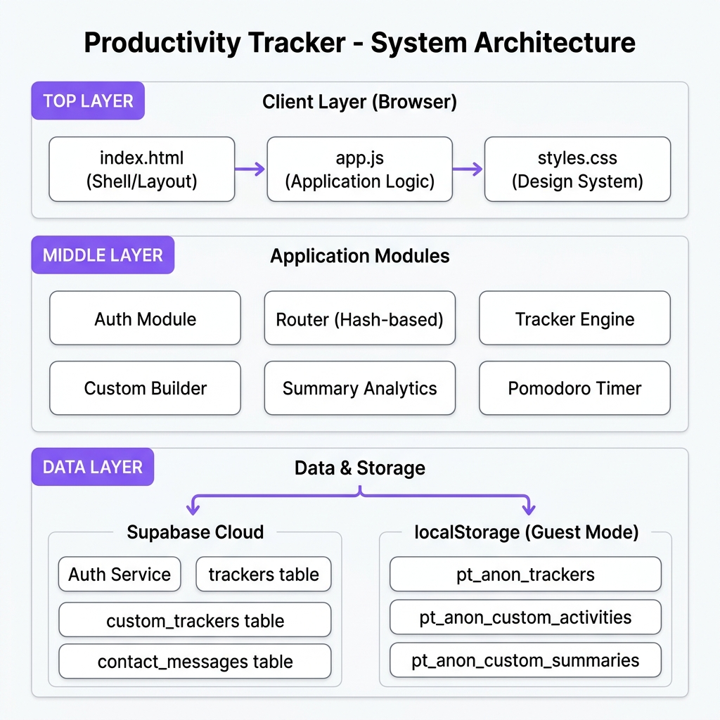
Figure 1: Productivity Tracker — System Architecture

3.2 Technology Stack
Layer | Technology | Details
HTML | Semantic HTML5 | Single index.html shell with nav, footer, Pomodoro widget
CSS | Vanilla CSS | CSS Custom Properties, animations, keyframes, glassmorphism
JavaScript | Vanilla ES2020+ | Single app.js (2775 lines) — async/await, DOM manipulation
Auth & DB | Supabase | Loaded via CDN (UMD build) — Auth + PostgreSQL
Fonts | Google Fonts (Inter) | Weights: 300, 400, 500, 600, 700, 800
Local Dev | npx serve | Zero-config static file server
Animations | CSS + Web Animations API | Transitions, keyframes, element.animate()

3.3 File Structure
File | Size | Purpose
index.html | 6.2 KB | App shell — navigation, footer, Pomodoro widget, CDN scripts
app.js | 129 KB | All application logic — routing, pages, auth, DB, UI rendering
styles.css | 70 KB | Complete design system — layout, components, animations, themes
config.js | 344 B | Supabase URL + anonymous API key configuration
assets/favicon.svg | 554 B | Brain emoji favicon
assets/*.jpg/png | ~5.4 MB | Profile, blog, podcast, video, and default images

4. Component Design

4.1 Component Hierarchy Diagram
The application is structured as a set of render functions, each responsible for generating the HTML for a specific page or component. The index.html provides the persistent shell (nav, footer, widgets), while the #root element is dynamically populated by the router.
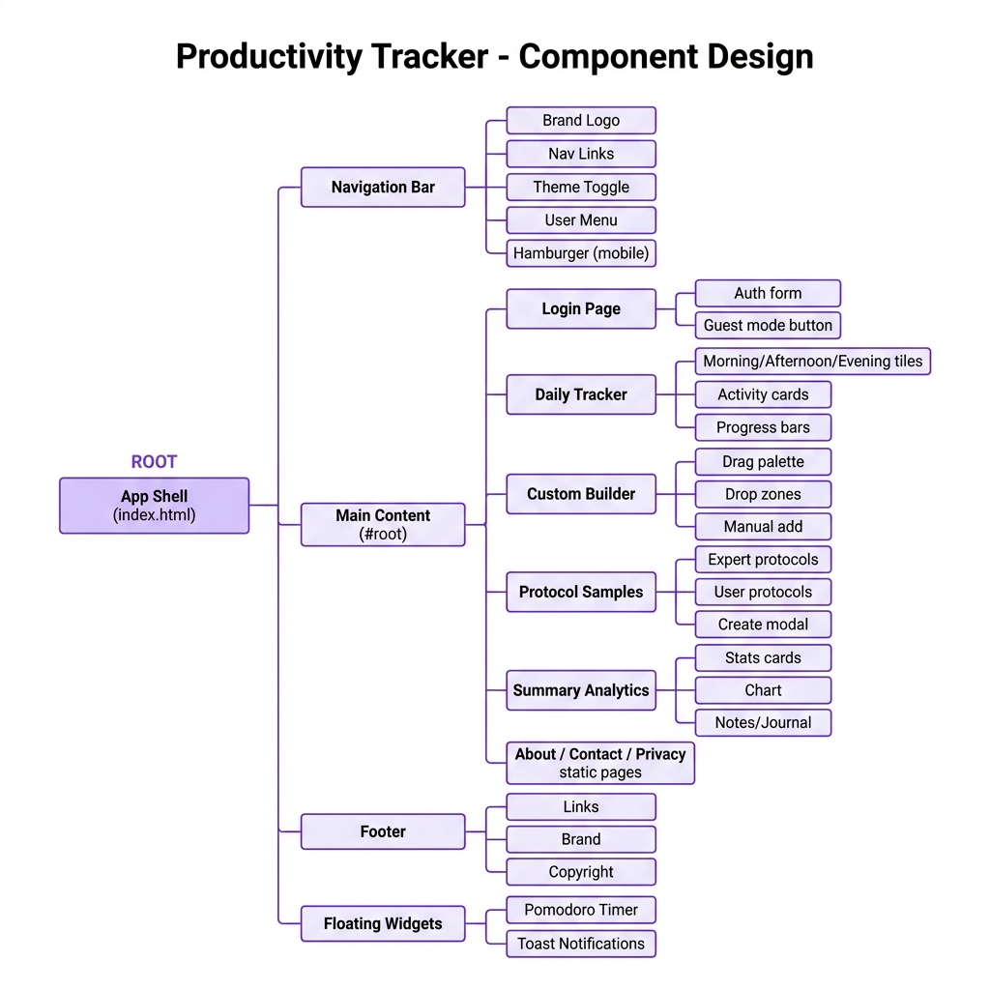
Figure 2: Productivity Tracker — Component Hierarchy

4.2 Navigation System
The navigation bar provides:
- Brand logo with brain emoji (🧠) and app title
- 7 navigation links: Home, Tracker, Custom, Samples, Summary, About, Contact
- Cross-site link to Zen Security (🛡️)
- Theme toggle button (☀️/🌙) with label for light/dark mode
- Pomodoro timer toggle button (⏱️ Focus)
- User session indicator with email/Guest label + Logout button
- Responsive hamburger menu with full mobile nav drawer
- Active link highlighting with underline + accent background
- Glassmorphic sticky header with backdrop-filter blur

4.3 Page Components
Page | Render Function | Key Features
Login | renderLogin() | Email/password form, Register toggle, Guest sign-in, inline validation
Daily Tracker | renderTracker() | Date picker, 3-phase grid, activity cards, progress bars
Custom Builder | renderCustom() | Drag palette, 3 drop zones, manual add form
Protocol Samples | renderSamples() | 6 expert + user protocols, bulk import, create modal
Summary | renderSummary() | Stats cards, 7-day chart, notes/journal CRUD
About | renderAbout() | Project description, phase explanations
Privacy | renderPrivacy() | Privacy policy for guest and registered users
Contact | renderContact() | Contact form → Supabase contact_messages table
Test Runner | renderTestRunner() | 6 automated E2E tests with progress tracking

4.4 Floating Widgets
Pomodoro Timer Widget:
- Glassmorphic floating panel with backdrop-filter blur (20px)
- Draggable via mouse and touch events with position persistence
- Three modes: Focus (25 min), Short Break (5 min), Long Break (15 min)
- Start/Pause/Reset controls with animated button states
- Toast notification on timer completion
- Position saved to localStorage for session persistence

Toast Notification System:
- Color-coded slide-in toasts: success (green), error (red), warning (amber)
- Auto-dismiss after configurable duration (default: 3 seconds)
- Smooth CSS transition fade-in/fade-out animation

5. Data Architecture

5.1 Data Flow Diagram
The application implements a dual-storage architecture: Supabase for authenticated users and localStorage for guest users. A unified API layer (db* functions) abstracts the storage backend, allowing all UI code to be storage-agnostic.
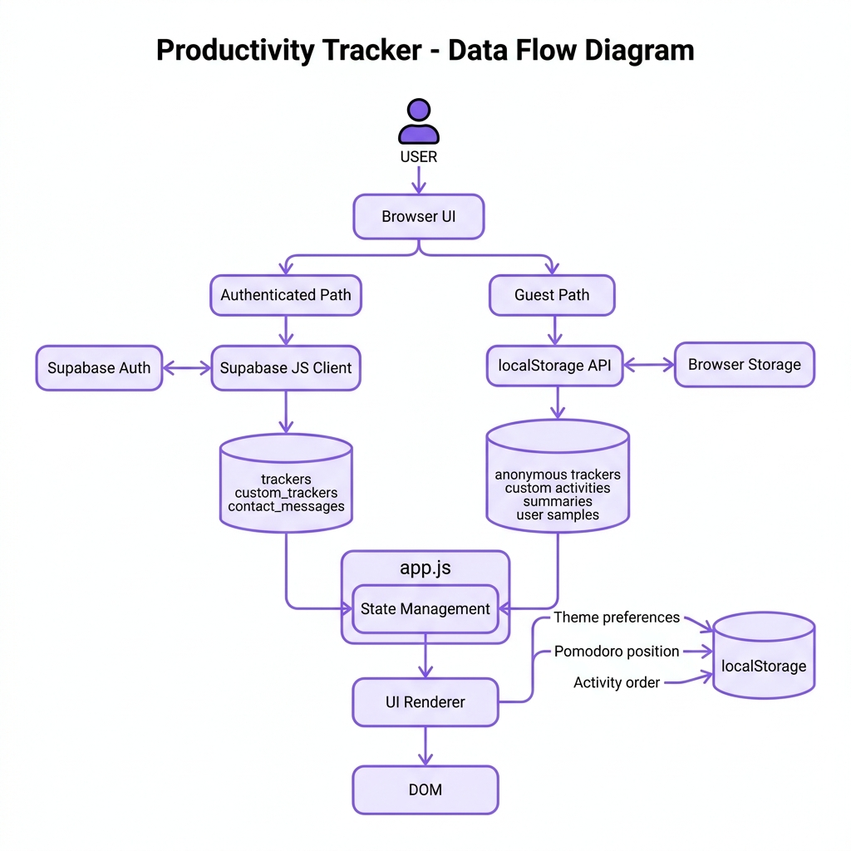
Figure 3: Productivity Tracker — Data Flow Diagram

5.2 Supabase Database Schema
Table: trackers
Column | Type | Constraints | Description
id | UUID | PRIMARY KEY, auto-generated | Unique tracker entry identifier
user_id | UUID | FK → auth.users, NOT NULL | Owner of this tracker entry
date | DATE | NOT NULL | The date being tracked
phase | TEXT | CHECK (morning|afternoon|evening) | Time-of-day phase
activities | JSONB | DEFAULT '{}' | Activity statuses & logs as JSON
completion_rate | NUMERIC | DEFAULT 0 | Phase completion percentage (0–100)
created_at | TIMESTAMPTZ | DEFAULT now() | Row creation timestamp

Table: custom_trackers
Column | Type | Constraints | Description
id | UUID | PRIMARY KEY, auto-generated | Unique custom activity ID
user_id | UUID | FK → auth.users, NOT NULL | Owner user
phase | TEXT | CHECK (morning|afternoon|evening) | Target phase
name | TEXT | NOT NULL | Activity display name
created_at | TIMESTAMPTZ | DEFAULT now() | Creation timestamp

Table: contact_messages
Column | Type | Constraints | Description
id | UUID | PRIMARY KEY, auto-generated | Unique message ID
name | TEXT | NOT NULL | Sender's name
email | TEXT | NOT NULL | Sender's email
message | TEXT | NOT NULL | Message content
created_at | TIMESTAMPTZ | DEFAULT now() | Submission timestamp

5.3 Local Storage Schema
Key | Type | Used By | Description
pt_anon_trackers | JSON Array | Guest Mode | Daily tracker data for anonymous users
pt_anon_custom_activities | JSON Array | Guest Mode | Custom activities for anonymous users
pt_anon_custom_summaries | JSON Array | All Users | Journal notes and reflections
pt_anon_user_samples | JSON Array | All Users | User-created protocol samples
pt_theme | String | All Users | Theme preference: 'dark' or 'light'
pt_pomodoro_pos | JSON Object | All Users | Pomodoro widget {left, top} position
pt_activities_order_{uid}_{phase} | JSON Array | All Users | Drag-reorder activity sequence
pt_anonymous_user (session) | JSON Object | Guest Mode | Session storage for guest user object
pt_anonymous_token (session) | String | Guest Mode | Session storage for guest token

5.4 Dual Storage Strategy
The application uses a Unified API pattern to abstract storage backends. Functions like dbGetTrackersForDate(), dbUpdateTrackerActivity(), and dbGetCustomTrackers() check the currentUser.isAnonymous flag to route operations to either Supabase or localStorage. This ensures all UI code remains storage-agnostic.
Decision flow:
- If currentUser is null → return empty data (not authenticated)
- If currentUser.isAnonymous is true → read/write localStorage
- Otherwise → call Supabase client API with user_id filter

6. Authentication & Security

6.1 Authentication Flows
Flow 1: Email/Password Registration
- User fills email + password (min 12 chars) + confirm password
- Client-side validation: email format, password length, password match
- supabaseClient.auth.signUp() called → Supabase creates user
- If auto-login enabled: session immediately available
- Otherwise: user must confirm email, then sign in manually

Flow 2: Email/Password Sign-In
- User enters email + password
- supabaseClient.auth.signInWithPassword() called
- On success: session stored, user redirected to #app
- On failure: inline error message (invalid credentials, unconfirmed email)

Flow 3: Anonymous Guest Sign-In
- User clicks '⚡ Sign In as Guest (Anonymous)'
- Synthetic user object created: { id: 'anonymous-guest-id', isAnonymous: true }
- Stored in sessionStorage (not localStorage) — dies with browser tab
- All data operations routed to localStorage instead of Supabase

Flow 4: Logout
- Clear sessionStorage guest data
- Call supabaseClient.auth.signOut() for registered users
- Reset currentUser and sessionToken to null
- Redirect to #login

6.2 Row Level Security (RLS)
Supabase tables use Row Level Security to ensure users can only access their own data. The RLS policies use auth.uid() to match against the user_id column:
- trackers: 'Own trackers' policy — FOR ALL USING (auth.uid() = user_id)
- custom_trackers: 'Own custom' policy — FOR ALL USING (auth.uid() = user_id)
- contact_messages: No RLS — any user can insert (public contact form)

6.3 Guest Mode Architecture
Guest mode is designed for maximum privacy. No data ever leaves the browser. The anonymous user object is stored in sessionStorage (not localStorage) so closing the browser tab ends the session. All tracking data uses localStorage keys prefixed with 'pt_anon_' for easy identification and cleanup.

7. Feature Design Details

7.1 Three-Phase Daily Tracker
The core of the application divides each day into three biological phases aligned with circadian science:
Phase | Time | Focus Area | Default Activities
🌅 Morning | Wake → Noon | Wakefulness, cortisol, light | Hydration, Caffeine delay, Sunlight, Deep work
☀️ Afternoon | Noon → 5 PM | Exercise, recovery, focus | Lunch, Walk, Nap/NSDR, Exercise, Dopamine reset
🌙 Evening | 5 PM → Bed | Wind-down, melatonin, sleep | Sunset, Dinner, Wind-down, Breathing, Sleep log

Each phase tile features:
- Phase label with emoji icon and completion percentage
- Animated progress bar with shimmer effect and cubic-bezier bounce
- Confetti celebration animation when reaching 100% completion
- Color-coded tile borders: gold (morning), blue (afternoon), purple (evening)

7.2 Rich Activity Cards
Each activity is rendered as an interactive card with contextual controls based on its type. The ACTIVITY_META object maps activity names to their metadata:
Activity Type | Interaction | Example Activities
checklist | Multi-checkbox list | Hydration checklist, Wind-down checklist
caffeine | Time input → calculated caffeine window | Delay caffeine (90 min)
sunlight | Duration + sky condition dropdowns | Morning sunlight log
deepwork | Focus aid modal buttons | Deep work session
lunch/dinner | Meal type dropdown | Lunch tracker, Dinner log
walk/exercise | Duration + location/type dropdowns | Afternoon walk, Exercise log
nsdr | Rest type chip selector | Nap / NSDR session
dopamine | Reset protocol modal | Dopamine reset
sunset | Dynamic sunset time notification | Sunset light exposure
breathe | Step-by-step breathing guide modal | Physiological sigh breathing
sleep | Bedtime + wake time inputs + weekly chart | Sleep schedule tracking

Card interaction features:
- Three status buttons: ✓ Done (purple), ✗ Skip (red), ↺ Reset (neutral)
- Drag-and-drop reordering with grip handle (⋮⋮)
- Optimistic UI updates — visual feedback before backend sync
- Status-dependent styling: green border (done), red/dimmed (skipped)

7.3 Custom Routine Builder
The Custom page provides a drag-and-drop builder for creating personalised routines:
- Activity Palette: 24 suggested activities across 3 phase tabs (8 per phase)
- Three Drop Zones: Morning, Afternoon, Evening with visual drop indicators
- Manual Add: Phase selector + text input for fully custom activities
- Already-added indicators: greyed-out palette tiles with '✓ Added' badge
- Custom activities appear in the Daily Tracker alongside default activities

7.4 Protocol Samples
The application includes 6 pre-built expert protocols:
Protocol | Expert | Phase | Activities
The Huberman Protocol | Andrew Huberman | Morning | Sunlight, Caffeine, Cardio, NSDR, Light Control
The Attia Longevity | Peter Attia | Afternoon | Fasting, Resistance, Protein, Sauna, Biomarkers
The Walker Sleep | Matthew Walker | Evening | Consistent bed, Cold room, No caffeine, Shower, No screens
The Goggins Discipline | David Goggins | Morning | 4:30AM wake, Cardio, Study, Cold exposure, Mirror
The Ferriss Efficiency | Tim Ferriss | Afternoon | 80/20, Cold, Slow-carb, Journal, Self-experiment
The Wim Hof Method | Wim Hof | Evening | Breathing, Cold immersion, Meditation, Commitment, Nature

Users can also create custom protocols via a modal form with:
- Protocol name, icon selection (20 emoji options), tagline, and phase assignment
- 1–10 custom activities with icon, name, and description
- Saved to localStorage and displayed alongside expert protocols

7.5 Progress Analytics
- Days Tracked: Total number of unique dates with tracking data
- Overall Consistency: Average completion rate across all tracked days
- Strongest Phase: Phase with highest average completion (Morning/Afternoon/Evening)
- Last 7 Active Days: Per-day completion bar chart with animated progress bars

7.6 Pomodoro Focus Timer
- Glassmorphic floating widget with backdrop-filter blur
- Three modes: Focus (25 min / 1500s), Short Break (5 min / 300s), Long Break (15 min / 900s)
- Start / Pause / Reset controls with hidden state toggling
- Draggable via mousedown/touchstart events with position persistence
- Boundary clamping to prevent widget from going off-screen
- Toast notification on timer completion: '⏱️ Timer finished!'

7.7 Notes & Journal System
- 6 categories: Reflection, Goal, Win, Challenge, Insight, Other
- Title (optional) + content (max 1000 chars) with character counter
- Color-coded category badges with custom CSS properties
- Sorted by creation date (newest first)
- Delete individual notes with instant re-render
- Stored in localStorage under pt_anon_custom_summaries key

8. UI/UX Design System

8.1 Design Tokens (CSS Custom Properties)
The application uses a comprehensive set of CSS Custom Properties for consistent theming across all components:
Token | Dark Mode Value | Light Mode Value | Usage
--bg-color | #0b0c10 | #fafafa | Page background
--panel-color | #0f1117 | #ffffff | Footer, panel backgrounds
--card-color | #11131a | #ffffff | Card, tile backgrounds
--text-color | #e8eaf0 | #0f172a | Primary text color
--muted-color | #a9b0be | #6b7280 | Secondary/muted text
--border-color | rgba(255,255,255,0.08) | rgba(0,0,0,0.09) | Border colors
--accent-color | #8b5cf6 | #8b5cf6 | Brand purple accent
--accent-hover | #7c3aed | #7c3aed | Hover state for accent
--nav-bg | rgba(15,17,23,0.75) | rgba(255,255,255,0.85) | Nav backdrop
--input-bg | #11131a | #fafafa | Form input background

8.2 Theme System (Dark/Light)
Theme switching mechanism:
- Dark mode is the default (matches Zen Security parent project)
- Toggle via [data-theme='light'] attribute on <html> element
- All CSS variables overridden under [data-theme='light'] selector
- Theme preference persisted to localStorage under 'pt_theme' key
- Smooth transitions: background 0.35s ease, color 0.25s ease
- Animated gradient background shifts between purple/blue/green/pink

8.3 Responsive Design
Breakpoints:
Breakpoint | Behaviour
≤ 1024px | Reduced nav link font size and padding, tighter nav spacing
≤ 768px | Nav links hidden, hamburger menu shown, single-column grids, footer collapses

Responsive patterns:
- CSS Grid: repeat(auto-fit, minmax(300px, 1fr)) for tracker tiles
- Hamburger menu with slide-down mobile drawer (aria-expanded)
- Theme toggle hides label text on mobile (icon only)
- Touch support for Pomodoro drag and activity card reordering

8.4 Animations & Micro-interactions
Animation | Type | Duration | Description
gradientShift | CSS @keyframes | 15s infinite | Animated background gradient position
radialFloat | CSS @keyframes | 20s alternate | Floating radial gradient orbs
progressShimmer | @keyframes | 2.5s infinite | Progress bar shimmer/glow effect
progressGlint | @keyframes | 2s infinite | Glint overlay sweep on progress bars
Confetti | Web Animations API | 1.5–3s | 60 particle burst on 100% completion
Toast slide | CSS transition | 350ms | Slide-in/fade-out notification
Card hover | CSS transition | 300ms cubic-bezier | translateY(-1px) + box-shadow
Button press | CSS :active | instant | scale(0.97) press feedback

9. Routing Architecture
The application uses hash-based routing (window.location.hash) with a central route() function that maps hash values to render functions. This approach requires no server-side configuration and works with static file hosting.
Hash | Page | Auth Required | Render Function
#login | Sign In / Register / Guest | No | renderLogin()
#app | Daily Tracker (default) | Yes | renderTracker()
#tracker | Daily Tracker (alias) | Yes | renderTracker()
#summary | Progress Analytics | Yes | renderSummary()
#custom | Custom Routine Builder | Yes | renderCustom()
#samples | Protocol Samples | Yes | renderSamples()
#about | About | Yes | renderAbout()
#privacy | Privacy Policy | Yes | renderPrivacy()
#contact | Contact Form | Yes | renderContact()
#test | E2E Test Runner | No | renderTestRunner()

Routing logic:
- hashchange event listener triggers route() on every navigation
- route() clears #root innerHTML and resets body class
- Unauthenticated users are redirected to #login (except #test)
- Active nav link highlighting via updateActiveNavLink()

10. Testing & Quality Assurance
The application includes a built-in E2E test runner accessible at the #test hash. It runs 6 automated tests to validate core functionality:
Test # | Name | What It Validates
1 | Operational Status | Both sites (Zen Security + Tracker) return HTTP 200
2 | Cross-Navigation | Bi-directional links between Zen Security and Productivity Tracker
3 | Interactive Elements | Pomodoro widget, drag handles, confetti function exist
4 | Header Link Integrity | All 7 nav links present with correct href values
5 | Registration Flow | Auth form toggle, email/password/confirm fields present
6 | Anonymous Guest Mode | Guest sign-in works, localStorage populated, cleanup works

Test runner features:
- Visual progress bar with step-by-step badge states (Pending → Running → Passed/Failed)
- Console log panel with monospace output
- Run all tests sequentially with a single button click

11. Deployment Guide

11.1 Prerequisites
- A Supabase project with API URL and anonymous key
- Database tables created (trackers, custom_trackers, contact_messages)
- RLS policies enabled on trackers and custom_trackers tables

11.2 Configuration
Edit config.js with your Supabase project credentials:
const SUPABASE_URL = 'https://your-project.supabase.co';
const SUPABASE_ANON_KEY = 'your-anon-key';

11.3 Local Development
From the workspace root (zensecurity-main/):
npx serve . -l 3000
Open: http://localhost:3000/Productivity_tracker/

11.4 Production Deployment
Compatible with any static file hosting:
Platform | Steps
Netlify | Push to GitHub → Connect Netlify → Set publish directory to ./
Vercel | Push to GitHub → Connect Vercel → No build command needed
GitHub Pages | Push to GitHub → Enable Pages → Set source to root
Manual | Upload Productivity_tracker/ folder to any web host

12. Future Enhancements
Planned features for future releases:
- OAuth integration: Google, GitHub, Apple sign-in via Supabase Auth
- Push notifications: Browser notification API for timer reminders
- Data export: CSV/JSON export of tracking history
- Social features: Share protocols with other users
- PWA support: Service worker for offline access
- Streak tracking: Visual streak counter for consecutive days
- Weekly/monthly reports: Email digest of tracking statistics
- AI insights: Pattern analysis and personalised recommendations
- Calendar heatmap: GitHub-style contribution graph for tracking history
- Supabase Realtime: Live sync across devices for registered users

— End of Document —
Generated for Productivity Tracker v1.0 • July 2026

