•

**Name :**

Anirban Mahata

•

**D.O.B :**

16.07.2001

•

**University :**

Vidyasagar University, Midnapore

•

**Current Course :**

Bachelor of Computer Application

•

**Email**

**-**

**ID :**

anirbanmahataofficial@gmail.com

•

**Contact :**

+918918722945

**Personal Information**

•

To

work

in

an

organization

where

culture

of

freedom

and

working

for

initiatives

is

ensured,

facilitating

my

contribution

through

thoughts

and

action

to

the

company’s

vision

and

thus

achieve

self

development

by

playing

a

significant

role

in

building

the

organization

.

**Objective**

•

Bachelor of Computer Application (2019

-

2022)

•

University : VIDYASAGAR UNIVERSITY

•

Score : 78.11%

•

Higher Secondary (2018

-

2019)

•

Board : West Bengal council of higher secondary education

•

Score : 72.8%

•

Matriculation (2016

-

2017)

•

Board : West Bengal board of secondary education

•

Score : 69%

**Academic details**

•

HTML

•

CSS

•

Javascript

•

REACT

•

C++

**Technical skills**

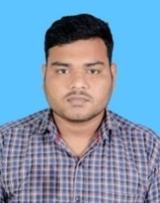

•

**Real time code runner:**

•

Developed and designed a Real Time HTML , CSS, JS code runner

which gives real time output of code.

•

**Link**

-

https://anirbanmahata.in/LIVE%20HTML%20CSS%20EDITOR/index.html

•

**Budget calculator using JS:**

•

Designed and developed a budget calculator to calculate and

manage monthly expenditure.

•

**Link**

-

https://anirbanmahata.in/Budget_Calculator/index.html

•

**Student Data Manager:**

•

Designed and developed a website for collecting and showing data

of students.

•

**Link**

**-**

https://anirbanmahata.in/Student_Data_Manager/index.html

**Projects**

•

Awarded the 2nd position in showcasing the Recent Trends in

Machine Learning in the Student webinar Organized by Department of

Computer science & B.C.A, Kharagpur College.

•

Web development Course by Megalith Indian Institute of Technology

Kharagpur

**Achievements and awards**

•

English

•

Hindi

**Languages**

•

Exploring

new

technologies

•

Traveling

**Hobbies**