Seminar assignment – EEPITM - 01
Green Disposal
(Green and Sustainable Computing)
Group #1
Anirban Roy Choudhury (EEPITM-01-001)
Gaurav Pratap Singh (EEPITM-01-004)
Satyajit Mohanty (EEPITM-01-020)
Siddharth Verma (EEPITM-01-023)
Sirish Kumar (EEPITM-01-024)

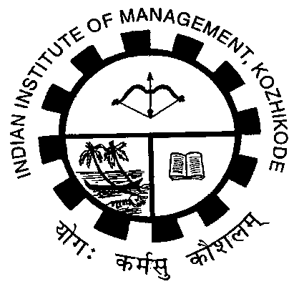

Indian Institue of management, Kozhikode
OCT 2013
Table of Contents

Disclaimer 2
1 Introduction 3
2 Popular Disposal Methods 4
3 Laws and Regulations for Green Disposal 7
4 Green Disposal Methods 8
5 References 10
6 Definitions, Acronyms and Abbreviations 10

Disclaimer
This term paper includes references and material from websites as indicated in the References section. No specific permission has been sought as it is understood that the material is present in the public domain and hence covered under GFDL (incase of Wikipedia: http://en.wikipedia.org/wiki/Wikipedia:Copyright_violations). Wherever else applicable and best possible, appropriate references have been made in accordance with Fair Use & Non Free Content Policy and Guidelines (http://en.wikipedia.org/wiki/Wikipedia:NFC). The authors are not liable for any copyright violations. The intent of the references is to introduce the topics under discussion and only for academic research with no commercial intent or use.

Introduction

Technology advancements in recent times have resulted in many new products appearing in the market more frequently than the previous decade and thus replacing the older products even before their lifetime is over. This leads to an over accumulation of e-Waste and that requires a proper disposal. Discarded PCs, Laptops, Mobile Phones, Digital Cameras etc. are some of the commonly accumulated e-Waste.

Electronic waste is mostly managed through three R’s (Reduce, Reuse, Recycle) and after exhausting these options if electronic item is neither re-usable nor-recyclable than it needs to be disposed off. Disposal comes at the bottom of the waste pyramid [Figure 1].

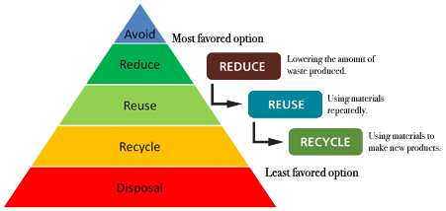
Figure: 1 Source: Waste Reduction Hierarchy, graphics sourced from I Sustain and ICE.

This paper mainly deals with the lowest layer of waste pyramid i.e. “Disposal”.

Section 3 of this paper outlines the rules, regulations and international treaties to manage e-Waste through Disposal without affecting environment. Section 2 highlights the popular and unorganized e-Waste disposal mechanisms prevalent especially in third-world countries. Section 4 gives an overview of the “Green” way of disposing of e-Waste and also highlights limitations of that.

Popular Disposal Methods
Flow chart below (Figure: 2) depicts the life-cycle of an electrical/electronic equipment from production to end-of-life.
Importer/Manufacturer
Distributor/Reseller
Relative/Friends
Industrial Customer
Personal Use
Donate
Exchange with Vendor
Dispose off to the local scrap dealer
Refurbishes/Replaces the Components
Dismantlers
E-Waste recyclers
Extract precious metals

Figure 2: Life cycle of an e-Equipment

E-Waste contains hazardous elements like:
- Heavy metals: Lead, Cadmium, Mercury, Barium, Arsenic, Selenium
- Precious metals: Gold, Silver, Platinum
- Other metals: Copper, Aluminum
- Chlorinated compounds: Poly Vinyl Chloride (PVC)
- Plastics: Poly Chlorinated Biphenyls (PCB), Poly Chlorinated Diphenyl Ether (PCDE)

E-Waste can generally take three routes:
- The right route is to process e-Waste through a service that recycles as much of the materials as possible.
- The bad route is to do local landfill, but in developed nations due to strong laws and proper enforcements hazardous “land filling” method is rare.
- The worst route is to transfer the equipment to a recycler who ships the stuff to a third-world country. In USA and Europe the traders have to pay $20 to recycle a computer properly but in countries like China and India it can be done in $2. So, most of the e-waste is exported to the developing countries governed by brute global economic forces where the environmental and occupational regulations are non-existent, minimal or not well-enforced. This is currently most common way of disposing off E-Waste in the developed nations.
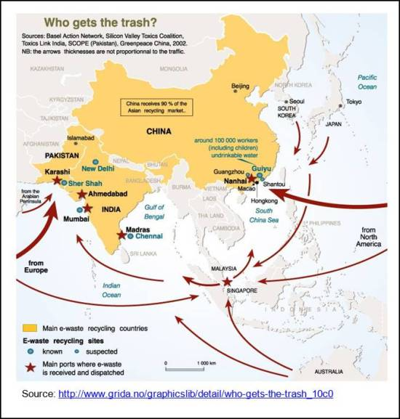
Figure 3: Who gets the e- trash
Guiyu, in the Guangdong province of China is a global dumping ground. It is described as the most toxic places on Earth. India is one of the largest e-waste importing countries in the world. In 2009, India produced 9 million tons of hazardous waste domestically and imported 6.4 million tones. In 2009, In India, the organized recyclers formed the e-waste recycler association but due to the stiff competition from the unorganized sector they were able to capture only 10% of the market.
Following table (Table 1) details the current popular ways by which e-waste is disposed off in an un-organized sector mostly in developing nations:
Table 1: Reference [1]
Method | Extraction | Emissions | Harmful Effects
Open Burning | Copper is recovered after burning PVC/PCBs/PWBs | PCBs and PCDEs in the PVCs emit Poly chlorinated dibenzo-p-dioxins (PCDDs) and Poly chlorinated dibenzo Furans (PCDFs) on burning.  Capacitors and Transformers produce dioxins and Furnas when burnt. | PCDDs and PCDFs are classified as carcinogens by WHO. They modify the DNA and cause genetic defects to future generations.
Incineration | None | Polybrominated Dioxins (PBDD), PBDFs and Polybrominated biphenyl (PBB) gases are produced during incineration. | PCDDs and PCDFs have same toxicological effects as PCDDs and PCDFs.
Land filing and Open Dumping.  . | CRTs are broken and copper is recovered from the yoke.  Hard disks are broken to recover the Aluminum casing, magnet, platter and the PWB that are inside.  Gold pins are extracted from PWBs by adding acid bath and mercury | The broken CRTs contain toxic lead and cadmium.  Toxins contaminate the ground soil and might contaminate the ground water too.  Old landfills become toxic bombs due to high emission of CO2 with time and overloading.  Methane is produced from such landfills which contribute towards global warming. | A landfill does not help in controlling toxins and its harmful effects  Heavy metals can cause damage to the nervous system, the brain, and the kidneys and can cause birth defects and cancer.  Toxic water can destroy Flora and Fauna in the rivers and oceans.
Toner Sweeping | Manually sweeping the toner out of printer cartridge without respiratory protection and many times without hand gloves. | Toner contains Class-A2 carcinogenic carbon black. | Chances of cancer and respiratory diseases.
Acid Stripping of Chips | PCBs are dipped in a acid bath consisting of 25% nitric acid and 75% of pure Hydrochloric acid. PCBs are dipped into the acid mixture until the PVC is separated from the chips and after this the acid is drained into the nearest drain or river. | Water samples tested around areas of such activities found to contain high level of toxics. | Water not fit for human consumption.

Laws and Regulations for Green Disposal

 | Rules/ Treaties/ Laws/ Regulations | Shortcomings/ Workarounds
1 | The Basel Convention on the Control of the Trans-boundary movement of Hazardous Waste and Their Disposal is the most comprehensive global environmental agreement on hazardous and other wastes. | However, the lucrative business that is created by e-waste recycling is responsible for the undermining of this convention in areas where e-waste is transported to the third-world countries like China, India, Pakistan, Bangladesh and Ghana.
2 | Waste Electrical and Electronic Equipment (WEEE) directives, the producer, re-seller and importer of electronic equipment will have legal obligations with regard to the recycling, reuse and disposal of electronic equipments or components. | Mostly, in past, producers did not consider the recycling costs and hence were hesitant in taking back the e-Waste. Now, due to similar regulations, they are deciding the product price assuming that the equipments need to be recycled but still cost of recycling is not recoverable by them.  There is need to give subsidies to the manufacturers who are actively involved in the recycling.
3 | In India, The Ministry of Environment and Forests (MoEF) issued the Guidelines for Environmentally Sound Management of E-Waste in 2008 for detailing out the activities and procedures for e-waste processing. In 2010, The MoEF issued the Draft E-Waste Management and Handling Rules. These Rules address the issue of waste management by introducing principles like Extended Producer Responsibility (EPR) and Restriction of Hazardous Substances (RoHS) in the law and putting the responsibility of e-waste management on producers. Under the proposed legislation the import of used EEE will be prohibited to India if it is designated for further usage. | This does not apply to the radioactive wastes such as Cobalt-60.  Due to lax law enforcement tons of e-waste enters India under the guise of donation, help etc and these finally land up in the street backyards where precious metals are extracted from them or they are recycled or disposed off in non-green way.  Free Trade Agreements (FTAs) or “Economic Partnership Agreements” (EPAs) are often used to disguise e-waste and developed nation ship the e-Waste to the developing economies. These practices are not caught due to lack of manpower, scanning equipments in ports and also partially due to corruption.

Green Disposal Methods

Proper disposal of e-Waste is required and primarily it should involve either of the below steps:
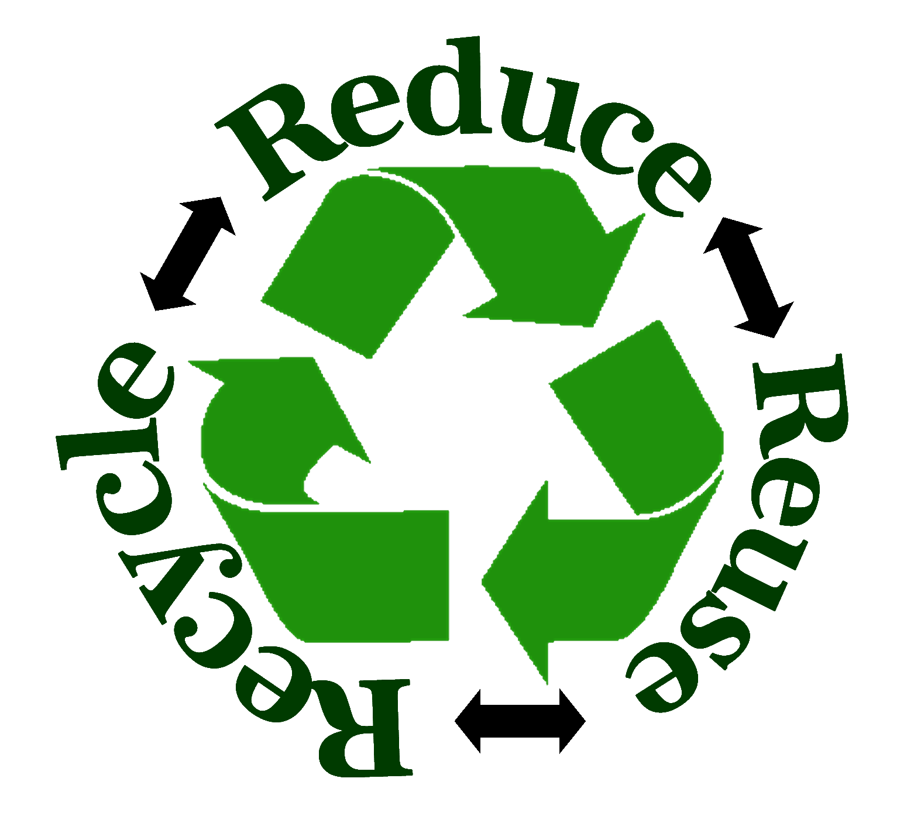
- Reuse: Design for longevity which can be achieved by variety of design changes.
- Recycle: Use Extended Producer Responsibility (EPR) approach in which the manufacturer takes responsibility of maintenance of the product post product life too.
  - Producer Responsibility: As part of maintenance, a producer can recycle the product, refurbish the product or can dispose of the product. For example, Nokia has established almost more than 1400 bins across India to collect disposed mobile phones and accessories from its consumers. Nokia is also collaborating with 10 companies who are actively engaged in electronics recycling. Globally, Nokia has collected more than 1.5 million pieces of phones & accessories weighing over 70 tones.
  - Bulk Consumer Responsibility: Bulk consumers need to make sure that all e-waste is directed to the authorized e-Waste dealers or an authorized collection center setup by the producers. Additionally, e-Waste can also be directed to the re-furbishers, registered dismantlers or recyclers or avail the pick-up or take back services provided by the producers. Bulk consumers are liable to pay a fine if they fail to follow the above process.
  - Individual Consumers: Consumers are required to submit the e-Waste or end-o-life electronic products to the dealer from where they purchased the equipment or drop it to the authorized collection centers. Producers should pay some minimum price on the returned equipments.
But this process is not cost effective and there is need to subsidize the recycling effort.
- Reduce : Reduce the usage of non-toxic and environmentally friendly raw materials in equipments
Below table compares the non-green way of disposing of CRTs and Circuit Boards by the un-organized sectors and highlights the green way of disposing off of these parts.
Table 2: Reference [3]
Non-Green | Green
CRTs are broken manually to separate its components – glass, metal and copper. The glass, comprising lead, is sold to bakeries or bangle makers. Since it retains heat, the glass goes into the base of ovens. Phosphors, if inhaled, can be toxic. The CRTs are sold to non-branded television makers. | Components of the CRTs are separated by heating in a closed chamber, which sucks out  Phosphors from the components. They are then crushed in shredder machines. Glass containing lead is sold to the companies that manufacture the CRTs.
Circuit boards have gold plated brass pins, microchips and condensers which are  Separated by heating. Fumes released during heating are toxic. Gold-plated brass pins are soaked in acid to recover the gold and brass separately. Microchips and condensers are heated in big containers filled with acid to extract metallic parts. | Circuit boards are crushed in shredder machines. They are sent to approved smelters abroad, where after smelting at 1200°C, the metals in the circuit board collect together. Since smelting is carried out in closed chambers at high temperature, it is not hazardous. The metals—lead, copper, nickel, tin, gold, silver, palladium—are then separated by electro-refining.

References

[1] S. Devika, Environmental Impact of Improper Disposal of Electronic Waste, 2010, IEEE Conference Publications
[2] Dr. SP. Victor, Shri S Suresh Kumar, Roadway for Sustainable Disposal of Scrap Computers in India, IEEE, 2011
[3] Research Unit (LARRDIS), E-Waste in India, Rajya Sabha Secretariat, New Delhi, 2011
[4] Mark G. O’Neill, Green IT for Sustainable Business Practice, British Informatics Society Limited
[5] http://www.thehindubusinessline.com/on-campus/ewaste-management-indias-wrong-turns/article4577332.ece [accessed on 09 Oct 2013]
[6] http://www.weeerecycle.in/safe_disposal_e_waste_overview.htm [accessed on 09 Oct 2013]
[7] http://en.wikipedia.org/wiki/Electronic_waste_in_China
[8] http://www.greenarth.com/blog/e-waste-stashing-the-right-way

