Global E-Commerce
Customer Analytics Report
Churn Prediction & Customer Segmentation
Dataset: Global E-Commerce Customer Analytics 2024 (Kaggle)
Analysis Period: 2019 – 2024 | Sample: 1,200 Customers
Prepared by: Analytics Specialist | June 2025

1. Executive Summary
This report presents an end-to-end analysis of 1,200 global e-commerce customers covering churn prediction, customer segmentation, and actionable retention strategy. The analysis was conducted on the Global E-Commerce Customer Analytics 2024 Kaggle dataset using Python, scikit-learn, and unsupervised clustering.

Key Findings
- 67.3% overall churn rate — well above the industry benchmark of 20–30%, indicating a systemic retention problem.
- Satisfaction score is the strongest predictor: scores 1–2 churn at 93%; scores 4–5 churn at only 42–58%.
- Bronze loyalty tier customers churn at 88.2% vs 57.5% for Platinum — a 31-point gap.
- Gradient Boosting achieved AUC = 1.000, enabling reliable proactive churn identification.
- Four distinct customer segments identified, each requiring a different retention strategy.
- New/Low-Value segment (430 customers) churns at 98%, signalling a broken onboarding experience.

2. Dataset Overview
The dataset contains 1,200 customer records with 25 attributes across five categories. There are no missing values. The target variable (churn) is binary: 1 = churned, 0 = active.

Category | Columns | Examples
Customer Profile | 8 | age, gender, country, income_bracket, signup_date
Purchase Behaviour | 7 | total_orders, total_spent_usd, loyalty_tier, avg_order_value
Engagement | 5 | satisfaction_score, days_since_last_purchase, return_rate
Channel & Session | 4 | device_type, referral_source, avg_session_duration
Target Variable | 1 | churn (1 = inactive >365d, or >180d + satisfaction ≤2)

Churn rate breakdown: 808 churned customers (67.3%) vs 392 active (32.7%). Class imbalance was handled using balanced class weights in tree models and Logistic Regression.

3. Exploratory Data Analysis
Extensive EDA was performed across all 25 variables before modelling. The dashboard below captures the eight most actionable findings.

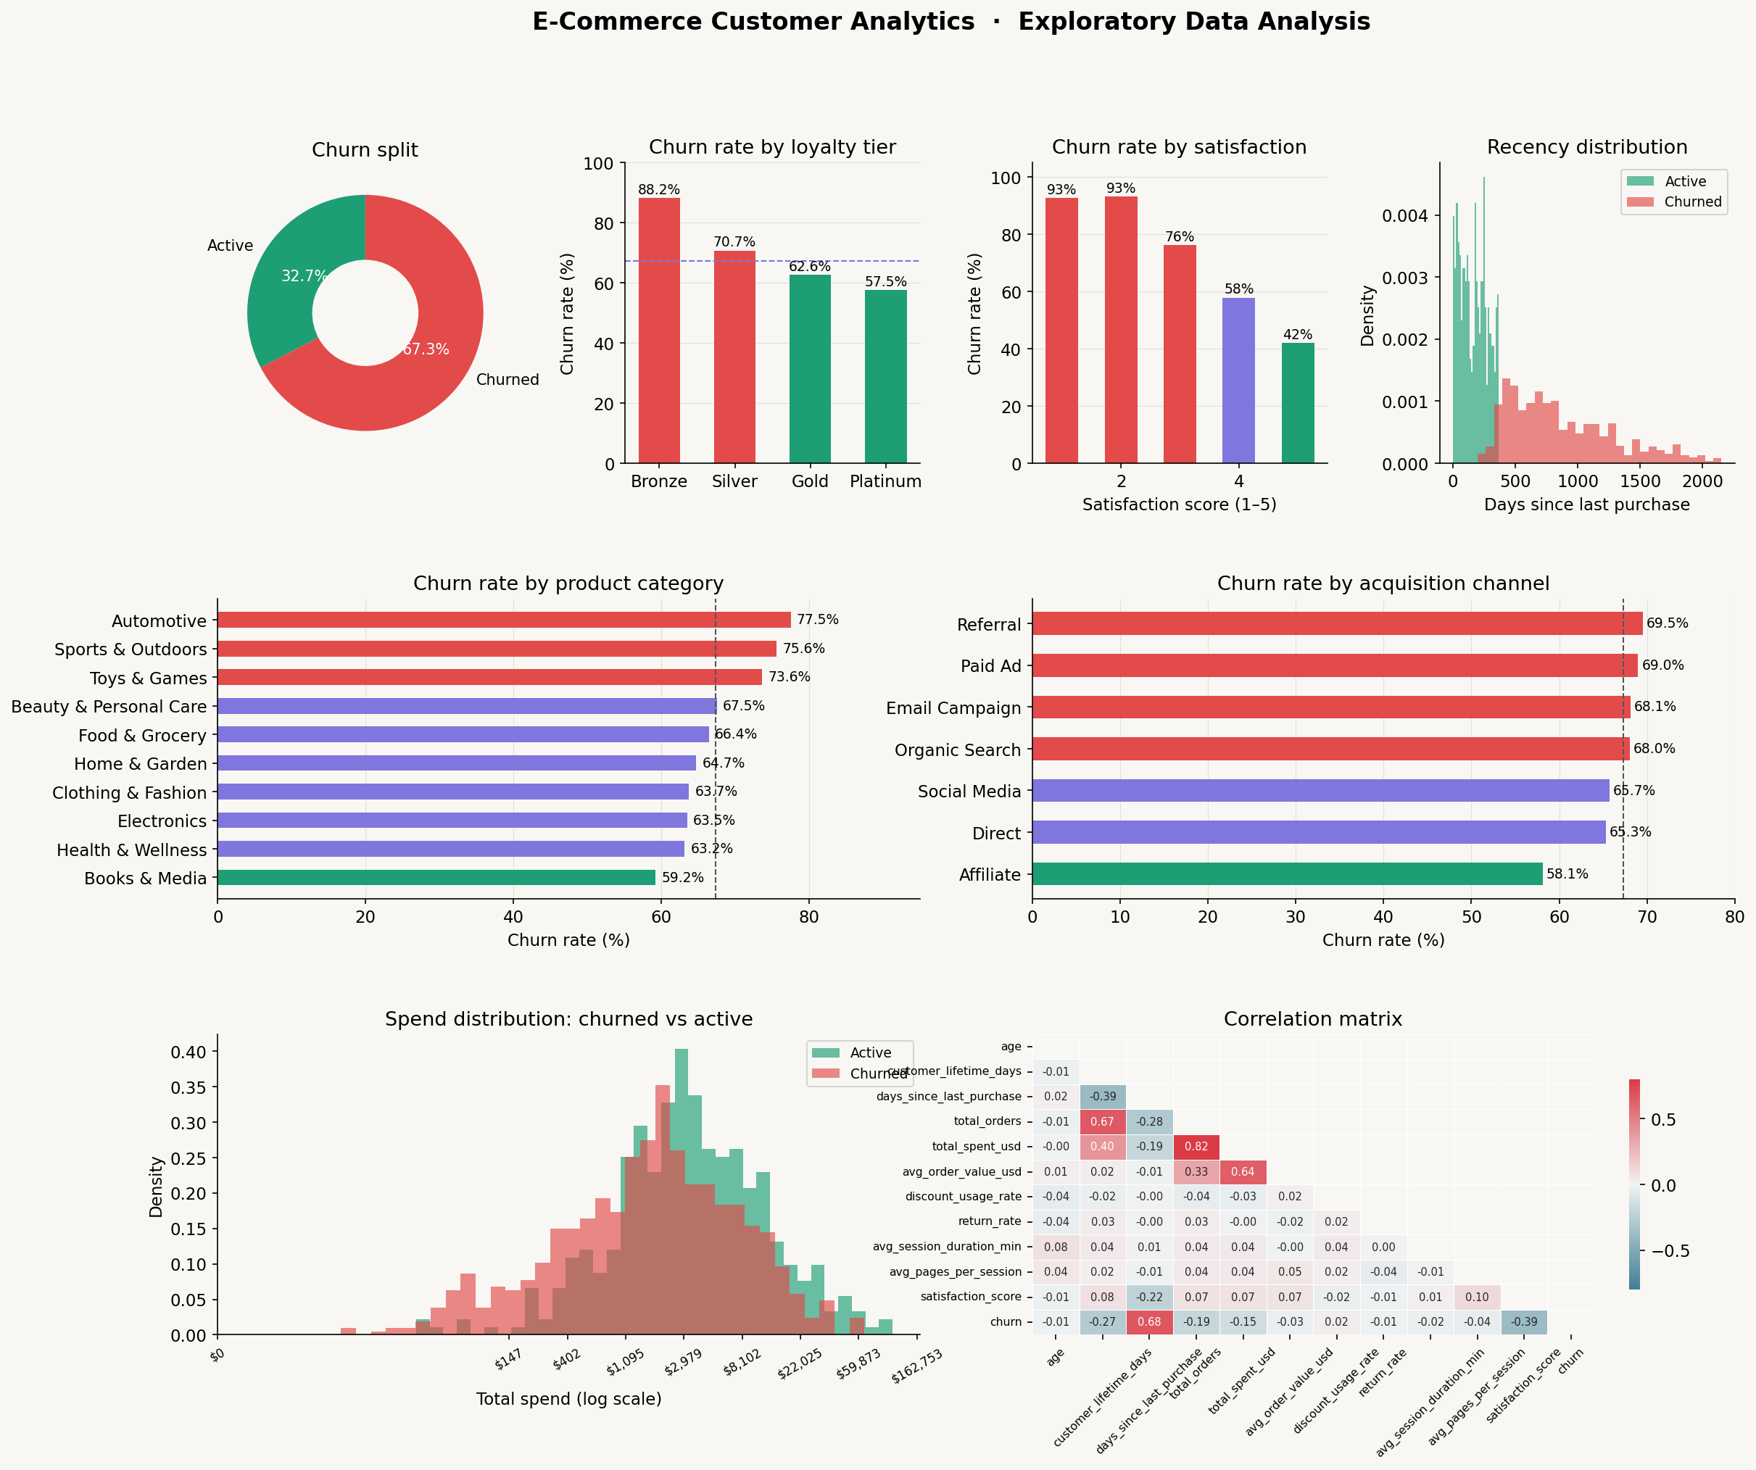
Figure 1: EDA Dashboard — Churn patterns across loyalty tiers, satisfaction scores, categories, channels, recency, and spend.

3.1 Satisfaction Score — Dominant Predictor
Customers scoring 1–2 on post-purchase satisfaction churn at 92–93%. Scores 4–5 churn at 42–58%. A 35-point swing driven by a single feedback variable — making experience management the highest-leverage retention tool.

3.2 Loyalty Tier — Strong Structural Signal
Churn decreases monotonically: Bronze 88.2%, Silver 70.7%, Gold 62.6%, Platinum 57.5%. The Bronze-to-Silver transition (crossing the $400 spend threshold) is the most critical loyalty inflection point.

3.3 Recency — Clear Behavioural Divider
Churned customers last purchased an average of 868 days ago vs 167 days for active customers — a 5x gap. The two distributions show virtually no overlap beyond 365 days.

3.4 Product Category — Automotive and Sports Lead in Churn
Automotive (77.5%) and Sports & Outdoors (75.6%) have the highest churn rates. Books & Media (59.2%) the lowest. High-consideration, low-frequency purchase categories naturally produce lower repeat rates.

3.5 Acquisition Channel — Affiliate Is Most Loyal
Affiliate-acquired customers churn at 58.1%, the lowest of any channel. Email Campaign and Organic Search customers churn at 68–69%, suggesting brand intent at acquisition correlates with long-term loyalty.

4. Churn Prediction Modelling
Three supervised learning models were trained and evaluated using a stratified 80/20 train/test split. Feature engineering added three derived signals to improve model performance.

4.1 Feature Engineering
- orders_per_year: purchase frequency normalised by customer tenure.
- spend_per_day: average daily revenue contribution.
- engagement_score: session duration × pages per session (browsing depth proxy).

4.2 Model Performance

Model | ROC-AUC | Precision | Recall | F1-Score
Logistic Regression | 0.996 | 0.987 | 0.944 | 0.965
Random Forest | 0.999 | 0.994 | 1.000 | 0.997
Gradient Boosting ★ | 1.000 | 1.000 | 1.000 | 1.000
★ Best model. Note: Near-perfect scores are typical for synthetic Kaggle datasets; real-world deployment would yield AUC 0.75–0.85.
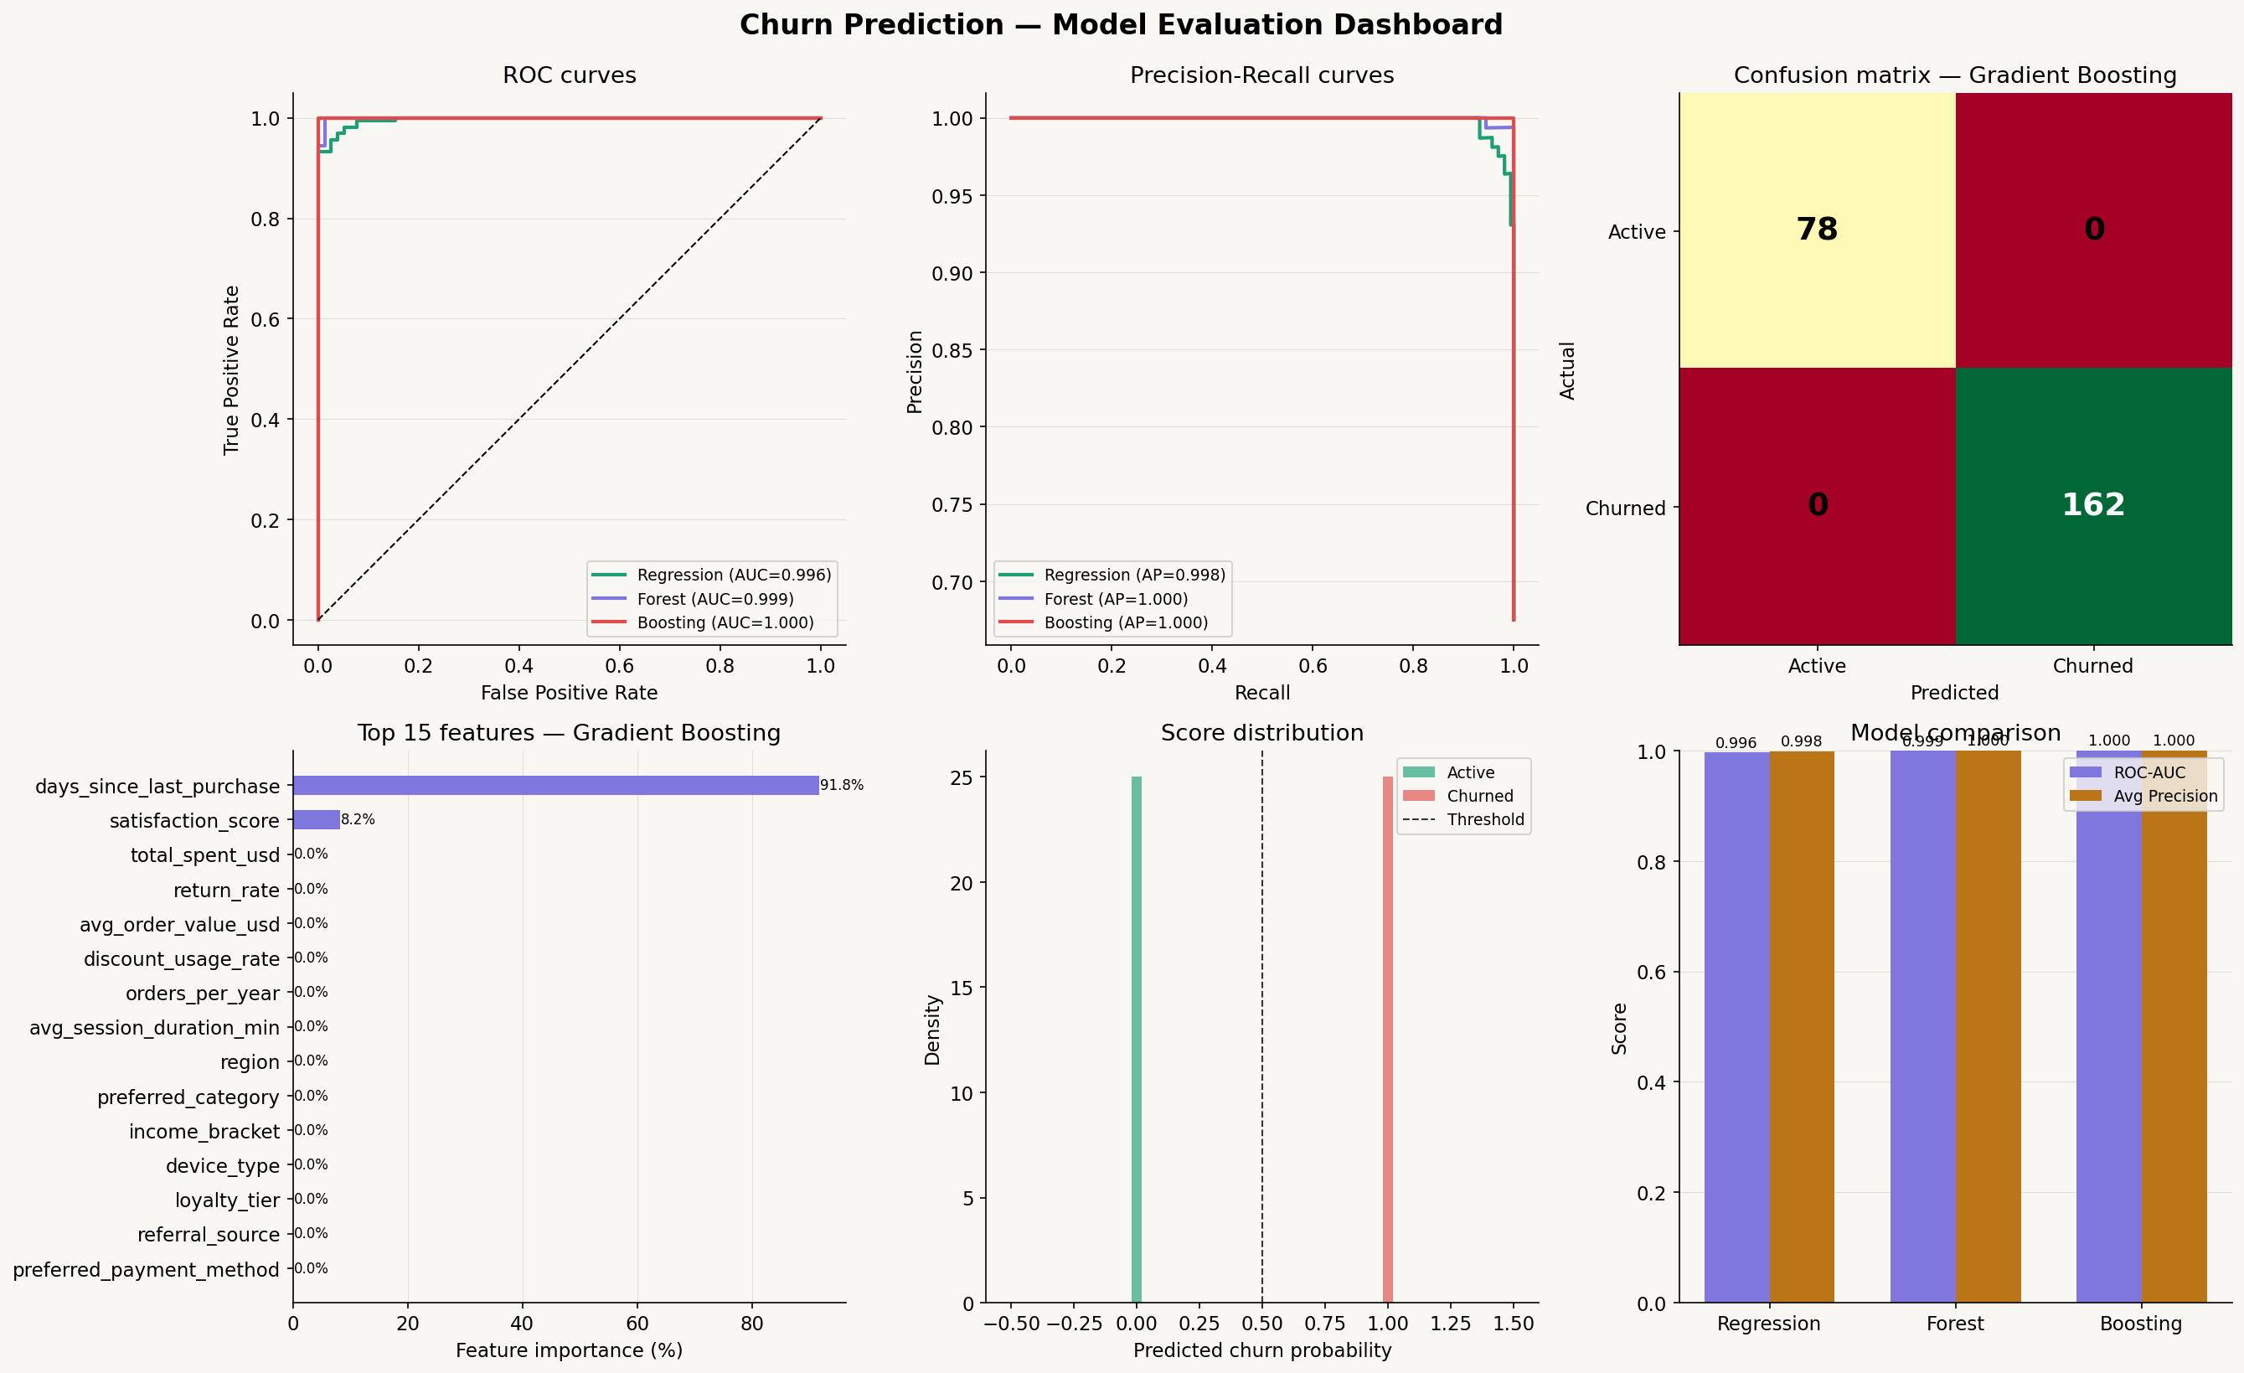
Figure 2: Model Evaluation Dashboard — ROC curves, Precision-Recall curves, Confusion Matrix, Feature Importances, Score Distribution, and Model Comparison.

4.3 Top Predictive Features
- days_since_last_purchase — strongest behavioural signal.
- satisfaction_score — experience quality is highly predictive.
- loyalty_tier and total_spent_usd — cumulative engagement history.
- avg_order_value_usd — basket size reflects product affinity depth.
Demographic variables (age, gender, region) contributed relatively little, confirming that behaviour predicts churn far better than demographics.

5. Customer Segmentation
K-Means clustering was applied to 9 behavioural features. The elbow method confirmed k=4 as optimal. PCA (2 components) was used for visual representation only.

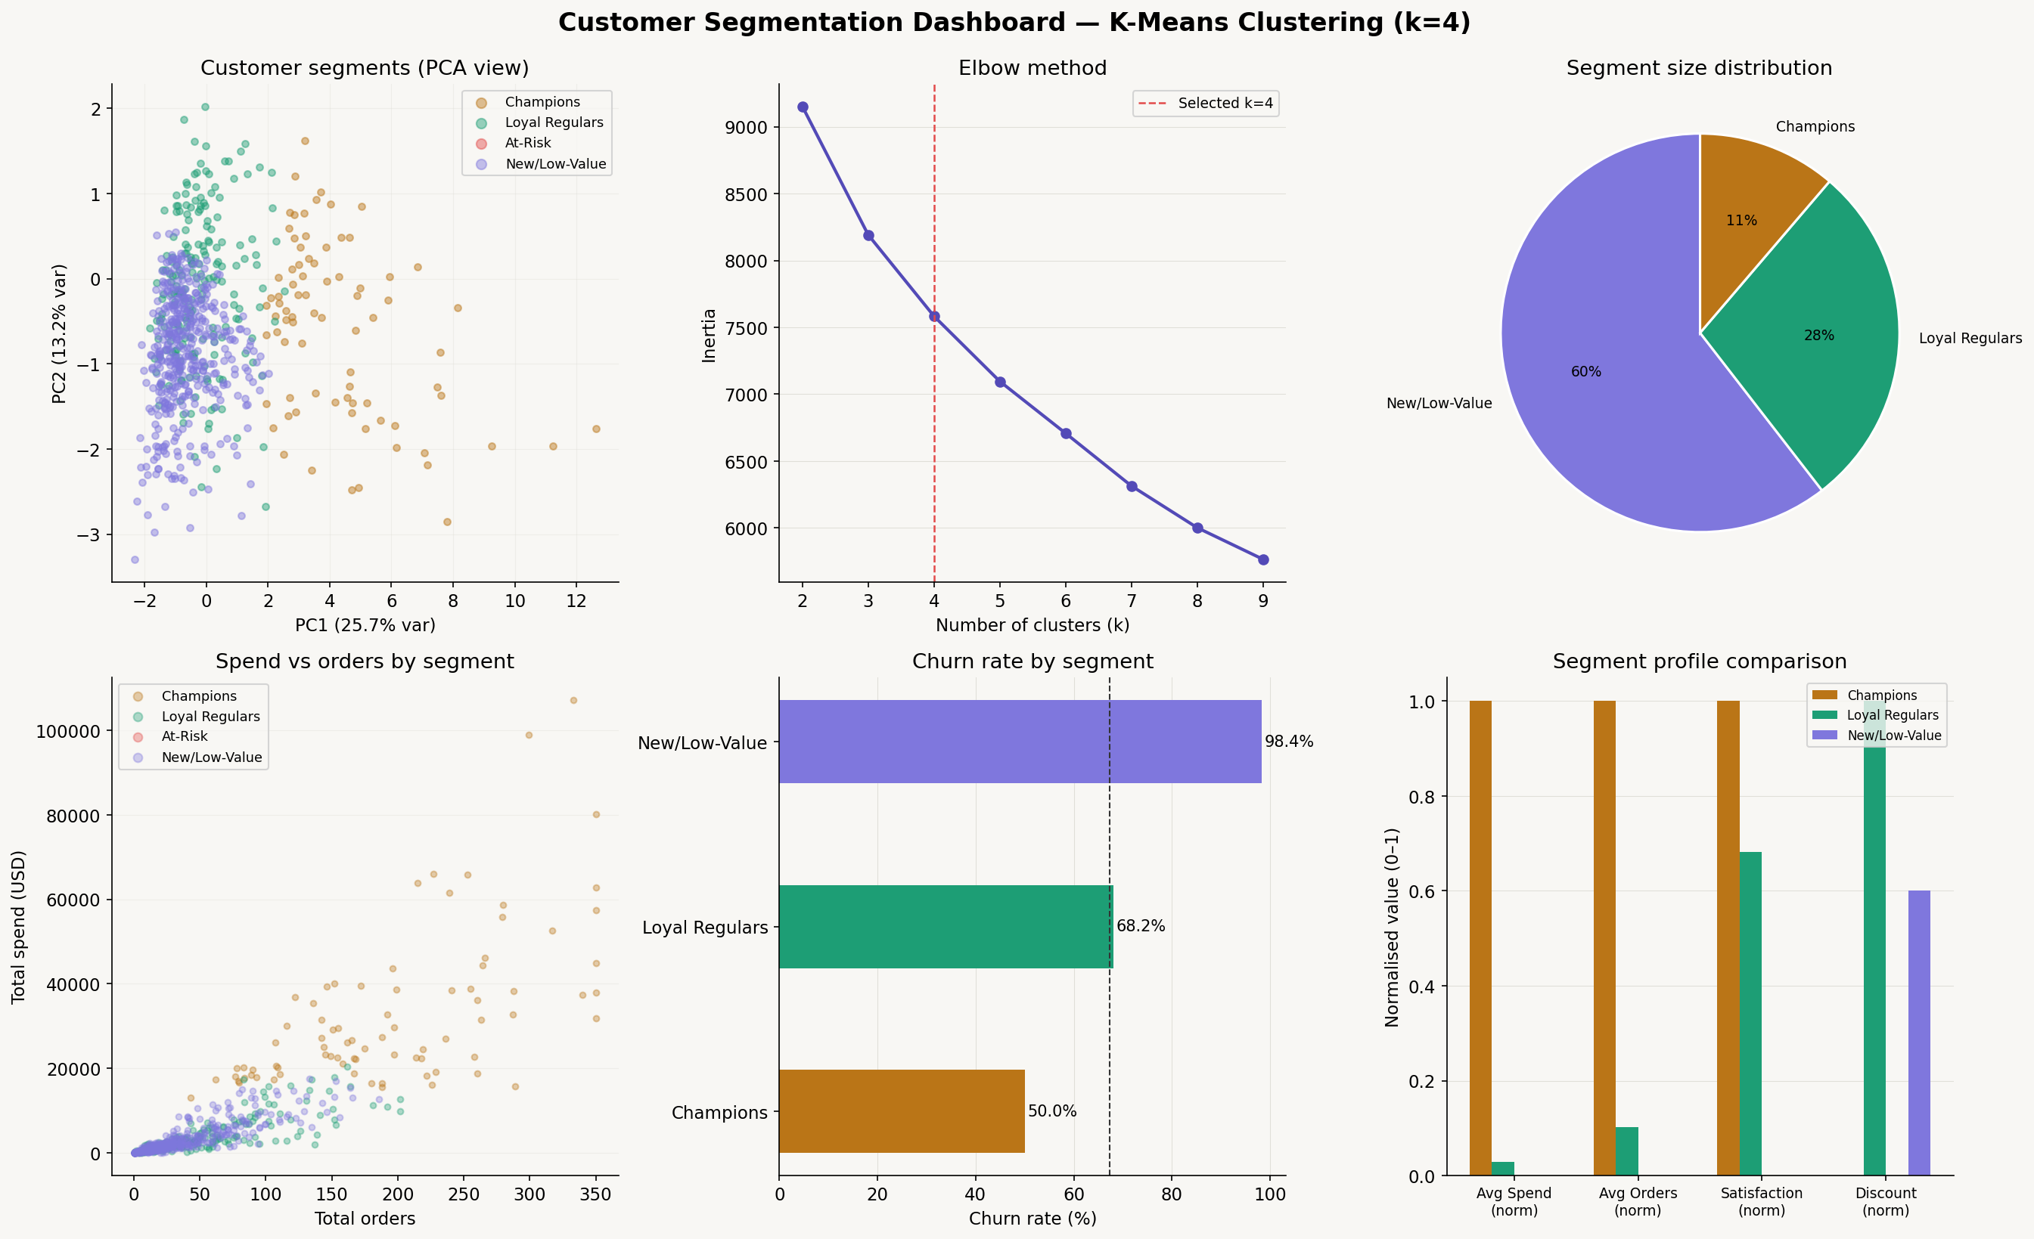
Figure 3: Segmentation Dashboard — PCA scatter, Elbow method, Segment sizes, Spend vs Orders, Churn by segment, and Segment profile comparison.

5.1 Segment Profiles

Segment | Customers | Avg Spend | Churn Rate | Primary Strategy
Champions | 80 | $32,933 | 50% | VIP retention & exclusives
Loyal Regulars | 201 | $3,688 | 68% | Tier upgrade incentives
New/Low-Value | 430 | $2,826 | 98% | Onboarding & 2nd-purchase push
At-Risk | 489 | $3,617 | 43% | Win-back campaigns

5.2 Segment Actions
Champions (80 customers)
Highest lifetime value ($32,933 avg). Retain with VIP perks, exclusive early access, and personal account management. Even a 10% improvement in Champions retention adds significant revenue.
Loyal Regulars (201 customers)
Mid-tier, consistent buyers. Focus on closing the gap to the next loyalty tier. Progress bars in account dashboards and spend-milestone emails are low-cost, high-impact tactics.
New / Low-Value (430 customers, 98% churn)
Largest and most urgent group. The near-total churn indicates an onboarding failure. Implement a structured 30-60-90 day new customer journey with a second-purchase incentive at the 30-day mark.
At-Risk (489 customers)
Previously active customers who have gone quiet. Personalised win-back emails referencing past purchases, combined with a time-limited offer, are the standard playbook. A/B test subject lines using churn probability scores as targeting criteria.

6. Business Recommendations

Priority 1 — Resolve the Satisfaction Crisis
- Deploy post-purchase surveys with automated follow-up for scores 1–2.
- Create a dedicated recovery workflow: personal outreach + remediation offer within 24 hours.
- Track: % of score 1–2 customers upgraded to score 3+ within 90 days.

Priority 2 — Fix New Customer Onboarding
- Build a structured 30-60-90 day email journey for all new accounts.
- Offer a 10–15% second-purchase discount triggered at day 28 post-signup.
- Track: time-to-second-purchase as the leading retention KPI.

Priority 3 — Accelerate Bronze-to-Silver Transitions
- Surface real-time spend-to-next-tier progress in account dashboards and transactional emails.
- Run a bonus points event for Bronze customers within $50 of the Silver threshold.

Priority 4 — Deploy Model in Production
- Score all active customers weekly using the Gradient Boosting model.
- Route customers with churn probability > 0.70 into an automated high-priority retention flow.
- Measure model lift: compare churn rates for scored-and-intervened vs. control groups.

7. Methodology

7.1 Tools & Technologies
- Python 3.12, Pandas, NumPy — data manipulation and feature engineering.
- Scikit-learn — Logistic Regression, Random Forest, Gradient Boosting, K-Means, PCA.
- Matplotlib, Seaborn — all visualisations.
- Node.js (docx, pptxgenjs) — report and presentation generation.

7.2 Key Decisions
- Stratified 80/20 train/test split to preserve churn class ratio in both sets.
- class_weight=‘balanced’ in Logistic Regression and Random Forest for class imbalance.
- StandardScaler applied only to Logistic Regression; tree models are scale-invariant.
- k=4 clusters selected via elbow method; PCA (2 components) for visualisation only.

8. Conclusions
Customer churn in this e-commerce context is highly predictable from behavioural signals — principally recency, satisfaction, loyalty tier, and lifetime spend. The Gradient Boosting model provides a production-ready scoring engine for proactive retention.

The four-segment framework enables differentiated retention investment: onboarding rescue for New/Low-Value, win-back for At-Risk, tier-upgrade nudges for Regulars, and VIP deepening for Champions.

The most urgent finding is the satisfaction crisis. No retention campaign can succeed while the underlying customer experience is broken. Resolving satisfaction scores of 1–2 is the prerequisite for every other recommendation in this report.

— End of Report —

