Design and Analysis of Algorithms

Math review
The goal of this document is to review some of the math needed for this course. It also contains links to web sites that provide added information on some of the topic. It contains also additional formulas and procedures.

Proofs and Mathematical Induction
http://www.purplemath.com/modules/inductn.htm
http://zimmer.csufresno.edu/~larryc/proofs/proofs.html
http://www.teachers.ash.org.au/mikemath/mathsc/structureproof/

Logarithms
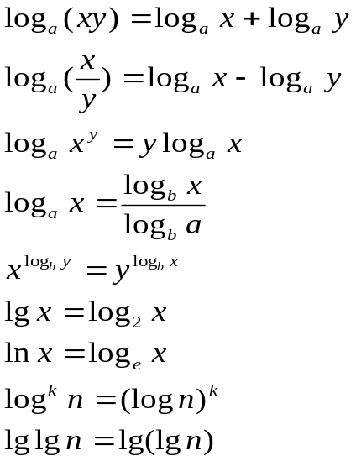
http://www.purplemath.com/modules/logs.htm

Other
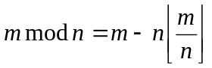

Simple Series
- Arithmetic series: The first n values are: a, a + d, a + 2d, …, a + (n – 1)d where a is an initial value and d is a fixed increment. The sum of the first n values is: 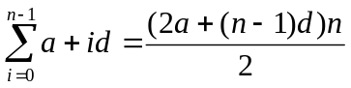.
Let a₁ = a, a_{n} = a + (n – 1)d the sum is also 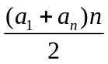.
- Geometric series: The first n values are: a, ar, ar²,…,ar^{n -1} where a is an initial value and r ≠ 1 is a fixed multiplier. The sum of the first n values is: 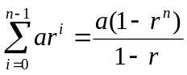.
- When -1< r <1 and r ≠ 1 the sum of the infinite geometric progression converges to: 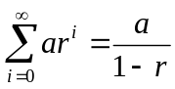.
- Harmonic series: The first n values are: 1, 1/2, 1/3,…,1/n. The sum of the first n values is: H_{n} = 1+ 1/2 + 1/3 +…+ 1/n satisfies 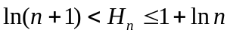.
Arithmetic and geometric progressions

L’Hopital’s Rule:

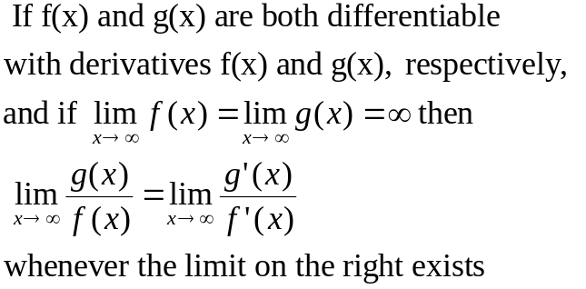

Review of limits

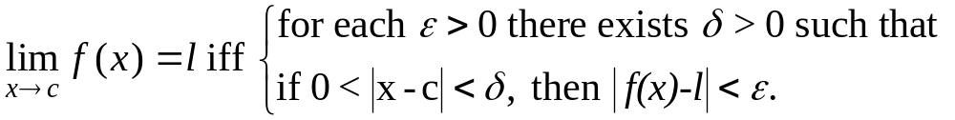
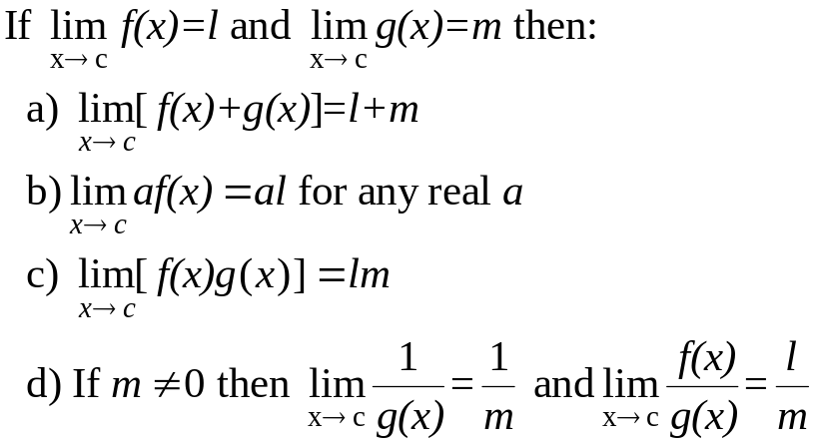

Review of derivatives

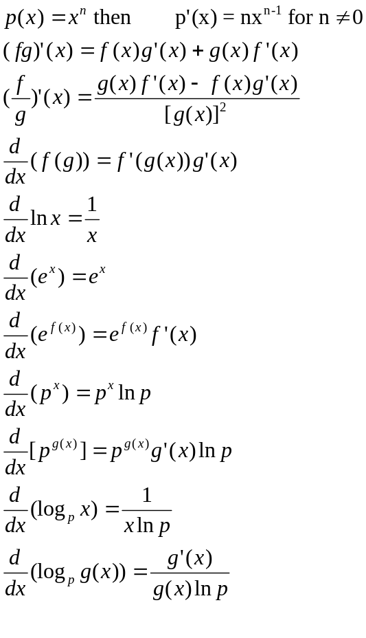

Master Theorem

Version 1

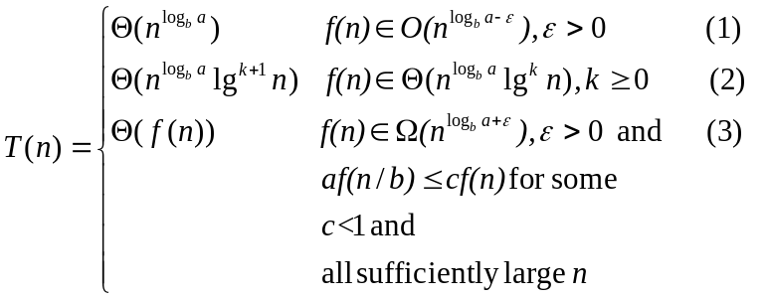
Version 2

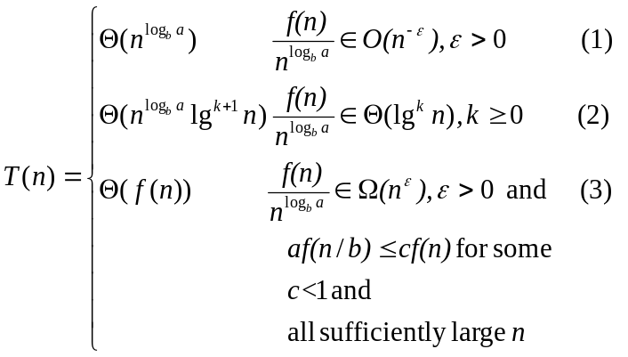Using limits to compare asymptotic growth:
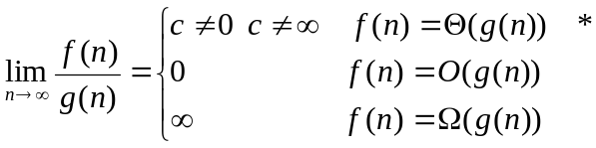
* Θ implies both O and Ω

Changing a linear programming problem to standard form
1. Inequality with ≥ action: (multiply inequality by –1)
2. Equality = action: (transform to one inequality with ≥, and one with ≤)
3. Objective function is minimum action: (Multiply objective function by –1 and replace min by max)
4. x is unrestricted action: (Replace x in problem by y - z, and add y ≥ 0, z ≥ 0)
5. x ≤ c for c < 0 action: (Replace x in problem by -y + c, and add y ≥ 0)

