Cost Estimation Using Text And Objects Tech Stack, Pipelines & Process Flows

1. System overview
On each PDF upload the backend runs three complementary tracks in parallel. Tracks A and B are text/geometry extractors over the full PDF. Track C is the computer-vision costing pipeline over rendered page images . Results land in SQLite and as downloadable PDFs.
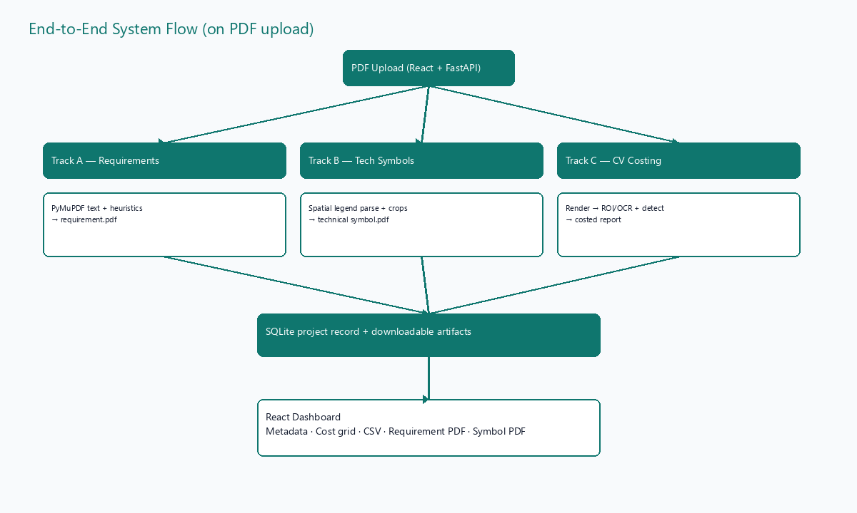
Figure 1 — End-to-end system flow

2. Shared tech stack
Layer | Technology | Role
API | Python 3.10+, FastAPI, Uvicorn | Upload, project CRUD, background jobs
Config | pydantic-settings | Env-driven Settings (mock vs real models)
PDF I/O | PyMuPDF (fitz), ReportLab, Pillow | Text extract, render, output PDFs
PDF render | pdf2image (+ Poppler) / PyMuPDF fallback | 300 DPI page PNGs for CV

2.1 Model stack (real models)
Default HVAC_USE_MOCK_MODELS=true uses deterministic mock detectors so the POC runs without heavy weights. Real backends plug in behind the same Protocols:

Component | Library | Notes
ROI / symbol detect | Detectron2 Faster R-CNN | No Windows wheels by default
OCR | PaddleOCR (en) | Title-block text lines
Device classify | timm CNN → ONNX Runtime | Crop → device type

3. Pipeline A — Requirement extraction
Purpose: pull provider/contact metadata and scope-of-work from bid/drawing sets into a readable ``<stem> requirement.pdf``.

3.1 Tech stack
Piece | Module / tool | Detail
Extract | ml/requirement_extractor.py | PyMuPDF text + family heuristics
Families | Garland / Architect CD | AGENT: block vs PROJECT OWNER cover
Scope | Numbered + trade SCOPE parsers | Handles split ``1.`` / body lines
Output PDF | ml/requirement_pdf.py + ReportLab | storage/requirements/
API | GET …/requirement.pdf | Download from dashboard
CLI | scripts/extract_requirements.py | Batch folder processing

3.2 Process
- Open the PDF with PyMuPDF and read embedded text (full page count).
- Classify layout family (Garland vs Architect CD) from headings/markers.
- Map agent, company, phones, address, project title, sheet indexes.
- Collect scope sections (numbered lists and/or trade SCOPE bodies).
- Generate requirement PDF; store path on the Project row.
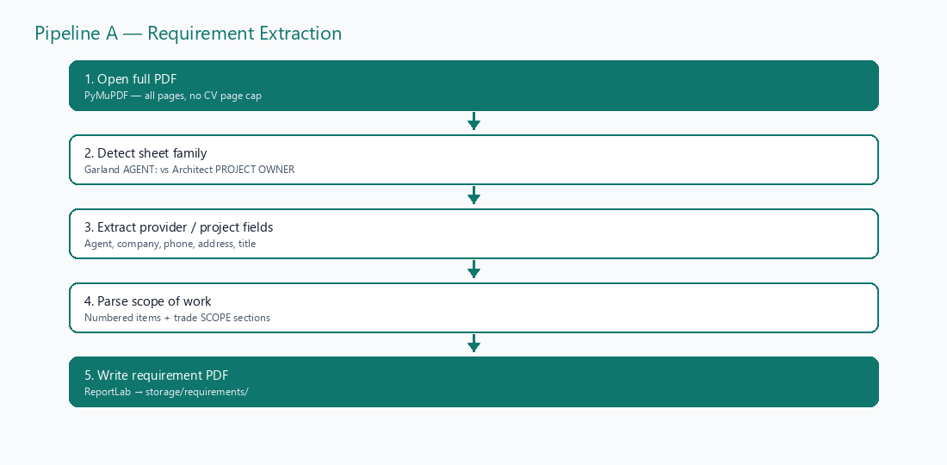
Figure 2 — Requirement extraction flow

4. Pipeline B — Technical symbol legend extraction
Purpose: extract TECHNOLOGY SYMBOL LEGEND and numbered SYMBOL LEGEND tables with real CAD glyphs (not ML classification) into ``<stem> technical symbol.pdf``.

4.1 Tech stack
Piece | Module / tool | Detail
Extract | ml/symbol_table_extractor.py | Text spans + spatial clustering
Tech legend | X-row / Y-column spatial parse | Handles page.rotation 90/270
Numbered legend | Line parse + glyph crop left of N. | Blank when sheet has no icon
Crop / clean | PyMuPDF pixmap + Pillow | rotation_matrix; strip table borders
Fallback icons | Pillow draw helpers | Only if tech-legend crop is blank
Output PDF | ml/symbol_table_pdf.py + ReportLab | Glyph + number side-by-side
API | GET …/technical-symbol.pdf | Download from dashboard
CLI | scripts/extract_technical_symbols.py | Batch / single PDF

4.2 Process
- Scan every page for SYMBOL LEGEND / TECHNOLOGY SYMBOL LEGEND headings.
- Technology path: locate column headers, cluster description rows, pack MFG/Part/Notes.
- Crop Symbol column cells with rotation-corrected visual rectangles; strip grid L-brackets.
- Numbered path: parse 1…N descriptions; crop ink immediately left of each ``N.`` label.
- When both glyph and number exist, PDF Symbol cell shows [glyph] [N.] like the drawing.
- Write technical symbol PDF under storage/technical_symbols/.
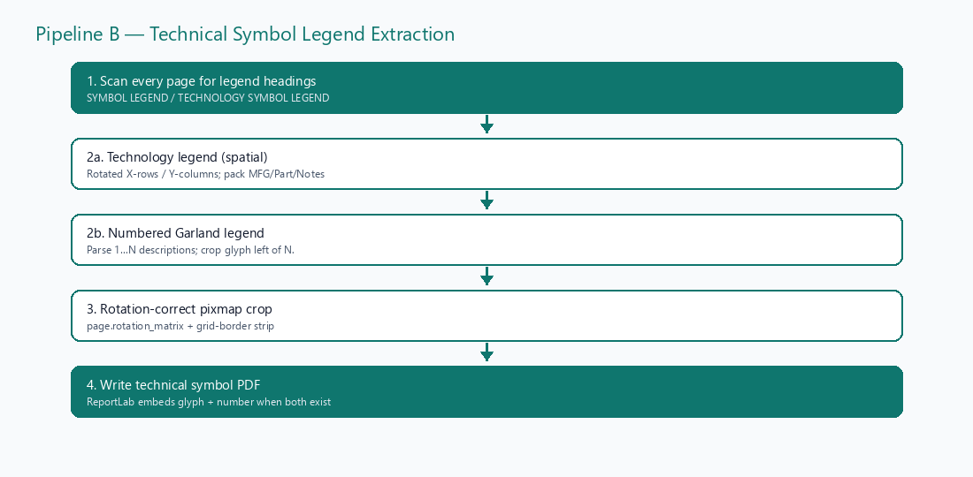
Figure 3 — Technical symbol extraction flow

