Session – 01
Task -1

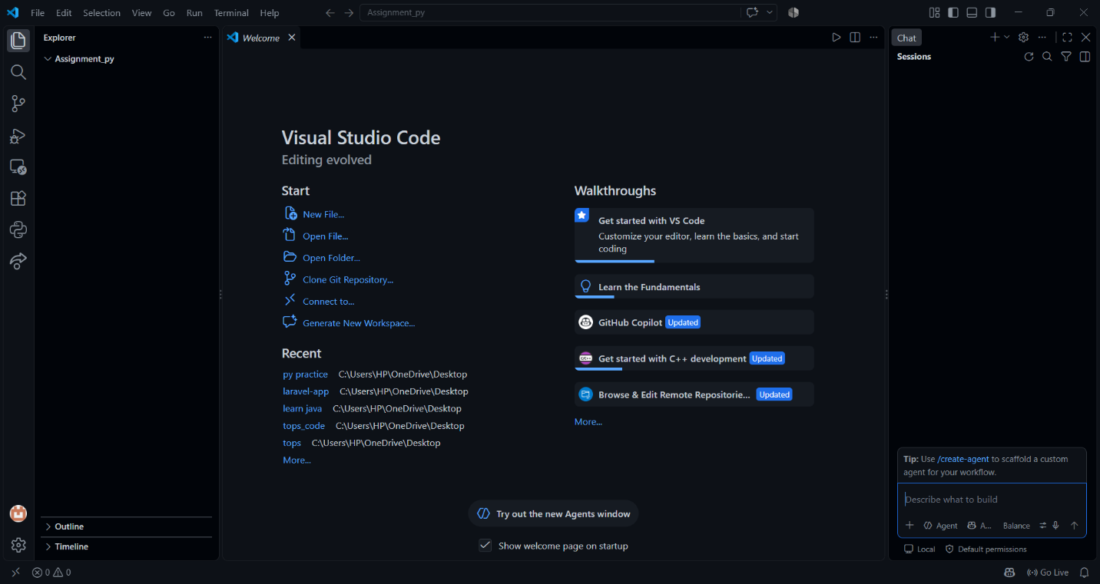

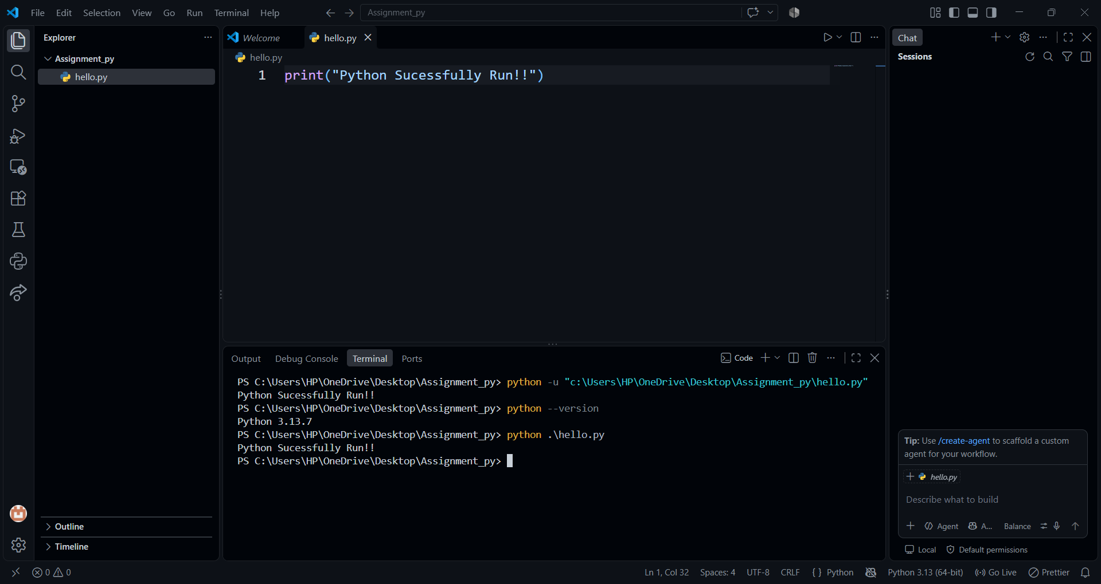
Task – 5
Python is generally called an interpreted language, but technically CPython first converts your .py code into bytecode, and then the Python Virtual Machine (PVM) executes that bytecode.
Java is different from Python . Java source code is compiled into bytecode, which is then executed by the JVM (Java Virtual Machine).

