**allergy-crud build documentation.**

Name: Aniruddha Prabhash

E-Mail: [aniruddhachakravarty99@gmail.com](mailto:aniruddhachakravarty99@gmail.com)

LinkedIn: <https://github.com/aniruddha-chakravarty>

Git-Hub: https://www.linkedin.com/in/aniruddhachakravarty/

__________________________________________________________________

* **Step 1: Create React App + Integrate Redux.**

*npx create-react-app allergy-crud --template redux*

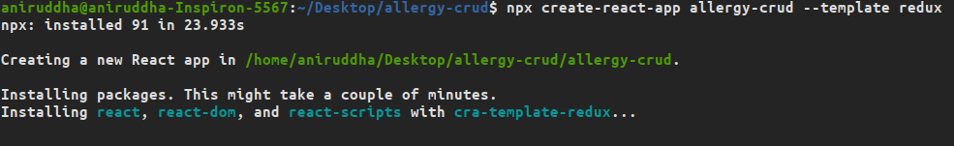

* **Step 2: Start the Development Server on localhost:3000**

*npm start*

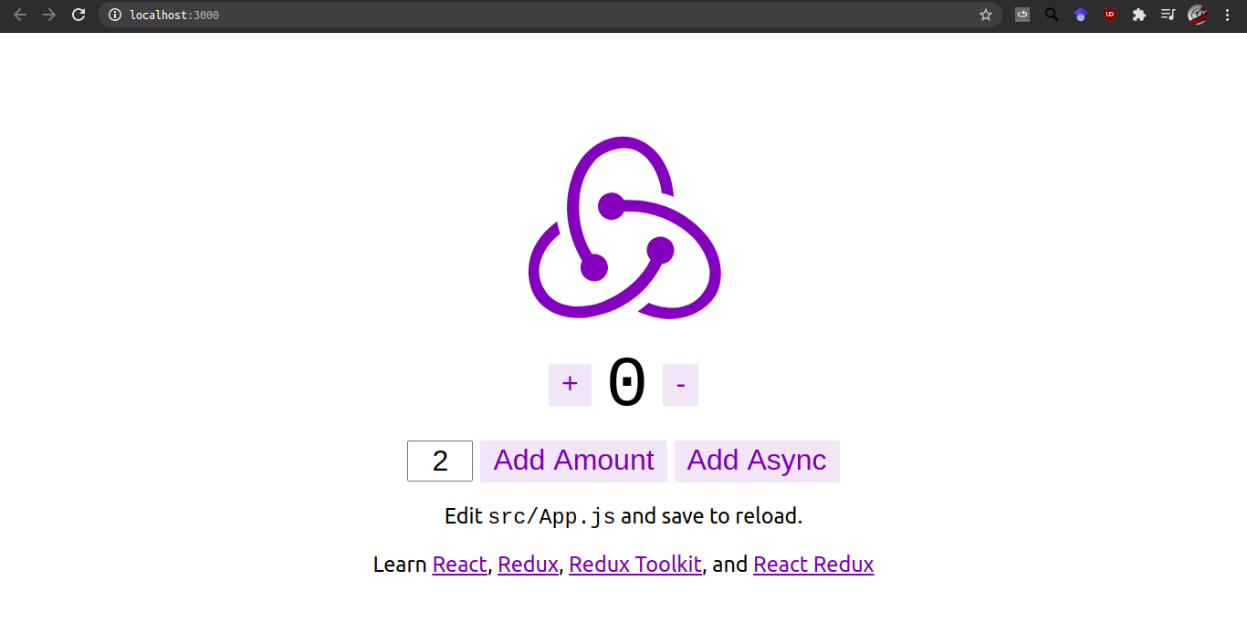

* **Step 3: Go to Firebase and create a new project.**

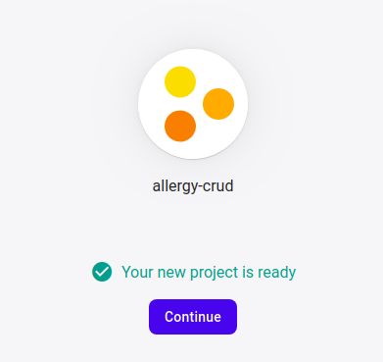

* **Step 4: Add Firebase CDN; we create a new folder in project called util and introduce a new file called firebase.js where we add the Firebase CDN.**
* **Step 5: Cloud Firestore DB: Create a realtime db on test-mode, allowing all reads and writes to your database. Client read/write access will be denied after 30 days if security rules are not updated.**

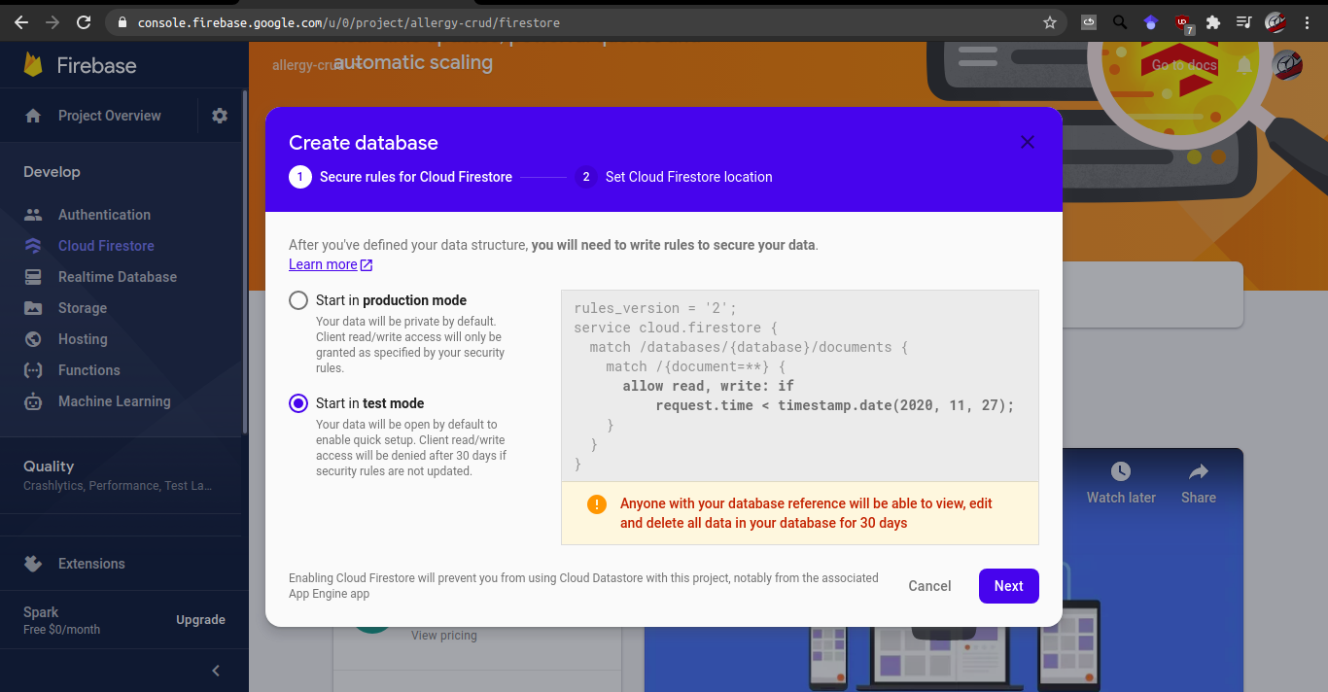

**Step 6: Set Cloud Firestore Location:**

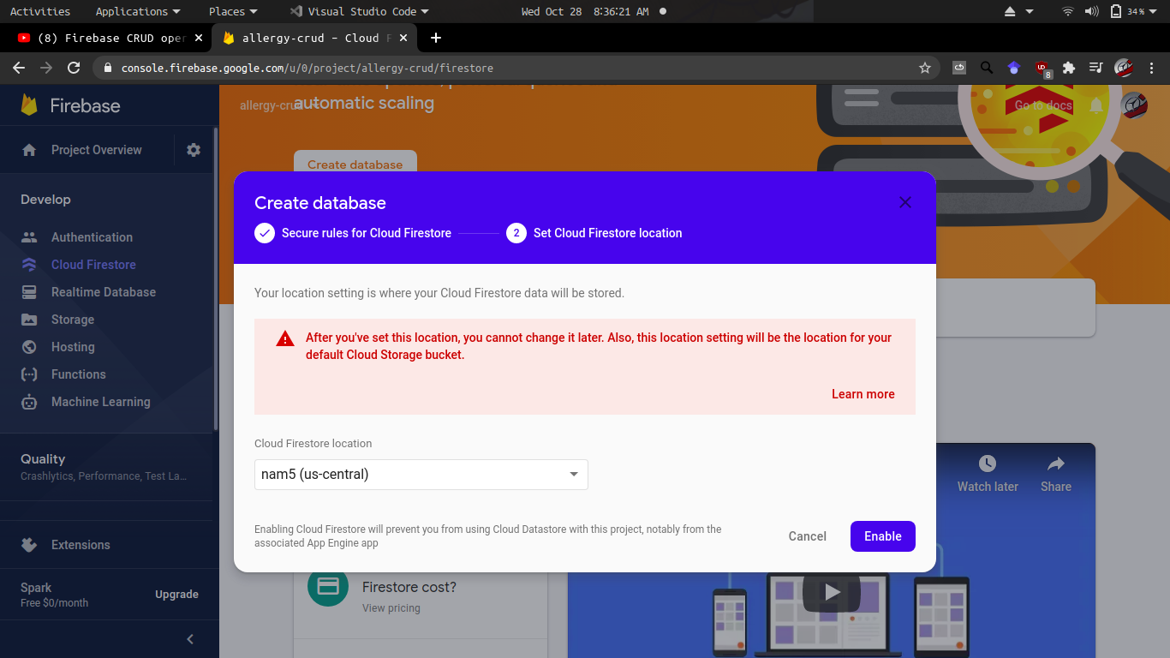

**Step 7: Set + Publish rules in real-time DB:**

