##### Fake Instagram Profile Identification using Machine Learning

# **Aniruddha Lalge, Apurv Badave, Nikhil Elajale, Pankaj Godara**

Department of Computer Engineering Smt. Kashibai Navale College of Engineering

Pune- 41, India

# **Prof. Priyanka Kinage**

# Priyanka.kinage_skncoe@sinhgad.edu

Department of Computer Engineering Smt. Kashibai Navale College of Engineering

Pune- 41, India

***Abstract***

**Rise of fake profiles on platforms like, Instagram possess significant challenges related to user privacy, security, and trust. This work presents a challenging task to identify and classify fake Instagram profiles using machine learning techniques. The findings of this research contribute to the ongoing efforts to combat the issue of fake profiles on Instagram and other social media platforms. By leveraging machine learning techniques and other comprehensive feature set, the proposed model demonstrates promising results in identifying and classifying fake profiles, thereby promoting a safer and more trustworthy online environment. This research opens avenues for further exploration, including the integration of real-time data streams and the adaptation of the model to other social media platforms.**

***Keywords:*** FakeProfile identification, User authentication, Data preprocessing, Model training, Online security, Machine learning.

**I. INTRODUCTION**

Counterfeit Instagram profiles encompass a spectrum from automated bots inundating feeds with spam to adept impostors aiming to deceive authentic users for various ulterior motives such as financial exploitation or social engineering. Traditional methods reliant on manual scrutiny and reporting prove inadequate in handling the overwhelming influx of profiles and engagements, thus necessitating the adoption of sophisticated technological interventions. Machine learning emerges as a potent instrument in combatting the proliferation of fake profiles across social media platforms. Leveraging the computational prowess of machine learning algorithms, it becomes feasible to automatically discern and categorize fake profiles based on discernible patterns and attributes. The amalgamation of the burgeoning influence of social media, the formidable challenges posed by counterfeit profiles, and the strides made in machine learning methodologies culminate in the formulation of solutions aimed at detecting and classifying these deceptive entities.

This research endeavors to address the imperative for a more secure and credible online milieu by proposing a holistic methodology to confront the issue of fake Instagram profiles through the application of machine learning.

**II.PROPOSED SYSTEM**

Developing a reliable algorithm capable of identifying counterfeit profiles on Instagram poses a formidable yet crucial endeavor. Instagram, akin to numerous other social networking platforms, grapples with the prevalence of fraudulent accounts perpetrating spam, deceit, or nefarious deeds. Below is a conceptual framework outlining a potential system designed to detect bogus profiles on Instagram.

1. Data Acquisition:

Accumulate a substantial dataset of Instagram profiles, encompassing both authentic and fraudulent accounts, showcasing a diverse array of attributes.

2. Feature Extraction:

Derive pertinent characteristics from user profiles. These attributes may entail:

• Examination of profile images: Scrutinize for substandard quality, incongruities, or recurrent usage.

• Analysis of activity patterns: Evaluate the frequency of posts, likes, comments, and followers.

• Evaluation of follower-to-following ratios: Identify extreme imbalances.

• Assessment of post content: Scrutinize posts for spam.

3. Machine Learning Framework:

Construct a machine learning framework to categorize profiles as genuine or counterfeit. Consider employing methodologies such as:

• Adoption of deep learning architectures, like neural networks, adept at capturing intricate patterns.

• Utilization of ensemble techniques such as Random Forest or Gradient Boosting to enhance accuracy.

4. Model Training and Validation:

Segment the dataset into distinct subsets for training, validation, and testing purposes. Train the model using the training data, refining hyperparameters as necessary.

• Validate the model's efficacy using the validation set, iterating as required.

5. Continuous Surveillance:

Implement the algorithm to operate seamlessly in real-time across Instagram profiles. Maintain ongoing vigilance over user activity, profiles, and engagements to find early on.

**A. Support Vector Machine :**

Support Vector Machines (SVMs) represent a prevalent form of supervised machine learning algorithm utilized for tasks involving classification and regression. SVMs exhibit versatility, capable of handling both linear and non-linear classification scenarios.

Working Steps of Support Vector Machine:

Step 1: Load essential libraries required for implementation.

Step 2: Acquire the dataset and segregate the independent variables (X) and dependent variable (Y).

Step 3: Partition the dataset into distinct training and testing subsets.

Step 4: Initialize the SVM classifier model.

Step 5: Train the SVM classifier model by fitting it to the training data.

Step 6: Generate predictions using the trained model.

Step 7: Assess the performance.

**B. Random Forest :** Random Forest serves as an ensemble learning approach extensively employed in machine learning for tasks encompassing classification and regression. This method amalgamates the forecasts of numerous decision trees to enhance predictive precision and resilience.

The working steps for Random Forest: Step 1: Import and preprocess the data. Step 2: Train the random forest classifier. Step 3: Evaluate the accuracy of predictions. Step 4: Visualize the outcomes derived from the classifier.

**III. SYSTEM DESIGN**

Crafting a system architecture for an Instagram counterfeit profile detection algorithm necessitates the incorporation of various components, each serving distinct roles and functionalities. Below are the constituent elements of the architecture:

1. Data Collection Layer

2. Preprocessing Layer

3. Feature Extraction

4. Classification Algorithms

5. Implementation

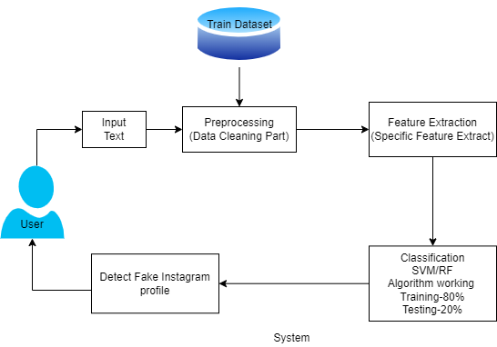

Fig. I System Architecture

This system architecture provides a comprehensive view of how different components work together to detect fake profiles on Instagram. The key to success is the continuous refinement of the machine learning model, real-time monitoring, and the ability to adapt to evolving strategies used by malicious actors.

**A. Data Flow Diagram :**

A Data Flow Diagram (DFD) illustrates the movement of data within a system. DFD0 serves as the foundational diagram depicting input and output as rectangles, with the system represented by a circle. DFD1 elaborates on the actual inputs and outputs of the system, such as textual or image data input and rumor detection output. Conversely, DFD2 delineates the actions performed by users and administrators within the system.

**DFD0 :**



**DFD1:**

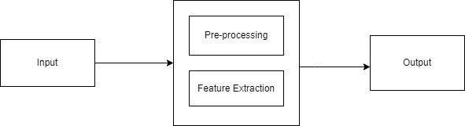

**DFD2:**

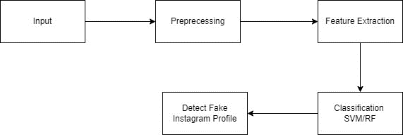

Fig. II Data Flow Diagram

**IV. FEASIBILITY AND SCOPE**

Counterfeit profiles often display identifiable traits that aid in their detection. These indicators comprise generic or limited profile images, a sparse follower count coupled with a high number of followings, irregular posting schedules, and minimal engagement levels on posts. Furthermore, scrutinizing the content shared by a user can yield valuable insights; fake profiles frequently repost or share content from other accounts, employ generic captions, or exhibit behaviors like excessive hashtag usage. Analyzing user behavior on the platform can also be revealing; fake profiles often partake in activities such as mass following and unfollowing, rapid liking and commenting across multiple posts, or initiating unsolicited messaging. Additionally, it is imperative to assess the financial requirements for tasks such as data collection, development of machine learning models, establishment of real-time monitoring infrastructure, and ongoing system maintenance. An appraisal of potential costs linked with both the creation and upkeep of the system is necessary, weighed against the benefits derived from mitigating the impact of fake profiles on the Instagram platform.

**V. BACK UP PLAN**

If obtaining enough labeled data proves difficult, explore methods like data augmentation to generate synthetic data, aiding in enhancing model effectiveness. Establish a system enabling users to flag suspicious profiles, which, when combined with automated detection, enhances accuracy. Employ ensemble models by merging various machine learning algorithms to boost precision and resilience. Collaborate closely with legal experts and contemplate enforcing stricter regulations for account validation and creation. Prioritize user privacy and ethical considerations, particularly when handling user data and profile details, ensuring compliance with guidelines.

**VI. ADVANTAGES**

* Identifying and removing fake profiles from Instagram improves users' experiences, making the platform more reliable.
* Fake profiles can cause harm by harassing users, sending spam, or spreading false information. By detecting and removing them, Instagram helps prevent these negative impacts.
* Removing fake profiles also helps reduce the spread of misinformation on the platform.
* Social media platforms often prioritize content and profiles based on user interaction. Removing fake profiles ensures that genuine content receives the attention it deserves.
* Many regions have laws requiring social media platforms to combat fake profiles and safeguard user data. Having a system to detect fake profiles helps platforms comply with these regulations.
* Platforms with fewer fake profiles and a better reputation are more appealing to genuine advertisers and content creators, potentially leading to increased revenue opportunities.
* Fake profiles may attempt to collect and misuse user data. Eliminating them protects users' data from unauthorized access.

**VII. LIMITATIONS**

* Malicious individuals are consistently adapting their methods to create more sophisticated fake profiles that can evade detection systems.
* There are privacy concerns associated with checking user profiles and behaviour to detect fake profiles.
* The number of genuine profiles on Instagram significantly outweighs the number of fake ones.
* New forms of fake profiles and malicious activities emerge regularly, posing challenges for detection algorithms to keep pace with evolving threats.
* Some legitimate users might utilize automation tools for harmless purposes, like managing their social media presence.
* Smaller social media platforms or startups may lack the resources needed to develop and maintain effective systems for detecting fake profiles.

**VIII. CONCLUSION**

The research on Fake Instagram Profile Identification and Classification using Machine Learning presents a comprehensive approach to tackle the persistent issue of fake profiles on social media platforms, with a specific focus on Instagram. By leveraging the power of machine learning techniques, this research contributes to creating a safer and more trustworthy online environment for users, bolstering userconfidence, and upholding the integrity of social media community. The research’s outcomes extend beyond the realm of academia, impacting the lives of individuals, businesses, and society as a whole. As social media continues to shape the digital landscape, the work presented here contributes to building a foundation of trust and authenticity, reinforcing the positive potential of online interactions and collaborations

**IX. REFERENCES**

[1] Zainab Agha, Neeraj Chatlani, Afsaneh Razi, and Pamela Wisniewski. 2020. Towards conducting responsible research with teens and parents regarding online risks. In Extended Abstracts of the 2020 CHI Conference on Human Factors.

[2] Shiza Ali, Afsaneh Razi, Seunghyun Kim, Ashwaq Alsoubai, Joshua Gracie, Munmun De Choudhury, Pamela J Wisniewski, and Gianluca Stringhini. 2022. Understanding the Digital Lives of Youth: Analyzing Media Shared within Safe Versus Unsafe Private Conversations on Instagram. (2022), 1–14.

[3] Detect fake profiles on social media network <https://telanganatoday.com/detect-fake-profiles-on-social-medianetworks>

[4] S. M. Din, R. Ramli and A. A. Bakar, "A Review on Trust Factors Affecting purchase Intention on Instagram", 2018 IEEE Conference on Application Information and Network Security (AINS), 2018

[5]. S.C. Boerman, "The effects of the standardized Instagram disclosure for micro- and meso-influencers", Computers in Human Behavior, vol. 103, pp. 199-207, 2020.

[6]. S. Sheikhi, An Efficient Method for Detection of Fake Accounts on the Instagram Platform, 2020.

[7]. J. Kang and L. Wei, "Let me be at my funniest: Instagram users' motivations for using Finsta (a.k.a. fake Instagram)", The Social Science Journal, 2019.

[8]. M. Mondal, L. A. Silva and F. Benevenuto, "A Measurement Study of Hate Speech in Social Media", Proceedings of the 28th ACM Conference on Hypertext and Social Media - HT '17, 2017.

[9]. B. Mathew, R. Dutt, P. Goyal and A. Mukherjee, "Spread of Hate Speech in Online Social Media", Proceedings of the 10th ACM Conference on Web Science.

[10]. H. Hilal Bashir and S. A. Bhat, "Effects of Social Media on Mental Health: A Review", The International Journal of Indian Psychology.