ASSIGNMENT - 10

Joining a Table to Itself.

1) Write a query that produces all pairs ofsalespeople who are living in the same city.Exclude combinations of salespeople with themselves as well as duplicate rows with the order reversed.

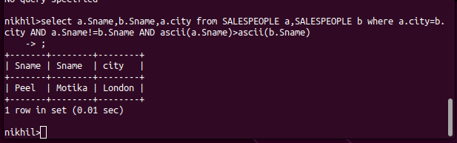

2) Write a query that produces the names andcities of all customers with the same rating as Hoffman.

