ASSIGNMENT - 11

1) Write a query that uses a subquery to obtain all orders for the customer named Cisneros. Assume you do not know his customer number (cnum).
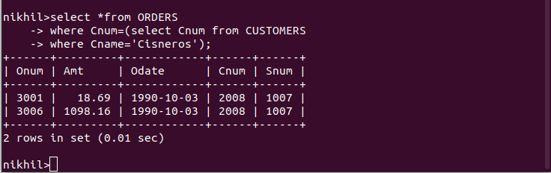

2) Write a query that produces the names andratings of all customers who have above-average orders.
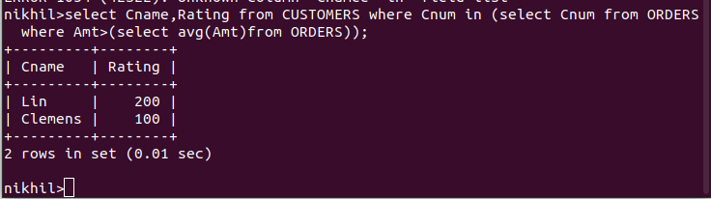

3) Write a query that selects the total amount inorders for each salesperson for whom this total is greater than the amount of the largest order in the table.



