1) Write a command that puts the following values,in their given order, into the salespeople table:city – San Jose, name – Blanco, comm – NULL, cnum – 1100.

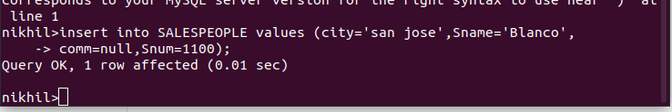

2) Write a command that removes all orders from customer Clemens from the Orders table.
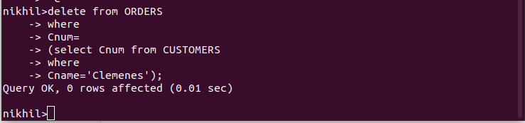

3) Write a command that increases the rating of all customers in Rome by 100.

