ASSIGNMENT - 15

1.Assume there is a table called Multicust, with all of the same column definitions as Salespeople. Write a command that inserts all salespeople with more than one customer into this table.
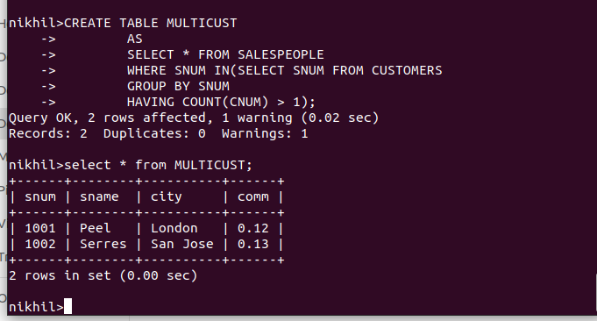
2) Write a command that deletes all customers with no current orders.

DELETE FROM CUSTOMERS
WHERE CNUM NOT IN (SELECT CNUM FROM ORDERS);

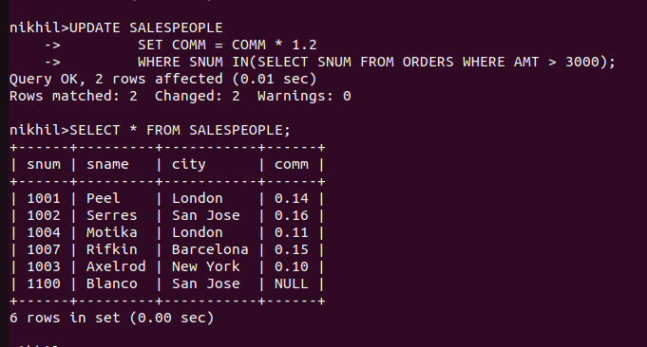
3) Write a command that increases by twenty percent the commissions of all salespeople with total orders above Rs. 3,000.

