**Global Stock Market Prediction Based on Stock Chart Images Using Deep Q-Network**

**Prof. Priyanka Kumbhar, Aniruddha V. Kasar, Shreyas M. Borkar, Aniket S. Surve**

1Prof. Priyankya Kumbhar**,** Information Technology , P.G.Moze College Of Engineering

2Aniruddha Kasar, Information Technology , P.G.Moze College Of Engineering

3Shreyas Borkar, Information Technology , P.G.Moze College Of Engineering

4Aniket Surve, Information Technology , P.G.Moze College Of Engineering

---------------------------------------------------------------------***---------------------------------------------------------------------

**ABSTRACT-** In this study, we present a novel approach to global stock market prediction using a Deep Q-Network (DQN) with a Convolutional Neural Network (CNN) function approximator. Our model is designed to analyze stock chart images as input to make predictions on the future movements of stock prices. Remarkably, our model not only demonstrates profitability when applied to the US stock market, where it was trained, but also consistently yields positive returns in 31 different countries over a span of 12 years.

We exclusively trained our model on historical data from the US stock market and then evaluated its performance on diverse international stock markets. Our findings reveal that the portfolios constructed based on our model's predictions typically generate returns ranging from 0.1% to 1.0% per transaction, prior to considering transaction costs, across the 31 countries tested. These results suggest the presence of patterns in stock chart images that exhibit consistent correlations with stock price movements on a global scale.

Moreover, our study demonstrates the remarkable transferability of our model's predictive capabilities. Even when trained and tested on data from different countries with varying market characteristics, our model consistently demonstrates the ability to forecast future stock prices effectively. This suggests that artificial intelligence-based stock price forecasting models can be employed in relatively small and emerging markets, even in cases where limited historical data is available for training.

In summary, our research underscores the potential of combining deep reinforcement learning techniques with CNNs for stock market prediction. Our model not only exhibits profitability in multiple global markets but also highlights the existence of universal patterns in stock chart images that transcend geographical boundaries. This research opens up exciting possibilities for the application of AI-based forecasting models in diverse and data-constrained financial markets, ultimately enhancing investment decision-making processes.

**KEY WORDS :** Stock Prediction, Live Chart Scraping, Web Scraping, CNN , LSTM, Data analysis

**1.INTRODUCTION**

Stock price prediction is a difficult task. It is because there is no certain variable that can precisely predict the stock price every day. Based on Efficient Market Hypothesis (EMH), new information is a significant factor that effects changes of stock price [1]. This information, such as news about company can influence people decision whether they will buy the company's stock. More people buy the company's stock, the price is getting higher. People tend to buy a company with good reputation. One way to know company's reputation is by seeing relationship between the company and customer [2]. The explosion of social media usage forces many companies to create their official account in social media in order to keep in touch with their customer. This make customer can express their opinion about products easily. One of the social media that commonly used by company is Twitter.

There are several researches about how the information from social media can affects the stock price. Based on research conducted by Johan Bollen. et.al [3]. it concluded that certain mood states of Twitter data can predict the Dow Jones Industrial Average (DJIA) value with 87.6% accuracy. Another research conducted by Anshul Mittal and Arpit Goel [4], shows that with the DJIA value, calmness and happiness mood states of twitter data on previous days can predict the DJIA value on the current day with 75.56% accuracy. This shows that information from Twitter can really be used to predict stock data.

The contribution of this research lies in the use of existing classification and prediction algorithm to the dataset. The dataset consists of twitter dataset and stock price dataset. Twitter dataset used was in Bahasa and stock price dataset retrieved from several companies in Indonesia.

## 2. Literature Survey

The literature survey provides valuable insights into the Indian startup ecosystem and its impact on the economy. Several academic studies and research papers have contributed to understanding the trends, investment patterns, and government initiatives related to startups in India.

1. **isec.ac.in - Indian Startup Ecosystem: Analysing Investment Trends**

This study delves into investment trends and the performance of government programs related to Indian startups. It contributes to the limited academic literature available on this topic, shedding light on the dynamics of the Indian startup ecosystem.

1. **mckinsey.com - Online and upcoming:**

The Internet's impact on India This research explores how the internet impacts India's economy both currently and in the future. It provides insights into the influence of the internet on various sectors and its potential to drive economic growth.

1. **srcc.edu - Startups Restoring The Indian Economy?**

This paper discusses the current innovative startup environment in India and highlights its role in restoring the Indian economy. It presents essential details about the startup ecosystem within the Indian context.

1. **mdpi.com - The Impact of Fintech and Digital Financial Services on**

While primarily focusing on fintech, this study investigates the impact of behavioral intention, trust in fintech services, usability, and social influence on user engagement. It offers insights into the evolving landscape of financial services in India.

1. **adb.org - Experiences from the Startup Action Plan in India**

This source provides insights into the Startup Action Plan (SAP) of 2016 in India. It addresses key areas for empowering startups, including funding and simplification, offering an understanding of the initiatives aimed at supporting the startup ecosystem.

Table:

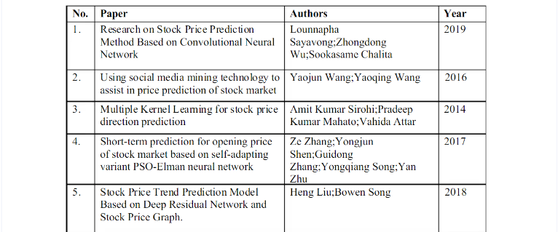

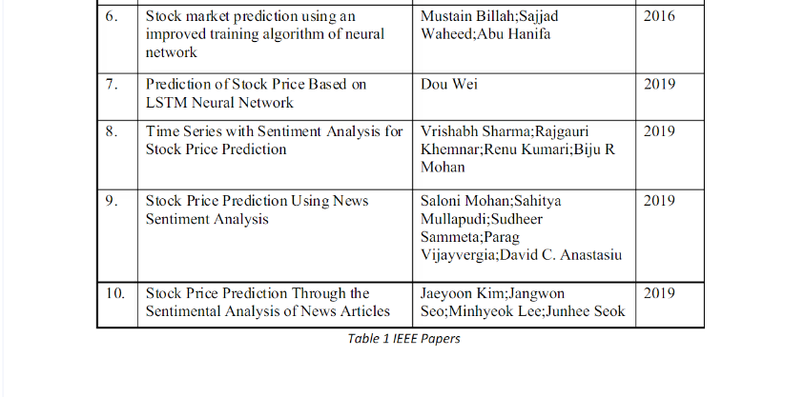

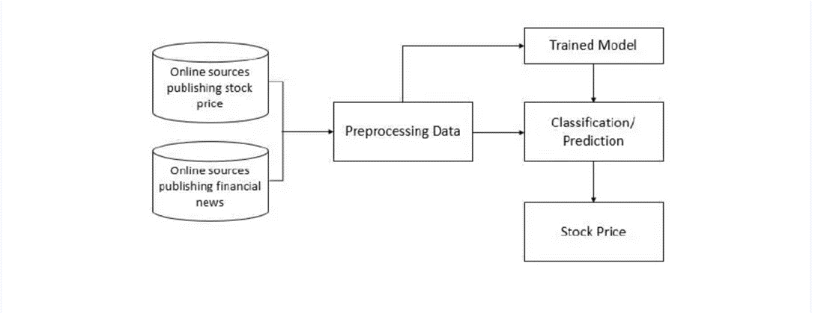

**Fig -1**: System Architecture

Charts

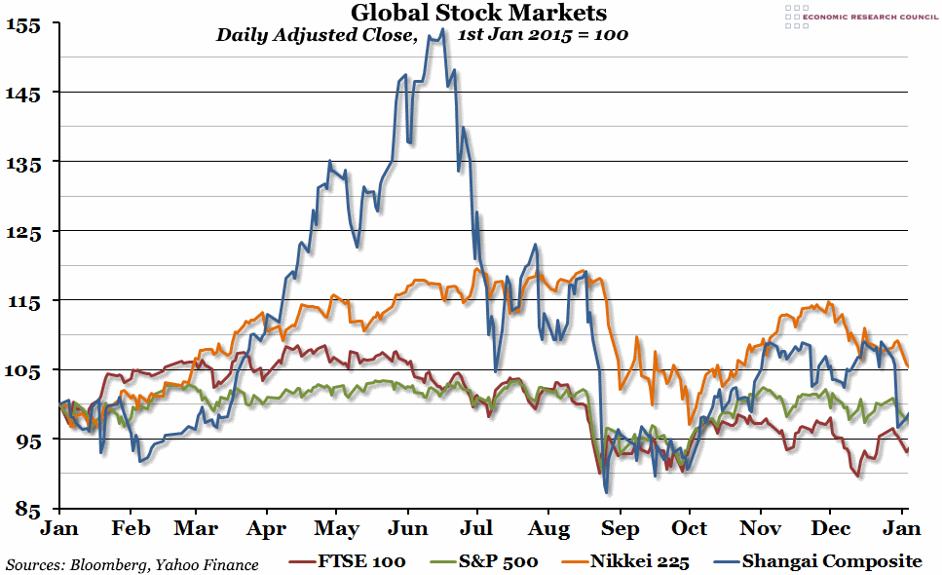

**3. CONCLUSIONS**

We conducted numerous experiments to determine whether our model trained on certain patterns in stock charts from a single country can make a profit not only in the given country but generally in all other countries. As our results show, our model trained in only the US market, also performed well or even better in many other markets for the 12-year testing period. Based on this observation, artificial intelligence and machine learning stock price forecasting studies, which have been conducted in only a single country so far, can be employed in global stock markets. In other words, if the model structure, input feature, and training procedure are satisfactory, the model does not have to be trained and tested in the same market. To the best of our knowledge, our artificial intelligence based model, which is trained on the data of only a single country, is the first to obtain numerous testing results on global stock markets.

**ACKNOWLEDGEMENT**

We express our sincere thanks to all those who have provided us the valuable guidance towards the successful completion of this system as a part of syllabus for the bachelor‘s course. We express our sincere gratitude towards our co-operative department for providing us with altheas valuable assistance and equipment for the system development .We hereby take this opportunity to sincerely thank **Prof. Priyankya Kumbhar** for his valuable guidance, inspiration, whole hearted involvement during every stage of this project and his experience, perception through professional knowledge which made it possible for us in successfully realizing the concept.

We are also thankful to **Prof. Abidali Shaikh** - Head of Department – Information Technology for his constant enlightenment, support and motivation which has been highly instrumental in successful completion of our project phase 1.

We are extremely thankful to **Dr. Navnath Narawade** Principal - PGMCOE, Wagholi for his encouragement and providing us the opportunity and facilities to carry out this work.

Finally, we like to express our deep sense of gratitude towards our parents, friendsand well- wishers who were always there for suggestions and help.

**REFERENCES**

1. Investopedia. (n.d.). Efficient Market Hypothesis: Is The Stock Market Efficient? Retrieved June 24, 2015, from Investopedia: http://www.investopedia.com/articles/basics/04/022004.asp
2. Bollen, J., Mao, H., & Zeng, X. J. (2010). Twitter mood predicts the stock market. arXiv. [3] Stock Price Prediction Through the Sentimental Analysis of News Articles Jaeyoon Kim, Jangwon Seo:Minhyeok Lee: Junhee Seok 2019 Eleventh International Conference on Ubiquitous and Future Networks (ICUFN) Year: 2019 Conference Paper Publisher: IEEE.
3. Applying long short term momory neural networks for predicting stock closing price Tingwei Gao; Yueting Chai; Yi Liu 2017 8th IEEE International Conference on Software Engineering and Service Science (ICSESS) Year: 2017 | Conference Paper Publisher: IEEE
4. Impact of financial ratios and technical analysis on stock price prediction using random forests K. S. Loke, 2017 International Conference on Computer and Drone Applications (IConDA). Year: 2017 Conference Paper | Publisher: IEEE
5. Stock price prediction using genetic algorithms and evolution strategies Sonal Sable; Ankita Porwal Upendra Singh 2017 International conference of Electronics, Communication and Aerospace Technology (ICECA) Year: 2017 | Volume: 2 | Conference Paper | Publisher: IEEE
6. Prediction of Stock Prices using Machine Learning (Regression, Classification) Algorithms, Srinath Ravikumar: Prasad Saraf 2020 International Conference for Emerging Technology (INCET), Year: 2020 Conference Paper | Publisher: IEEE
7. Stock Price Prediction Based on Information Entropy and Artificial Neural Network, Zang Yeze; Wang Yiying, 2019 5th International Conference on Information Management (ICIM). Year: 2019 Conference Paper Publisher: IEEE
8. Optimised Prediction Model for Stock Market Trend Analysis, Devpriya Soni: Sparsh Agarwal; Tushar Agarwel; Pooshan Arora; Kopal Gupta, 2018 Eleventh International Conference on Contemporary Computing (IC3), Year: 2018 | Conference Paper | Publisher: IEEE
9. “Apache Spark - Lightning-Fast Unified Analytics Engine,” 2020. Available: https://spark.apache.org/
10. V. Atanasov, C. Pirinsky, and Q. Wang, “The efficient market hypothesis and investor behavior,” 2018.
11. S. Agrawal, D. Thakkar, D. Soni, K. Bhimani, and C. Patel, “Stock market prediction using machine learning techniques,” International Journal of Scientific Research in Computer Science, Engineering and Information Technology, 2019.
12. M. Afeef, A. Ihsan, and H. Zada, “Forecasting stock prices through univariate arima modeling,” 2018.
13. P.-F. Pai and C.-S. Lin, “A hybrid arima and support vector machines model in stock price forecasting,” Omega, vol. 33, no. 6, pp. 497–505, 2018.
14. D. Karmiani, R. Kazi, A. Nambisan, A. Shah, and V. Kamble, “Comparison of predictive algorithms: Backpropagation, svm and lstm for stock market,” in 2019 Amity International Conference on Artificial Intelligence (AICAI). IEEE, 2019, pp. 228–234.
15. E. Ahmadi, M. Jasemi, L. Monplaisir, M. A. Nabavi, A. Mahmoodi, and P. A. Jam, “New efficient hybrid candlestick technical analysis model for stock market timing on the basis of the support vector machine and heuristic algorithms of imperialist competition and genetic,” Expert Systems with Applications, vol. 94, pp. 21–31, 2018.
16. S. Sharma and B. Kaushik, “Quantitative analysis of stock market prediction for accurate investment decisions in future,” Journal of Artificial Intelligence, vol. 11, pp. 48–54, 2018.