Rule: General Rules
- Main umpire, Leg umpire, Right and Left boundary umpires will be appointed from neutral teams.
- Argument and misconduct with the umpires is not allowed.
- Match referee can bar a player from bowling in next match depending on seriousness of misconduct.
- Umpire decision will be final unless reviewed.
- Maximum of 2 overs for a bowler.
- No runner is allowed even if a player is injured.
- Catching/fielding will be considered legal even if the fielder is in contact of the boundary wall while catching/fielding the ball. But if they go outside the box on left or right side then it will be illegal and declared not out and Declared runs for same will be credited.
- Bat change call is mandatory.
- Bowling side change and keeper change/keeper off call is not mandatory.
- In case of collisions (batter & fielder) if the batter is runout at any end then umpires will decide whether the batter is out or not. Captains can withdraw the appeal for run-out if they wish to do so.
- Nets will be considered as bounce.
- If the bowler is bowling over the wicket, non-striker should stand on the opposite side of the bowler and vice versa.
- Dummy runner will be decided by batting team captain.
- Strike Change: Strike will change only if the batter completes odd runs by running. Any declared runs as a result of overthrows, byes or leg-byes will not impact the strike change.
- NEW RULE introduced in CPL 8.0: Players purchased for zero points during the auction must bowl at least one over in all the league matches.
Rule: Runs
- Runs for Byes and Leg Byes are allowed.
- Run and Overthrow runs is applicable if Batter didn’t have any contact of bat with the Ball.
- Taking the run when ball has touched hand without touching bat or wrist is allowed.
- All declared runs are valid as normal.
- For non-declared runs, Batter should touch the bat behind the crease line for run to be considered as complete. Otherwise, no run will be credited.
- Ball hitting with bounce to tree outside the box will have declared run valid according the first impact of the bounce.
- Ball landing directly in Gym balcony area has 2 declared runs.
- Ball hitting Inside tree, trunk and going to boundary line will be considered as 4 and If ball goes outside the box, then declared runs will be considered as per the landing area of the ball after bounce. Refer photographs of each individual tree for tree specific rules.
- Ball hitting directly inside shed area (box area) will be considered as boundary.

Rule: Six
- If the ball crosses the boundary line after touching the leaves of any tree, then it will be considered as a SIX.
- If the ball directly touches any part of the trees (coconut tree and Almond tree) on the boundary line, then it will be considered as a SIX.
- If the ball directly touches the coconut tree (long on for Right-handed batter) or goes
- above the coconut tree, then it will be considered as a SIX. In case of close calls, umpires will discuss and take a final call.
- If the ball crosses the boundary line after going above the Gym balcony then it will be considered as a SIX. But if the ball crosses the boundary line after crossing the net above the shed/Gym Terrace then batter will be given OUT.
- If the ball goes outside the ground but within the V-range i.e., Coconut tree (long on for Right-handed batter) and Gym Balcony (long off for Right handed batter) then it will be considered as a SIX.
Rule: Review System
- Bowling team captain and striker can take review only for one bounce, beamer and wide over the head.
- Each team will get only one review per inning.
- Video recording if available will be considered by all the umpires for decision making after review is taken.
- When video recording is not available, all umpires will consult and take the final decision.
- Batting team review can be taken by Batter within 30 seconds after umpire decision.
- Bowling team review can be taken only by Fielding Captain within 30 seconds after Umpire decision.
- Incorrect review will result in loss of taken review.
- Correct review will retain the taken review
- Overstepping /runout reviews are available only for umpires.
- Umpires have authority to take review multiple times.
Rule: Wide Ball Rules – 1 run will be added to batting team
- Any ball down the leg-side will be given as Wide provided it is not going over the stumps.
- If batter significantly moves or takes off-stump guard while facing the delivery then yellow wide lines WILL NOT be considered. In such cases, umpires will take a judgement call depending on the batter's position while facing the ball. It'll be signaled wide only if it is not within batter's reach.
- For deciding above-the-head or over-the-shoulder wide and no balls, batter's height within the crease in normal upright position will be considered.
- First over-the-shoulder and below-the-head ball of the over will be considered as a 1st bounce warning.
- If the batter does not touch first above-the-head ball, then it will directly be signaled as wide and first warning. But if the batter touches first above-the-head ball then it will just be signaled as a first warning.
- When batter steps out and bowler bowls a bouncer then batter's normal stance within the crease and upright position will be considered for deciding whether the ball was over-the-shoulder or above-the-head.
- Second ball above-the-head or over-the-shoulder will be signaled as a NO BALL followed by FREE-HIT.
Rule: No Ball Rules – 1 run will be added to batting team and next ball will be a free hit.
- Direct Full toss above waist level when batter is within the crease will be given No Ball. If batter is stepping out, then it will be fair delivery.
- Bowler crossing the crease line, some part of the foot should be behind the crease line.
- Only throw is allowed, and no full pitch bowling action allowed. Full pitch bowling action will be NO BALL
- Only one bouncer above shoulder level and below head level is allowed in an over with warning, second bouncer above shoulder level will be considered as No Ball.
- Beamer – First will be warning and second will be disqualification from bowling further in the match
- No ball will be considered if the bowling stump is dropped while bowling.
- No ball will be given in case someone from fielding team speaks during bowling.
- If there is more than one bounce before the ball reaches the batting crease, it will be called a NO-BALL, with all the rules of a no-ball applying, including a free hit on the next legal delivery.
- In case of free hit, stumping is not-out. Only run outs are allowed.
Rule: Deflections
- Rare case of deflection due to overhead cables/pipes: After touching the overhead cables/pipes, if the ball crosses the boundary line then it will be considered as a SIX. If fielder directly catches the ball after touching the overhead cables/pipes then it will be considered as OUT.
- If ball touches backside net/bar (behind the keeper) then it will be considered as bounce.
- A thumb rule for all the trees: If a ball hits trunk of the tree then it will be considered as a bounce. And if it hits any part of the tree other than the trunk then it will NOT be considered as a bounce.
- For some of the trees, trunk is marked in below photos. For all other trees, trunk portion is until first branch of the tree from the bottom.
- Refer below photos to understand tree specific deflection rules

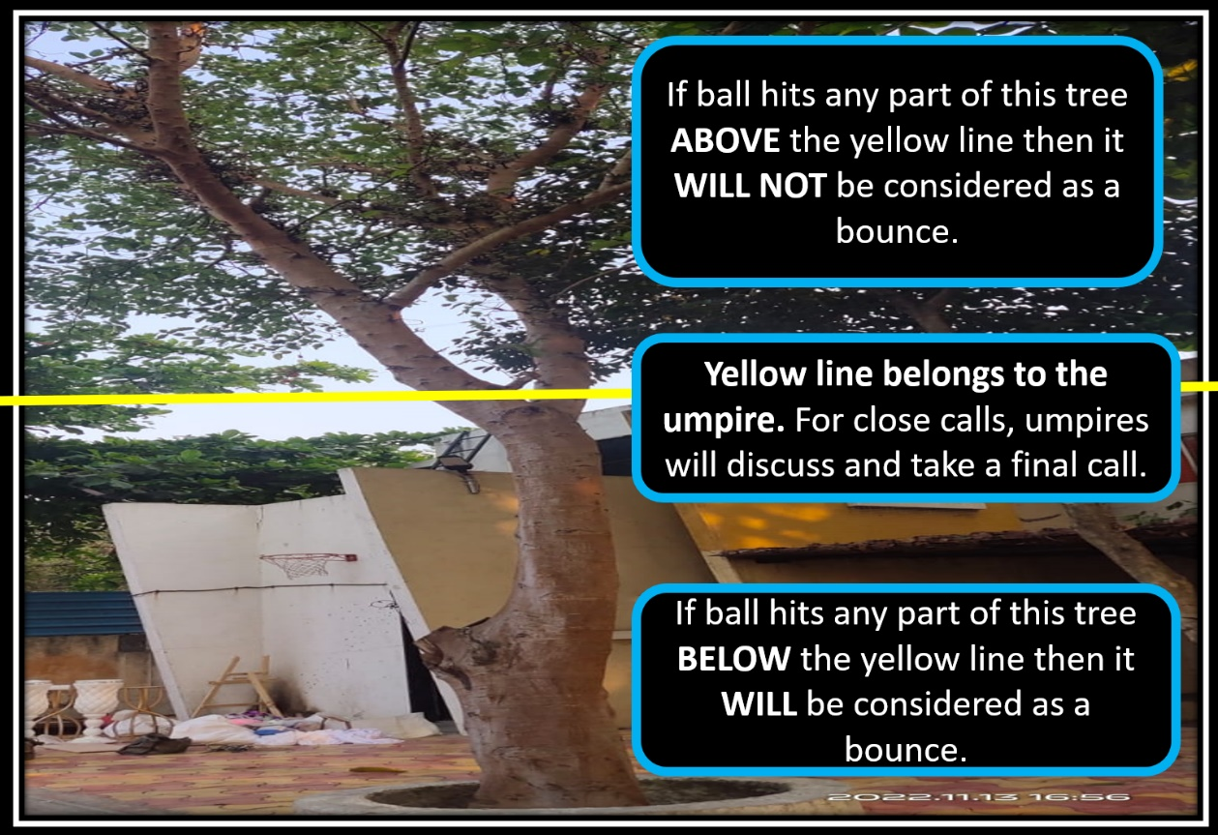

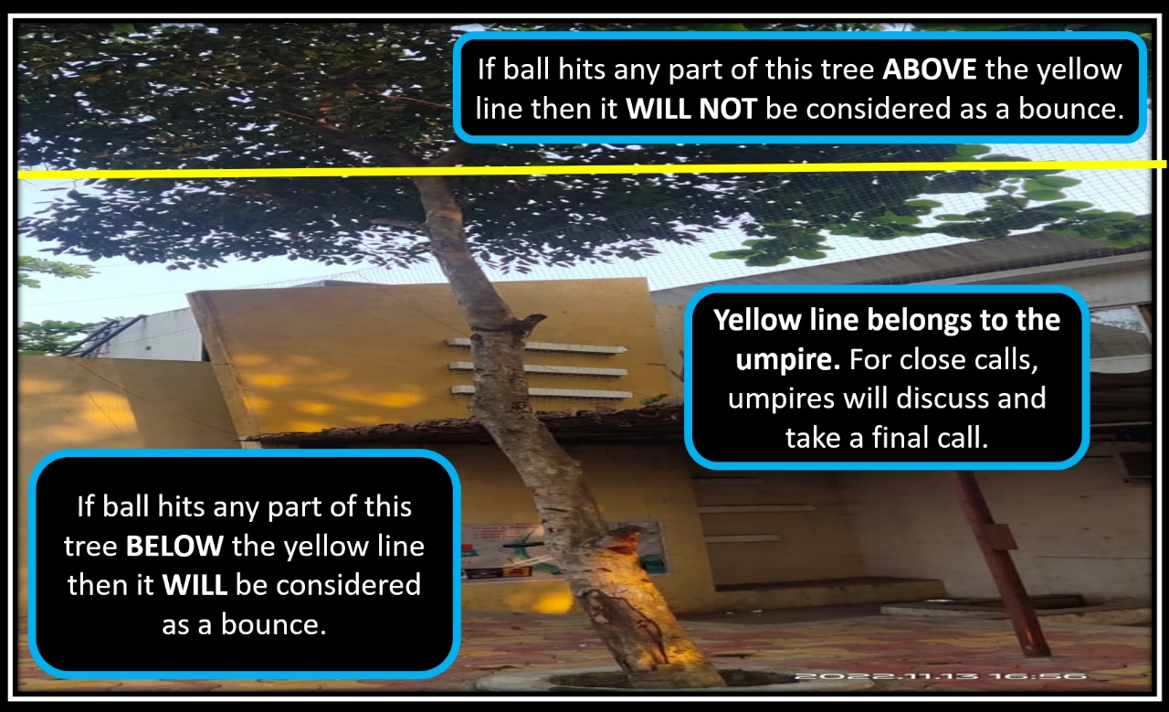

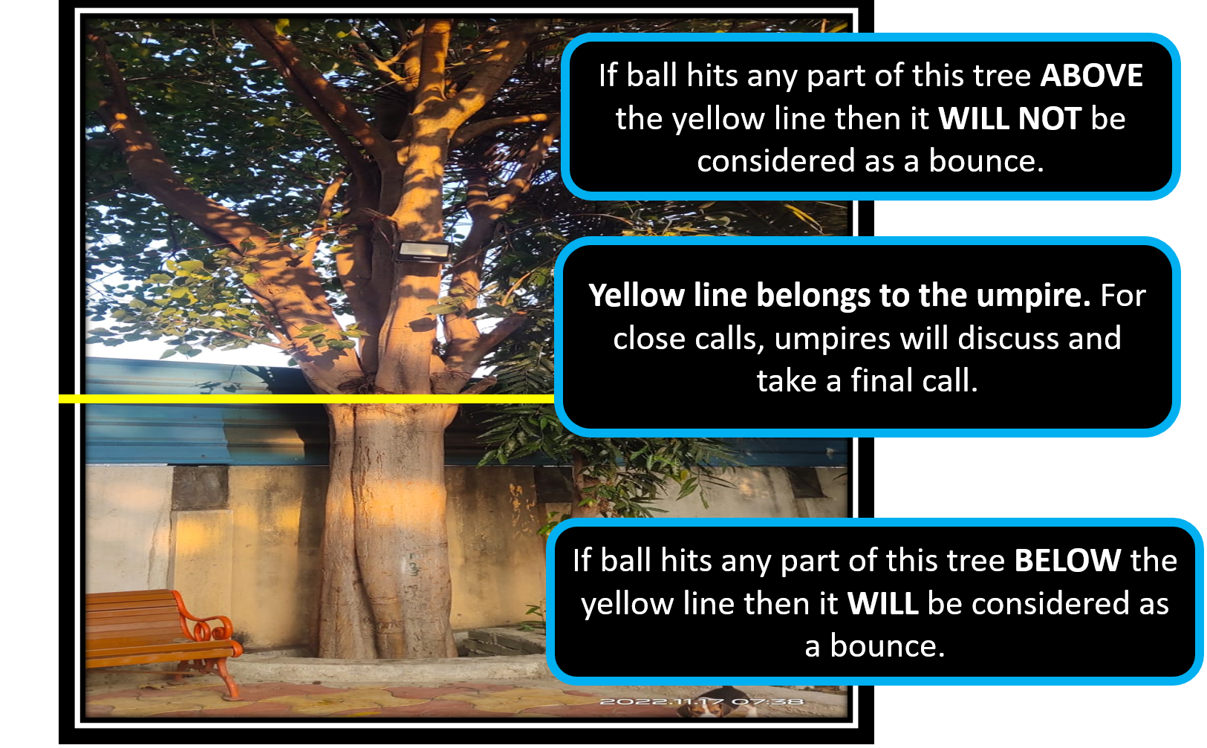
Rule: Out
- LBW is not allowed
- Bowled, Catch, Stumping, Hit-Wicket, Run-Out
  - For Run out, Bowler side stumps need to fall after the ball hits the stumps.
  - If ball touches the stump and stump is not fallen, it will be considered NOT-OUT
  - If stump is already down then fielder needs to lift the stump and ball together in hand and touch the ball to stump for claiming run-out. Otherwise it will be considered as Not Out
  - For Bowled out, it is important the bails are fallen. If bails are touched but not fallen, then it is NOT OUT
- Hitting the ball directly outside the wall behind the batter.
- Ball direct hitting above the net and landing on metal sheet above the shed area.
  - If ball touches the net or tree then it is considered not out.
- Direct bounce outside the box on left and Right side above net. Ball touching the net and going outside is considered not out.
- If ball lands or bounces on the left or right box boundary and goes outside, it is NOT OUT
- Obstructing the field
Rule: Rules for Catch Out
- Catch taken after ball hitting any hard surface like Tree Base, Tree trunk, Pole, Walls etc. will be considered as bounce and hence catch is not valid and it will be NOT OUT
- Contact with leaves and cable wire in between the ground will not be considered as a bounce. Catch will be considered legal even if the ball touches leave/cable on its way.
- If catch is taken and fielder goes outside the box on left and right-side area, then catch is invalid and declared runs of 2/4/6 will be credited.
Rule: Super Over
- If match is tied, result will be decided based on a Super Over.
- Super over will be played for 1 over each side.
- Unlimited wickets up to number of players in a team.
- Batter who is out in super over can’t bat again in same super over.
- Team scoring highest runs will be declared winner.
- Super over will continue until there is result out of the match. If super over is tied then there will be next super over within the teams.
- Super over runs will not be considered for calculating net run rate.
- Celebria Cricket rules will be applicable during super over as well.
Rule: BATTING POWER OVER
- Each inning will have one batting power over.
- Total Runs scored in the BATTING POWER OVER (including extras) will be doubled. For ex: If a team scores 12 runs in the BATTING POWER OVER then additional 12 runs will be awarded as BONUS runs to the team’s score.
- Before the start of any over after 3rd over in league matches and any over after 4th over in knockout matches, batting team’s captain can decide if he wants to go for the BATTING POWER OVER. If batting team does not choose to go for the BATTING POWER OVER then last over of the inning will automatically be the BATTING POWER OVER.
- Bowling team will have liberty to choose the bowler after batting team has decided an over to be a BATTING POWER OVER.
- Batting power over can be taken by the batting team after 3 overs in league matches. Whereas apart from league matches it can be taken after first 4 overs of the match.
Rule: BOWLING AREA
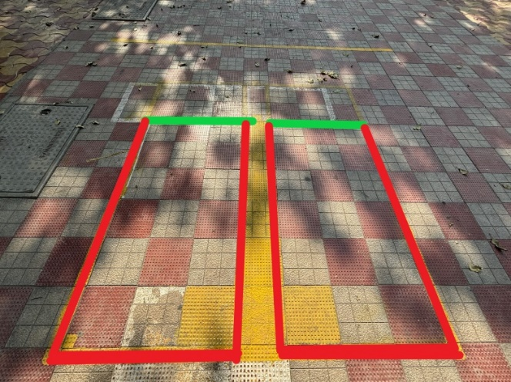
- Box area marked in red is the assigned space for bowler to bowl a legal delivery. Bowler can take run-up just within this red box. If side or back red line is touched during bowling then it will be considered as NO BALL and free-hit will be given to batting team.
- Some section of the foot should remain behind the front green line to be considered as a LEGAL DELIVERY.
Rule: Bowling Powerplay
- Bowling powerplay can be taken by the bowling team within first 3 overs in league matches. Whereas apart from league matches it can be taken in first 4 overs of the match.
- During Bowling powerplay, six outside the ground (Jungle area) will be considered as zero run and will be considered as a DOT BALL.
- If the ball is stuck on boundary net, coconut tree, badam tree then it will be considered as a six. But after touching the frame or tree, if the ball falls in the jungle area then it will NOT be considered as a six.
- If ball touches club house wall and then goes in the jungle area then it will be considered as 2 runs.
- If ball bounces on the floor of play area or below v-section of Umbra tree and then goes in the jungle area then it will be considered as four runs.
Rule: Code of conduct
- Umpires have authority to show yellow/red card in case of misconduct by bowling or batting team.
- Yellow card – warning to the entire team, Red Card – Penalty of (+6 or -6 runs) depending on the team facing the penalty. Yellow/Red card penalty will only be applicable for current inning.
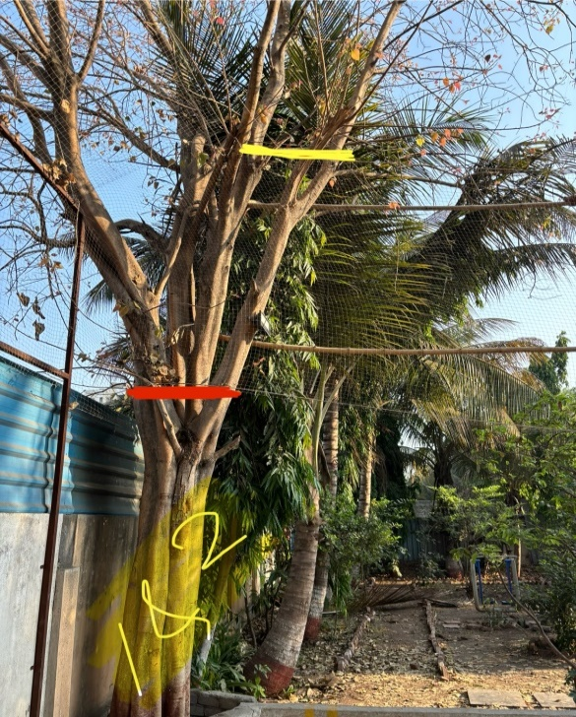
Rule: Special Rule for Trees inside the ground
- Bounce below red line will be called as declared runs. Indirect hit – 1 run & direct hit- 2 runs.
- Bounce above yellow line and ball lands inside cricket ground is not out.
- Bounce above yellow line and ball lands outside cricket ground is out.

Rule: Terrace pole
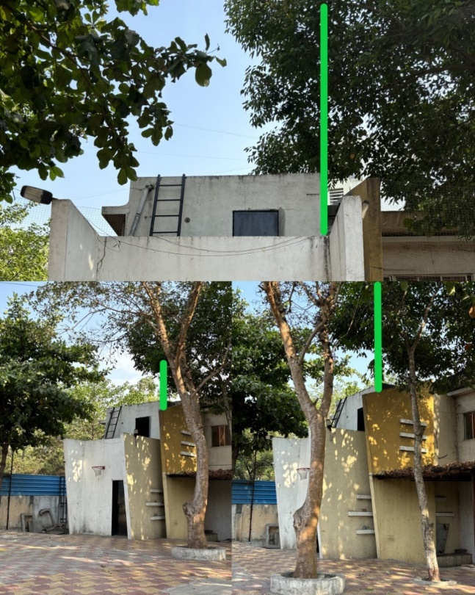
- If ball travel out of ground from right side of green line is considered as out.
- If ball travel out of ground from left side of green line is considered as not out and batter will get runs according to ball landing.

Rule: Run out
In the case of a run-out during the first attempt where the batter has reached inside the crease but the stumps are dislocated, to make the second attempt successful, the fielder has to fix the stumps in place and then remove the stumps with the ball and stump in hand.

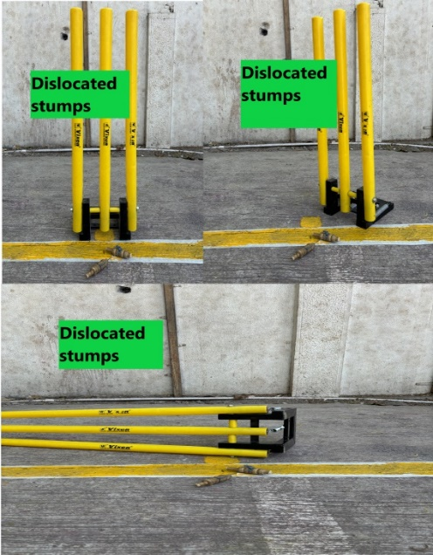
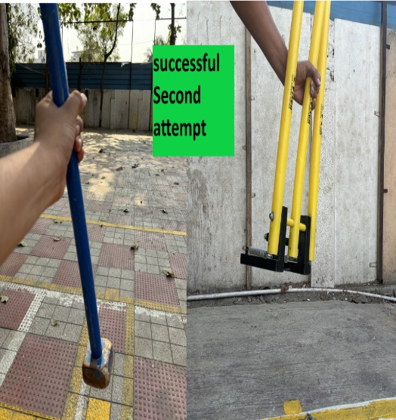
Rule: EXTENDED BOUNDRY and BOWLING AREA 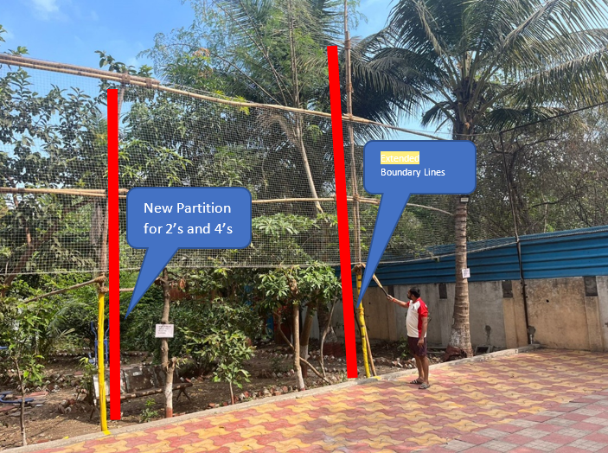
Rule: SCHEDULE
Once schedule is disclosed and generated, it will not be changed at any given point in future.
Rule: TIME BOUND RESTRICTION
Match will start at given scheduled time. Waiting period of 15mins will start from the assigned match time for the whole team to arrive. If all members are not available at the end of 15th minute then match should be started with available players. As and when missing player arrives, he will be introduced at the end of the running over.
Rule: BALL BOY RESPONSIBILITY
Team that violates/ignores ball boy responsibility or if the assigned players are not available at assigned duty area, that team will be restricted to 6 players during bowling for first 2 overs in next match during fielding.
Rule: I have to bowl in league match
Min 2 overs in total for each player during league matches, captains have to complete it in any match during league matches, either in different matches or 2 overs in the same match. If not used in first 4 matches then in last league match it will be mandatory to use those overs of the player. This rule is implemented so that everyone will get some overs to bowl during league matches.

Below is the table to understand it more clearly
Player | Match1 | 2 | 3 | 4 | 5 | Current rule | New rule Total
1 | 2 | 2 | 2 | 2 | 2 | 10 | 10
2 | 2 | 2 | 2 | 2 | 2 | 10 | 10
3 | 1 | 1 | 1 | 1 | 1 | 5 | 4
4 | 1 | 1 | 1 | 1 | 1 | 5 | 4
5 | 1 | 1 | 1 | 1 | 1 | 5 | 4
6 | 1 | 1 | 1 | 1 | 1 | 5 | 4
7 | 0 | 0 | 0 | 0 | 0 | 0 | 2
8 | 0 | 0 | 0 | 0 | 0 | 0 | 2
Rule: Match Schedule
From CPL 7 each team must play against every team which is mandatory.
And due to any unavoidable reason if day 1 scheduled matches are not completed on time then all the remaining matches will be moved to day 2 and day 2 scheduled league matches will be cancelled.
If such scenario occurs then rule of mandatory 2 overs per player will not be applicable.
Rule: Mera ball boy Mera toss
The team which is responsible for ball boy as per the schedule, that team’s captain has to do the toss for next match. If not done then penalty described in the “Ball Boy Responsibility” rule will be applied.
Rule: Rukna nahi
As we have lot of matches on both day, lets avoid delays in schedule. Hence play will not stop due to sun light in the morning. It has to be continued. Play can stop only in case both the teams are facing similar issue. For example rain or any natural disaster.
Rule: Patra Baja toh 2 ya 4 mila
If ball hits metal sheet(patra) anywhere only in/near box area (washing area) it will be considered as 2 or 4 runs based on bounce of the ball.
Rule: All other cricketing rules are applicable as normal

