**Class:** Third Year (Computer Science and Engineering)

**Year:** 2020-21 **Semester:** 2

**Course:** Advanced Web and Mobile Application Development Lab (4CS381)

**Exam Seat No:**

Name: Aniruddha Sanjay Palekar

Exam Seat Number: 2018BTECS00044

**Problem Statement 1**

problem statement:-Create an Express App for Conference registration form with following requirements:  
1. Student should fill details (Name, City, Branch, Conference)  
2. Use 'ConfForm.html' route and also use root route.  
3. Use GET method method to transfer and display the data using JSON  
4. Run the Application

**Screenshot #:**

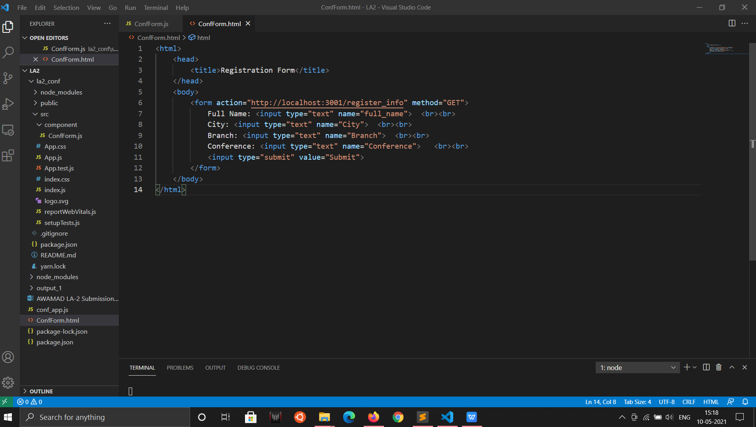

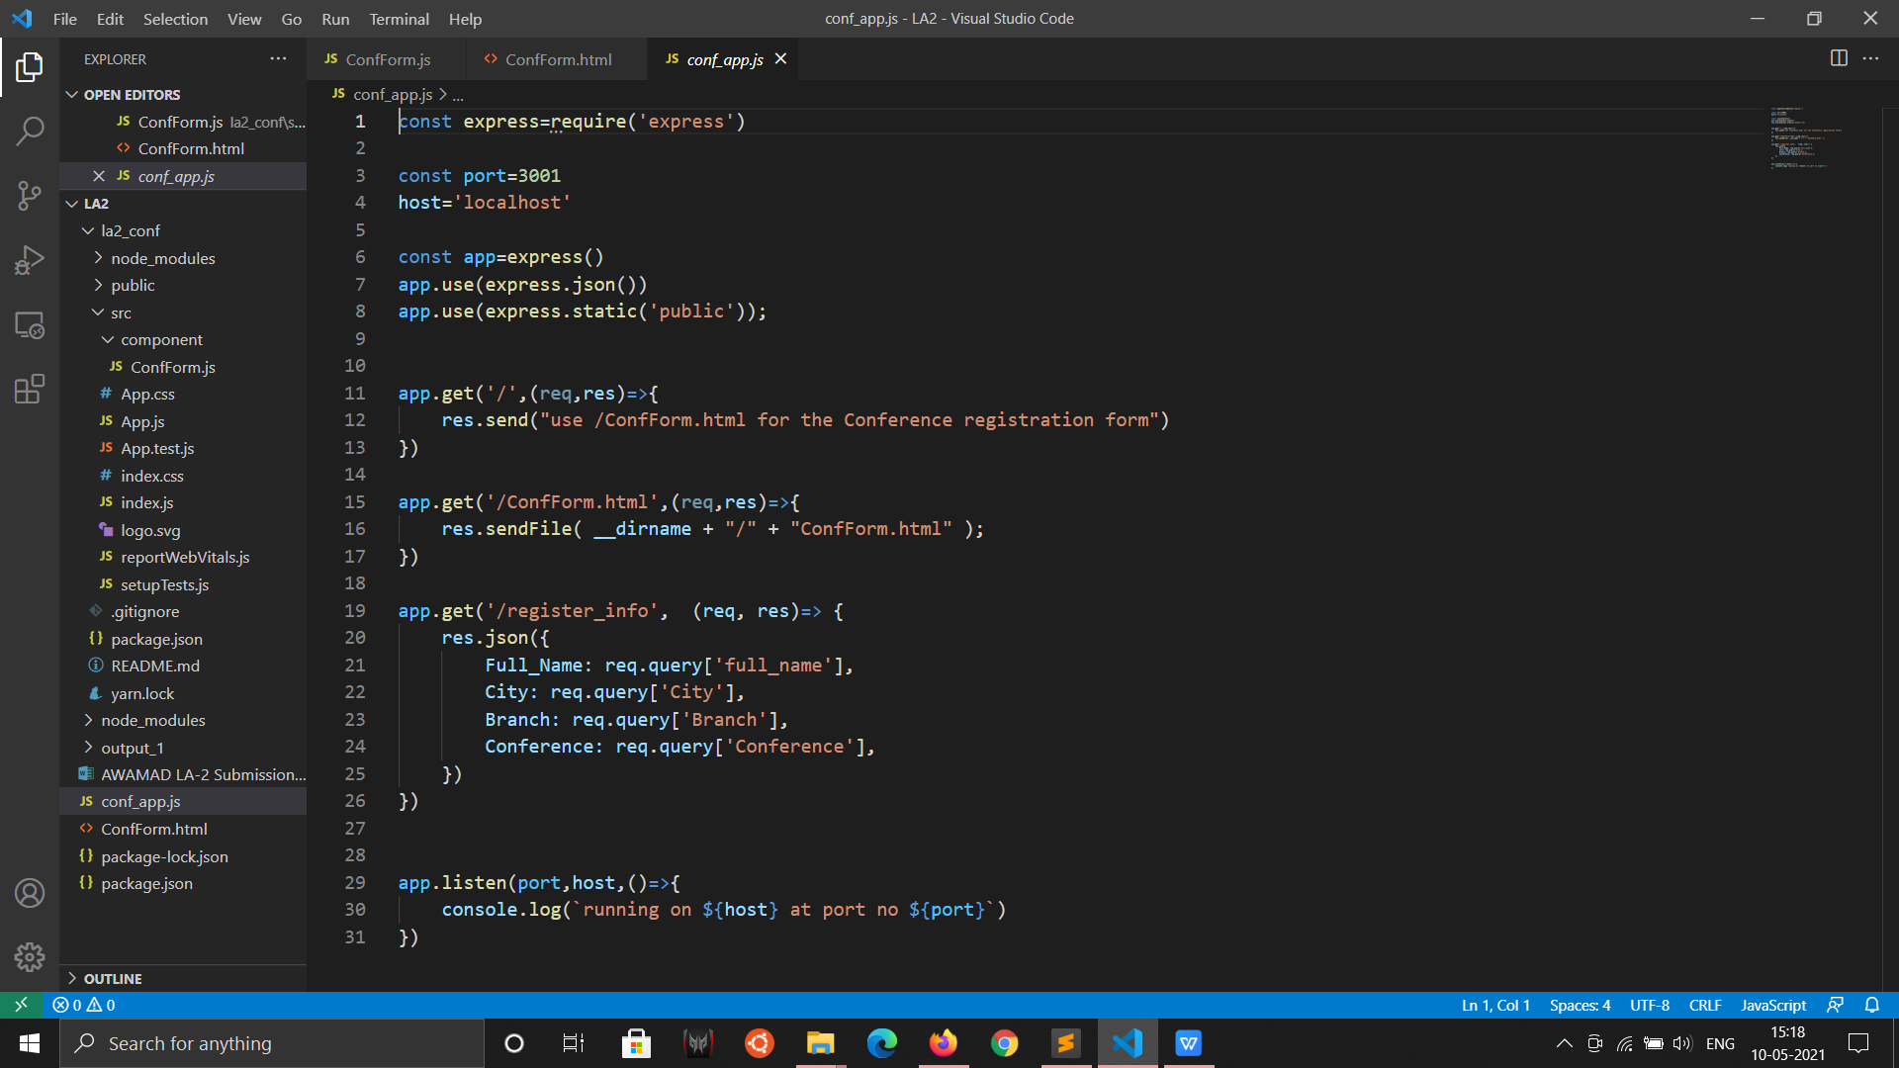

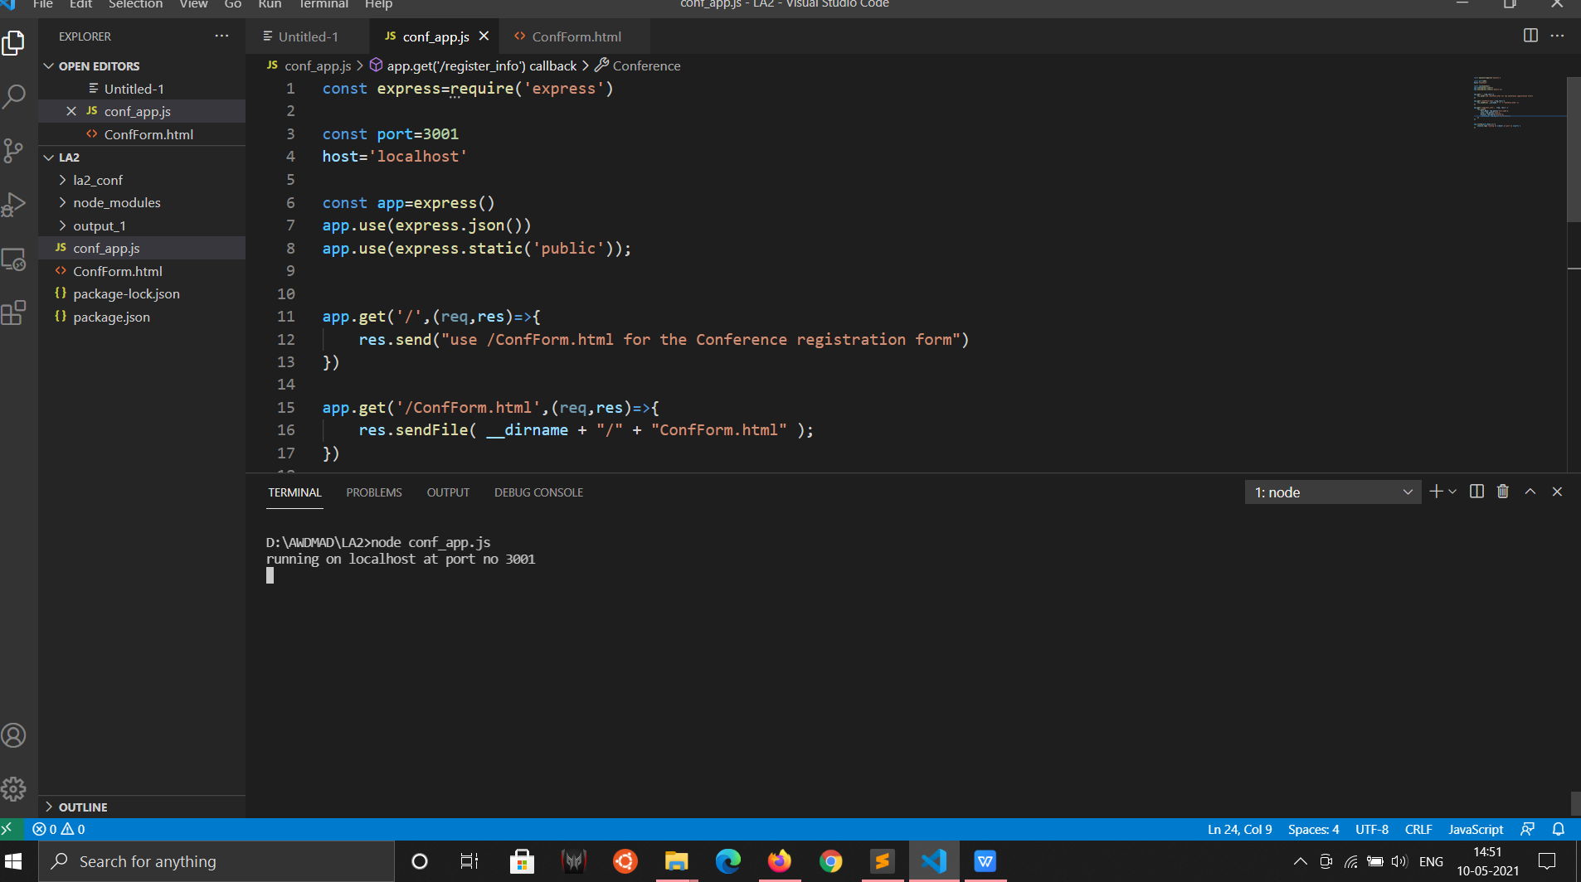

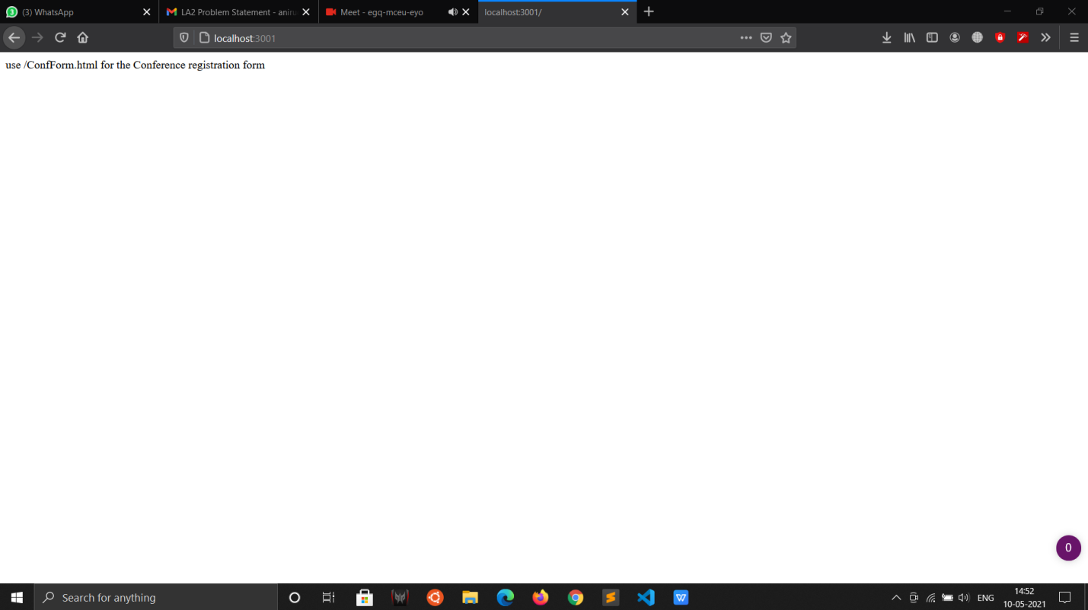

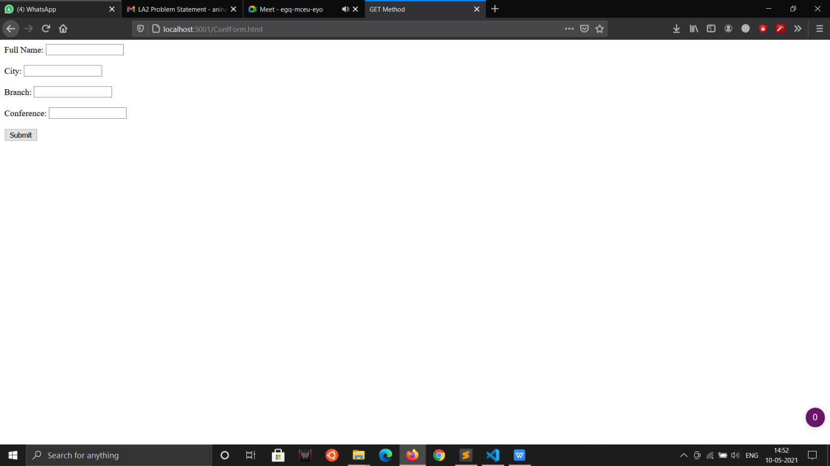

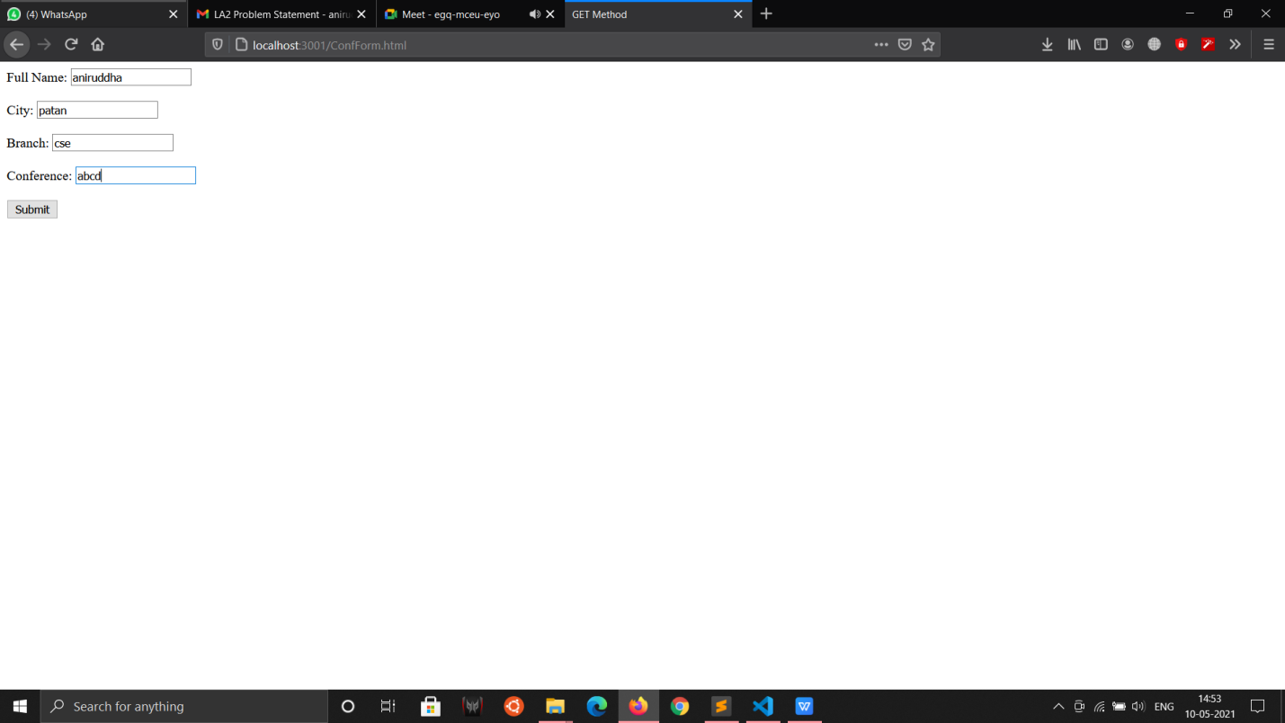

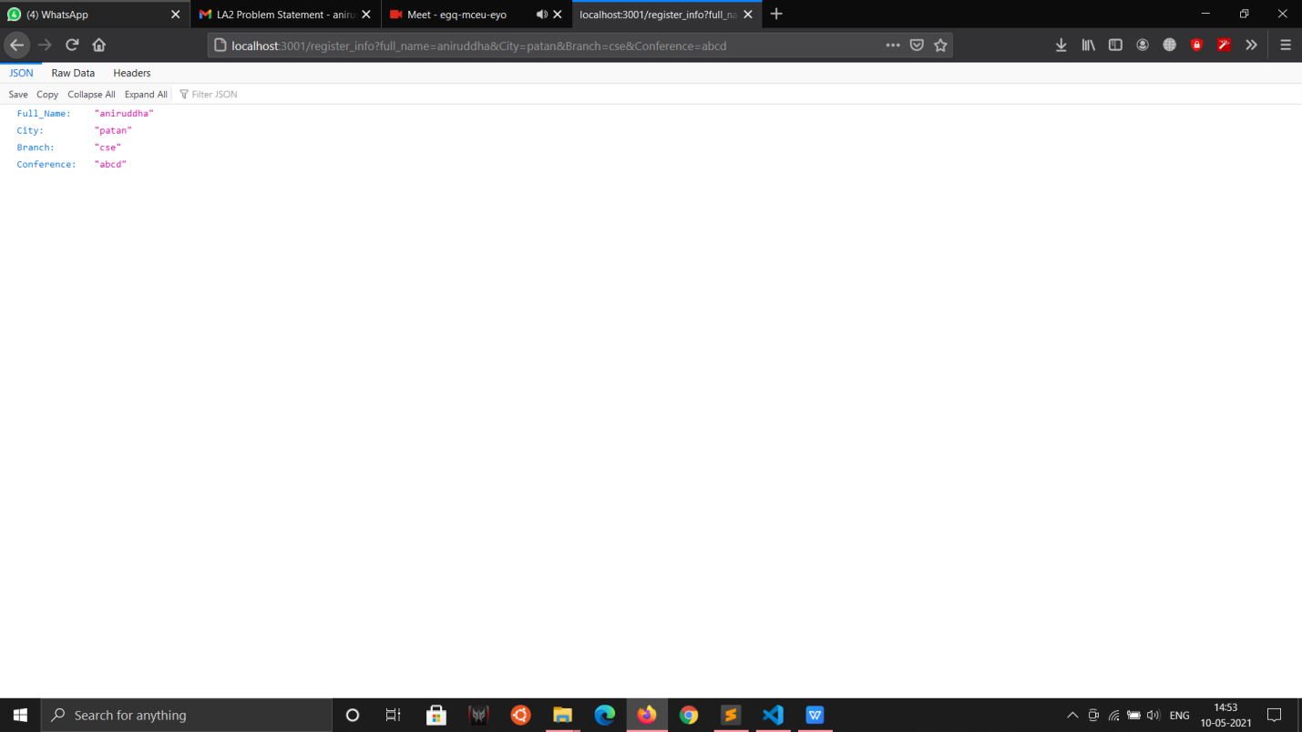

**Information #:**

**Problem Statement 2**

problem statement2:-Create a React App for Conference Registration form with following requirements:

1. Use Components and props appropriately  
   2. Use Controlled Components  
   3. Create at least one user defined component  
   4. Run the application

**Screenshot #:**

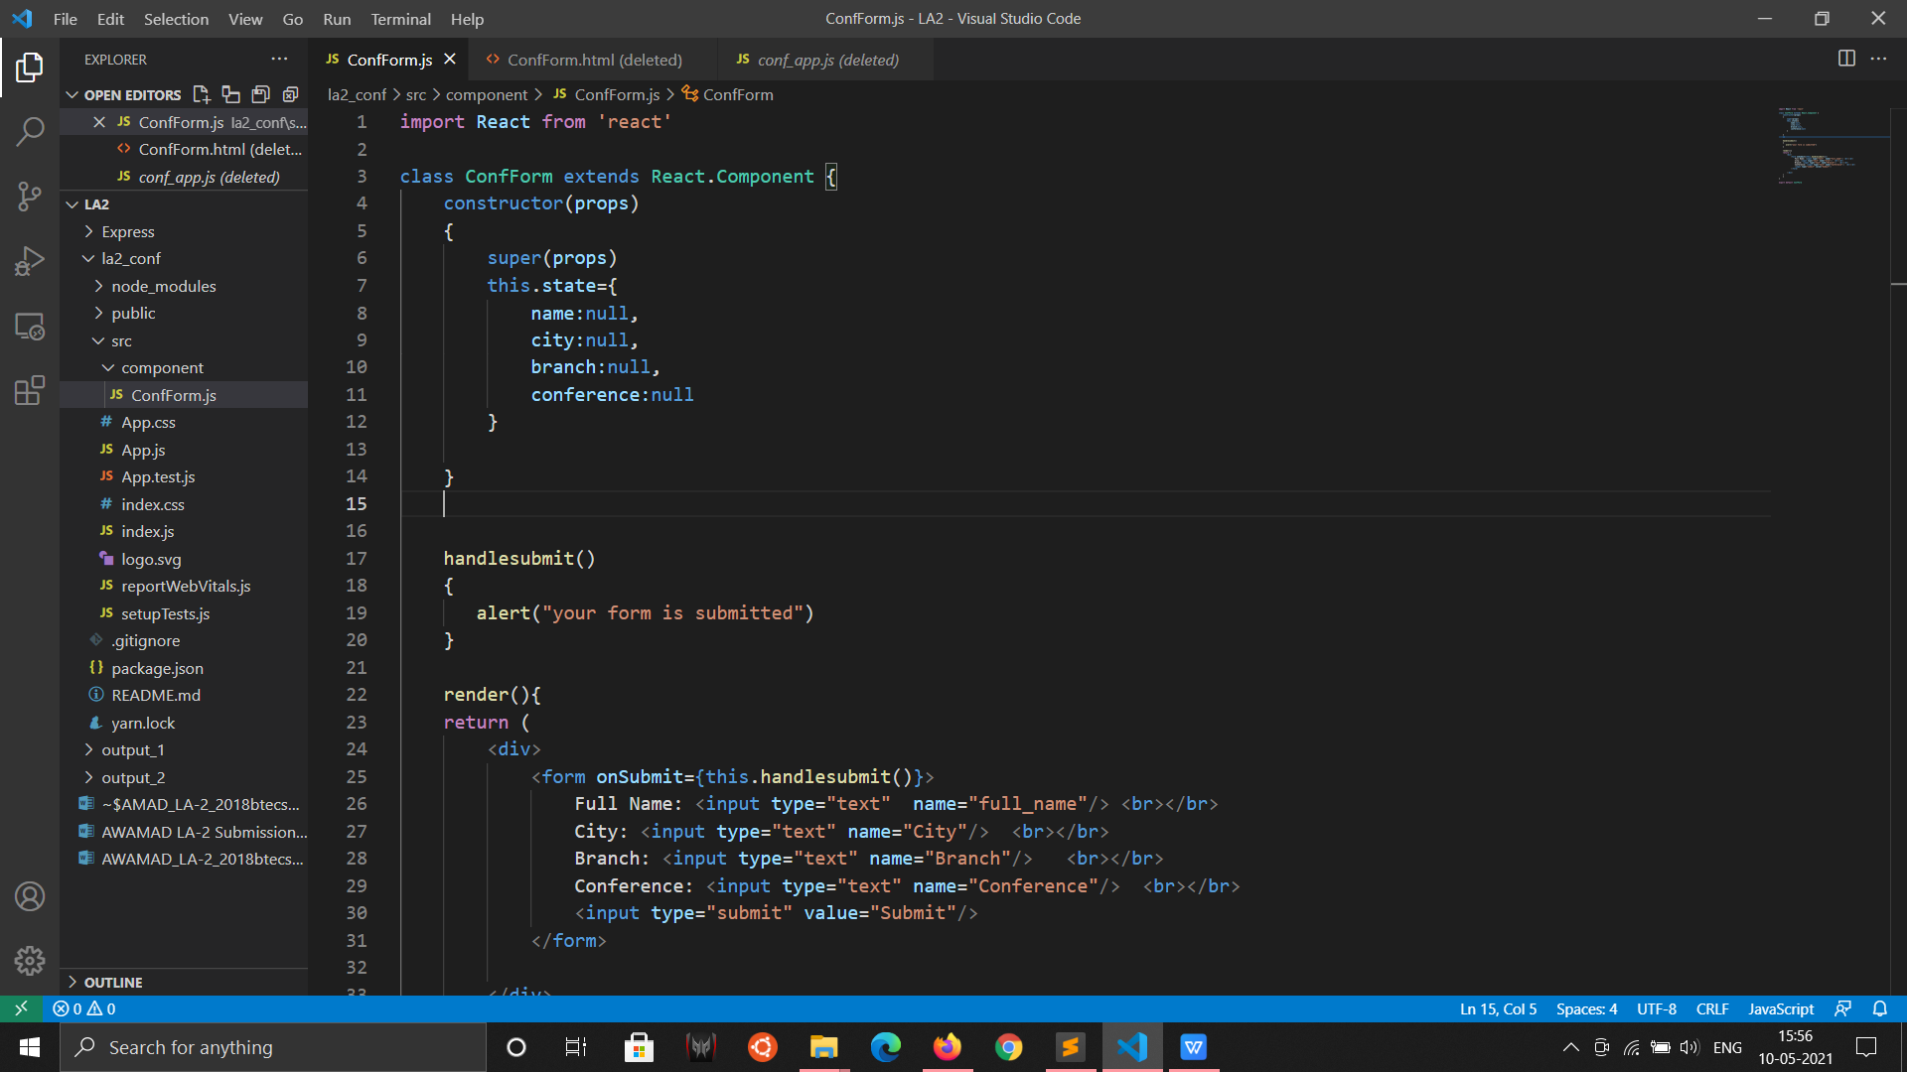

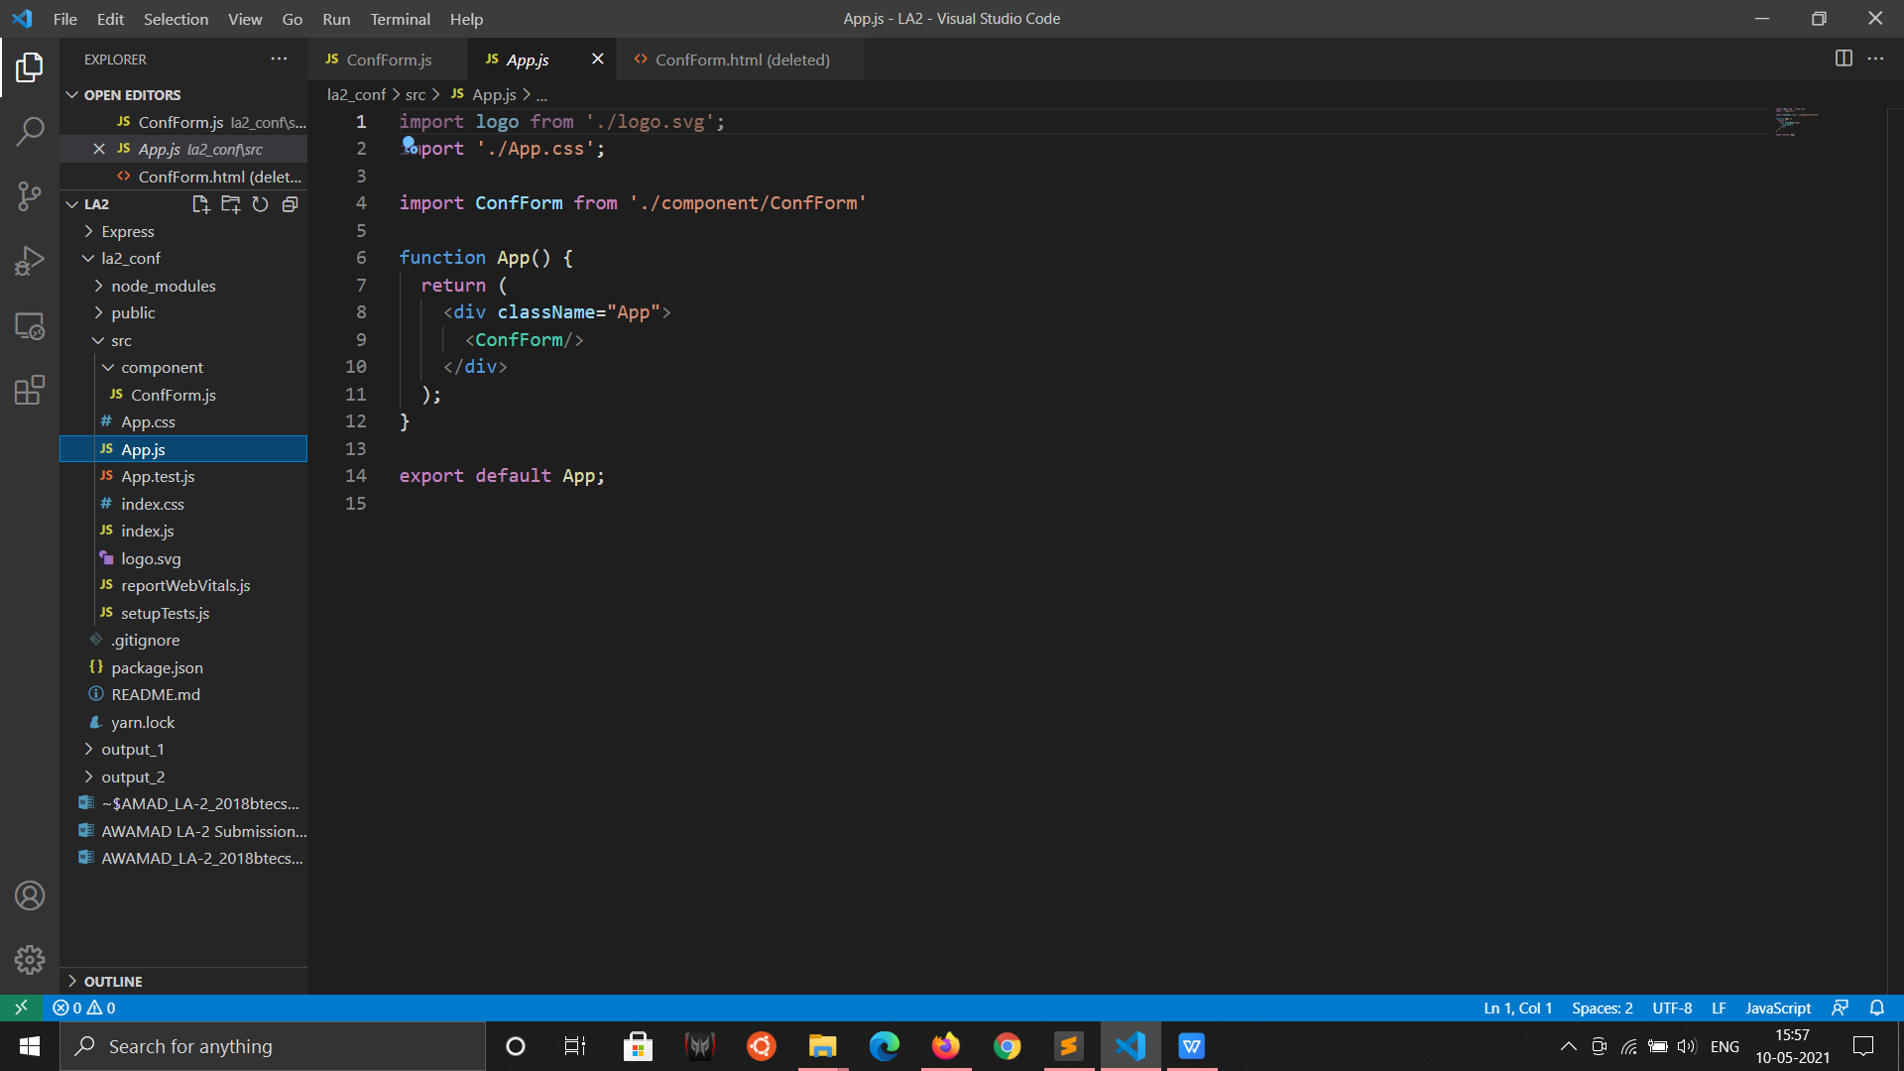

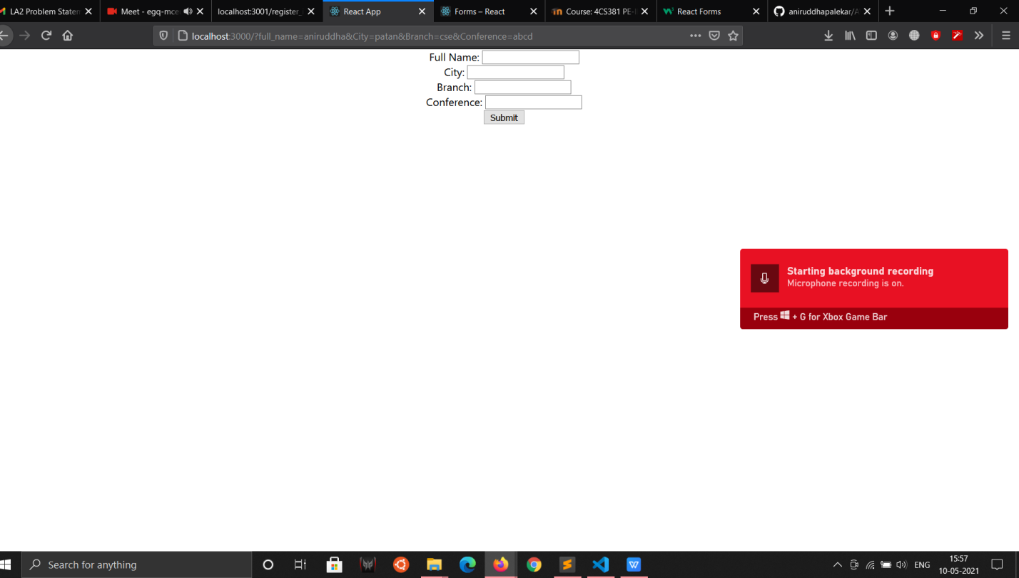

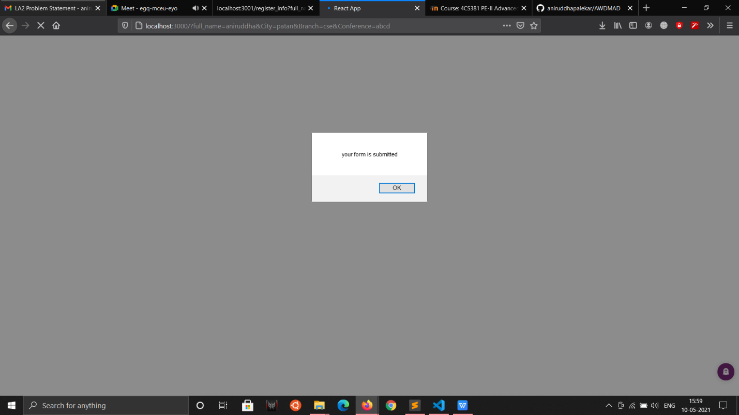

**Information #:**

**GitHub Link:-https://github.com/aniruddhapalekar/AWDMAD**