**Walchand College of Engineering, Sangli,Department of**

**Computer Science and Engineering**

**Practical No. 7**

Express.js Route Handlers

**Exam Seat No:** 2018BTECS00044

**Name :** Aniruddha Sanjay Palekar

**Problem Statement 1:**

1. Write an Express app that uses the multiple call-back functions to handle a request.
2. Use different routes to show the use of call-back functions.
3. Use at least two call-back functions.
4. Use array of functions as an argument.

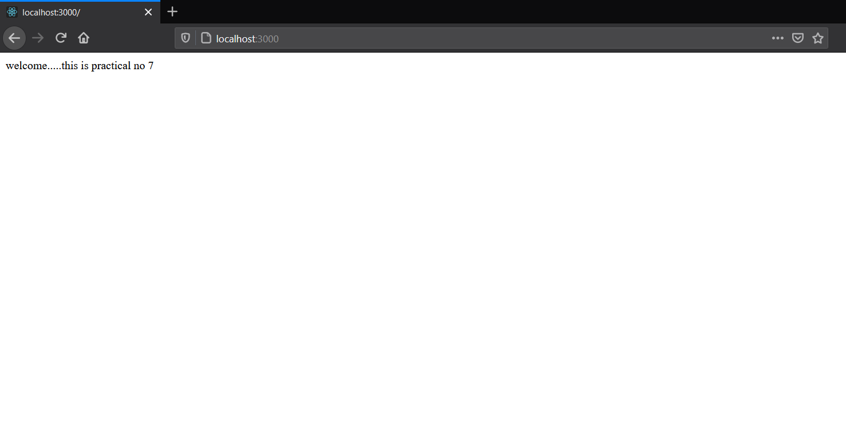

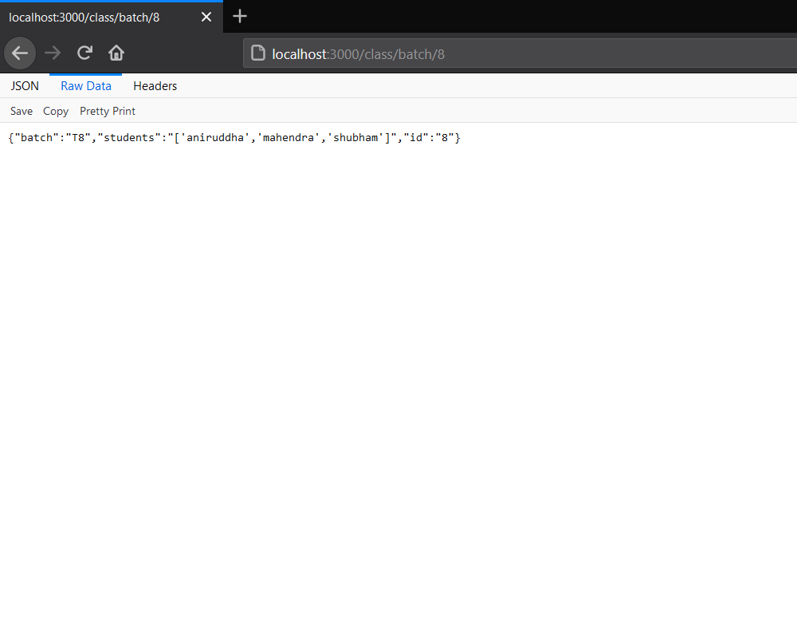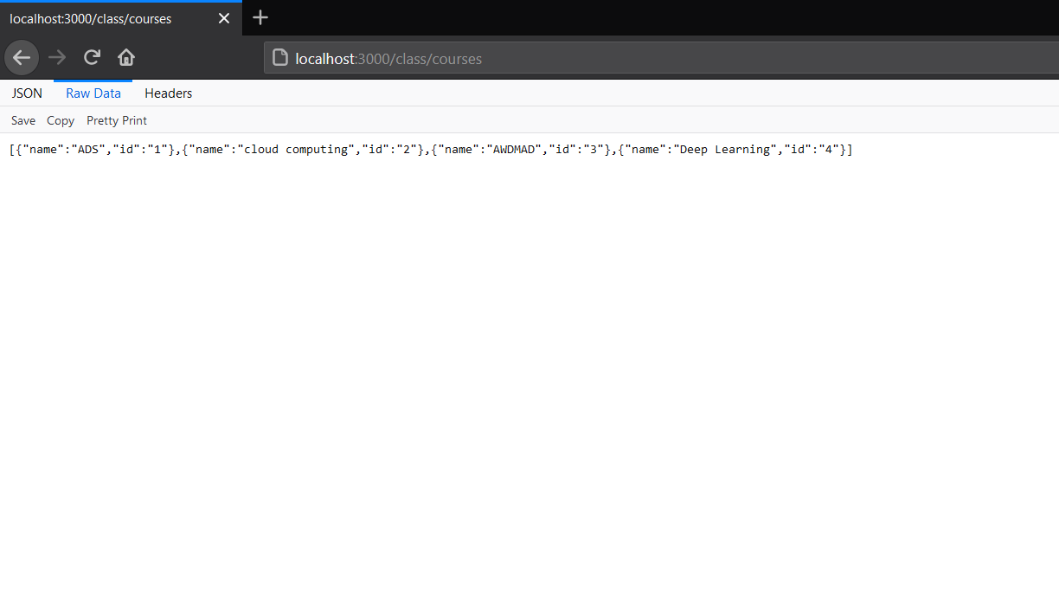

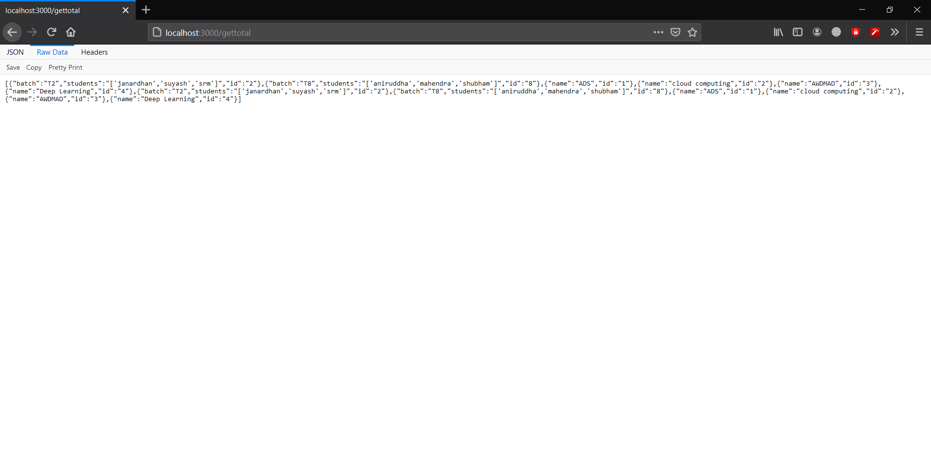

Github:-https://github.com/aniruddhapalekar/AWDMAD