Walchand College of Engineering, Sangli

Department of Computer Science and Engineering

**Class:** Final Year (Computer Science and Engineering)

**Year:** 2021-22

**Semester:** 1

**Course:** High Performance Computing Lab

**Batch:** B4

**Practical No. 04**

➢ **Exam Seat No :**

2018BTECS00044 - Aniruddha Sanjay Palekar

➢ **Problem Statement 1 :**

**Fibonacci Series using Dynamic Programming :**

The next Fibonacci number depends on the previous one. So it should be

serial, Hence ordered construct can be used as shown in below

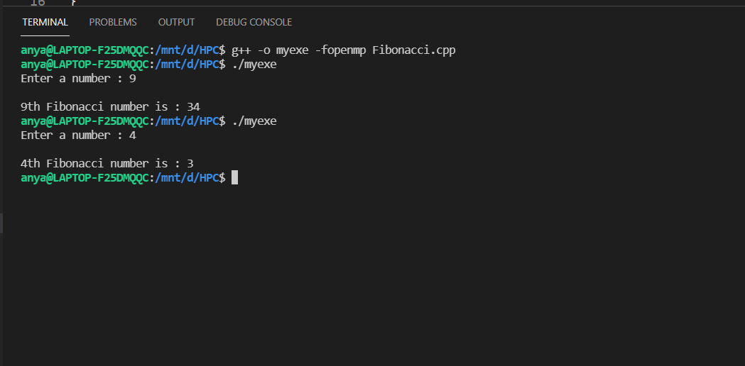

➢ **Problem Statement 2 :**

Analyse and implement a Parallel code for below programs using OpenMP

considering synchronization requirements. (Demonstrate the use of different

clauses and constructs wherever applicable)

**Producer Consumer Problem –**

**Solution 1 :**

Using variables as counting semaphores. Here the synchronization will be

achieved as the processes will be called through the critical section.

Output :

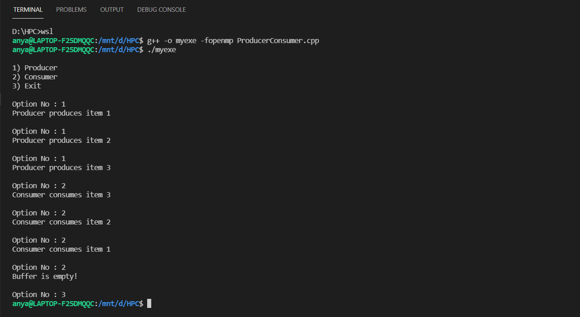

**Solution 2 :**

Using lock construct as mutex (Lock Variable) and calling producer and

consumer processes in parallel using simply parallel construct. Here the

synchronization will be achieved using the lock variable.

Output :

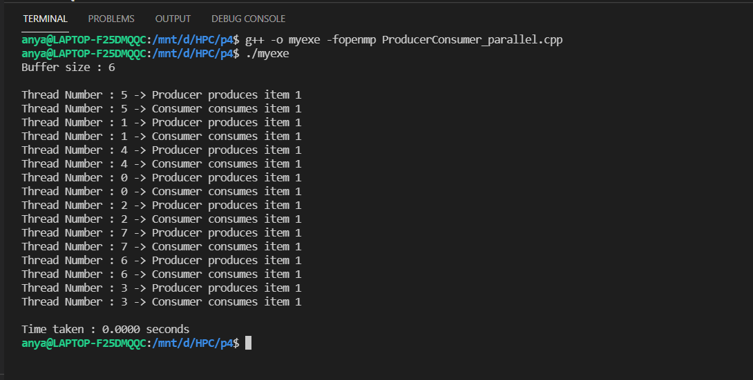

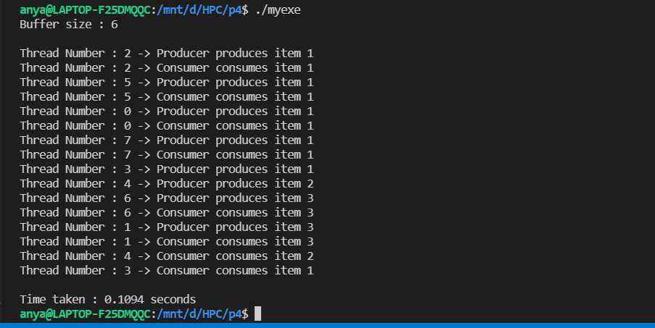

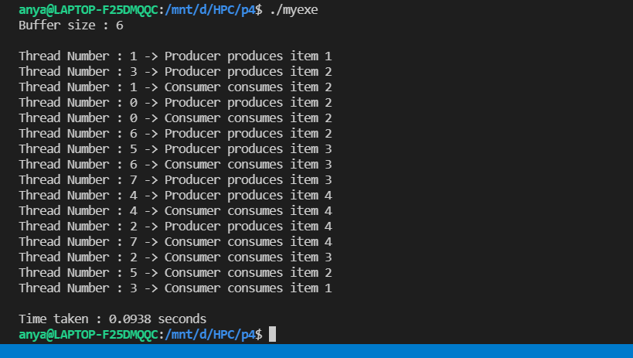

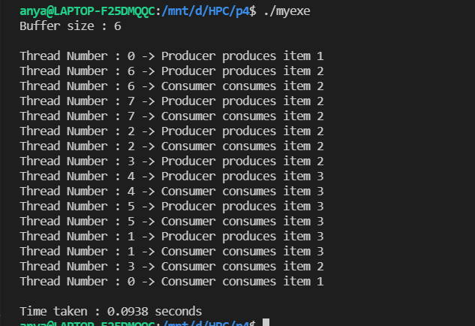

➢ **Github Link : https://github.com/aniruddhapalekar/HPC**