Walchand College of Engineering, Sangli

Department of Computer Science and Engineering

**Class:** Final Year (Computer Science and Engineering)

**Year:** 2021-22

**Semester:** 1

**Course:** High Performance Computing Lab

**Batch:** B4

**Practical No. 04B**

➢ **Exam Seat No :**

2018BTECS00044 - Aniruddha Sanjay Palekar

Complete the installation of MPI on the platform chosen by you.

**Installation:**

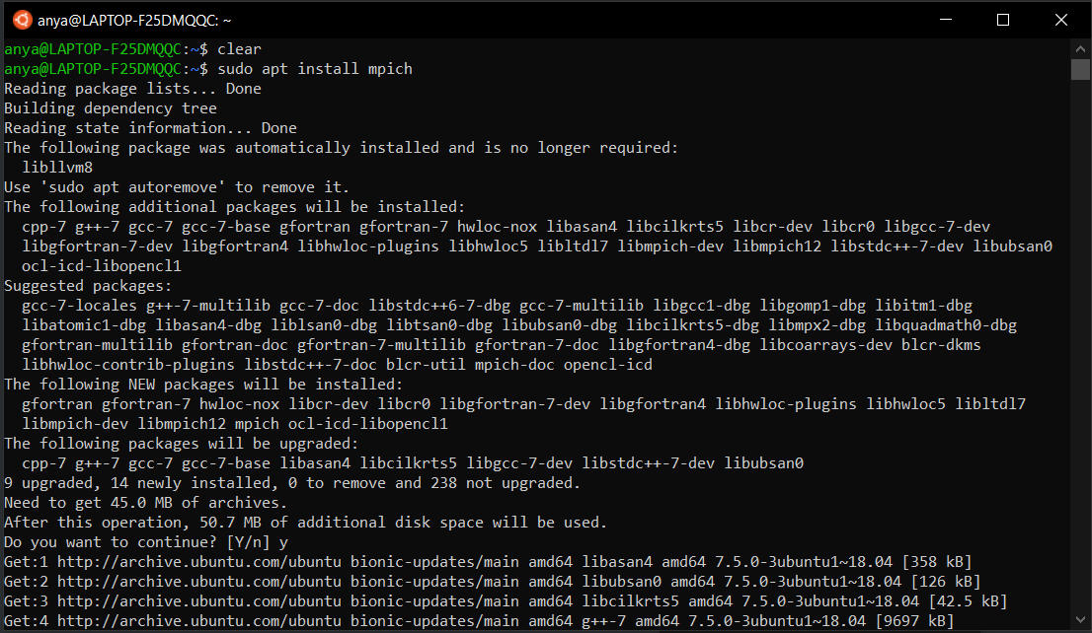

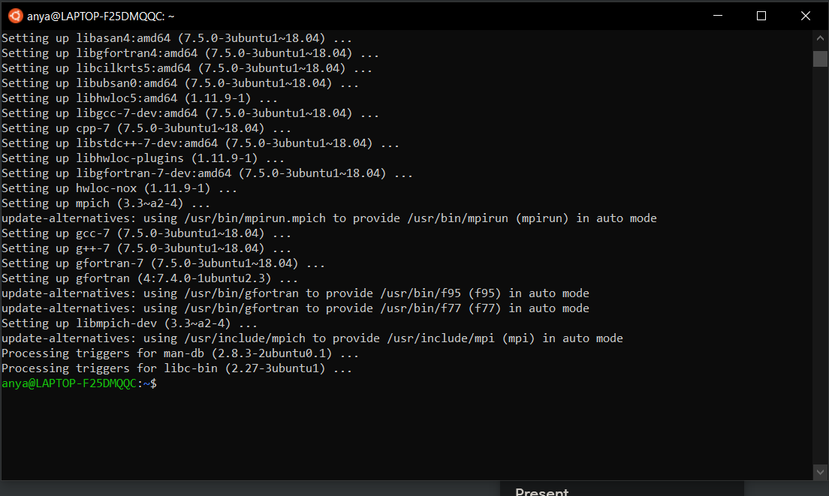

**Q1:** Implement a simple hello world program by setting number of processes equal to 15.

**Output:**

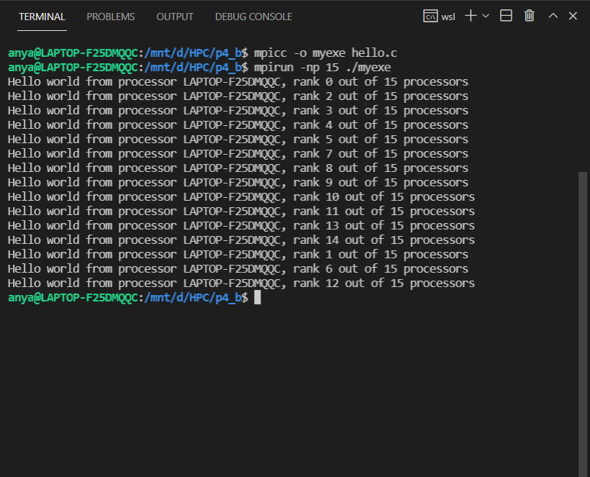

**Q2.** Implement a program to display rank and communicator group of ten processes.

**Output:**

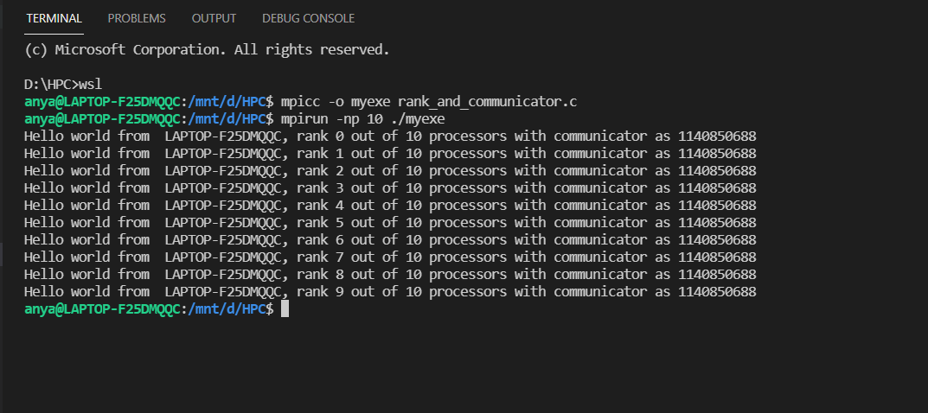

**Github Link : https://github.com/aniruddhapalekar/HPC**