ShareRickshaw: Trust-Aware Grounded Route Planning for Informal Shared Autorickshaw Mobility in Mumbai
Author Name(s) Withheld for Final Submission
Department of Computer Engineering, Bharatiya Vidya Bhavan's Sardar Patel Institute of Technology (S.P.I.T.), Mumbai, India
ABSTRACT
Shared autorickshaws provide low-cost last-mile mobility in Mumbai, but their fixed-corridor operations remain largely offline, creating uncertainty around route discovery, fare transparency, and passenger safety. This paper presents ShareRickshaw, a full-stack web prototype for informal paratransit routing, booking, driver coordination, and safety workflows. The central contribution is a trust-aware grounded route planner that ranks database-backed stand-route candidates using normalized travel time, fare, first/last-mile walking distance, and a transparent trust risk score. Optional LLM-generated routes are constrained to structured JSON and validated against known stands, destinations, transport modes, and cost-time totals before being returned. Offline seeded-data evaluation over seven Mumbai origin-destination cases achieved mean evidence recall of 1.0; the selected shared-auto options reduced estimated fare by 53% to 71% compared with direct-auto estimates, with 58% mean saving. Sensitivity analysis shows that top-ranked routes remain stable under most single-weight perturbations. The prototype demonstrates a reproducible approach for digitising informal shared mobility while making algorithmic evidence, limitations, and privacy requirements explicit.
Index Terms--informal transit, paratransit, route planning, shared autorickshaw, trust-aware ranking, LLM grounding.
I. INTRODUCTION
Shared autorickshaws operate as a low-cost, high-frequency, informal transit layer in many Indian cities. Unlike formal rail or bus services, their route knowledge is often local, corridor-based, and weakly represented in machine-readable feeds. A passenger may know a destination coordinate but not the correct stand, fixed route label, transfer point, or fare expectation. Generic routing tools can visualize roads, but they rarely prove that an informal shared-auto leg is connected to a real stand and corridor. ShareRickshaw addresses this gap through a grounded route-planning prototype for Mumbai-style shared autorickshaw travel.
The research challenge is not simply to build another booking interface. Informal shared-auto travel has three linked uncertainties: passengers may not know which physical stand serves their destination, fare information is often mediated through manual quotes, and first/last-mile walking exposure can change route acceptability, especially at night. A useful system therefore needs to expose evidence behind a recommendation instead of returning an opaque black-box route.
Formal Problem Statement
Given origin o=(lat,lng), destination d=(lat,lng), departure time t, and stand database D={s₁,...,s_{n}}, each stand s_{i} contains fixed routes R_{i}={r_{i1},...,r_{im}}. The output is an ordered list of route plans P=[p₁,p₂,...]. The objective is to minimize S(c) while exposing candidates where T(c) < T_{min}.
Contributions
This paper makes four contributions: a full-stack prototype for shared-auto discovery, booking, driver coordination, fare estimation, and safety workflows; a grounded route-planning pipeline that validates optional LLM output against known stands and fixed routes; a trust-aware ranking function that exposes first/last-mile walking risk; and a reproducible evaluation package containing offline route cases, sensitivity analysis, fare-savings summaries, and figure generation scripts.
II. RELATED WORK
Prior work on informal transit digitisation, including the Digital Matatus project, shows that semi-formal transport systems can be made queryable through structured route data. GTFS offers a standard for formal transit feeds, but many shared-auto corridors lack complete schedules, stop sequences, and machine-readable fare rules. Recent work on retrieval-augmented generation and hallucination mitigation motivates a grounded approach for LLM use: the model may help synthesize route instructions, but database evidence and deterministic validation must constrain final output.
This work differs from conventional ride-hailing dispatch because it does not optimize assignment between a private driver and a single passenger. It reasons over fixed informal corridors represented by a stand-route registry. It also differs from unconstrained conversational route assistants because LLM output is optional, schema-bound, and rejected when it cannot be tied back to known database evidence.
The paper also connects to transport safety and data-governance literature. Mobility applications that collect location traces, emergency contacts, and vehicle identifiers can create value during distress events, but they also introduce retention, consent, and access-control responsibilities. For that reason, ShareRickshaw treats safety features as prototype workflows and explicitly separates them from claims of verified crime prevention or production-grade compliance.
III. SYSTEM ARCHITECTURE
ShareRickshaw consists of a browser frontend, an Express/Node.js backend, MySQL-backed stand and route tables, Socket.IO booking notifications, and Gemini-assisted structured route and license-plate extraction. Fig. 1 summarizes the deployed prototype architecture.
The database separates user accounts, stands, fixed shared-auto routes, booking records, safety contacts, SOS logs, and night-tracking events. This separation supports reproducibility: the route planner can be evaluated offline from seed data without requiring live bookings, emergency events, or an active Gemini API key. The API returns route evidence metadata so each recommendation can be inspected during experiments.
The route-planning service is deliberately isolated from the controller layer. This makes the deterministic scoring and validation functions testable without an HTTP server, JWT token, MySQL connection, or Gemini key. That design choice is useful for research reproducibility because offline evaluation scripts can import the same ranking functions used by the live API.
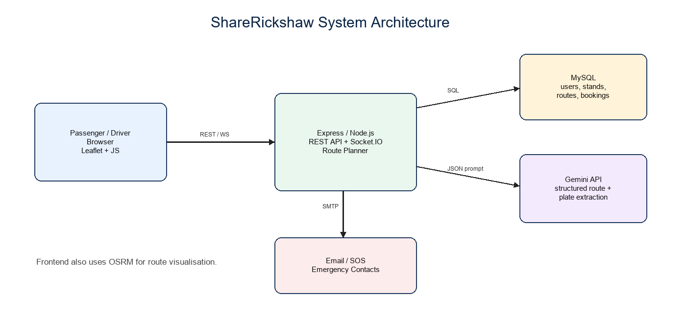
Fig. 1. ShareRickshaw system architecture.
IV. TRUST-AWARE GROUNDED ROUTE PLANNING
The planner first validates coordinates, loads known stand-route pairs, and computes deterministic candidates. Each candidate is represented by travel time, fare, access walking distance, egress walking distance, and evidence completeness. The trust score penalizes long first/last-mile walking, with extra exposure under night-travel conditions. The composite ranking score is:
S(c) = 0.42 time + 0.26 cost + 0.18 access + 0.14 trustRisk
Lower values of S(c) are preferred. The current weights are design weights stress-tested by sensitivity analysis rather than claimed as population-optimal behavioral coefficients. Fig. 2 shows the route-ranking pipeline and LLM validation branch.
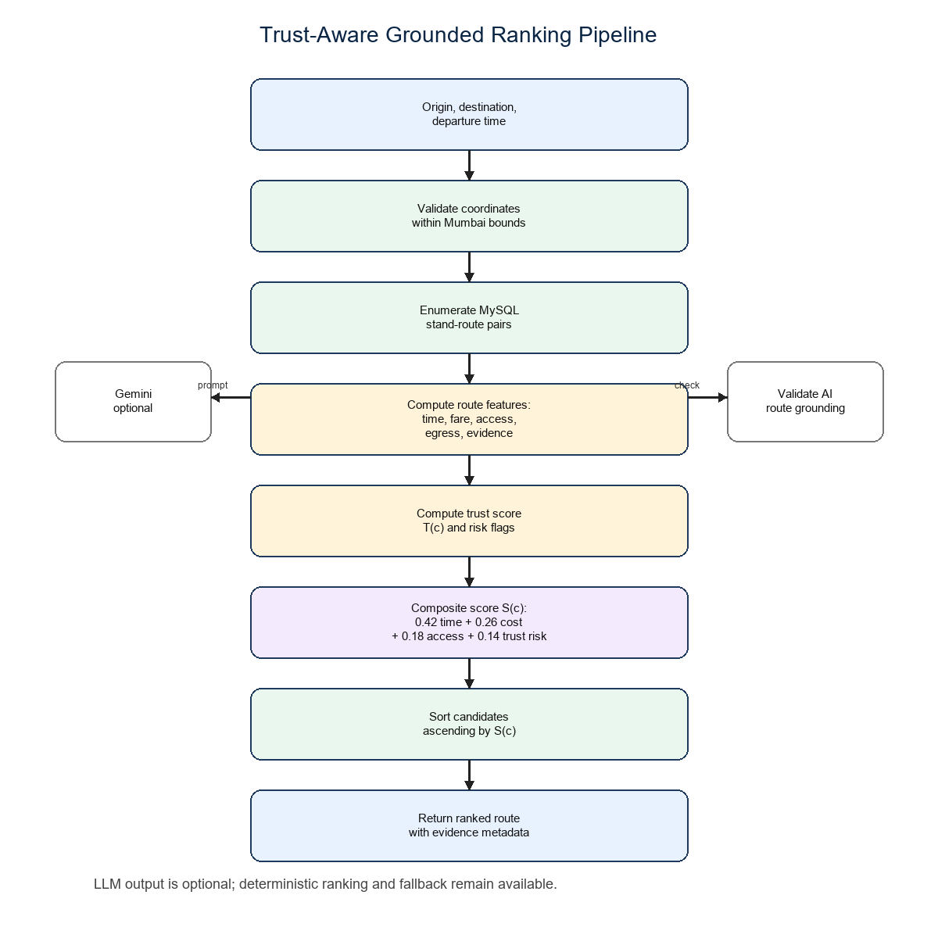
Fig. 2. Trust-aware grounded ranking and validation pipeline.
Trust Score
The trust score is intentionally transparent. It begins from an evidence-backed default, adds confidence when the stand, fixed route, and coordinates are present, and subtracts penalties for long access or egress walking. Under night-travel conditions, candidates with long first/last-mile exposure receive an additional penalty. The score should not be interpreted as a crime prediction or formal safety guarantee; it is a user-facing indicator of route evidence quality and walking exposure.
This design avoids two common failure modes. First, it prevents low-cost but uncomfortable routes from being silently promoted when they involve long walking exposure after the shared-auto leg. Second, it prevents LLM-generated instructions from appearing authoritative when they mention unsupported stands, unsupported transport modes, or inconsistent totals. The planner can still return a direct-auto estimate and deterministic fallback, so service degradation is explicit rather than hidden.
Algorithm
Step | Operation
1 | Validate origin and destination within supported Mumbai prototype bounds.
2 | Load stand-route registry from MySQL or seeded offline data.
3 | Generate deterministic direct-auto estimate for comparison.
4 | Enumerate stand-route candidates and compute time, fare, access, and egress features.
5 | Compute trust score and composite ranking score for each candidate.
6 | Optionally request a structured Gemini route using the stand-route registry.
7 | Validate generated route steps against known stands, destinations, modes, and totals.
8 | Return ranked deterministic, AI-validated, or fallback route options with evidence metadata.
Table I. Grounded structured multimodal planning procedure.
V. IMPLEMENTATION
The backend implements deterministic route estimation, candidate scoring, trust-aware re-ranking, structured Gemini prompting, and post-generation validation. The validator checks allowed transport modes, known stand names, known route destinations, and consistency between step-level and route-level cost/time totals. If the AI route is unavailable or weakly grounded, the system returns deterministic fallback routes with evidence metadata. The frontend exposes route options, fare estimation, booking flows, SOS alerts, emergency contacts, and night-tracking workflows.
The API response includes evidence metadata such as planner type, stand identifier, route identifier, candidate score, walking distances, trust score, and validation warnings. These fields are not merely debugging details; they are the mechanism by which the paper's claims can be audited. A reviewer can trace a displayed recommendation back to a structured database entry and to the exact ranking logic that selected it.
Module | Implementation role
Authentication | JWT-based login flows with separate user and driver-facing screens.
Stand registry | MySQL tables and seed data for stands, destinations, fares, times, and coordinates.
Route planner | Deterministic scoring, trust-aware ranking, Gemini prompting, validation, and fallback routing.
Booking | Passenger request flow and driver dashboard supported by REST and Socket.IO.
Safety | Emergency contacts, SOS email flow, night-tracking records, and ALPR-assisted plate extraction.
Evaluation | Offline route-case runner, regression tests, sensitivity sweep, and generated paper artifacts.
Table II. Prototype modules and implementation roles.
VI. EVALUATION
Evaluation uses offline seeded-data experiments because live MySQL credentials and production deployment were not available during this study. The seed database contains 10 stands and 31 fixed route entries. Seven origin-destination cases were chosen to cover distinct Mumbai localities and risk combinations.
The evaluation is therefore a controlled route-grounding study rather than a city-wide deployment. The main dependent variables are evidence recall, fare savings relative to a deterministic direct-auto baseline, top-ranked candidate changes under trust-aware ranking, and sensitivity of the ranking to weight perturbation. This framing avoids overclaiming while still testing whether the implemented algorithm behaves reproducibly.
Evidence recall is computed by checking whether the selected and fallback route descriptions contain the expected stand and destination labels for each seeded case. Fare savings are calculated by comparing the selected grounded shared-auto candidate against the deterministic direct-auto estimate produced by the same service. The sensitivity sweep varies one ranking weight at a time from 0.0 to 0.5 while rescaling the remaining weights proportionally so the total remains 1.0.
Property | Coverage
Zero access walk candidate | 7/7
Non-zero egress in selected shared-auto route | 3/7
Night travel | 2/7
Long egress candidate flagged (>1.2 km) | 6/7
Ranking changed by trust-aware composite | 3/7
Distinct Mumbai localities represented | 7/7
Table III. Seven-case coverage summary.
The planner achieved mean evidence recall of 1.0 against expected stand and destination labels. The selected shared-auto options produced fare savings from 53% to 71%, with 58% mean saving relative to direct-auto estimates.
Case | Direct | Shared | Saving
Bandra | Rs 34 | Rs 15 | 56%
Andheri | Rs 51 | Rs 15 | 71%
Dadar | Rs 36 | Rs 15 | 58%
Kurla | Rs 23 | Rs 10 | 57%
Malad | Rs 23 | Rs 10 | 57%
Powai night | Rs 43 | Rs 20 | 53%
Ghatkopar night | Rs 57 | Rs 25 | 56%
Table IV. Fare savings for selected shared-auto options.
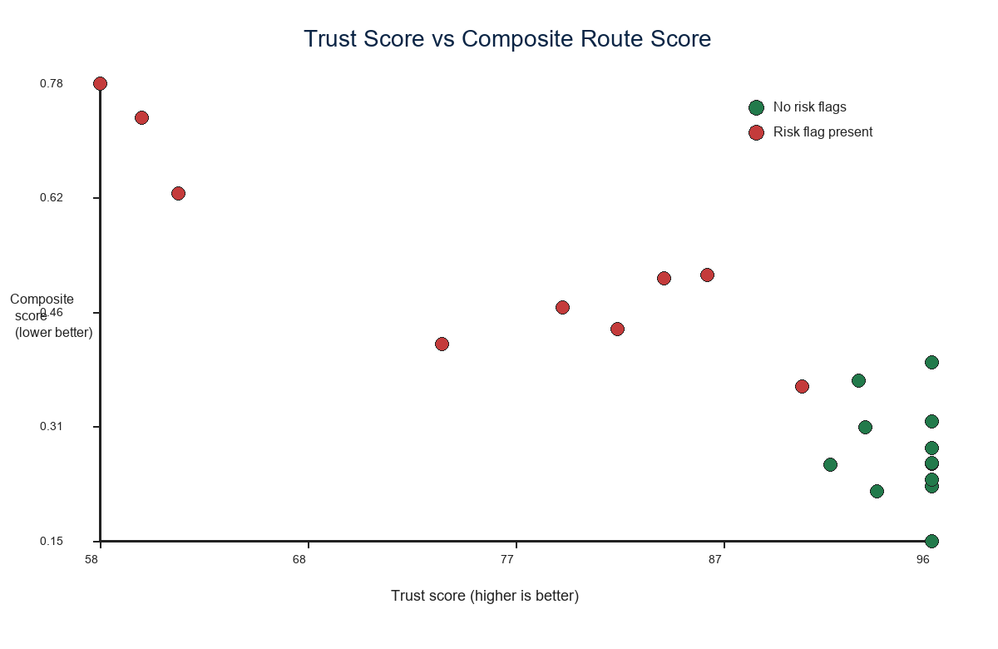
Fig. 3. Trust score versus composite route score for the top three candidates in each evaluation case.
Weight Sensitivity
Weight | Stable range | Observed top-1 changes
time | 0.0-0.5 | 0/7 at all sweep points
cost | 0.2-0.4 | changes at 0.0, 0.1, and 0.5
access | 0.0-0.3 | changes at 0.4 and 0.5
trust | 0.0-0.5 | 0/7 at all sweep points
Table V. Summary of one-at-a-time sensitivity sweep.
Bandra Case Interpretation
Both Bandra candidates have identical trust scores (96.0), so the ranking change is driven by cost-time trade-off rather than trust penalisation. Trust-aware ranking selected Linking Road because its fare advantage (Rs 15 versus Rs 25) dominated its small time disadvantage (16 versus 14 min) after normalization.
This is an important qualitative result because it shows that the composite function is not simply a safety filter. In cases where trust is equal, the ranking behaves as a multi-objective optimiser over cost, time, and walking distance. In cases with long egress or night walking, the trust term makes the risk visible and can prevent superficially cheap options from appearing unqualified.
Preliminary Usability Evaluation Protocol
A human-factor evaluation instrument is prepared for final submission. It asks 5-10 participants to rate route understandability, fare transparency, and perceived safety from SOS/night tracking on a five-point Likert scale. Participant statistics are not reported here because responses must be collected from real users before submission. The repository includes the questionnaire so that these results can be added without changing the technical evaluation pipeline.
Once responses are collected, the intended report format is mean plus standard deviation for each item. The three items measure whether participants understand the recommended route and transfer points, whether fare transparency improves trust compared with manual quotes, and whether SOS and night tracking increase perceived night-travel safety. This keeps the human-factor study lightweight but aligned with the system's actual claims.
VII. PRIVACY AND DATA GOVERNANCE
The prototype processes sensitive mobility and safety data, including GPS coordinates, booking timestamps, emergency contacts, and license-plate text extracted from user-submitted images. Night tracking is user-initiated and should be terminable by the passenger. Production deployment would require explicit consent flows, data minimisation, a retention schedule, access controls, and review against India's Digital Personal Data Protection Act, 2023.
VIII. LIMITATIONS
The current evaluation is offline and seed-data based; it does not prove city-wide coverage, real-time traffic optimality, official tariff compliance, production reliability, or passenger safety impact. ALPR accuracy and user-perceived usability require labeled image data and real participant responses before final submission.
The seven cases are deliberately diverse but not statistically exhaustive. The ranking weights are stress-tested but not derived from a large stated-preference survey. These constraints make the paper strongest as a controlled prototype and algorithmic evaluation, with live deployment, larger route datasets, and human-subject validation left for the next study phase.
A production system would also need live feed maintenance, route closure handling, official fare integration, accessibility review, driver-side misuse controls, and a formal privacy impact assessment. These requirements are outside the current controlled prototype, but the architecture leaves room for them through explicit route evidence, modular safety tables, and reproducible evaluation scripts.
IX. CONCLUSION
ShareRickshaw demonstrates a grounded, trust-aware route-planning prototype for informal shared-auto mobility. Its main contribution is not LLM usage alone, but the evidence layer around route generation: structured stand-route data, deterministic ranking, transparent trust features, validation of AI output, and reproducible offline evaluation. This makes the system a credible base for controlled pilot studies and future larger-scale informal transit digitisation.
REFERENCES
[1] S. Williams, A. White, P. Waiganjo, D. Orwa, and J. M. Klopp, "The digital matatu project: Using cell phones to create open source data for Nairobi's semi-formal bus system," Journal of Transport Geography, 2015.
[2] General Transit Feed Specification, "GTFS documentation overview," MobilityData.
[3] Y. Gao et al., "Retrieval-Augmented Generation for Large Language Models: A Survey," arXiv:2312.10997.
[4] L. Huang et al., "A Survey on Hallucination in Large Language Models: Principles, Taxonomy, Challenges, and Open Questions," ACM Transactions on Information Systems, 2025.
[5] R. Laroca et al., "A Robust Real-Time Automatic License Plate Recognition Based on the YOLO Detector," arXiv:1802.09567.
[6] Government of India, "The Digital Personal Data Protection Act, 2023," India Code.

