# Test Case 1:

Test Scenario – Create a New Trade

Expected Result – A new Trade should be added to database

Actual Result - PASSED

Screenshots

Trade 1

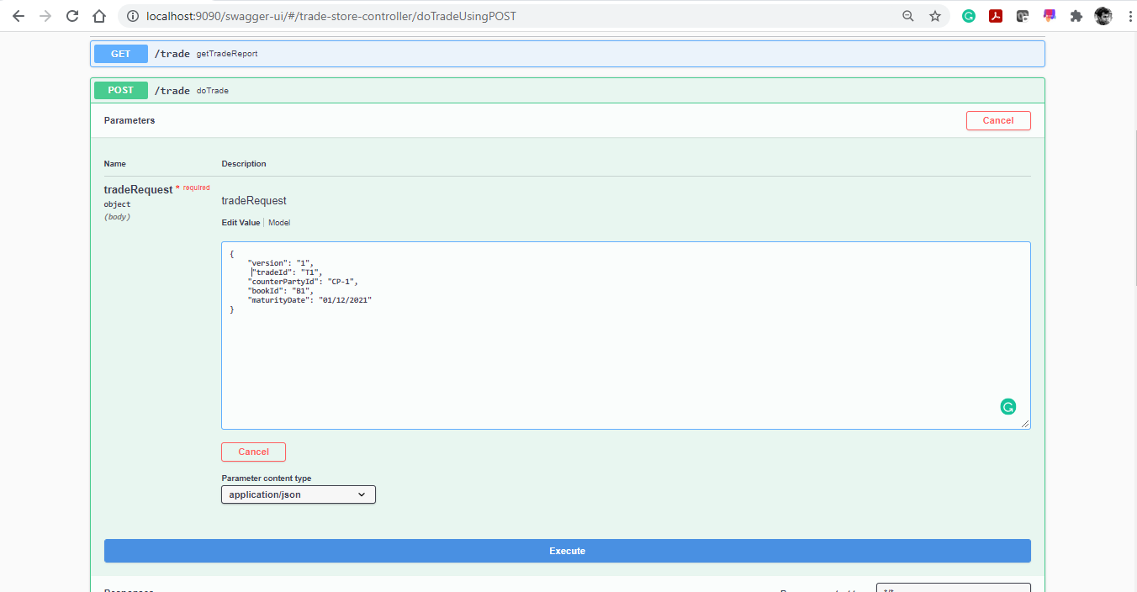

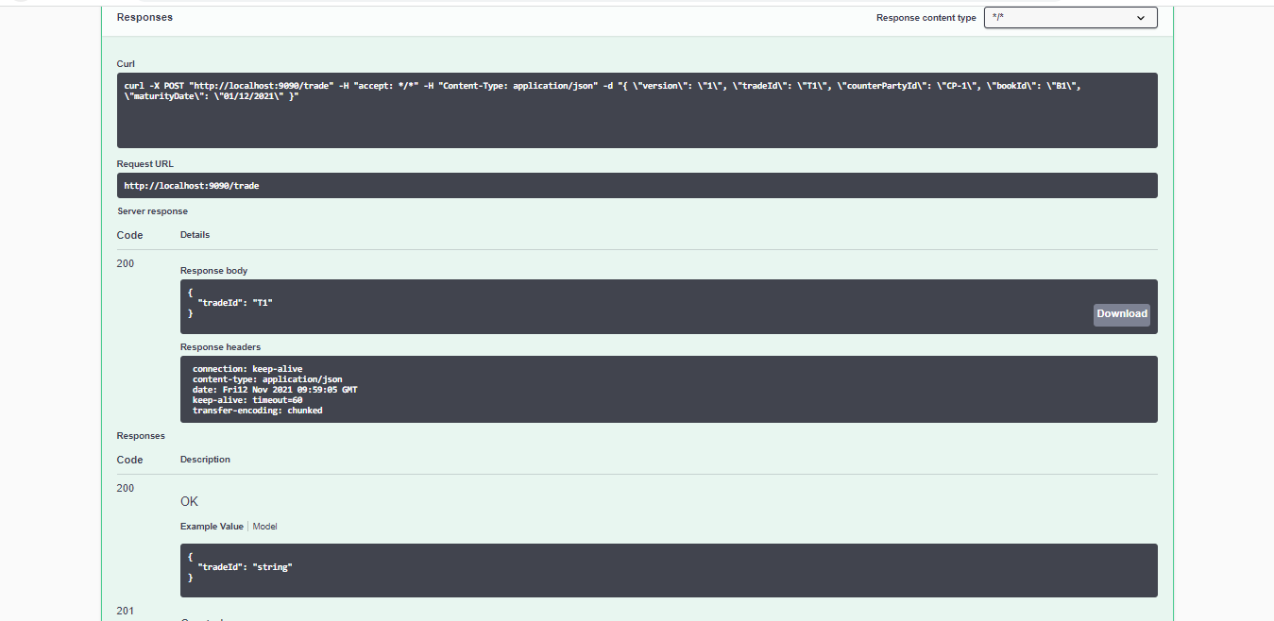

Trade 2

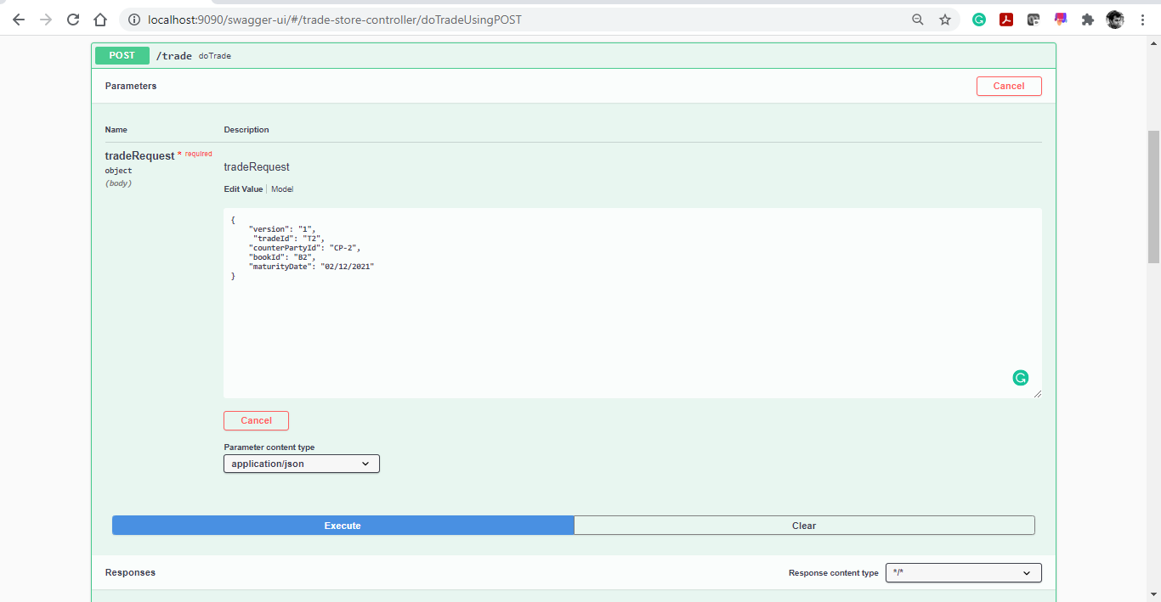

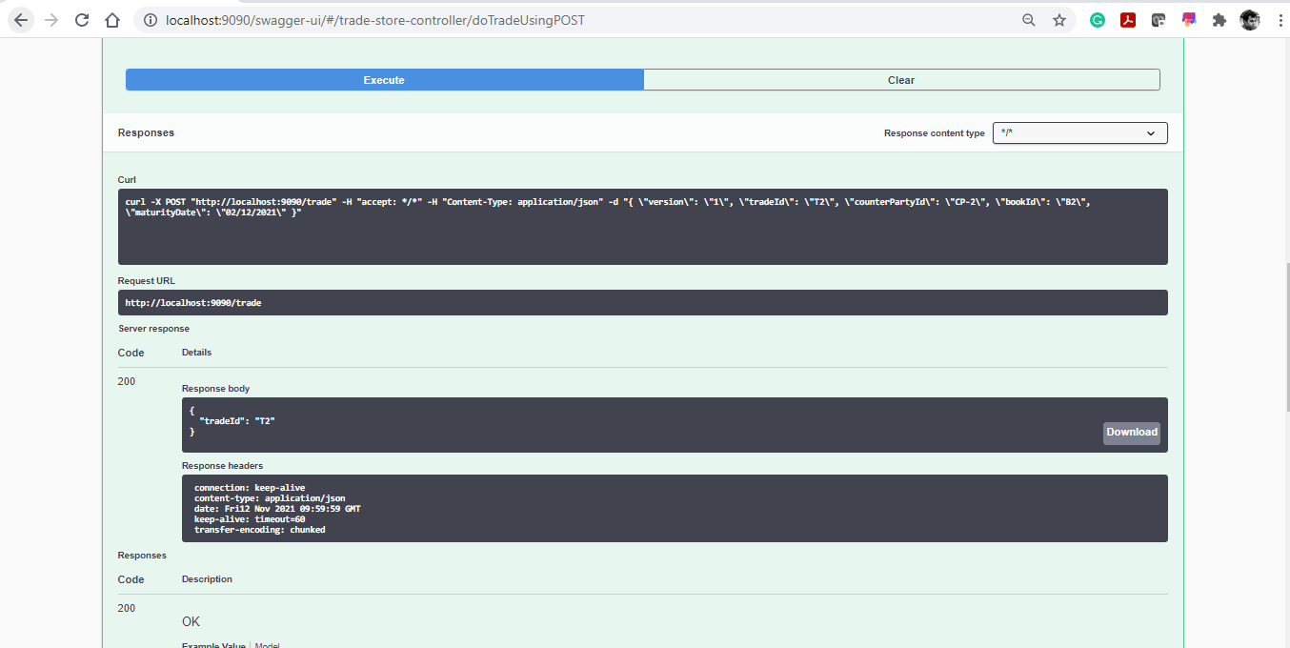

Trade 3

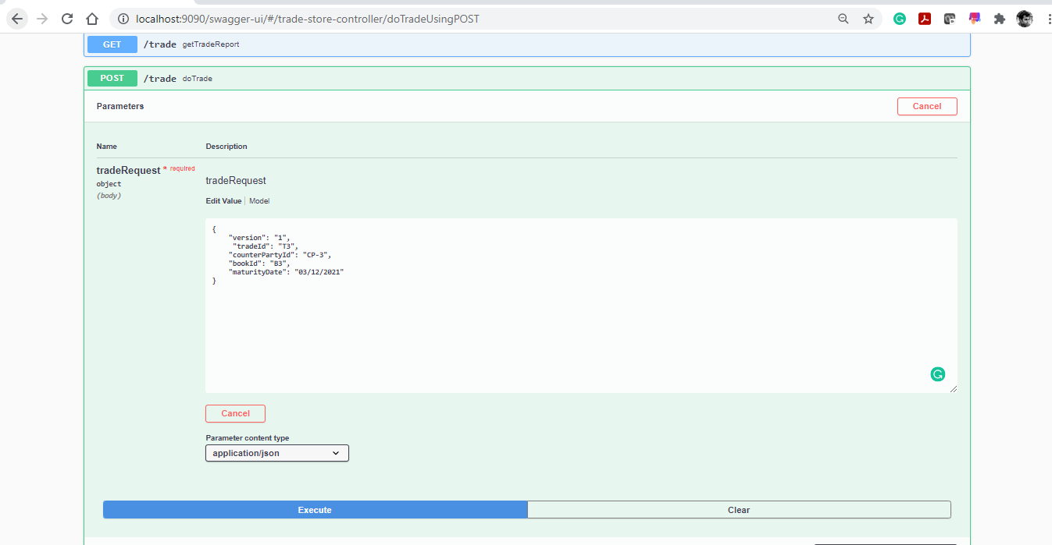

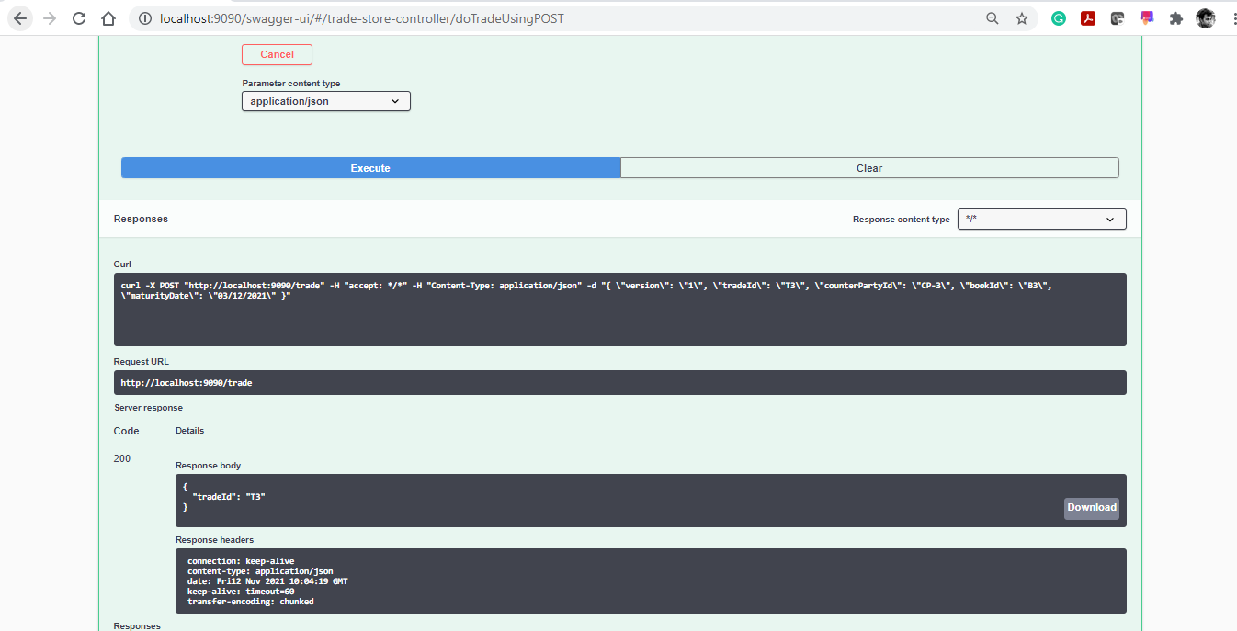

DB Screenshot

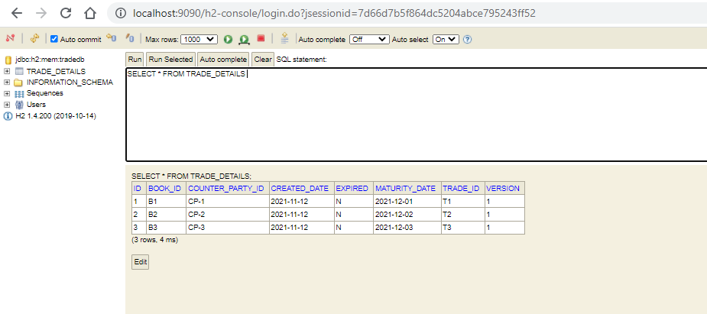

# Test Case 2:

Test Scenario – If maturity date is less than today’s date, system should throw an exception

Expected Result – System Throws Validation exception & Trade is not added to DB

Actual Result – Passed

Screenshots

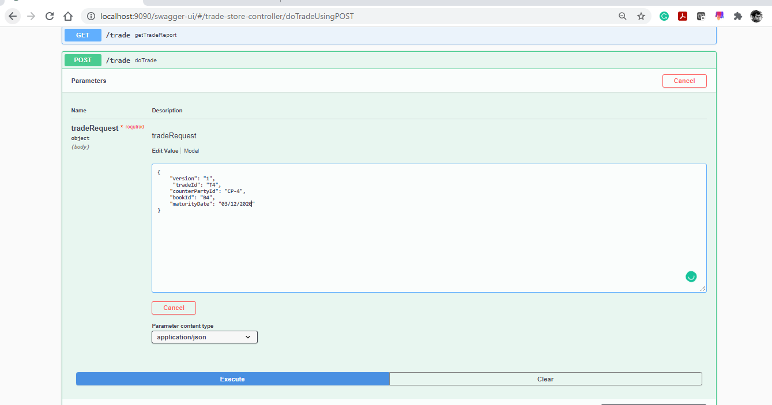

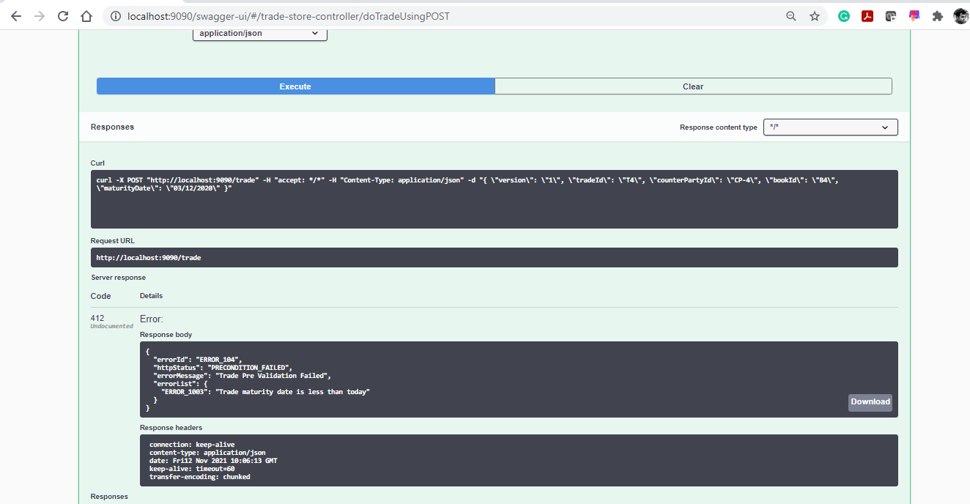

# Test Case 3:

Test Scenario – Trade with same version should update existing record

Expected Result – Trade Should be updated in DB

Actual Result – PASSED

Screenshots

Initial DB State

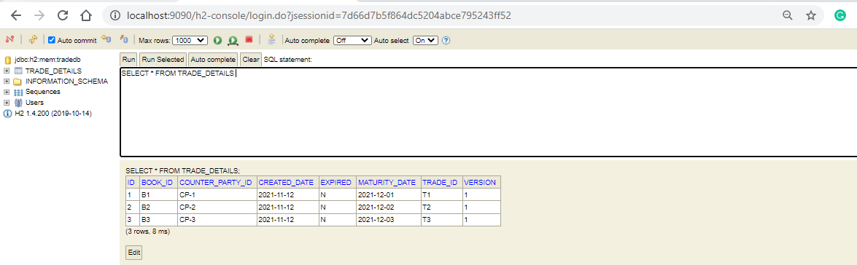

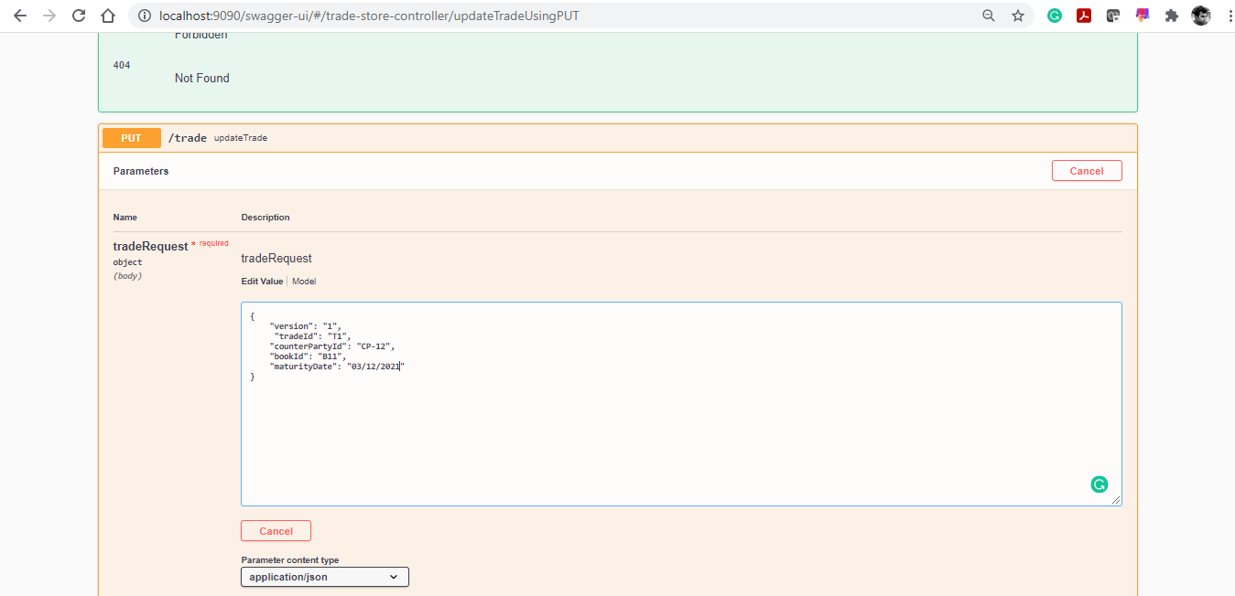

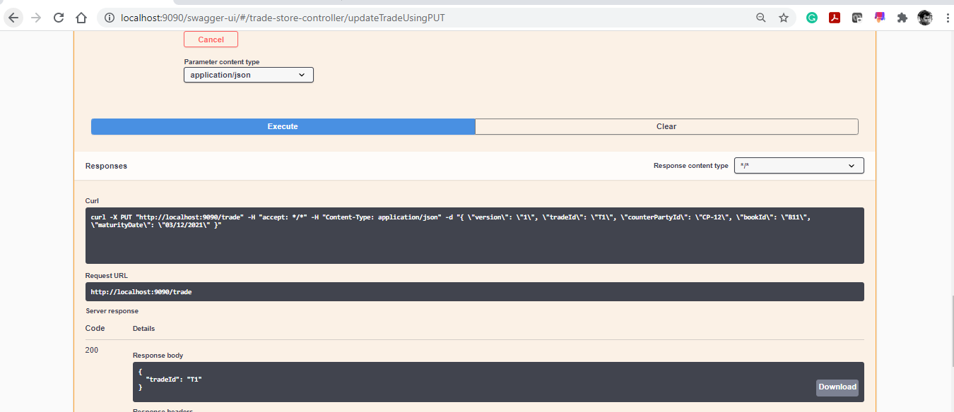

Final State of DB

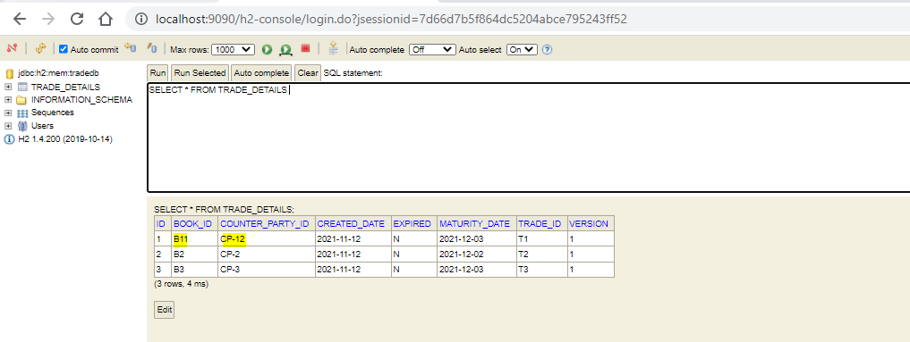

# Test Case 4:

Test Scenario – Trade with higher version should be added to DB

Expected Result – Trade should be added

Actual Result - PASSED

Screenshots

Initial DB Screenshot

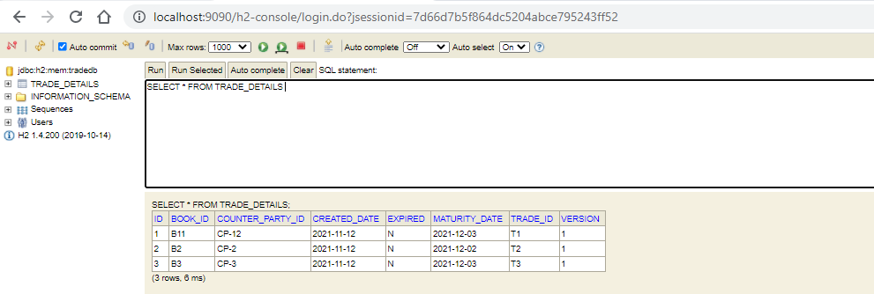

Adding Trade with higher version

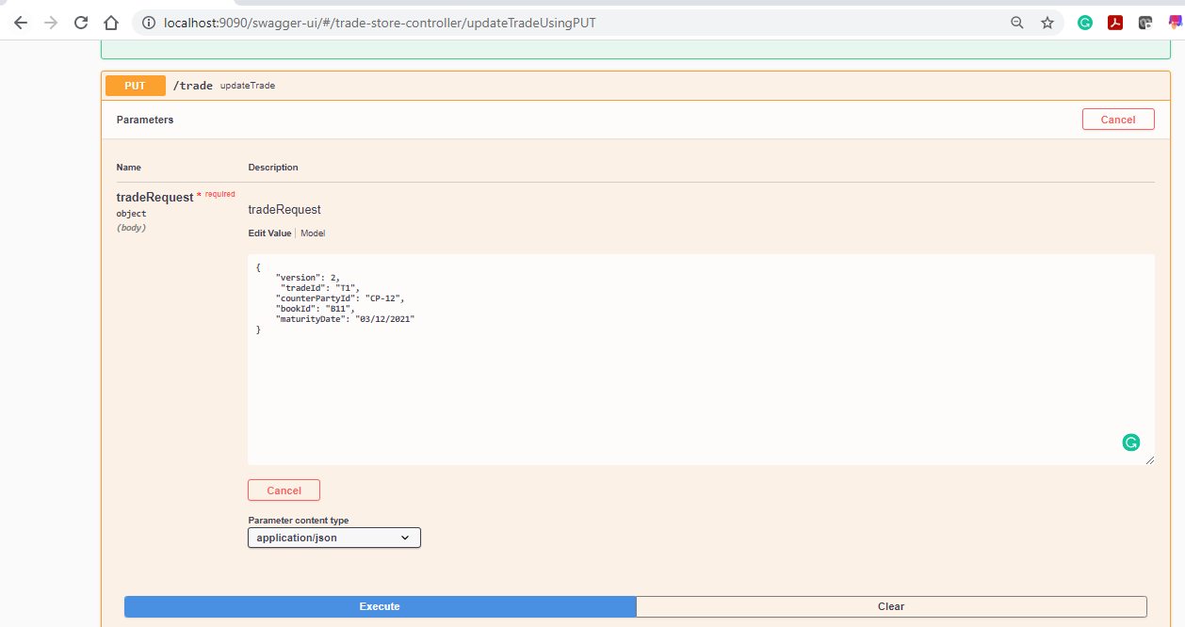

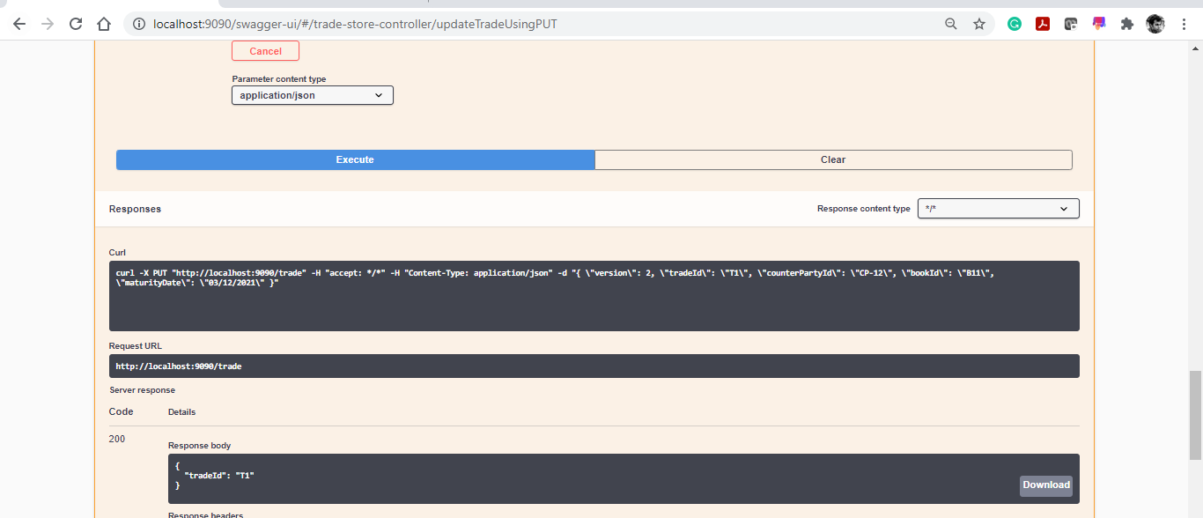

Final DB State

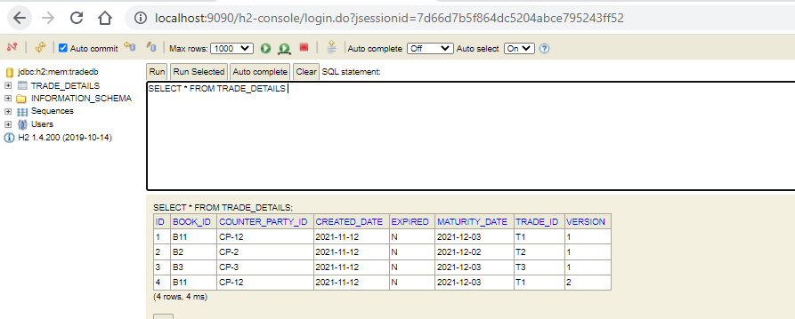

Test Case 5:

Test Scenario – Trade with lower version should not be allowed

Expected Result – Application should throw exception

Actual Result - PASSED

Screenshots

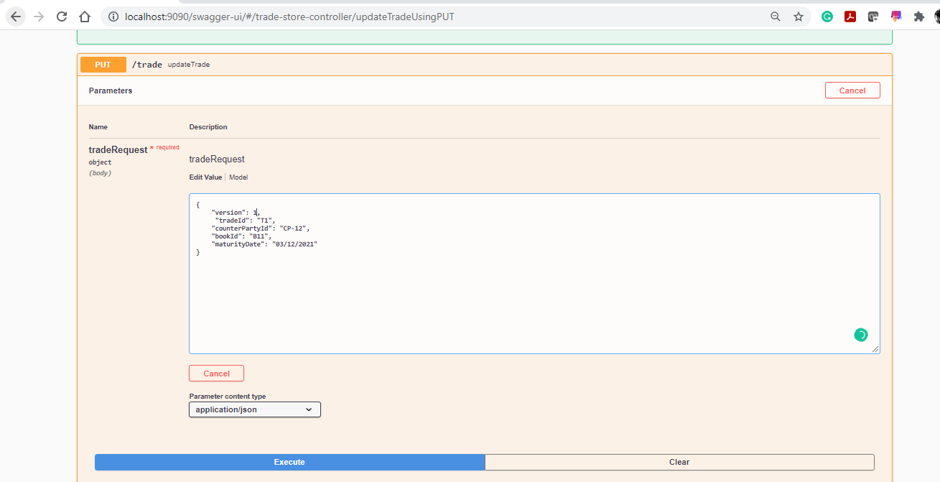

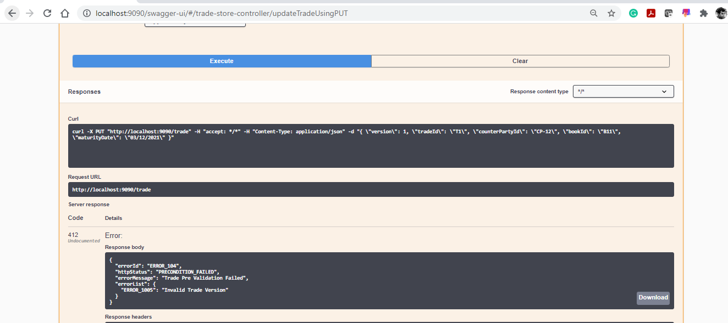

# Test Case 5:

Test Scenario – Scheduler should expire Trade older than today’s date

Expected Result – Status of Trade is changed to Expired - Y

Actual Result – PASSED

Assumption – To test this scenario, DEV team have changed Maturity date from backend & updated schedule cron to 1 minute ( actual – every night 12:00 AM )

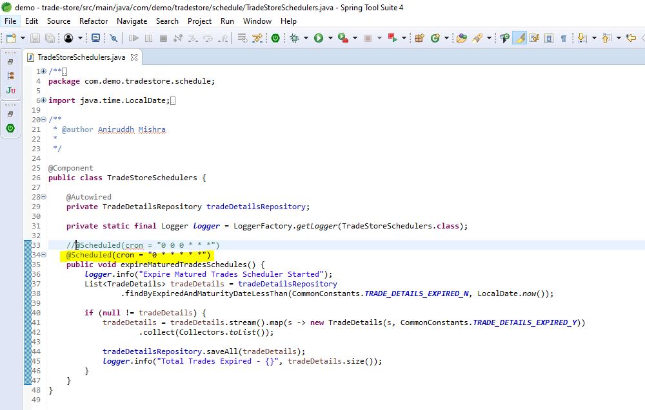

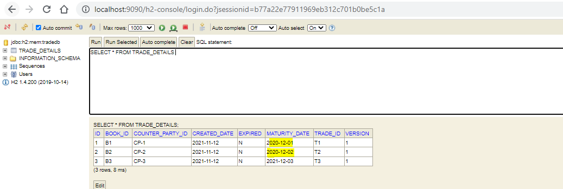

Screenshots

Scheduler Logs

|  |
| --- |
| [2m2021-11-12 16:10:00.002[0;39m [32m INFO[0;39m [35m7548[0;39m [2m---[0;39m [2m[ scheduling-1][0;39m [36mc.d.t.schedule.TradeStoreSchedulers [0;39m [2m:[0;39m Expire Matured Trades Scheduler Started  Hibernate: select tradedetai0_.id as id1_0_, tradedetai0_.book_id as book_id2_0_, tradedetai0_.counter_party_id as counter_3_0_, tradedetai0_.created_date as created_4_0_, tradedetai0_.expired as expired5_0_, tradedetai0_.maturity_date as maturity6_0_, tradedetai0_.trade_id as trade_id7_0_, tradedetai0_.version as version8_0_ from trade_details tradedetai0_ where tradedetai0_.expired=? and tradedetai0_.maturity_date<?  Hibernate: call next value for hibernate_sequence  Hibernate: call next value for hibernate_sequence  Hibernate: insert into trade_details (book_id, counter_party_id, created_date, expired, maturity_date, trade_id, version, id) values (?, ?, ?, ?, ?, ?, ?, ?)  Hibernate: insert into trade_details (book_id, counter_party_id, created_date, expired, maturity_date, trade_id, version, id) values (?, ?, ?, ?, ?, ?, ?, ?)  [2m2021-11-12 16:10:00.044[0;39m [32m INFO[0;39m [35m7548[0;39m [2m---[0;39m [2m[ scheduling-1][0;39m [36mc.d.t.schedule.TradeStoreSchedulers [0;39m [2m:[0;39m Total Trades Expired - 2 |

DB State after Scheduler execution

