23917-MDSC-102-ESE

Name: Anirudh Yandrapu
Reg no: 23917
Sub: Inferential Statistics(P)

About Dataset:
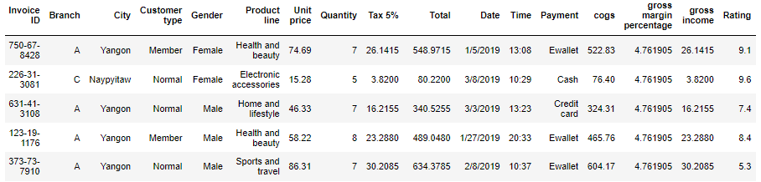
The dataset 'supermarket_sales' consists of 17 features and 1000 rows. This dataset records sales transactions in a store, including details like product, price, and customer information. It helps track sales performance, customer behaviour, and profit margins. It captures sales of various product categories in branches located in specific cities at particular times and dates. Key columns include 'Product line', 'Total', and 'Rating'. The 'Customer type' feature indicates whether a customer is a member of the supermarket or a regular shopper, while the 'Payment' feature describes the payment method used, including Credit card, Cash, or Ewallet.

Information:
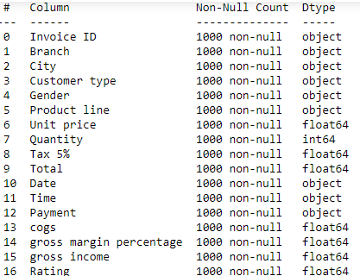

We can observe that many of the columns are of Object dtype and Some of the object dtype columns cannot be pre-processed like City, Product line which are meaning and helpful for analysis.

Pre-processing:
- Dropping un-useful column for analysis
- Changing the format of Date
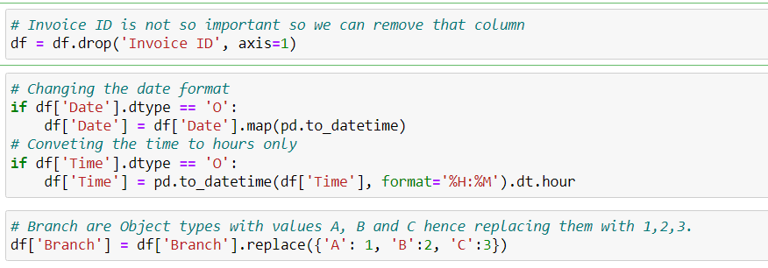
- Converting Time into Hours
- There are no null values so no need of imputing values
Plots Visualization:
- Let’s see how many customers are there in each City:
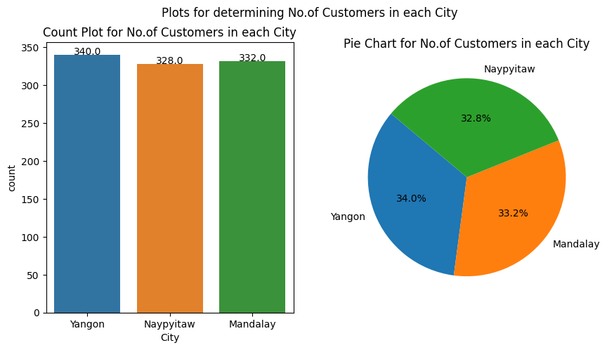

We can see that there are 340 customers in Yangon, 328 in Naypyidaw and 332 in Mandalay
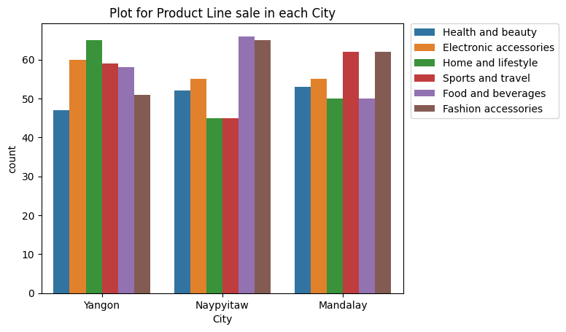
- City wise Products sale:
. Yangon: The most purchased products are Home and lifestyle and the least
purchased products are Health and beauty.
Naypyidaw: The most purchased products are Food and beverages and the least
purchased products are Home and lifestyle, Sports and travel.
Mandalay: The most purchased products are Sports and travel, Fashion accessories and the
Least purchased products are Home and lifestyle, Food and beverages.
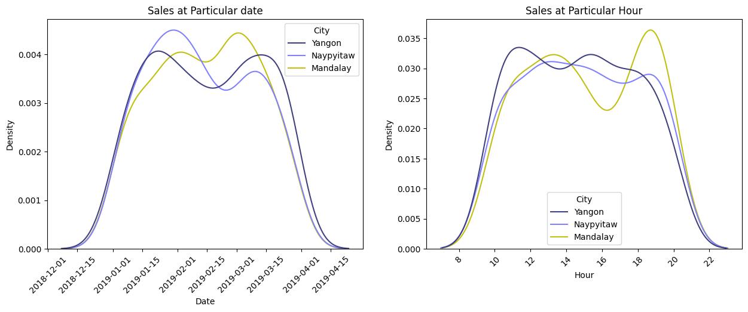
- Sales Analysis at particular date and time:
Date: The sales in the cities are almost same inconsideration of dates
Time: At 20:00 hrs the sales in the city Mandalay are very high compared to other cities and the remaining hours are almost same.
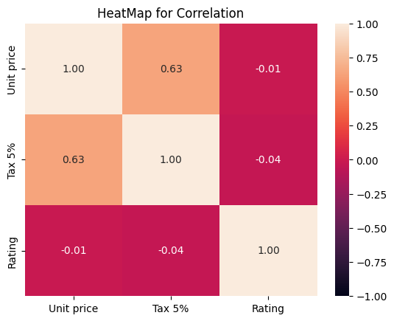
- Correlation between the Columns product, tax and it rating:

There is no correlation between the price of product and it tax to the final product rating, maybe the quality of product and time of deliver could influence this variable but it is an information not available in dataset unfortunately
- 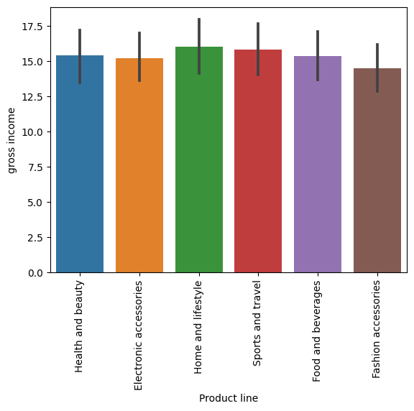Bar Plot for gross income feature:

From the above we can infer the gross income of each product line. If we observe the plot, Home and lifestyle has high gross income whereas fashion accessories have less gross income.

- 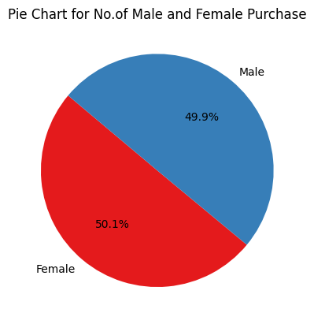Plot of visualizing no of males and females:

Female Purchases are more compared to male.
Inference of the features based on Hist, Box and Prob Plot:
1) Unit Price: Observing Boxplot we cannot say that it is Skewed and from
histplot is not sure whether Unit Price is Skewed but, from Probability
Plot we can say that Unit Price is skew.
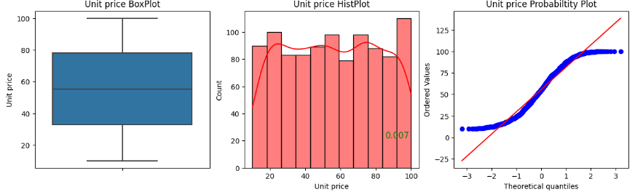

2) Quantity: Observing Boxplot we cannot say that it is Skewed and from
histplot is not sure whether Quantity is Skewed. But, from Probability
Plot we can say that Quantity is skew.
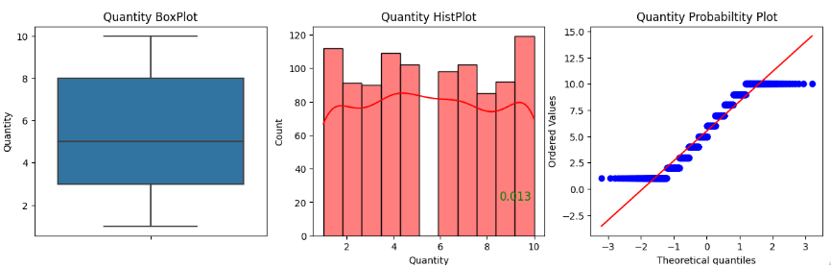

Similarly, for other features:
3) Tax 5%: Observing BoxPlot and HistPlot we say that Tax 5% is Right Skewed and
from Probability Plot we can say that Tax 5% is skew and also having some
outliers.

4) Total: Observing BoxPlot and HistPlot we say that Total is Right Skewed and from
Probability Plot we can say that Total is skew and also having some outliers.

5) Time: Observing Boxplot we cannot say that it is Skewed and from histplot is not
sure whether Time is Skewed. But, from Probability Plot we can say that Time is skew.

6) cogs: Observing BoxPlot and HistPlot we say that cogs are Right Skewed and from
Probability Plot we can say that cogs are skew and also having some outliers.

7) Gross margin Percentage: Is a straight line, which means in every city the margin %
is same.

8) Gross income: Observing BoxPlot and HistPlot we say that Gross income is Right
Skewed and from Probability Plot we can say that Gross income is skew
and also having some outliers.

9) Rating: Observing Boxplot we cannot say that it is Skewed and from histplot is not
sure whether Rating is Skewed. But, from Probability Plot we can say that Rating is skew.

Conclusion:
The above features are Skewed. So we apply the transformation by boxcox function to transform the DataFrame(df).

Normalization:
- We apply boxcox function and transform the data into normal form. Here, are the few graphs after transformation:

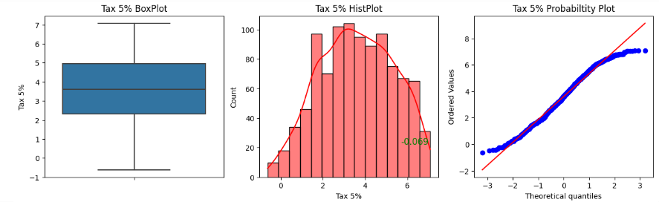
For Tax 5%:

Transformed data Inference:
We cannot say that there is no skewness in each column but they are reduced compared to before and we can verify by Probability Plot which are almost normal and having less outliers.

Confidence Intervals:
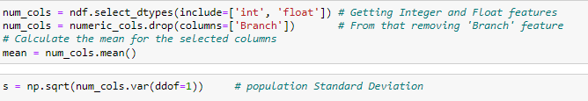
- Let’s see the Confidence Intervals for MEAU for several features:(l.s = 0.05)

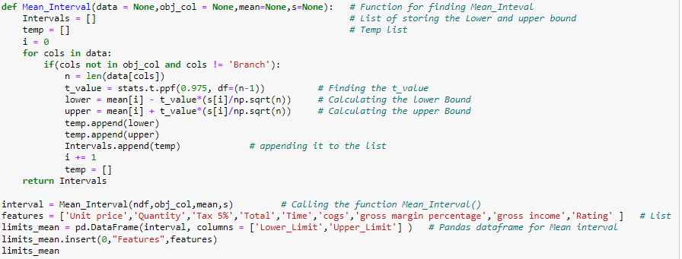
- Function for Finding Confidence Intervals:

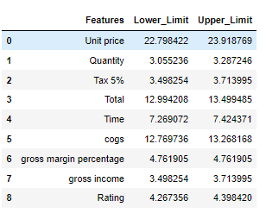
OUTPUT:

- Confidence Interval for Variance: (l.s = 0.05, meau is not known)

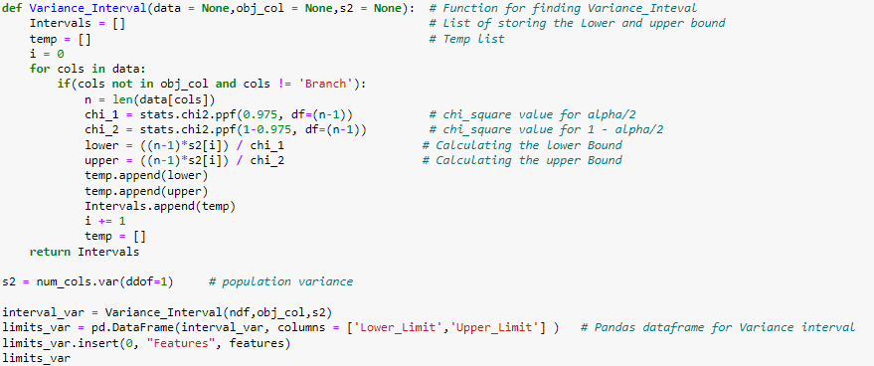
- Function for finding the CI for Variance:

OUTPUT:
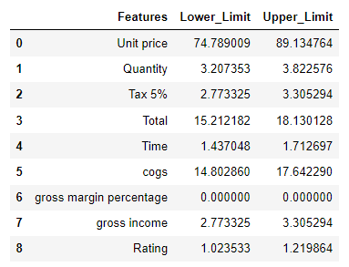

Testing Hypothesis:
Function for Testing Hypothesis for μ:
The function inputs are:
Data: the feature of the dataset
Alpha: the confidence value
Ho: Null hypothesis
Var: Value of variance is known
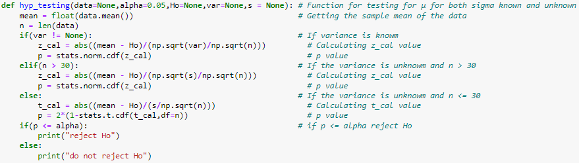
S: sample variance
- Testing whether the μ of feature ‘Total’ is 320 or Not.
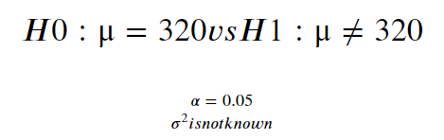

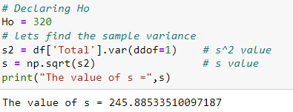

- Calling the above Function: hyp_testing ()

Result: Do not REJECT Ho

- Testing whether the μ of feature ‘gross income’ is 20 or Not.
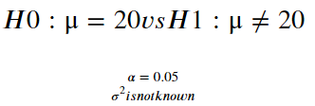

- Declaration:
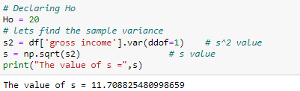

- Calling the above Function: hyp_testing ()

Result: Do not REJECT Ho

JAI SAIRAM

