**Q1)**

**a)**

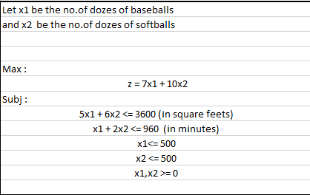

Optimal Solution:

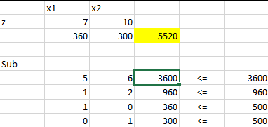

Therefore: x1 = 360, x2 = 300 and z = 5520

**b) Cost coeff Sensitivity analysis:**

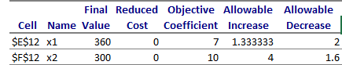

Here, **x1**: can be decreased up to 2 dollars i.e. till 5 dollars

and can be increased up to 1.34 dollars i.e. till 8.34 dollars

And **x2**: can be increased up to 4 dollars i.e. till 14 dollars

and can be decreased up to 1.6 dollars i.e. till 8.4 dollars.

**c) Right Hand Side Sensitivity Analysis:**

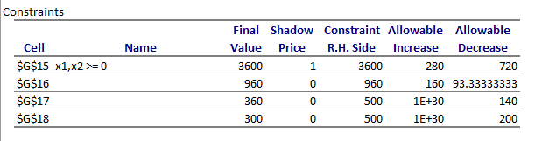

Analysis:

1. For cowhide sheets: The allowable increase is 280 square feet’s i.e. till 3880 square feet’s

And allowable decrease is 720 square feet’s i.e. till 2880 square feet’s

1. Forno. of minutes: The allowable increase is 160 minutes i.e. till 1120 minutes

And allowable decrease is 93.34 minutes i.e. till 866.66 minutes

1. For no. of dozens of x1: we can increase as much as we can till 1E+30

And allowable decrease is 140 dozen i.e. till 360 dozen

1. For no. of dozens of x1: we can increase as much as we can till 1E+30

And allowable decrease is 200 dozen i.e. till 300 dozen

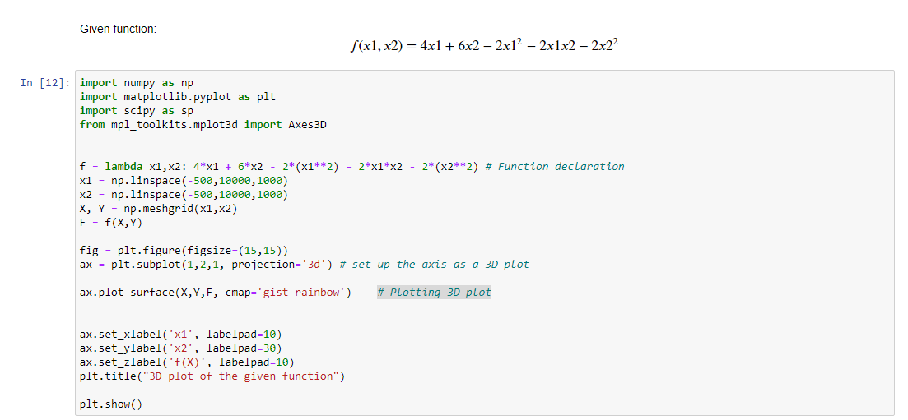**Q2) A)**

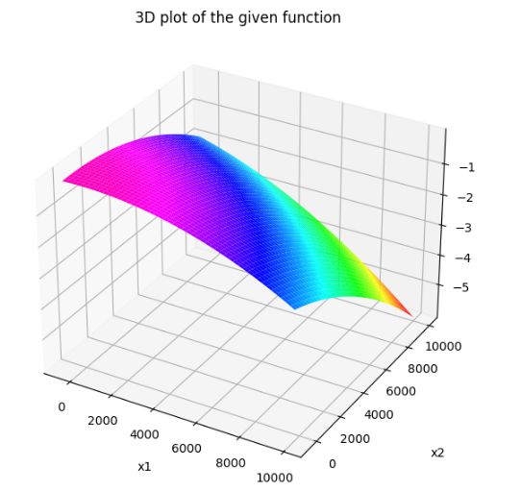

**Minimization Function**

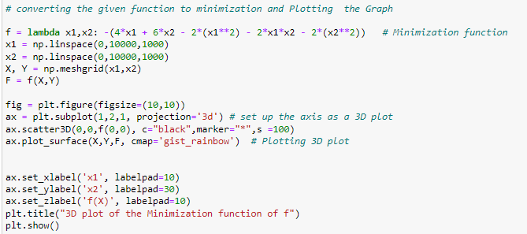

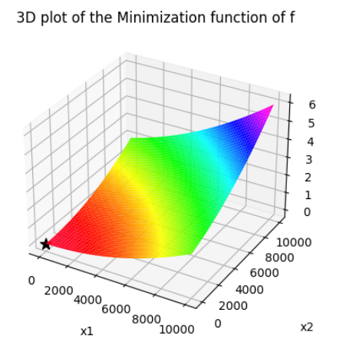

**B) Gradient_Descent:** 