**Create table queries**:

mysql> create database travel;

Query OK, 1 row affected (0.01 sec)

mysql> use travel;

Database changed

mysql> create table passenger(

-> pass_name varchar(20),

-> category varchar(10),

-> gender char(1),

-> boarding_city varchar(20),

-> dest_city varchar(20),

-> distance int(10),

-> bus_type varchar(20));

Query OK, 0 rows affected, 1 warning (0.03 sec)

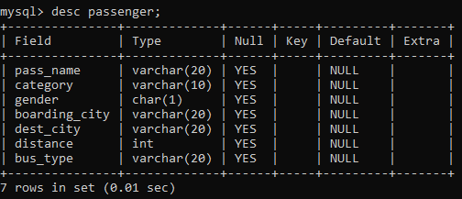

mysql> create table price(

-> bus_type varchar(20),

-> distance int(10),

-> price int(10));

Query OK, 0 rows affected, 2 warnings (0.02 sec)

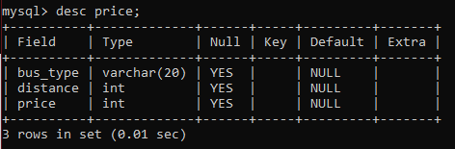

**Insert into table queries**:

insert into passenger values("Sejal", "AC", 'F', "Bengaluru", "Chennai", 350, "Sleeper")

insert into passenger values("Anmol", "Non-AC", 'M', "Mumbai", "Hyderabad", 700, "Sitting")

insert into passenger values("Pallavi", "AC", 'F', "Panaji", "Bengaluru", 600, "Sleeper")

insert into passenger values("Khusboo", "AC", 'F', "Chennai", "Mumbai", 1500, "Sleeper")

insert into passenger values("Udit", "Non-AC", 'M', "Trivandrum", "panaji", 1000, "Sleeper")

insert into passenger values("Ankur", "AC", 'M', "Nagpur", "Hyderabad", 5000, "Sitting")

insert into passenger values("Hemant", "Non-AC", 'M', "panaji", "Mumbai", 700, "Sleeper")

insert into passenger values("Manish", "Non-AC", 'M', "Hyderabad", "Bengaluru", 500, "Sitting")

insert into passenger values("Piyush", "AC", 'M', "Pune", "Nagpur", 700, "Sitting")

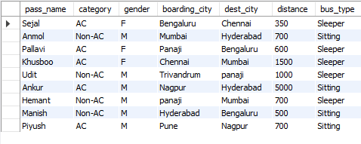

|  |  |
| --- | --- |
| insert into price values("Sleeper", 350, 770)  insert into price values("Sleeper", 500, 1100)  insert into price values("Sleeper", 600, 1320)  insert into price values("Sleeper", 700, 1540)  insert into price values("Sleeper", 1000, 2200)  insert into price values("Sleeper", 1200, 2600)  insert into price values("Sleeper", 1500, 2700)  insert into price values("Sitting", 500, 620)  insert into price values("Sitting", 600, 744)  insert into price values("Sitting", 700, 868)  insert into price values("Sitting", 1000, 1240)  insert into price values("Sitting", 1200, 1488)  insert into price values("Sitting", 1500, 1860) |  |

**Queries**:

1. select count(gender) from passenger where distance>=600



1. select min(price) from price where bus_type like 'sleeper'



1. select pass_name from passenger where pass_name like 'S%'



1. select pa.pass_name, pr.price from passenger pa, price pr where pa.bus_type like 'sitting' and pr.distance=1000

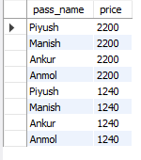

1. select pa.pass_name, p.*, pa.boarding_city, pa.dest_city from price p, passenger pa

where pa.pass_name like 'Pallavi' and p.distance=600

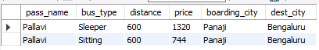

1. select distinct distance from passenger order by distance desc

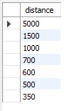

1. select pass_name, distance*100/(select sum(distance) from passenger) as 'Distance Percentage' from passenger

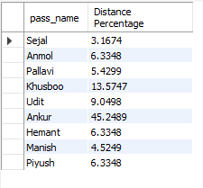

1. select distance, price,

case

when price > 1000 then 'Expensive'

when price > 500 and price < 1000 then 'Average'

else 'Cheap'

end as 'Cost'

from price

