Full Stack Development with MERN
Book a Doctor
DOCUMENTATION

DocSpot: Seamless Appointment Booking for Health

1. Introduction
Project Title: DocSpot: Seamless Appointment Booking for Health
Team Members: udumula sai Sudheer reddy(238X1A45C2) , Velaga sri Varshini(238X1A05F5), Sanka Giri Siva Santosh Gupta , Talari Bhanu Prasad

2. Project Overview
Purpose
DocSpot is a web-based platform that simplifies the process of booking medical appointments by connecting patients with healthcare providers in a user-friendly interface. It enables real-time scheduling, secure user authentication, and streamlined management of appointments.
Features
- User authentication (patients and doctors)
- Browse/search doctors by specialty, location, availability
- Book, reschedule, or cancel appointments
- Doctor dashboard to manage schedules and view bookings
- Email notifications and reminders
- Responsive, mobile-friendly design

3. Architecture
Frontend (React)
- Built using React.js with functional components and hooks
- React Router for navigation
- Axios for API communication
- Redux for global state management (optional)
Backend (Node.js & Express.js)
- RESTful API developed with Express.js
- JWT-based authentication middleware
- Controllers for managing appointments, users, doctors
- Centralized error handling
Database (MongoDB)
- MongoDB Atlas used as a cloud-hosted NoSQL database
- Mongoose ODM to define schema and interact with data
Schemas:
- User: name, email, password, role (doctor/patient), etc.
- Doctor: user reference, specialty, availability
- Appointment: patient ID, doctor ID, date, time, status

4. Setup Instructions
Prerequisites
- Node.js (v16+)
- npm
- MongoDB (local or MongoDB Atlas)
Installation
bash
CopyEdit
# Clone the repository
git clone https://github.com/your-repo/docspot.git
cd docspot

# Setup server
cd server
npm install
# Add .env file with DB_URL, JWT_SECRET, etc.

# Setup client
cd ../client
npm install
# Add .env file with REACT_APP_API_URL

5. Folder Structure
Client (React)
pgsql
CopyEdit
client/
│
├── public/
├── src/
│ ├── components/ # Reusable components (Header, Footer, etc.)
│ ├── pages/ # Pages (Home, Login, Profile, Booking)
│ ├── services/ # API calls using Axios
│ ├── context/ # Auth context or global state
│ ├── App.js
│ └── index.js
Server (Node.js)
bash
CopyEdit
server/
│
├── controllers/ # Logic for routes
├── models/ # Mongoose schemas
├── routes/ # Route definitions
├── middleware/ # Auth and error handlers
├── config/ # DB connection
├── utils/ # Helper functions
├── .env
├── server.js

6. Running the Application
Frontend
bash
CopyEdit
cd client
npm start
Backend
bash
CopyEdit
cd server
npm start

7. API Documentation
Endpoint | Method | Description | Auth Required | Request Body / Params | Sample Response
/api/auth/register | POST | Register a new user | No | { name, email, password, role } | 201 Created
/api/auth/login | POST | Login and receive JWT token | No | { email, password } | { token, user }
/api/doctors | GET | Get list of doctors | No | N/A | [ { id, name, specialty } ]
/api/appointments | POST | Book appointment | Yes | { doctorId, date, time } | 201 Created
/api/appointments/me | GET | Get logged-in user's appointments | Yes | Token in header | [ { id, status, date } ]

8. Authentication
- Uses JWT (JSON Web Tokens) stored in localStorage.
- Tokens are required for protected routes and verified via middleware.
- Passwords are hashed using bcrypt.
- Role-based access control for patient and doctor.

9. User Interface

Patient Dashboard
- View upcoming appointments
- Book or cancel appointments

Doctor Dashboard
- View scheduled appointments
- Set or edit availability

10. Testing
- Unit Testing: Jest for backend APIs
- Frontend Testing: React Testing Library
- Postman used for manual API testing

11. Screenshots or Demo:
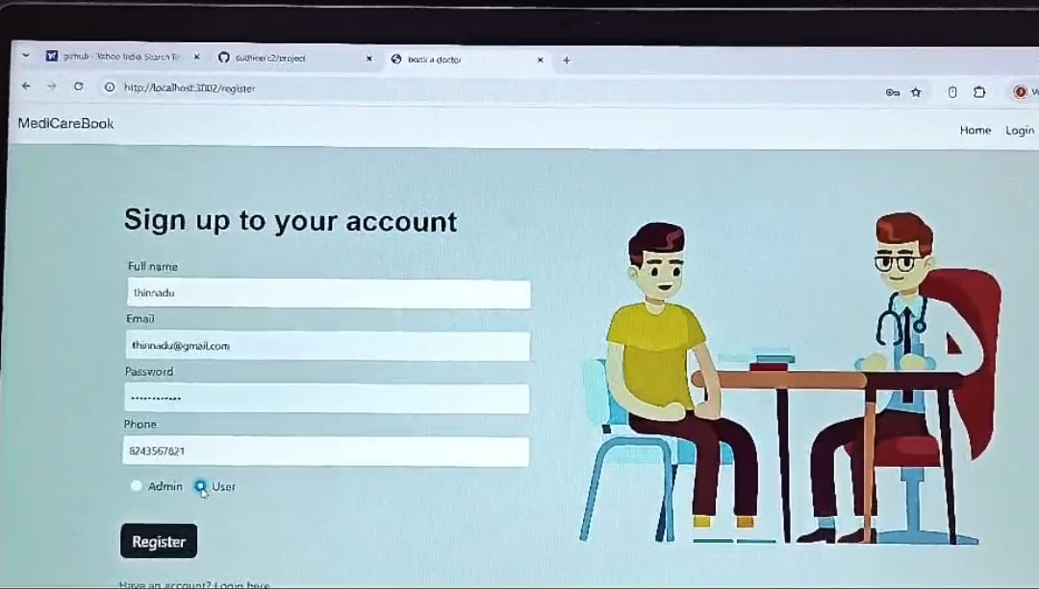
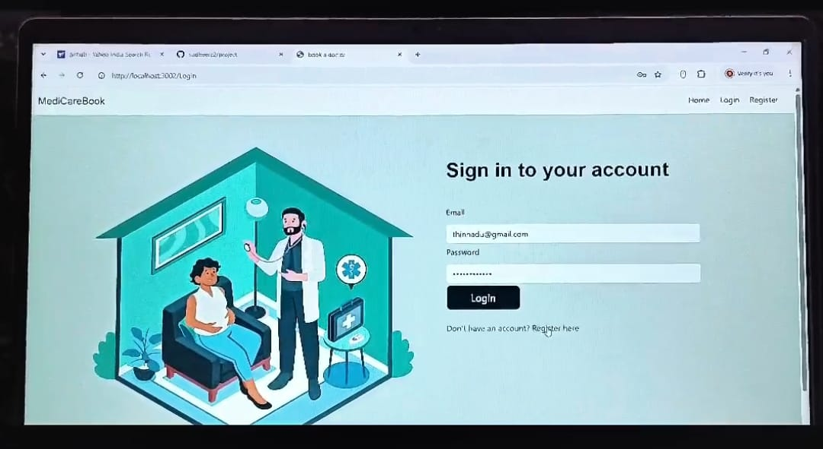

12. Known Issues
- Appointment conflicts not checked in real-time in some edge cases
- Limited mobile support on low-resolution devices
- Email notifications may delay occasionally (SMTP limits)

13. Future Enhancements
- Integrate real-time chat between patient and doctor
- Video consultations via WebRTC
- Push notifications for mobile users
- Admin panel for monitoring system usage
- Improved calendar UI with drag & drop rescheduling

