ChE 331
Assignment # 1
Due: 19 Jan 2024
10% off each late day
Not accepted after 22 Jan

1. (a) Calculate the production rate of copper (in kg/day) in a 25,000 amp cell operating at 93% current efficiency with respect to the formation of Cu° at the cathode. The electrolyte is an acidic sulphate solution so that the overall reaction is

Cu²⁺(aq) + H₂O(ℓ) → Cu° (s) + ½ O₂(g) + 2H⁺(aq)

(b) Repeat the above calculation for the case where electrolysis is being carried out in an alkaline cyanide-based solution so that the overall reaction is now

2Cu(CN)₃²⁻ (aq) + 2 OH⁻(aq) → 2Cu°(s) + ½ O₂(g) + H₂O (ℓ) + 6CN⁻(aq)

Assume that the cell operates at the same current as in a) and the current efficiency for Cu deposition at the cathode is 93%.

2. i) Calculate the production rate of aluminum (in kg/day) in a 150,000 amp Hall-Heroult cell operating at 95% current efficiency with respect to the formation of Al at the cathode. The overall reaction involving aluminum reduction is

Carbon is fed continuously into the cell and is “baked” by the heat within the reactor to continually form anodes which are consumed by the above reaction. Determine the rate (in kg/day) at which carbon must be fed into the cell to maintain the above current under steady state conditions assuming the oxidation of carbon to CO₂(g) is the only anodic process that occurs.

ii) Under normal conditions, a small amount of the CO₂ produced at the anode can be transported to the cathode where it is reduced to CO by the reaction

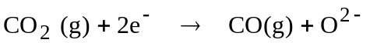

Consider that this is the side reaction that consumes 5% of the cathodic current for the conditions described in i) above. Determine the rate (in kg/day) at which CO₂(g) and CO(g) are produced in the cell.

3. A continuous electrolytic process for galvanizing steel sheets involves passing a sheet through a ZnSO₄ solution between closely spaced lead plates, as shown below.

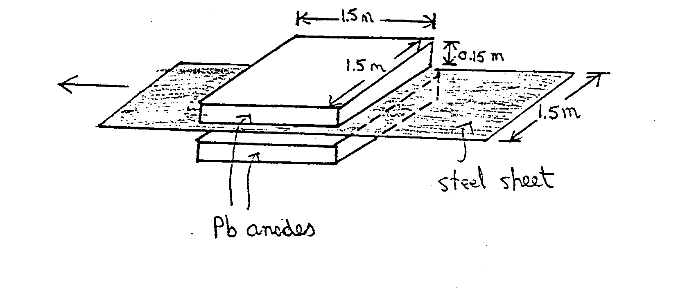
The sheet is made the cathode and the lead plates the anodes so that zinc metal is simultaneously plated onto both sides of the sheet as it passes between the plates. The side edges of both lead plates are insulated, as are the upper face of the top lead plate and the lower face of the bottom lead plate. Consequently, current flows only between the steel sheet and the faces of the lead plates directly above and below it.

The cell is operated at a current density of 0.07 amps cm⁻².

The current efficiency for zinc deposition at the cathode is 90%.

If the dimensions of the lead plates and the width of the steel sheet are as given in the figure, calculate the speed at which the sheet should be passed through the solution to produce a deposit with a thickness of 0.0035 cm on each side. The density of the zinc deposit is 6.00 g cm⁻³.

4. A polymer electrolyte membrane (PEM) fuel cell generates electrical energy through the following reactions:

Anode: H₂(g) → 2H⁺ (aq) + 2e⁻

Cathode: ½ O₂ (g) + 2H⁺ (aq) + 2e⁻ → H₂O (ℓ)

A commercial PEM fuel cell consists of closely spaced alternating cathodes and anodes. Each cathode and anode has a porous, 3-dimensional structure of electronically conducting material. Following are typical operating conditions:

- the voltage generated between each adjacent cathode and anode is 0.7 V when the cell operates at a current density of 1.0 A cm⁻² (assume each cathode and anode have the same surface area)
- each electrode reaction operates at 100% current efficiency

- pure H₂ is fed continuously to the anode compartment at a rate 1.2 times in excess of the amount required
- O₂ is fed continuously to the cathode compartment at a rate 2 times in excess of the amount required; air is the source of O₂
- the cell is hooked up in bi-polar connection; effectively each ‘stack’ of cells contains 220 cathodes and 220 anodes

If the objective of the fuel cell is to generate 75 kW of power under the above operating conditions, determine the following:

- total stack current
- total stack voltage
- cell voltage and cell current
- electroactive area of each electrode
- feed rate of H₂ (in kg/day)
- feed rate of air (in kg/day)

Repeat this question with a mono-polar arrangement.
Comment on how you would design the a fuel cell stack – monopolar or bi-polar?
Hint – there are optional ‘readings’ on fuel cells on the course web site that may help with this question.

5. Aluminium is being produced in a conventional Half-Heroult cell (see notes) operating at a total current of 200,000 amps. The overall reaction within the molten bath is

4AlF₆³⁻ + 3C(s) + 6O²⁻ → 4Alº(R) + 3 CO₂(g) + 24F ⁻

Carbon is fed continuously into the cell and is "baked" by the heat within the reactor to continually form anodes which are consumed by the above reaction.
i) Calculate the production rate of aluminium (in g/sec) and the rate at which carbon must be fed into the cell to maintain the above current under steady state conditions assuming 100% current efficiency.
ii) In actual practice, complications occur which rob some of this current and reduce the current efficiency.
The following competing reactions occur at the cathode:

1. AlF₆³⁻ + 3e⁻ →Alº(R) + 6F⁻ primary reaction

2. CO₂(g) + 2e⁻ → CO(g) + O²⁻ side reaction

Similarly, competing reactions occur at the anode:

1. C(s) + 2O²⁻ → CO₂(g) + 4e⁻ primary reaction

2. Alº(R) + 6F⁻ → AlF₆³⁻ + 3e⁻ side reaction

The primary anodic and cathodic reactions combine to yield the desired overall reaction given in part i). However, a small amount of the CO₂ produced by this overall reaction is reduced at the cathode to CO by the side reaction given above. This causes some of the Alº that had been formed at the cathode to be re-oxidized and to re-dissolve into the molten bath as AlF₆³⁻.

Calculate the aluminum production rate and the required carbon feed rate if only 95% of the total current at each electrode is used for the primary reaction and the remaining 5% is used for the side reaction.

