Basic Chemistry Equations

PV = ZnRT; Z = 1.0 for ideal gases

Average molecular velocities: 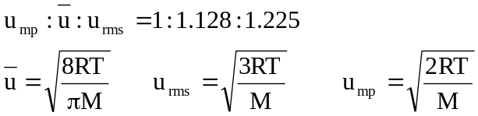

Effusion rate = 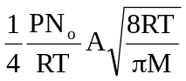 Mean free path: 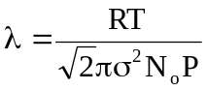

Heat capacities: 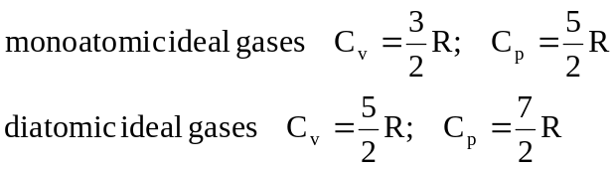

Henry’s law: 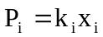 Dalton’s law: 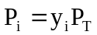 Clapeyron Equation:
Raoult’s law: 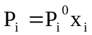 Amagat’s law: 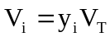 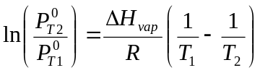

Colligative properties: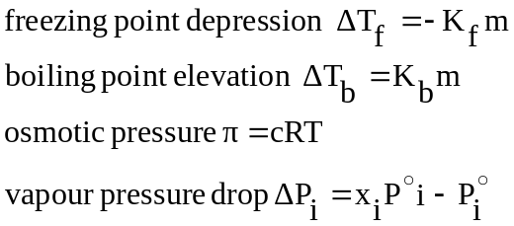

Nernst equation: 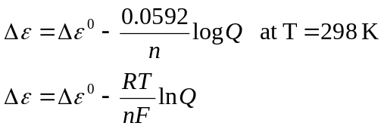 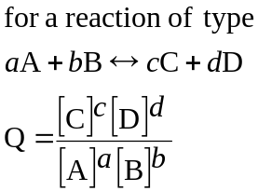
Arrhenius equation: 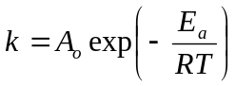

Nomenclature
A: cross-sectional area of pinhole | P_{i}: partial pressure of substance i
A_{o}: pre-exponential factor | P_{i}º: vapour pressure of pure substance i
c: molar concentration of solute in solution | P_{T}: total pressure
C_{p}: molar heat capacity at constant P | Q: reaction quotient
C_{v}: molar heat capacity at constant V | R: gas constant
E_{a}: activation energy | T: absolute temperature
F: Faraday’s constant | V: volume
K_{b}: boiling point elevation constant | V_{i}: partial volume of substance i
K_{f}: freezing point depression constant | V_{T}: total volume
k: reaction rate constant | x_{i}: mole fraction of i in liquid phase
k_{i}: Henry’s law constant | y_{i}: mole fraction of i in vapour phase
M: atomic or molecular mass | Z: compressibility factor
m: molality | Δεº: standard cell potential
n: number of moles | Δε: cell potential
n: number of electrons transferred | λ: mean free path
N_{o}: Avogadro’s number | π: osmotic pressure
P: pressure | σ: molecular diameter

Empirical formula: Gives the relative number of atoms in a molecule. Different substances can have the same empirical formula.

The empirical formula of hexene C₆H₁₂ is simply CH₂
Molecular Formula: Shows the actual number of atoms in a molecule.
It can be obtained from the empirical formula if the gas density is known.

At STP (0 ºC, 1 atm) 1 mol of most gases have a volume of 22.4 L

Gas density: 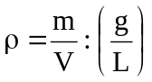
Since at STP: 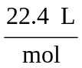
Then: 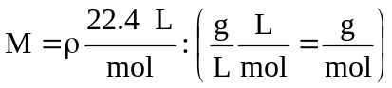

With the empirical formula and the molar mass known, it is easy to calculate the actual number of atoms in a given molecule.

Combustion Problems

Important observations:
- Air (21 mol % O₂ and 79 mol % N₂) is generally the source of O₂ in combustion reactions. Since N₂ is inert, it will be present in the products in the same amount it is present in the reactants.

- Complete combustion of hydrocarbons produces only CO₂ and H₂O
C₆H₁₂ + 9 O₂ → 6 CO₂ + 6 H₂O

- Presence of CO or C in the products indicates incomplete combustion.
Important Combustion definitions:
- Composition on wet basis: compound mole fractions including water

- Composition on dry basis: compound mole fractions excluding water
Ex: 33.3% CO₂, 33.3% N₂, 33.4% H₂O (wet basis)
50% CO₂, 50% N₂ (dry basis)

- Stack or flue gas: product gas that leaves combustion chamber
- Theoretical oxygen (n_{O2 theor}): number of moles of oxygen (O₂) needed for the combustion of all fuel
- Theoretical air (n_{air theor}): quantity of air that contains the theoretical oxygen
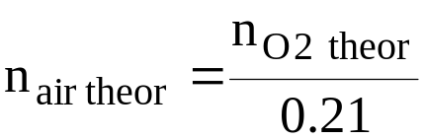
- Excess air (n_{air ex}): amount of air fed to the combustion chamber minus theoretical air
n_{air ex} = n_{air} - n_{air theor}
- Percent excess air:
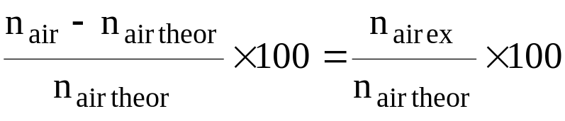
Ideal Gas Law
The combination of Boyle’s and Charles’s laws leads to the ideal gas law:
Charles law: 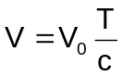
Boyle’s law: 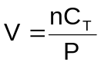
Solving for V₀ :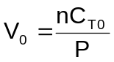
Substituting V₀ in Charles’s law: 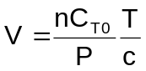
Rearranging: 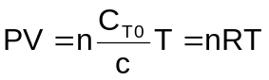
where R = C_{T0}/c.

At SPT it can be proven experimentally that 1 mole of most gases occupy 22.4 L. This can be used to calculate the gas constant, R:
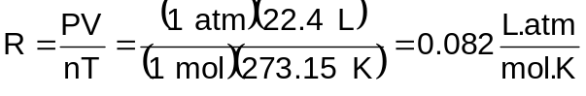
Therefore, the ideal gas law is expressed as:
PV = nRT
or
PV_{m} = RT
where V_{m} is the molar volume (V_{m} = V/n).
Sometimes it is more convenient to express the ideal gas law using the last expression, since all variables are intensive, as opposed to the first form where n is an extensive variable.
What is an ideal gas?
→ Idealization that assumes there are no intermolecular forces between gas molecules. It also assumes that gas molecules have no molecular volume. That is why there is no term in the ideal gas law equation to account for differences among gas molecule types

Composition of Solutions

Mole Fraction
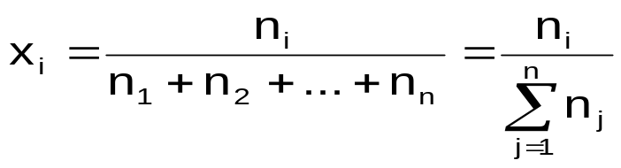
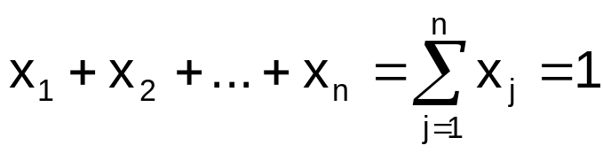

Molality
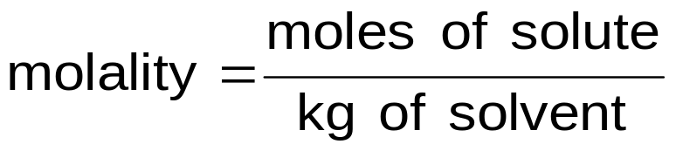

Molarity
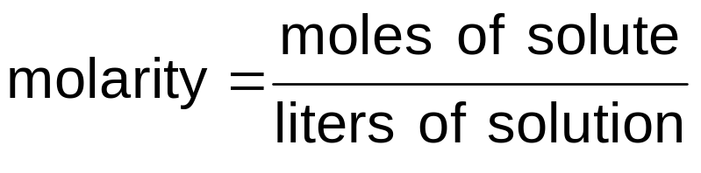
Important: molarity varies with temperature
Percentage
25% (v/v) 25 ml of solute in 100 ml of solution
25% (w/v) 25 g of solute in 100 ml of solution
25% (w/w) 25 g of solute in 100 g of solution
Henry’s Law

Henry’s law is generally applied to gas-liquid solutions. It relates the partial pressure of a gas (solute) to its molar fraction in the liquid (solvent) by the following equation:
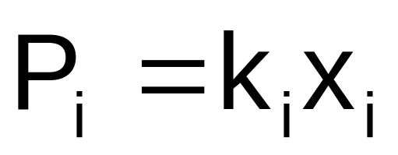

where k_{i} (called Henry’s law constant) depends on the solute/solvent pair and on temperature.

Henry’s law is an important relationship to calculate the solubility of gases in liquids, since
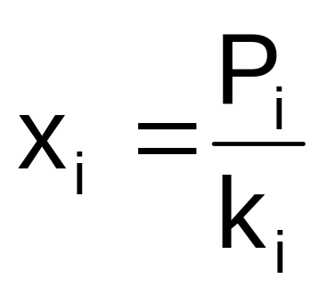
Therefore, increasing the pressure of the gas will increase its concentration in the liquid phase at a given temperature. Notice also that increasing k_{i} will decrease the solubility of the gas in the liquid phase.
Raoult’s Law

Raoult’s law relates the partial pressure of a gas to its vapour pressure in liquid/liquid and liquid/solid solutions by the simple expression:
P_{i} = x_{i}Pº_{i}
where Pº_{i} is the vapour pressure of pure substance i.

For binary, liquid/liquid solutions:
P = P₁ + P₂ = x₁Pº₁ + x₂Pº₂ = x₁Pº₁ + (1-x₁)Pº₂

For binary, solid/liquid solutions:
P = P_{solid} + P_{liq} = x_{solid}Pº_{solid} + x_{liq}Pº_{liq} = x_{liq}Pº_{liq}

since Pº_{liq} >> Pº_{solid} in general.
Colligative Properties of Solutions

Consider a solution formed by dissolving a non-volatile solute (such as sugar) in a liquid solvent (such as water). If this solution obeys both Raoult’s and Henry’s laws it is called an ideal solution. We will study the following four properties of ideal solutions:
Vapour-pressure lowering
Boiling-point elevation
Freezing-point depression
Osmotic pressure

Colligative properties are a consequence of Raoult’s law. The equations that will be used apply only for dilute solution, where the assumption of ideality is valid.
The effect of dissociation

If a solute dissociates (as does NaCl when it dissolves in water to form Na⁺ and Cl⁻ ions), then the effective number of solute particles increases.

Because the colligative particles depend on the number of dissolved particles, the equations describing them must be adjusted to take dissociation into account.
The required change is the insertion of an additional factor, the van’t Hoff i.
ΔT_{b} = i K_{b}m

where i equals the number of particles released into solution per formula unit of solute. Its minimum value equals 1 (no dissociation); its maximum value equals the number of particles generated by complete dissociation of a formula unit of solute. For instance, for NaCl, the maximum value i can have is 2. (Because aquated ions of opposite charges associate into ion-pairs as a function of solution concentration, the value of i for NaCl might be less than 2 and must be determined experimentally)
Osmotic Pressure

Osmotic pressure is defined as the pressure exerted by the height of liquid in the column:
π = hρg
π is the osmotic pressure (expressed as a ‘head’ of the fluid)
It can be shown that, for ideal solutions,
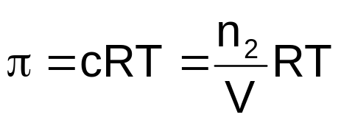 (van’t Hoff equation)

where c is the molar concentration of solute in solution.

The Empirical Law of Mass Action /

The Equilibrium Constant
Consider the generic chemical equation:
a A + b B = c C + d D
where A, B, C and D are chemical substances and a, b, c and d their respective stoichiometric coefficients. It can be experimentally demonstrated that at equilibrium, the ratio defined by
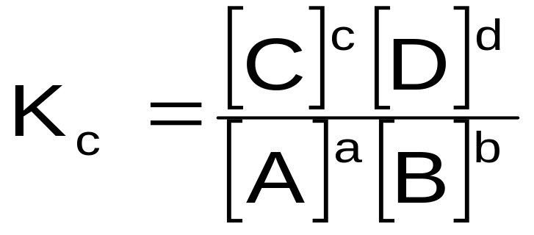
is a constant value (for a given temperature) independent of the initial concentration or reactants and products.
K_{c} is called equilibrium constant. K_{c} has units of (concentration)^{d+c-a-b}.
- K_{c} is an intrinsic property of the chemical reaction
- Large K_{c} indicates that products are present in higher amount than reactants
- Small K_{c} indicates that reactants are present in higher amount than products

The Direction of Change and the Reaction Quotient
Consider the generic chemical reaction:
a A + b B = c C + d D
The reaction quotient, Q, for this reaction at any concentration of reactants and products is defined as:
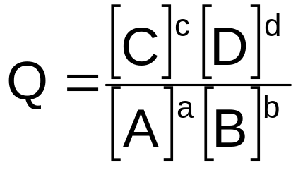
Notice that the definition of Q is equivalent to definition for K_{C}, but Q is defined for any concentration of reactants and products, while K_{C} is only defined when chemical equilibrium is achieved.
Q = K_{c} ⇒ chemical equilibrium
Q < K_{c} ⇒ reactants are in excess
Q > K_{c} ⇒ products are in excess
The reaction quotient can also be defined in terms of gas pressures as:
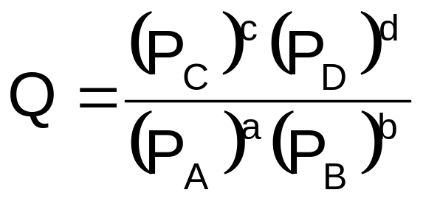
Solubility and Solubility Product Constant
Section 11.1 – 11.3
The equilibrium between solid ionic solute and liquid solvent can be treated in a similar way to the one used to study chemical equilibrium (in fact, several previous examples dealt with dissolution equilibrium):
AgCl(s) = Ag⁺(aq) + Cl⁻(aq)

A solubility product constant is defined in a similar way to the reaction equilibrium constant:
K_{sp} = [Ag⁺][Cl⁻]
Notice that the concentration of the solid species is taken into account implicitly in the definition of K_{sp}, as also done for K_{C} and K_{p}.
K_{sp} is related to the solubility of the solute in the solvent, S:
S = [Ag⁺] = [Cl⁻]
Solubility is simply the maximum amount (in g or mol) of the solute that will dissolve in the solvent at a given temperature.
Therefore, in this case: K_{sp} = [Ag⁺][Cl⁻] = (S)(S) = S²
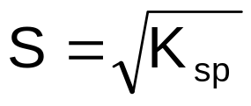
ELECTROCHEMISTRY
Chapter 12
(Batteries, Fuel Cells , Corrosion, Metal Processing, Plating)

Oxidation States
Useful definitions:
- A chemical substance is oxidized when it loses electrons.
- A chemical substance is reduced when it gains electrons.
- The substance that causes the oxidation of another is called the oxidizing agent or oxidant.
- The substance that causes the reduction of another is called the reducing agent or reductant.
Zn + Cu²⁺ → Zn²⁺ + Cu
Zn is oxidized (loses 2 e⁻) → Zn is the reductant
Cu²⁺ is reduced (gains 2 e⁻) → Cu is the oxidant

Oxidation Numbers
(Oxtoby, Section 3.9, pages 80-82)
- The oxidation number of monoatomic species is the net charge on the atom. Ex: the oxidation number of S⁻² is –2, of Fe³⁺ is +3 and of Cu is 0.
- For polyatomic species:
- Zero, for pure elements.
- +1 for alkali metals (Li, Na, K, Rb, Cs, Fr).
- +2 for alkaline earth metals (Be, Mg, Ca, Sr, Ba, Ra).
- -1 for halogens (F, Cl, Br, I, At), except when combined with oxygen and other halogens. F has always oxidation number of –1.
- +1 for hydrogen in all compounds, except for those with bonds to metals, in which it is equal to –1 (LiH, for instance).
- -2 for oxygen in all compounds, except for peroxides (such H₂O₂ and N₂O₂, where it is -1), or when combined with F (in OF₂, it is equal to +2).
- All the other oxidation numbers are selected to make the algebraic sum of the oxidation numbers equal to the net charge of the molecule or ion.
Balancing Oxidation-Reduction Reactions
General guidelines for balancing oxidation-reduction equations:
- Write separate half-reactions for oxidation and reduction.

- Balance all atoms, except H and O.

- Balance O by adding H₂O.

- Balance H:
- Acidic medium: Add H⁺ to the hydrogen-deficient side.
- Basic medium: Add H₂O to the hydrogen-deficient side and OH⁻ to the other side.

- Balance charges by adding e⁻.

- Add half-reactions to cancel e⁻.

Note: Oxtoby balances the H in acidic medium by adding H₃O⁺ to the hydrogen deficient side and an equivalent amount of H₂O to the other side or the chemical equation.
Standard Cell Potentials
The voltage of galvanic cells depend on:
- reactants used in the two half-cells
- concentrations in the two half-cells
- temperature
In order for one to compare the voltages of different galvanic cells, it is necessary to define a standard state:
- 1.0 M concentration for dissolved species
- 1 atm pressure for gases
- (Most stable form at 25 ºC for solids)
Gas electrodes are used when gases are part of a galvanic cell. The metal surface of these electrodes (made of Pt, for instance), is saturated with gas (H₂ in this case). For this particular case, the redox reaction and the half-cell reactions are:
H₂(g) + Cu²⁺ (aq) → Cu(s) + 2 H⁺(aq)
H₂(g) → 2 H⁺(aq) + 2 e⁻ Oxidation
Cu²⁺ (aq) + 2 e⁻ → Cu(s) Reduction
The Standard Cell Potential (ΔΕº) is defined as the voltage measured at the standard state.
Sign convention for Εº:
Zn + Cu²⁺ = Cu + Zn²⁺ ΔΕº = +1.10 V → spontaneous direction
Cu + Zn²⁺ = Zn + Cu²⁺ ΔΕº = - 1.10 V ←
Non - spontaneous direction
The Nernst Equation
Thus far we have calculated cell voltages at standard conditions (1 M concentration, 1 atm, 25 ºC). How can one calculate cell voltages at different conditions?
The Nernst equation quantifies the dependency of cell voltage on the concentration of chemical species and temperature in a galvanic cell.
For a generic cell reaction:
a A + b B → c C + d D
The Nernst equation at 25 ºC is:
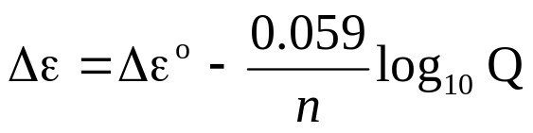
where
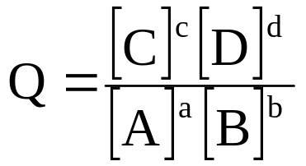
and
ΔΕº: standard cell potential
n: number of electrons transferred in the reaction as written
[A]: concentration of chemical species A in mol/L

Faraday’s law of electrolysis
“The number of moles of material oxidized or reduced at an electrode is related by the stoichiometry of the electrode reaction to the amount of electricity passed through the cell.”

Simply stated:
1 mole e⁻ → 1 mole Ag⁺
→ ½ mole Cu²⁺
→ 1/3 mole Al³⁺

Remember: Charge of 1 mole e⁻ = 1 F = 96,485 c

I=Q/t
Current (Amperes) Equals Charge passed (Coulombs) per Unit of Time (Seconds)

Also Useful:
ΔG=-nFE
Energy Available is ΔG

Power = Current * Voltage
Power * Time = Energy

Differential Rate Laws
Rate laws relate the rate of reaction to the concentration of reactants. Rate laws are generally empirical and cannot be derived from the stoichiometry of reactions, except for some special cases that will be discussed later.
Differential rate laws are generally stated as:
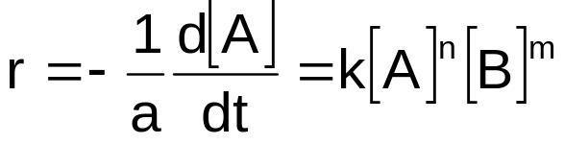

where,
n : order of reaction with respect to chemical species A
m: order of reaction with respect to chemical species B
n+m: overall order of reaction
k: reaction rate constant.
Rate constants generally vary significantly with temperature.

Order of Reaction
Important: For a given reaction
a A + b B → c C
n is not necessarily equal to a
m is not necessarily equal to b
m and n must be determined experimentally

For instance, the rate for the reaction
H₂ + I₂ → 2 HI
is determined experimentally to be:
r = k[H₂][I₂]
but, the rate for the reaction
H₂ + Br₂ → 2 HBr
is found to be:
r = k[H₂][Br₂]^{1/2}

Method of the Initial Rates
In the method of initial rates, the instantaneous rate of reaction is determined at the beginning of the reaction, before reactant concentrations have changed significantly.
Consider the reaction:
NH₄⁺(aq) + NO₂⁻(aq) → N₂(aq) + 2 H₂O(l)
The following rate law is proposed:
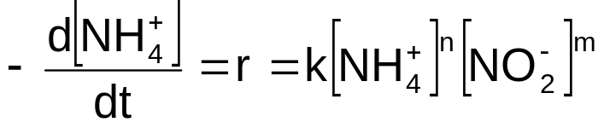
The following set of experimental data was measured:
 | [NH₄⁺]º | [NO₂⁻]º | rº (mol/L.s)
1 | 0.1 M | 0.005 M | 1.35x10⁻⁷
2 | 0.1 M | 0.01 M | 2.7x10⁻⁷
3 | 0.2 M | 0.01 M | 5.4x10⁻⁷
where the superscript º indicates initial conditions.
Therefore for experiments 1 and 2,
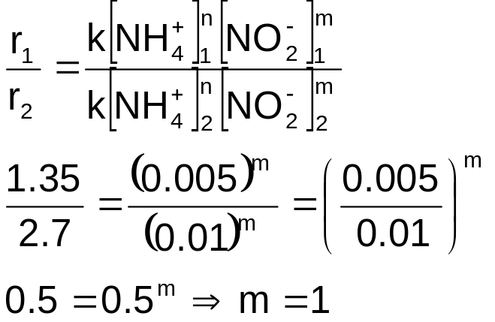
Similarly, for reactions 2 and 3,
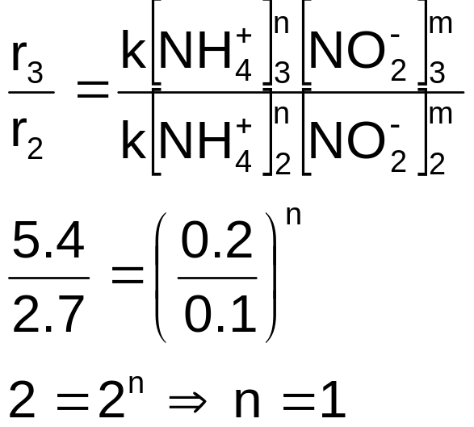
Therefore, the differential rate law is:
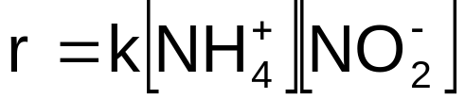
and an estimate of the rate constant can be calculated by:
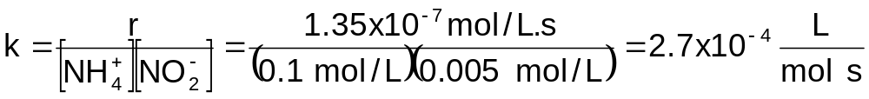

Integrated Rate Laws
Differential rate laws can be integrated in time to generate integrated rate laws. For instance, given that for the reaction
N₂O₅ → 2 NO₂ + ½ O₂
the differential rate law is
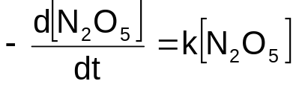

ln C slope = -k

t
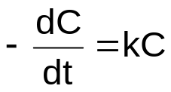

The integrated rate law can be calculated as
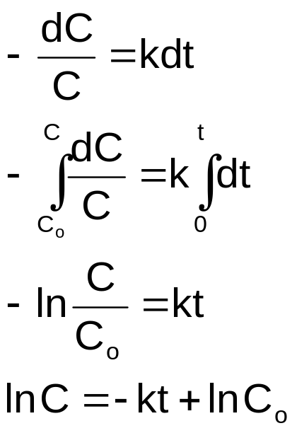

Therefore, a plot of ln C versus t is linear, with slope –k and intercept ln C_{o} for first order reactions.

For second order reactions,

1/C
slope = k

t

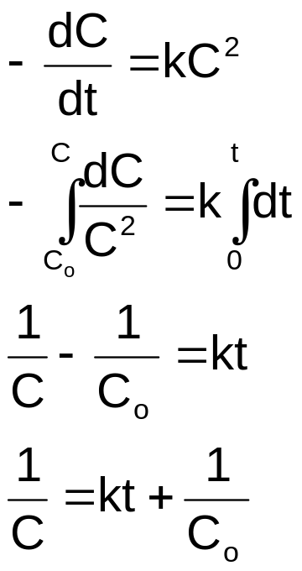

Plot the data of Example 2 as a 1st and as a 2nd order reactions and verify which rate law better represents the data.

Half-Life of Reactions
Half –life (t_{1/2})of a reactant is the time required for its concentration to decrease to ½ of its original value.
1st order reactions
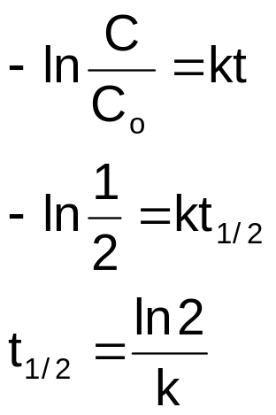

2nd order reactions
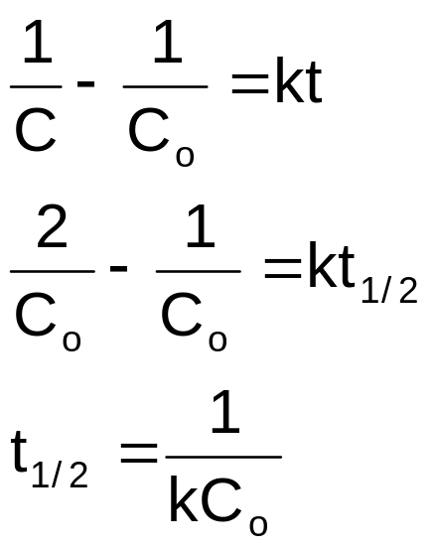
Note that this concept can be easily extended to other concentrations. One can easily define a t_{1/3}, t_{1/5}, etc.

