Galvanic Cell  Spontaneous Reaction  Cathode– Reduction + Anode – Oxidation - | E_{cell} is Positive  ΔG is Negative | In a galvanic cell. Current flows from the positive electrode (cathode in this case) through the external load and then into the negative electrode (anode in this case.
Electrolytic Cell  Need an External Power Source  Cathode - Reduction -Anode – Oxidation + | E_{cell} is Negative  ΔG is Positive | In the case of an electrolytic cell, current leaves the positive terminal of the power source, flows through the anode (positive electrode), then across the electrolyte to the cathode, then through the cathode and back to the negative terminal of the power supply.
Current (opposite to the flow of electrons) | + into the Anode | - into the Cathode
Anodic Reaction | Current is + | Electrode reaction equivalent to a transfer of positive charge from the electronic to the ionic conductor. An anodic reaction is an oxidation process. An example is:  Me -> Me(+n) + n(e-).  LEO – loss of electron oxidation
Cathodic Reaction | Current - | Electrode reaction equivalent to a transfer of negative charge from the electronic to the ionic conductor. A cathodic reaction is a reduction process. An example is:  Ox + n(e-) -> Red.  GER – gain of electron Reduction
- if the actual electrode potential 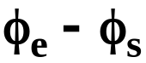 exceeds E, then the reaction proceeds in the anodic reaction
- if 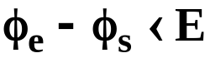, then the reaction proceeds cathodically
- if 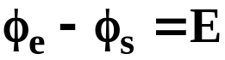, then the reaction is at equilibrium

How do we determine E?
either read Eº from tables or compute Eº from tabulated μº (or 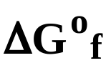) values using Eqn. (12) when at standard conditions 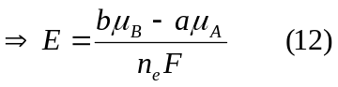
- compute  term from the concentrations of the species in the solution
How to use the Nernst formula:
  - write reaction with electrons on the RHS regardless of the way reaction is actually occurring, i.e., 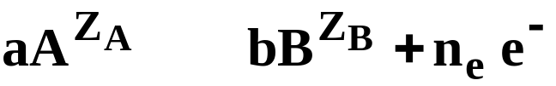
⇌
DO NOT change the sign of E°_{H} from table.
  - use “+” sign in front of ℓn term
  - put activity of products in numerator of ℓn term; put activity of reactants in denominator
  - either read E° from table or calculate E° using
