Name: Prajakta Rajendra Bhosale
Roll No: 4012
Batch: R-10
Problem Statement: Android-database Connectivity: Create a SQLite Database for an Android Application and perform CRUD (Create, Read, Update and Delete) database operations.

Code:

MainActivity.java:

package com.example.assignment3;

import androidx.appcompat.app.AlertDialog;
import androidx.appcompat.app.AppCompatActivity;

import android.content.DialogInterface;
import android.database.sqlite.SQLiteException;
import android.os.Bundle;
import android.view.View;
import android.widget.EditText;
import android.widget.TextView;
import android.widget.Toast;

public class MainActivity extends AppCompatActivity {

EditText firstname, lastname;
TextView textview;
DB_Controller controller;

@Override
protected void onCreate(Bundle savedInstanceState) {
super.onCreate(savedInstanceState);
setContentView(R.layout.activity_main);

firstname = (EditText) findViewById(R.id.firstname_input);
lastname = (EditText) findViewById(R.id.lastname_input);
textview = (TextView) findViewById(R.id.textView);

controller = new DB_Controller(this,"",null,1);
}

public void btn_click(View view) {
switch (view.getId()) {
case R.id.button_add:
try {
controller.insert_student(firstname.getText().toString(),lastname.getText().toString());
}
catch (SQLiteException e) {
Toast.makeText(MainActivity.this,"ALREADY EXISTS",Toast.LENGTH_SHORT).show();
}
break;

case R.id.button_delete:
controller.delete_student(firstname.getText().toString());
break;

case R.id.button_update:
AlertDialog.Builder dialog = new AlertDialog.Builder(MainActivity.this);
dialog.setTitle("ENTER NEW FIRSTNAME");

final EditText new_firstname = new EditText(this);
dialog.setView(new_firstname);

dialog.setPositiveButton("OK", new DialogInterface.OnClickListener() {
@Override
public void onClick(DialogInterface dialogInterface, int i) {
controller.update_student(firstname.getText().toString(),new_firstname.getText().toString());
}
});
dialog.show();
break;

case R.id.list_students:
controller.list_all_students(textview);
break;
}
}
}

DB_Controller.java

package com.example.assignment3;
import android.content.ContentValues;
import android.content.Context;
import android.database.Cursor;
import android.database.sqlite.SQLiteDatabase;
import android.database.sqlite.SQLiteOpenHelper;
import android.widget.TextView;

import androidx.annotation.Nullable;

public class DB_Controller extends SQLiteOpenHelper {
public DB_Controller(@Nullable Context context, @Nullable String name, @Nullable SQLiteDatabase.CursorFactory factory, int version) {
super(context, "TEST.db", factory, version);
}

@Override
public void onCreate(SQLiteDatabase sqLiteDatabase) {
sqLiteDatabase.execSQL("CREATE TABLE STUDENTS(ID INTEGER PRIMARY KEY AUTOINCREMENT, FIRSTNAME TEXT UNIQUE, LASTNAME TEXT);");
}

@Override
public void onUpgrade(SQLiteDatabase sqLiteDatabase, int i, int i1) {
sqLiteDatabase.execSQL("DROP TABLE IF EXISTS STUDENTS;");
onCreate(sqLiteDatabase);
}

public void insert_student(String firstname, String lastname) {
ContentValues contentValues = new ContentValues();
contentValues.put("FIRSTNAME",firstname);
contentValues.put("LASTNAME",lastname);
this.getWritableDatabase().insertOrThrow("STUDENTS","",contentValues);
}

public void delete_student(String firstname) {
this.getWritableDatabase().delete("STUDENTS","FIRSTNAME='"+firstname+"'",null);
}

public void update_student(String old_firstname, String new_firstname) {
this.getWritableDatabase().execSQL("UPDATE STUDENTS SET FIRSTNAME='"+new_firstname+"' WHERE FIRSTNAME='"+old_firstname+"'");
}

public void list_all_students(TextView textView) {
Cursor cursor = this.getReadableDatabase().rawQuery("SELECT * FROM STUDENTS",null);
textView.setText("");
while (cursor.moveToNext()) {
textView.append(cursor.getString(1) + " " + cursor.getString(2)+"\n");
}
}
}

activity_main.xml:

<?xml version="1.0" encoding="utf-8"?>
<LinearLayout xmlns:android="http://schemas.android.com/apk/res/android"
xmlns:app="http://schemas.android.com/apk/res-auto"
xmlns:tools="http://schemas.android.com/tools"
android:id="@+id/linear"
android:layout_width="match_parent"
android:layout_height="match_parent"
android:orientation="vertical"
tools:context=".MainActivity">

<EditText
android:id="@+id/firstname_input"
android:layout_width="match_parent"
android:layout_height="wrap_content"
android:layout_marginTop="10dp"
android:hint="Firstname" />

<EditText
android:id="@+id/lastname_input"
android:layout_width="match_parent"
android:layout_height="wrap_content"
android:layout_marginTop="10dp"
android:hint="Lastname" />

<Button
android:id="@+id/button_add"
android:layout_width="match_parent"
android:layout_height="wrap_content"
android:layout_marginTop="10dp"
android:onClick="btn_click"
android:text="Add Student" />

<Button
android:id="@+id/button_delete"
android:layout_width="match_parent"
android:layout_height="wrap_content"
android:layout_marginTop="10dp"
android:onClick="btn_click"
android:text="Delete Student" />

<Button
android:id="@+id/button_update"
android:layout_width="match_parent"
android:layout_height="wrap_content"
android:layout_marginTop="10dp"
android:onClick="btn_click"
android:text="Update Student" />

<Button
android:id="@+id/list_students"
android:layout_width="match_parent"
android:layout_height="wrap_content"
android:layout_marginTop="10dp"
android:onClick="btn_click"
android:text="List Student" />

<TextView
android:id="@+id/textView"
android:layout_width="match_parent"
android:layout_height="wrap_content"
android:layout_marginTop="10dp"
android:gravity="top|center"
android:text="Display Data"
android:textAppearance="?android:attr/textAppearanceLarge" />

</LinearLayout>

Output:
Add Student (Sahil Bhosale) Delete Student (Sahil Bhosale)
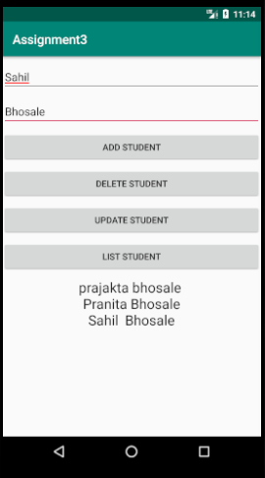
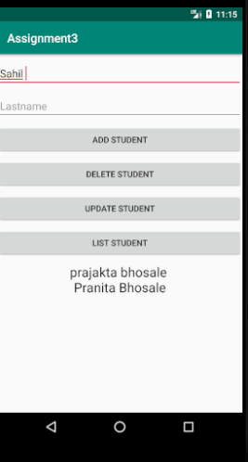

Update Student (Pranita) List Students
