Hello Corinne,

From: Corinne Nagle <corinne.nagle@veeva.com>
Sent: Monday, August 18, 2025 8:21 AM
To: Lay, Yvonne <yvonne.lay@abbott.com>
Cc: Raynard, Dan <daniel.raynard@abbott.com>; Roy, Susobhan <susobhan.roy@abbott.com>; O'Neill, Megan <megan.oneill@abbott.com>; Abaniel, Richard <richard.abaniel@abbott.com>; Shukla, Druti <druti.shukla@abbott.com>; Narina, Chaithanya <chaithanya.narina@abbott.com>; Hu, Qihong <qihong.hu@abbott.com>; Katie Puckett <katie.puckett@veeva.com>; julia.deng@veeva.com; Sharma, Anirudh <anirudh.sharma1@abbott.com>; John Czerwinski <john.czerwinski@veeva.com>; Ahmed, Asif Abrar <Asif.Ahmed@abbott.com>; Kingan, Andrew <andy.kingan@abbott.com>; Leverant, Kalvina <kalvina.leverant@abbott.com>; Tanguturi, Maheswari <maheswari.tanguturi@abbott.com>; Hari Bhanu Prasanth, Gogula <gogula.haribhanuprasanth@abbott.com>; Barrett, Adam C <adam.barrett@abbott.com>; Madnani, Heena <heena.madnani@abbott.com>; Novodvorska, Kateryna <kateryna.novodvorska@abbott.com>
Subject: Re: ADC Veeva MedInquiry : CRM Integration - Recurring Inquiry Push Job Error

Hi, This is a quick permission set update once the change request is approved. Thanks, Corinne On Fri, Aug 15, 2025 at 7: 46 PM Lay, Yvonne <yvonne. lay@ abbott. com> wrote: Hi Dan, This change should be managed through Veeva, and we’ll need
ZjQcmQRYFpfptBannerStart
This Message is From an External Sender
Only click links or open attachments if you recognize the sender and know the content is safe.
Report Suspicious ‌

ZjQcmQRYFpfptBannerEnd
Hi,
This is a quick permission set update once the change request is approved.
Thanks,
Corinne

On Fri, Aug 15, 2025 at 7:46 PM Lay, Yvonne <yvonne.lay@abbott.com> wrote:
Hi Dan,

This change should be managed through Veeva, and we’ll need to follow the appropriate documentation process. I’ll have Ani begin drafting the documentation on Monday, August 15th and will aim to complete it by noon.

@Sharma, Anirudh – Please share an update once you're ready for Veeva to proceed with the changes.

@corinne.nagle@veeva.com – Will you be supporting the changes in SalesAssist? If so, based on the details below, how quickly do you anticipate they can be implemented?

Yvonne

From: Raynard, Dan <daniel.raynard@abbott.com>
Sent: Wednesday, August 13, 2025 9:56 AM
To: Roy, Susobhan <susobhan.roy@abbott.com>; O'Neill, Megan <megan.oneill@abbott.com>; Abaniel, Richard <richard.abaniel@abbott.com>; Shukla, Druti <druti.shukla@abbott.com>; Narina, Chaithanya <chaithanya.narina@abbott.com>; Hu, Qihong <qihong.hu@abbott.com>; Katie Puckett <katie.puckett@veeva.com>; julia.deng@veeva.com; Lay, Yvonne <yvonne.lay@abbott.com>; corinne.nagle@veeva.com
Cc: John Czerwinski <john.czerwinski@veeva.com>; Ahmed, Asif Abrar <Asif.Ahmed@abbott.com>; Kingan, Andrew <andy.kingan@abbott.com>; Leverant, Kalvina <kalvina.leverant@abbott.com>; Tanguturi, Maheswari <maheswari.tanguturi@abbott.com>; Hari Bhanu Prasanth, Gogula <gogula.haribhanuprasanth@abbott.com>; Barrett, Adam C <adam.barrett@abbott.com>
Subject: RE: ADC Veeva MedInquiry : CRM Integration - Recurring Inquiry Push Job Error

Hi All,

It looks like the integration permission set criteria for Med Info user didn’t make it to Production. We’ll need to update the Edit Access for address, city, state, and zip to mirror the same permissions tested in Full Sandbox. This should resolve the push sync error “Unable to create/update fields: ADC_Primary_City__c”. @O'Neill, Megan – post update, this should resolve the missing Response Document Link for completed Medical Inquiries.

@Lay, Yvonne – let us know what is needed from documentation and if you’d like Veeva or the business to update.

Production – ADC_Med_Inquiry_Vault_Integration Permission Set
https://salesassist.lightning.force.com/lightning/setup/PermSets/page?address=%2F0PSHq000001P3Sh%3Fs%3DEntityPermissions%26o%3D01I1U0000007nNs
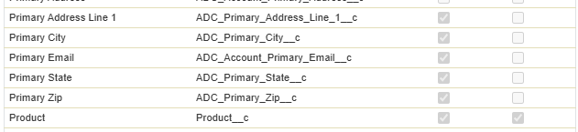

Full Sandbox – ADC_Med_Inquiry_Vault_Integration Permission Set
https://salesassist--full.sandbox.my.salesforce-setup.com/lightning/setup/PermSets/page?address=%2F0PSD3000000BH7Z%3Fs%3DEntityPermissions%26o%3D01I1U0000007nNs
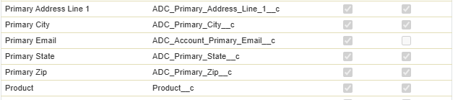

Thanks,
Dan
Daniel Raynard
CRM Strategy & Channel Enablement Manager
M: +1 510-703-0290

From: Roy, Susobhan <susobhan.roy@abbott.com>
Sent: Thursday, August 7, 2025 4:45 AM
To: O'Neill, Megan <megan.oneill@abbott.com>; Raynard, Dan <daniel.raynard@abbott.com>; Abaniel, Richard <richard.abaniel@abbott.com>; Shukla, Druti <druti.shukla@abbott.com>; Narina, Chaithanya <chaithanya.narina@abbott.com>; Hu, Qihong <qihong.hu@abbott.com>; Katie Puckett <katie.puckett@veeva.com>; julia.deng@veeva.com; Lay, Yvonne <yvonne.lay@abbott.com>; corinne.nagle@veeva.com
Cc: John Czerwinski <john.czerwinski@veeva.com>; Ahmed, Asif Abrar <Asif.Ahmed@abbott.com>; Kingan, Andrew <andy.kingan@abbott.com>; Leverant, Kalvina <kalvina.leverant@abbott.com>; Tanguturi, Maheswari <maheswari.tanguturi@abbott.com>; Hari Bhanu Prasanth, Gogula <gogula.haribhanuprasanth@abbott.com>
Subject: RE: ADC Veeva MedInquiry : CRM Integration - Recurring Inquiry Push Job Error

Hi All,

Thank you for joining the call. Below is a summary of the key points discussed and agreed upon:

- Based on inputs from the Veeva team, it was evaluated that enabling the checkbox in question will not impact existing functionalities related to CRM integration or Open Data. With this confirmation, the business has agreed to proceed with enabling the checkbox in Production.

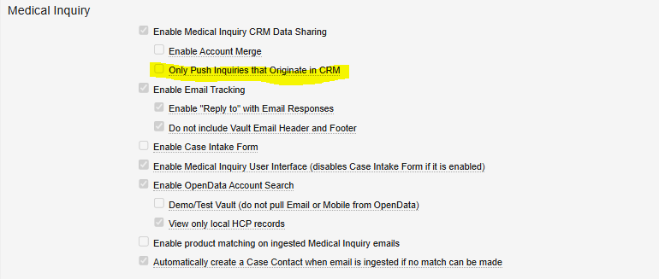

- The Veeva team confirmed that updates to Contact information by the integration user on the CRM side occur at the Inquiry level, not at the Account level. Therefore, this does not affect the principle that CRM account information remains the source of truth.

- To ensure that all expected Case object information related to responses is being correctly sent to CRM, a test was proposed in the lower environment. The test was successfully conducted and verified. (Please refer to the email trail for detailed results.)
The successful test also indicates a mismatch in access authority for the integration user between the lower and production environments.
@Raynard, Dan – Kindly share a tentative timeline for when the integration user's access can be aligned in the Production environment.

- It was also noted that for Non-Prescribed users, fields such as Primary Email Address and address details are non-mandatory on the CRM side. This will be reviewed for potential updates in a future release.

Please review and let us know if any points have been missed or if there are any concerns.

Thanks and Regards,
Susobhan Roy

Susobhan Roy  Software Consultant,  IBM Managed Services | IBM Delivery Center  Bangalore, India | Cell +91 9932221346  susobhan.roy@abbott.com
Upcoming Leaves: 13th June 2025
This communication may contain information that is proprietary, confidential, or exempt from disclosure. If you are not the intended recipient, please note that any other dissemination, distribution, use or copying of this communication is strictly prohibited. Anyone who receives this message in error should notify the sender immediately by telephone or by return e-mail and delete it from his or her computer.

From: O'Neill, Megan <megan.oneill@abbott.com>
Sent: Thursday, August 7, 2025 4:33 AM
To: Raynard, Dan <daniel.raynard@abbott.com>; Abaniel, Richard <richard.abaniel@abbott.com>; Roy, Susobhan <susobhan.roy@abbott.com>; Shukla, Druti <druti.shukla@abbott.com>; Narina, Chaithanya <chaithanya.narina@abbott.com>; Hu, Qihong <qihong.hu@abbott.com>; Tanguturi, Maheswari <maheswari.tanguturi@abbott.com>; Hari Bhanu Prasanth, Gogula <gogula.haribhanuprasanth@abbott.com>; Katie Puckett <katie.puckett@veeva.com>; julia.deng@veeva.com; Lay, Yvonne <yvonne.lay@abbott.com>; corinne.nagle@veeva.com
Cc: John Czerwinski <john.czerwinski@veeva.com>; Ahmed, Asif Abrar <Asif.Ahmed@abbott.com>; Kingan, Andrew <andy.kingan@abbott.com>; Leverant, Kalvina <kalvina.leverant@abbott.com>
Subject: Re: ADC Veeva MedInquiry : CRM Integration - Recurring Inquiry Push Job Error

Great news! Thank you Richard and Dan!

Be well,
Megan

For Medical Information Inquiries for HCPs, visit: https://www.medicalaffairs.abbott
 | Megan O'Neill, PA-C, CDCES  Sr Mgr Medical Engagement  Global Medical Affairs | Abbott Diabetes Care Inc.  1360 South Loop Road  Alameda, CA 94502 | M +1 831-402-7401  megan.oneill@abbott.com

The information provided to you in this communication is in response to an unsolicited request for information. The information provided may relate to a use and/or product that the FDA has not cleared/approved. ADC is not recommending or implying that you use any product referenced herein for an unapproved use.
This communication may contain information that is proprietary, confidential, or exempt from disclosure. If you are not the intended recipient, please note that any other dissemination, distribution, use or copying of this communication is strictly prohibited. Anyone who receives this message in error should notify the sender immediately by telephone or by return e-mail and delete it from his or her computer.

From: Raynard, Dan <daniel.raynard@abbott.com>
Sent: Wednesday, August 6, 2025 6:01 PM
To: Abaniel, Richard <richard.abaniel@abbott.com>; Roy, Susobhan <susobhan.roy@abbott.com>; O'Neill, Megan <megan.oneill@abbott.com>; Shukla, Druti <druti.shukla@abbott.com>; Narina, Chaithanya <chaithanya.narina@abbott.com>; Hu, Qihong <qihong.hu@abbott.com>; Tanguturi, Maheswari <maheswari.tanguturi@abbott.com>; Hari Bhanu Prasanth, Gogula <gogula.haribhanuprasanth@abbott.com>; Katie Puckett <katie.puckett@veeva.com>; julia.deng@veeva.com <julia.deng@veeva.com>; Lay, Yvonne <yvonne.lay@abbott.com>; corinne.nagle@veeva.com <corinne.nagle@veeva.com>
Cc: John Czerwinski <john.czerwinski@veeva.com>; Ahmed, Asif Abrar <Asif.Ahmed@abbott.com>; Kingan, Andrew <andy.kingan@abbott.com>; Leverant, Kalvina <kalvina.leverant@abbott.com>
Subject: RE: ADC Veeva MedInquiry : CRM Integration - Recurring Inquiry Push Job Error

Thanks, Richard. Both MIs passed the expected results in .full.

Expected result:
- Fulfillment Status field updates to Completed ✅
- Response Document Link field populates✅
- Response Notes field populates✅

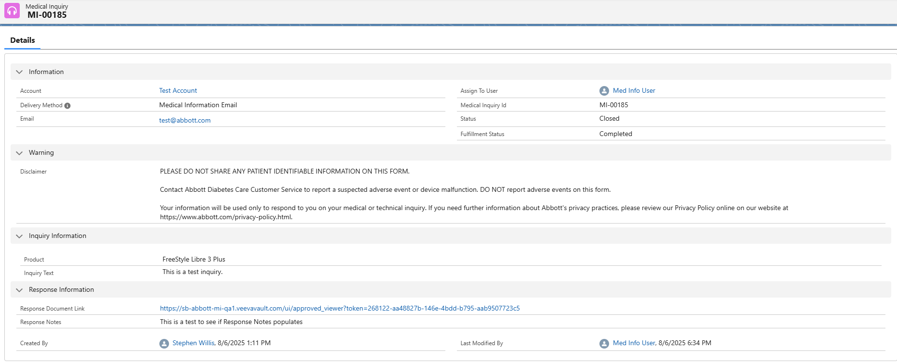
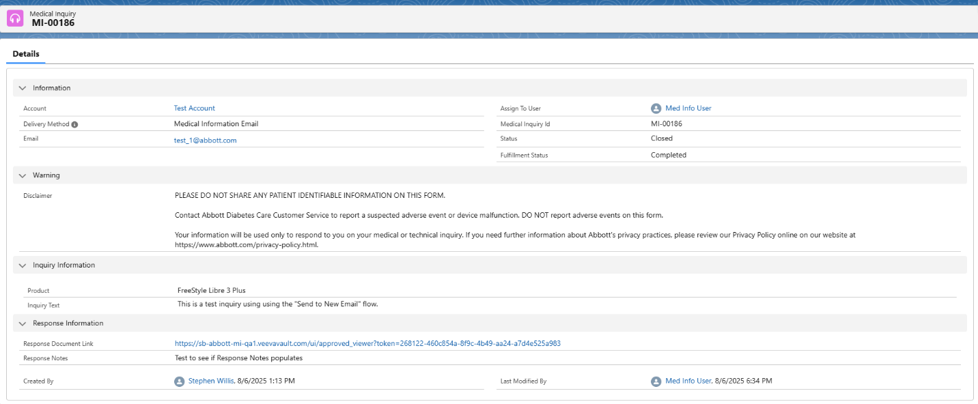

Daniel Raynard
CRM Strategy & Channel Enablement Manager
M: +1 510-703-0290

From: Abaniel, Richard <richard.abaniel@abbott.com>
Sent: Wednesday, August 6, 2025 3:02 PM
To: Raynard, Dan <daniel.raynard@abbott.com>; Roy, Susobhan <susobhan.roy@abbott.com>; O'Neill, Megan <megan.oneill@abbott.com>; Shukla, Druti <druti.shukla@abbott.com>; Narina, Chaithanya <chaithanya.narina@abbott.com>; Hu, Qihong <qihong.hu@abbott.com>; Tanguturi, Maheswari <maheswari.tanguturi@abbott.com>; Hari Bhanu Prasanth, Gogula <gogula.haribhanuprasanth@abbott.com>; Katie Puckett <katie.puckett@veeva.com>; julia.deng@veeva.com; Lay, Yvonne <yvonne.lay@abbott.com>; corinne.nagle@veeva.com
Cc: John Czerwinski <john.czerwinski@veeva.com>; Ahmed, Asif Abrar <Asif.Ahmed@abbott.com>; Kingan, Andrew <andy.kingan@abbott.com>; Leverant, Kalvina <kalvina.leverant@abbott.com>
Subject: RE: ADC Veeva MedInquiry : CRM Integration - Recurring Inquiry Push Job Error

Hi Dan,
I can confirm that I was able to see all necessary fields: name, delivery method, email, address (Street, City, State, Zip Code), submitter, product, and inquiry text. I have also completed both cases and filled the Response Notes and generated a Response List.

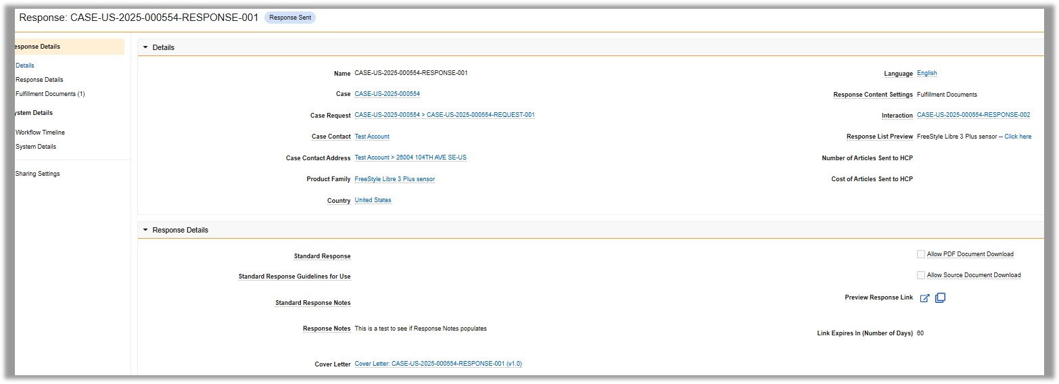
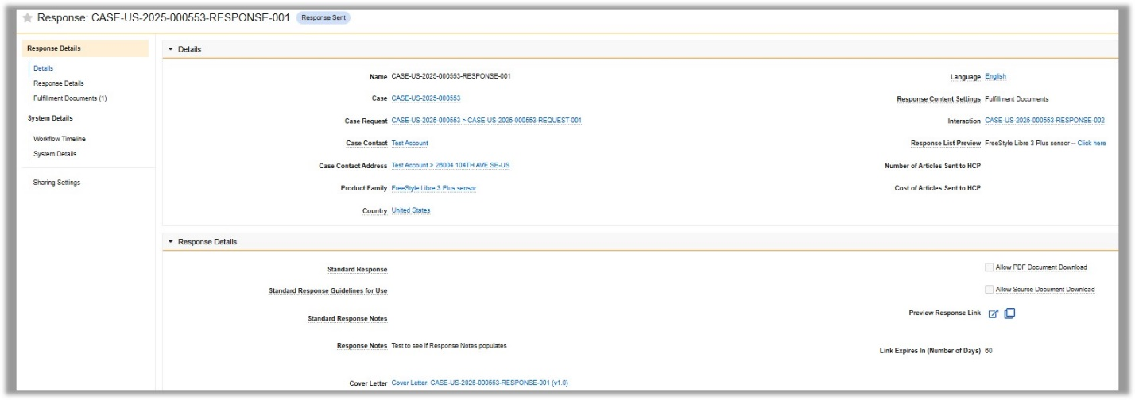

All the best,
Richard Abaniel

From: Raynard, Dan <daniel.raynard@abbott.com>
Sent: Wednesday, August 6, 2025 10:22 AM
To: Roy, Susobhan <susobhan.roy@abbott.com>; Abaniel, Richard <richard.abaniel@abbott.com>; O'Neill, Megan <megan.oneill@abbott.com>; Shukla, Druti <druti.shukla@abbott.com>; Narina, Chaithanya <chaithanya.narina@abbott.com>; Hu, Qihong <qihong.hu@abbott.com>; Tanguturi, Maheswari <maheswari.tanguturi@abbott.com>; Hari Bhanu Prasanth, Gogula <gogula.haribhanuprasanth@abbott.com>; Katie Puckett <katie.puckett@veeva.com>; julia.deng@veeva.com; Lay, Yvonne <yvonne.lay@abbott.com>; corinne.nagle@veeva.com
Cc: John Czerwinski <john.czerwinski@veeva.com>; Ahmed, Asif Abrar <Asif.Ahmed@abbott.com>; Kingan, Andrew <andy.kingan@abbott.com>; Leverant, Kalvina <kalvina.leverant@abbott.com>
Subject: RE: ADC Veeva MedInquiry : CRM Integration - Recurring Inquiry Push Job Error

@Abaniel, Richard below are two test inquiries within the Sandbox environment. Please confirm if you can see all necessary fields related to medical inquiry (name, delivery method, email, address, submitter, product, and inquiry text) and complete the cases. Roy – can you confirm if you see same primary city error within Sandbox?

Expected result:
- Fulfillment Status field updates to Completed
- Response Document Link field populates
- Response Notes field populates

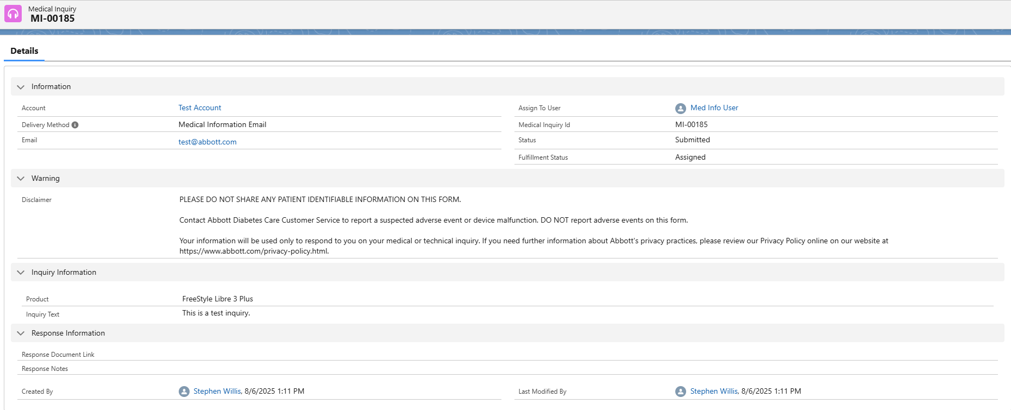

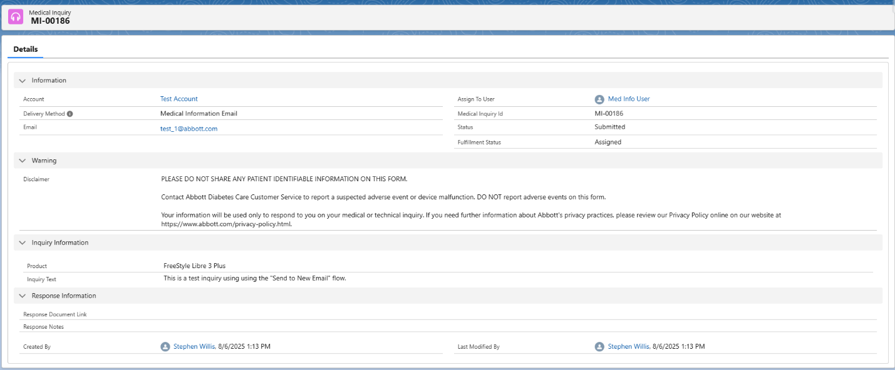

Daniel Raynard
CRM Strategy & Channel Enablement Manager
M: +1 510-703-0290

-----Original Appointment-----
From: Roy, Susobhan <susobhan.roy@abbott.com>
Sent: Monday, August 4, 2025 10:26 AM
To: Roy, Susobhan; Abaniel, Richard; O'Neill, Megan; Shukla, Druti; Narina, Chaithanya; Hu, Qihong; Tanguturi, Maheswari; Hari Bhanu Prasanth, Gogula; Katie Puckett; julia.deng@veeva.com; Raynard, Dan; Lay, Yvonne; corinne.nagle@veeva.com
Cc: John Czerwinski; Ahmed, Asif Abrar; Kingan, Andrew; Leverant, Kalvina
Subject: ADC Veeva MedInquiry : CRM Integration - Recurring Inquiry Push Job Error
When: Wednesday, August 6, 2025 10:00 PM-10:30 PM (UTC+05:30) Chennai, Kolkata, Mumbai, New Delhi.
Where: Microsoft Teams Meeting

Rescheduling as per business availability.
Hi All,
This meeting has been scheduled to align on the following key points related to the Veeva MedInquiry – CRM Integration:

- Status update on the fix for the integration user permission issue on the CRM side
- Clarification on disabling the feature that sends inquiry information from other channels to CRM
Your participation will be appreciated to ensure alignment and clarity on these topics. Looking forward to your inputs during the discussion.

Thanks and Regards,
Susobhan Roy

________________________________________________________________________________
Microsoft Teams Need help?
Join the meeting now
Meeting ID: 262 302 515 295 9
Passcode: 3EM3KD6g

Dial in by phone
+91 22 6001 5207,,,,951710097# India, Mumbai
Find a local number
Phone conference ID: 951 710 097#
Join on a video conferencing device
Tenant key: abbott@m.webex.com
Video ID: 117 297 401 0
More info
For organizers: Meeting options | Reset dial-in PIN
Abbott Users: For more detail on joining a Teams meeting from a video device, click the Help link.
Org help
________________________________________________________________________________

--
Corinne Nagle
Managed Services Consultant
Veeva Systems
corinne.nagle@veeva.com

Upcoming Out of Office:

