From: Roy, Susobhan <susobhan.roy@abbott.com>
Sent: Wednesday, October 1, 2025 8:48 AM
To: Sharma, Anirudh <anirudh.sharma1@abbott.com>
Cc: Hu, Qihong <qihong.hu@abbott.com>; Kingan, Andrew <andy.kingan@abbott.com>; Raynard, Dan <daniel.raynard@abbott.com>; Madnani, Heena <heena.madnani@abbott.com>; Julia Deng <julia.deng@veeva.com>; Tanguturi, Maheswari <maheswari.tanguturi@abbott.com>; Hari Bhanu Prasanth, Gogula <gogula.haribhanuprasanth@abbott.com>; Kumar, Abhishek <abhishek.kumar34@abbott.com>; Gopalan, Kannan <kannan.gopalan@abbott.com>; Gupta, Muneeshwar <muneeshwar.gupta@abbott.com>; Raynard, Dan <daniel.raynard@abbott.com>; Corinne Nagle <corinne.nagle@veeva.com>; Katie Puckett <katie.puckett@veeva.com>
Subject: RE: ADC Veeva MedInquiry - CRM Integration Updates - QA Changes

Hi Anirudh,

Due to the updates at the CRM end, there needs to be updates made in the configuration at the MI side.
We have been working with SQA on the change control process.
The testing in SBX has been completed and we are expecting to complete the testing in QA by this week.

Will keep you posted on the progress.

Thanks and Regards,
Susobhan Roy

Susobhan Roy  Software Consultant,  IBM Managed Services | IBM Delivery Center  Bangalore, India | Cell +91 9932221346  susobhan.roy@abbott.com
Upcoming Leaves: 30th Sep and 1st Oct 2025
This communication may contain information that is proprietary, confidential, or exempt from disclosure. If you are not the intended recipient, please note that any other dissemination, distribution, use or copying of this communication is strictly prohibited. Anyone who receives this message in error should notify the sender immediately by telephone or by return e-mail and delete it from his or her computer.

From: Sharma, Anirudh <anirudh.sharma1@abbott.com>
Sent: Wednesday, October 1, 2025 8:50 PM
To: Katie Puckett <katie.puckett@veeva.com>; Corinne Nagle <corinne.nagle@veeva.com>; Roy, Susobhan <susobhan.roy@abbott.com>
Cc: Hu, Qihong <qihong.hu@abbott.com>; Kingan, Andrew <andy.kingan@abbott.com>; Raynard, Dan <daniel.raynard@abbott.com>; Madnani, Heena <heena.madnani@abbott.com>; Julia Deng <julia.deng@veeva.com>; Tanguturi, Maheswari <maheswari.tanguturi@abbott.com>; Hari Bhanu Prasanth, Gogula <gogula.haribhanuprasanth@abbott.com>; Kumar, Abhishek <abhishek.kumar34@abbott.com>; Gopalan, Kannan <kannan.gopalan@abbott.com>; Gupta, Muneeshwar <muneeshwar.gupta@abbott.com>; Raynard, Dan <daniel.raynard@abbott.com>
Subject: RE: ADC Veeva MedInquiry - CRM Integration Updates - QA Changes

Hi Team,
++ Kannan and Muneeshwar

This is a production defect, and per our SLA, such issues are expected to be resolved within 10 days. However, it has now been over 30 days since this was reported.

I’d appreciate it if we could expedite the resolution of this bug. Looping in Dan Raynard as the Business Process Owner for visibility and support.

Thanks in advance for your prompt attention.

Best,
Anirudh Sharma

From: Katie Puckett <katie.puckett@veeva.com>
Sent: Friday, September 26, 2025 1:57 PM
To: Corinne Nagle <corinne.nagle@veeva.com>
Cc: Roy, Susobhan <susobhan.roy@abbott.com>; Hu, Qihong <qihong.hu@abbott.com>; Kingan, Andrew <andy.kingan@abbott.com>; Raynard, Dan <daniel.raynard@abbott.com>; Madnani, Heena <heena.madnani@abbott.com>; Julia Deng <julia.deng@veeva.com>; Sharma, Anirudh <anirudh.sharma1@abbott.com>; Tanguturi, Maheswari <maheswari.tanguturi@abbott.com>; Hari Bhanu Prasanth, Gogula <gogula.haribhanuprasanth@abbott.com>; Kumar, Abhishek <abhishek.kumar34@abbott.com>
Subject: Re: ADC Veeva MedInquiry - CRM Integration Updates - QA Changes

Hi Susobhan, The MI Pull job errors have been resolved in QA, as Corinne mentioned the one push failure will go away once we enable the setting she mentions. Thanks, Katie Puckett On Fri, Sep 26, 2025 at 12: 36 PM Corinne Nagle <corinne. nagle@ veeva. com>
ZjQcmQRYFpfptBannerStart
This Message is From an External Sender
Only click links or open attachments if you recognize the sender and know the content is safe.
Report Suspicious ‌

ZjQcmQRYFpfptBannerEnd
Hi Susobhan,

The MI Pull job errors have been resolved in QA, as Corinne mentioned the one push failure will go away once we enable the setting she mentions.

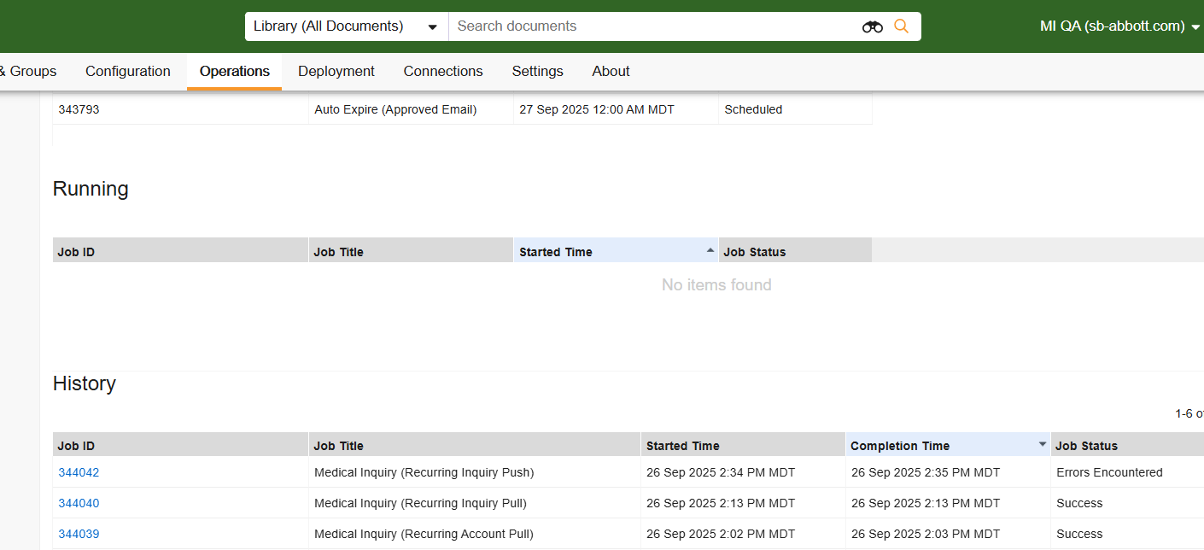

Thanks,

Katie Puckett

On Fri, Sep 26, 2025 at 12:36 PM Corinne Nagle <corinne.nagle@veeva.com> wrote:
Hi Susobhan,

We are working on resolving the pull errors. The push error should be resolved once you update the setting to 'Only Push Inquiries in CRM' to true; the error is due to a mismatch in the character limit for the field in Vault to CRM. This won't matter once this setting is updated because the MI in question originated in vault medical.
Thanks,
Corinne

On Thu, Sep 25, 2025 at 10:34 AM Roy, Susobhan <susobhan.roy@abbott.com> wrote:
Hi Corinne/Katie,

As requested, starting a new thread.
Attached are the current error logs form QA.
Once the above errors are fixed in QA , will proceed to make the below updates in MedInquiry :
1. Update CRM Field Names - Revise the CRM field names in the CRM Data Mapping object records for the following fields: Primary Address Line 1 , Primary City, Primary State and Primary Zip.
2. Inquiry Push Update - Enable the option to only push inquiries that originated within CRM.
3. Create Notification User Group - Establish a new user group to receive notifications on the completion status of CRM integration jobs.
Thanks and Regards,
Susobhan Roy

Susobhan Roy  Software Consultant,  IBM Managed Services | IBM Delivery Center  Bangalore, India | Cell +91 9932221346  susobhan.roy@abbott.com
Upcoming Leaves: 4th September 2025
This communication may contain information that is proprietary, confidential, or exempt from disclosure. If you are not the intended recipient, please note that any other dissemination, distribution, use or copying of this communication is strictly prohibited. Anyone who receives this message in error should notify the sender immediately by telephone or by return e-mail and delete it from his or her computer.

--
Corinne Nagle
Managed Services Consultant
Veeva Systems
corinne.nagle@veeva.com

Upcoming Out of Office:

