From: Raj Bhattacharjee <raj.bhattacharjee@veeva.com>
Sent: Wednesday, October 8, 2025 12:41 PM
To: Sharma, Anirudh <anirudh.sharma1@abbott.com>
Cc: Raynard, Dan <daniel.raynard@abbott.com>; Erla, Raj Kumar Reddy <rajkumarreddy.erla@abbott.com>; Madnani, Heena <heena.madnani@abbott.com>; Gopalan, Kannan <kannan.gopalan@abbott.com>
Subject: Re: Request to Reset NPI Account for Web Sampling Test

There are 2 records in the NCO Staging table that have the Network VID of the HCP and no associated compliance order. It therefore returns "Has an existing NCO Order". Delete those 2 records and it will reset. -- Raj Bhattacharjee
ZjQcmQRYFpfptBannerStart
This Message is From an External Sender
Only click links or open attachments if you recognize the sender and know the content is safe.
Report Suspicious ‌

ZjQcmQRYFpfptBannerEnd
There are 2 records in the NCO Staging table that have the Network VID of the HCP and no associated compliance order. It therefore returns "Has an existing NCO Order". Delete those 2 records and it will reset.

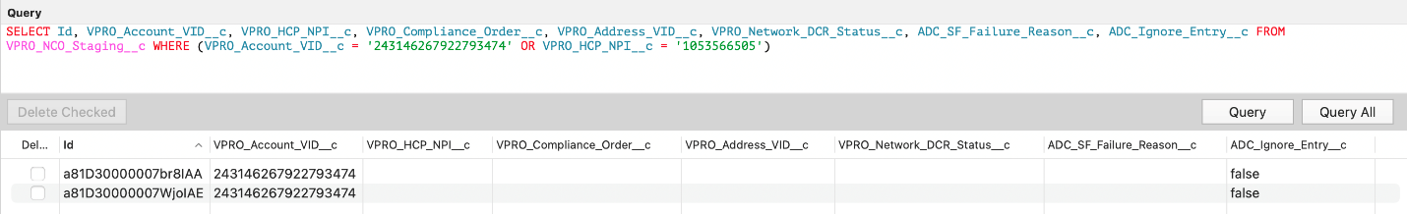

--
Raj Bhattacharjee
Veeva | Practice Manager, Commercial Technical Services

On Tue, Oct 7, 2025 at 5:33 PM Sharma, Anirudh <anirudh.sharma1@abbott.com> wrote:
Hello Raj,
Good day!
We are testing a jira requirement in full sandbox: [SAVEEVACRM-269] HCP CRM - MyInsights HCP Insights add Web Sample Date - Jira,
Requirement Summary:
As a sales user, we need to confirm if a web sample was completed for an account.
- Web samples are stored in the Compliance Order Object under Order Type = NCO Web Sampling.
- If Order Type = NCO Web Sampling AND Status = Completed Order, then display the Order Fulfilled Date.
- This date should appear below “Last Sample Date” as “Last Web Sample Date”.
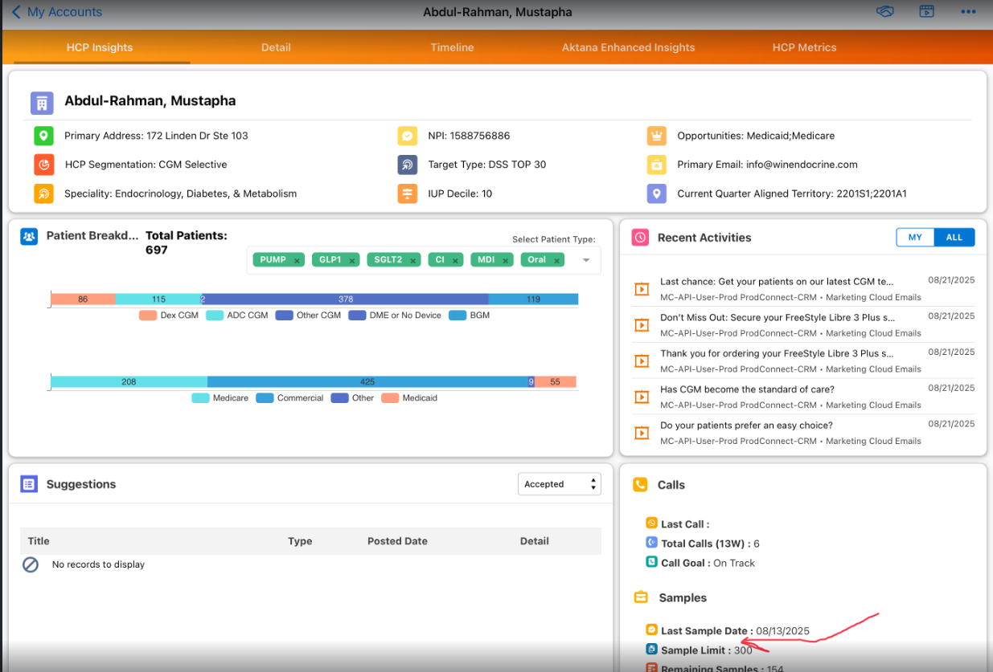
Current Test Details:
- Test user: Brian Odom
- Eligible HCP account: NPI #1053566505
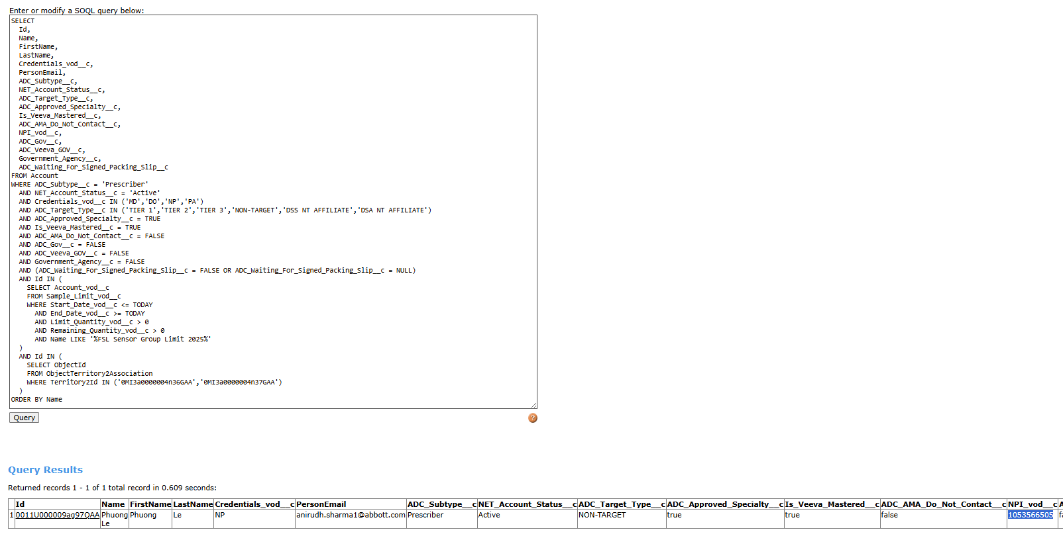
Issue Observed:
- When submitting a new order request from the web form, we encounter an error.
- No NCO orders currently exist for this HCP.
- The website team confirmed the web form is functioning as expected, and the web service returns:
{
"hasOpenDCR": true,
"hasExistingNCOOrder": true,
"LastNCOOrderStatus": "Has an existing NCO Order"
}
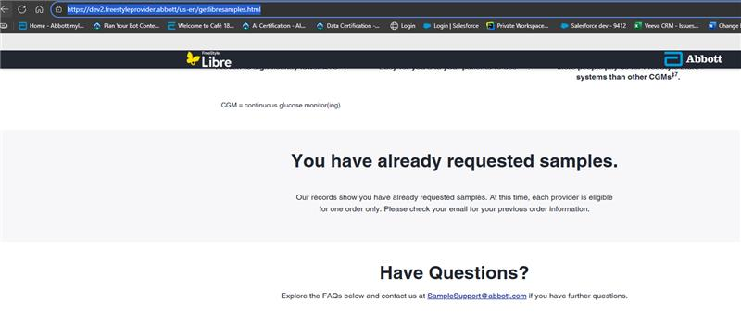

Request:
Could you please reset this NPI account so we can test on the iPad whether the “Last Web Sample Date” updates correctly for Brian Odom?

Thank you for the support.

Best regards,
Anirudh Sharma

