From: Sharma, Anirudh
Sent: Friday, September 19, 2025 9:54 AM
To: Pavithra Vishwanath <pavithra.vishwanath@veeva.com>
Cc: Gopalan, Kannan <kannan.gopalan@abbott.com>; Madnani, Heena <heena.madnani@abbott.com>
Subject: Request for 15-Min Discussion on Duplicate Orders Issue

Hello Pavithra,
Greetings!
During a short release in July, we had reported an issue with duplicate orders in the full sandbox, which you had kindly helped resolve (email attached).
Recently, a similar issue has been reported in the production environment, where duplicate orders are being placed for an HCP:
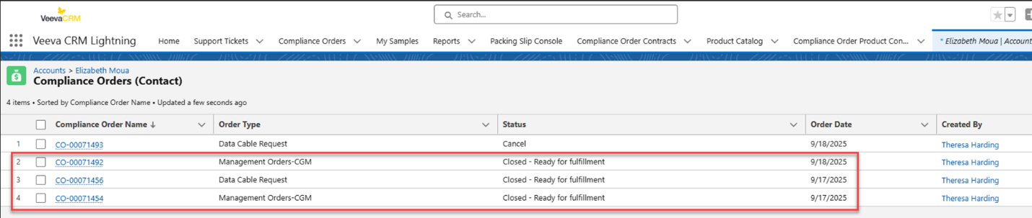
Would you be available for a 15-minute discussion today or Monday to help us understand what was fixed in the sandbox and what corrective actions we can take in production?
Thanks for the support.

Best regards,
Anirudh Sharma

