From: Lay, Yvonne <yvonne.lay@abbott.com>
Sent: Tuesday, August 19, 2025 6:46 PM
To: Raj Bhattacharjee <raj.bhattacharjee@veeva.com>
Cc: Liu, Janet <janet.liu@abbott.com>; Kelley, Jamila M <jamila.kelley@abbott.com>; Karthikeyan, Krithika <krithika.karthikeyan@abbott.com>; Erla, Raj Kumar Reddy <rajkumarreddy.erla@abbott.com>; Singh, Abhisar <abhisar.singh@abbott.com>; Madnani, Heena <heena.madnani@abbott.com>; Sharma, Anirudh <anirudh.sharma1@abbott.com>; Novodvorska, Kateryna <kateryna.novodvorska@abbott.com>
Subject: RE: Project Carbon – Testing Issues Identified
Importance: High

Hi Raj,

Great news—Janet and I completed the retesting, and everything has passed!

However, we did observe two issues. Could you review and share your feedback? Thanks!

- Eligibility Flag Behavior
The HCP is eligible for ordering samples. When we manually update an HCP with Approved Specialty = false, the existing sample order link still remains active. According to one of the criteria, only HCPs with Approved Specialty = true should be able to submit new sample requests. This behavior could lead to unauthorized sample orders.

- Reordering Risk
If an order is in the “Closed – Ready for Fulfillment” status on the compliance page and Packing Slip Status=null, the account is not stamped with “Waiting for Packing Slip.” As a result, the website allows a new order to be submitted, which poses a risk of multiple orders being placed simultaneously.

From: Raj Bhattacharjee <raj.bhattacharjee@veeva.com>
Sent: Tuesday, August 19, 2025 1:59 PM
To: Lay, Yvonne <yvonne.lay@abbott.com>
Cc: Liu, Janet <janet.liu@abbott.com>; Kelley, Jamila M <jamila.kelley@abbott.com>; Karthikeyan, Krithika <krithika.karthikeyan@abbott.com>; Erla, Raj Kumar Reddy <rajkumarreddy.erla@abbott.com>; Singh, Abhisar <abhisar.singh@abbott.com>; Madnani, Heena <heena.madnani@abbott.com>; Sharma, Anirudh <anirudh.sharma1@abbott.com>; Novodvorska, Kateryna <kateryna.novodvorska@abbott.com>
Subject: Re: Project Carbon – Testing Issues Identified

I believe all the issues are fixed now. Please retest. @Lay, Yvonne, i have removed all the bad records that were stuck in the NCO staging. They were causing issues with the AI returning unintended records. You report may be some of the "duplicate"
ZjQcmQRYFpfptBannerStart
This Message is From an External Sender
Only click links or open attachments if you recognize the sender and know the content is safe.
Report Suspicious ‌

ZjQcmQRYFpfptBannerEnd
I believe all the issues are fixed now. Please retest.

@Lay, Yvonne, i have removed all the bad records that were stuck in the NCO staging. They were causing issues with the AI returning unintended records. You report may be some of the "duplicate" records

--
Raj Bhattacharjee
Veeva | Practice Manager, Commercial Technical Services

On Tue, Aug 19, 2025 at 2:47 PM Lay, Yvonne <yvonne.lay@abbott.com> wrote:
Thank you for confirming the issues are fixed.

@Kelley, Jamila M @Liu, Janet @Karthikeyan, Krithika We can resume testing this afternoon. I will share the test links in a separate thread. Thanks!

From: Lay, Yvonne
Sent: Tuesday, August 19, 2025 9:58 AM
To: 'Raj Bhattacharjee' <raj.bhattacharjee@veeva.com>
Cc: Liu, Janet <janet.liu@abbott.com>; Kelley, Jamila M <jamila.kelley@abbott.com>; Karthikeyan, Krithika <krithika.karthikeyan@abbott.com>; Erla, Raj Kumar Reddy <rajkumarreddy.erla@abbott.com>; Singh, Abhisar <abhisar.singh@abbott.com>; Madnani, Heena <heena.madnani@abbott.com>; Sharma, Anirudh <anirudh.sharma1@abbott.com>; Novodvorska, Kateryna <kateryna.novodvorska@abbott.com>
Subject: RE: Project Carbon – Testing Issues Identified
Importance: High

I have one more issue. Could you check and inform us asap? Thanks!

The T&C is still showing the old version (VF0046) but it should be VF0052.

CO-00058718

<Fixed>

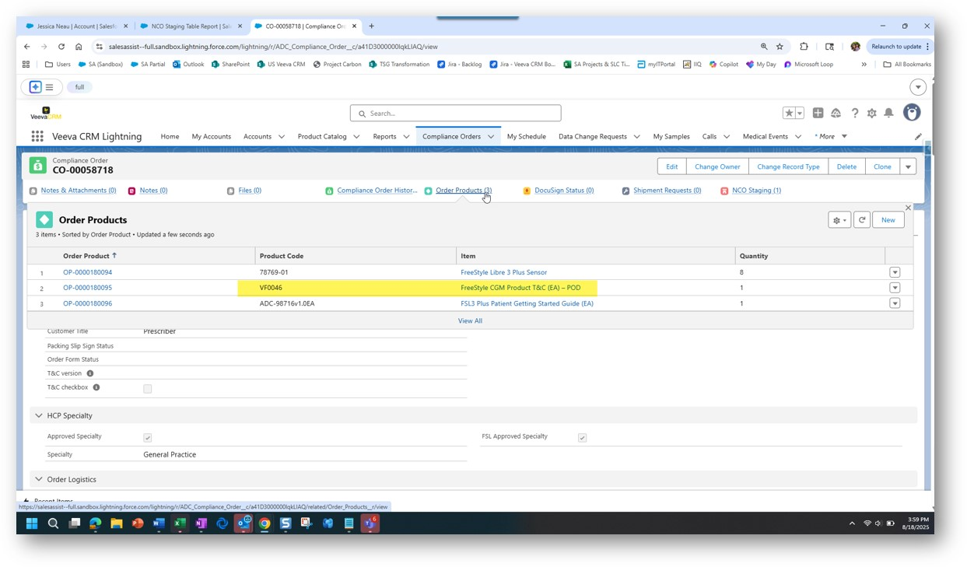

From: Lay, Yvonne
Sent: Monday, August 18, 2025 6:06 PM
To: 'Raj Bhattacharjee' <raj.bhattacharjee@veeva.com>
Cc: Liu, Janet <janet.liu@abbott.com>; Kelley, Jamila M <jamila.kelley@abbott.com>; Karthikeyan, Krithika <krithika.karthikeyan@abbott.com>; Erla, Raj Kumar Reddy <rajkumarreddy.erla@abbott.com>; Singh, Abhisar <abhisar.singh@abbott.com>; Madnani, Heena <heena.madnani@abbott.com>; Sharma, Anirudh <anirudh.sharma1@abbott.com>; Novodvorska, Kateryna <kateryna.novodvorska@abbott.com>
Subject: RE: Project Carbon – Testing Issues Identified

One more issue.

Raj Kumar submitted one web form for the following NPI:
- NPI: 1598700213
- Name: Irene Newton

However, there are two order links associated with the account:
- CO-00058711 – This compliance order appears to have been generated from the NCO record.
- CO-00058710 – It's unclear how this order was created.
<Fixed>

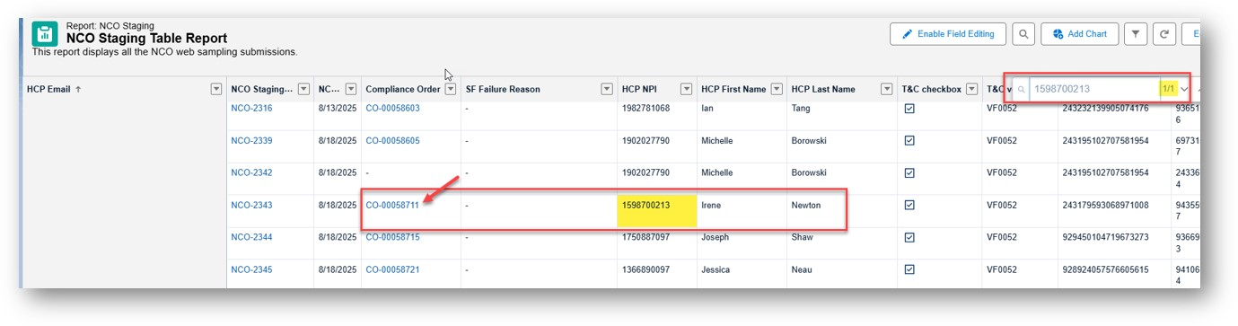
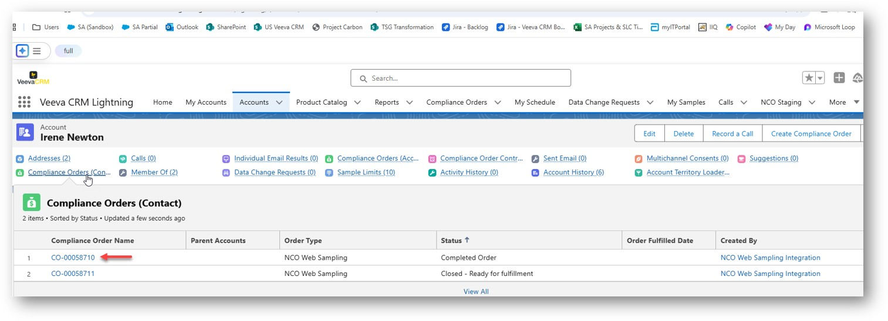

From: Lay, Yvonne
Sent: Monday, August 18, 2025 5:59 PM
To: Raj Bhattacharjee <raj.bhattacharjee@veeva.com>
Cc: Liu, Janet <janet.liu@abbott.com>; Kelley, Jamila M <jamila.kelley@abbott.com>; Karthikeyan, Krithika <krithika.karthikeyan@abbott.com>; Erla, Raj Kumar Reddy <rajkumarreddy.erla@abbott.com>; Singh, Abhisar <abhisar.singh@abbott.com>; Madnani, Heena <heena.madnani@abbott.com>; Sharma, Anirudh <anirudh.sharma1@abbott.com>; Novodvorska, Kateryna <kateryna.novodvorska@abbott.com>
Subject: Project Carbon – Testing Issues Identified

Hi Raj

We$B!G(Bve (Jamila, Janet, Krithia) completed another round of testing for Project Carbon and identified the following issues:

Could you prioritize and fix them? Thanks!

1. Terms & Conditions (T&C) Sync Issue (order CO-00058605)
The T&C acknowledged on the website are syncing correctly to the staging table and the associated staging record. However, this data is not syncing to the Compliance Order record. This functionality is currently working in production.

Ask: Ensure this is syncing correctly to the Compliance Order.

- T&C Version
- T&C Checkbox
<Fixed>
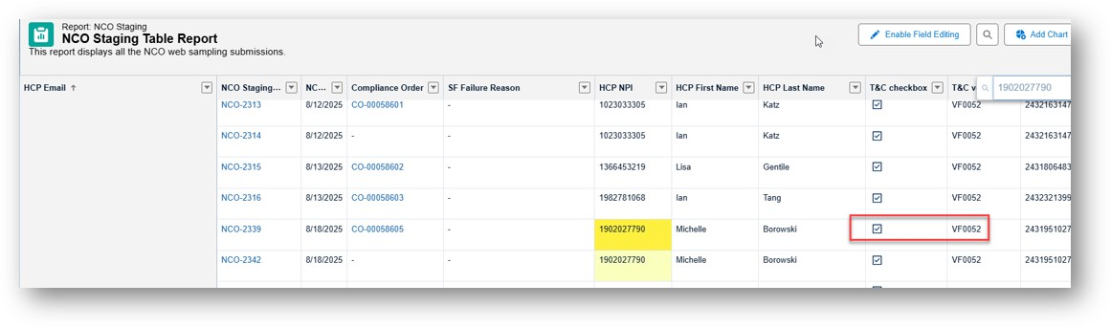
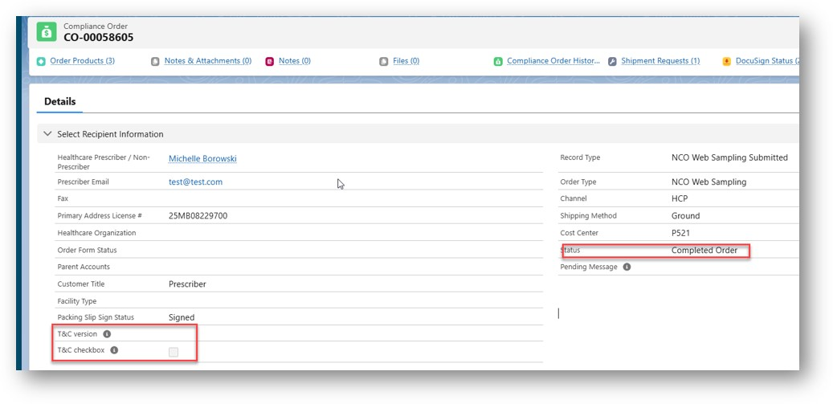

2. Reordering Functionality Issue:
After the initial order is completed—packing slip generated and account cleared—a new request is submitted via the website. While the staging table successfully receives the new order, a corresponding Compliance Order is not being created.

NPI: 1902027790 (Michelle Borowski)
- NCO-2339 $B"*(B Linked to Compliance Order CO-00058605
- NCO-2342 $B"*(B No Compliance Order created
NPI: 1366890097 (Jessica Neau)
- NCO-2345 $B"*(B Linked to Compliance Order CO-00058721
- NCO-2346 $B"*(B No Compliance Order created
<Fixed>

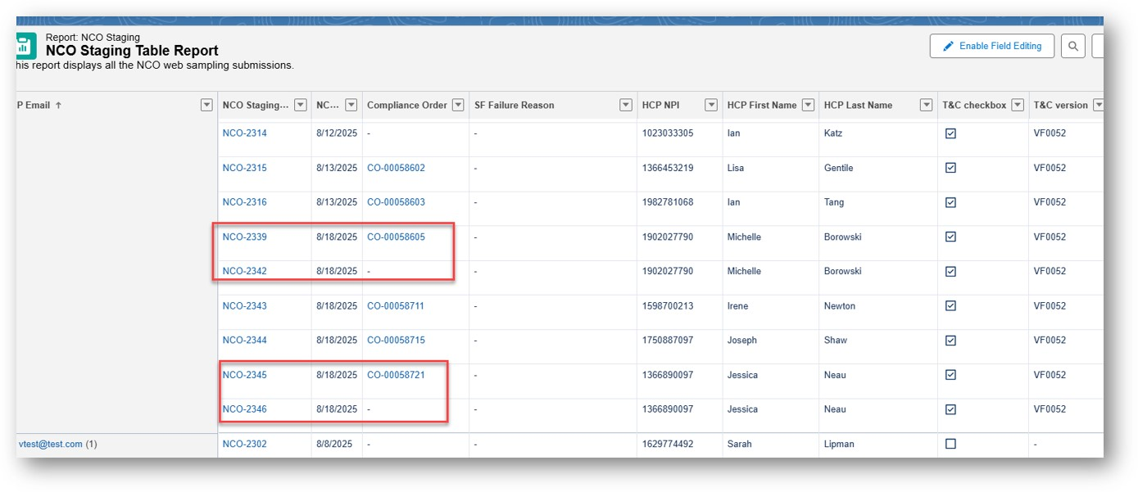

Yvonne

