From: Raj Bhattacharjee <raj.bhattacharjee@veeva.com>
Sent: Wednesday, September 10, 2025 9:56 AM
To: Erla, Raj Kumar Reddy <rajkumarreddy.erla@abbott.com>
Cc: Novodvorska, Kateryna <kateryna.novodvorska@abbott.com>; Pattanaik, Ipsita <ipsita.pattanaik@abbott.com>; Kommera, Deepthi <deepthi.kommera@abbott.com>; Choudhary, Deepak <deepak.choudhary1@abbott.com>; Desai, Shweta <shweta.desai@abbott.com>; Ghosh, Vivek <vivek.ghosh@abbott.com>; Pavan Kumar, Pathepur <pathepur.pavankumar@abbott.com>; Nair, Archana <archana.nair1@abbott.com>; Akhtar, Mohammed Waseem <mohammedwaseem.akhtar@abbott.com>; Sawaikar, Suyog <suyog.sawaikar@abbott.com>; Karthikeyan, Krithika <krithika.karthikeyan@abbott.com>; Sharma, Anirudh <anirudh.sharma1@abbott.com>; Singh, Abhisar <abhisar.singh@abbott.com>; Madnani, Heena <heena.madnani@abbott.com>
Subject: Re: ADC_Veeva_Gov_c Field Missing

The integration user does not have access to the field in CRM. @Novodvorska, Kateryna @Heena Madnani Do you want me to provide access to the "ADC - Read Only" Profile? -- Raj Bhattacharjee Veeva | Practice Manager, Commercial Technical
ZjQcmQRYFpfptBannerStart
This Message is From an External Sender
Only click links or open attachments if you recognize the sender and know the content is safe.
Report Suspicious ‌

ZjQcmQRYFpfptBannerEnd
The integration user does not have access to the field in CRM.

@Novodvorska, Kateryna @Heena Madnani Do you want me to provide access to the "ADC - Read Only" Profile?

--
Raj Bhattacharjee
Veeva | Practice Manager, Commercial Technical Services

On Wed, Sep 10, 2025 at 11:23 AM Erla, Raj Kumar Reddy <rajkumarreddy.erla@abbott.com> wrote:
Hi Raj B,

The ADC_Veeva_Gov__c field is missing from the response in both UAT and Production environments. Could you please investigate this? We're currently receiving the ADC_Gov__c field, but we need both fields to be included in the response. Now, only one is coming through. Which working fine on last Thursday .

Note: If you're making any changes in UAT or Production, please inform @Novodvorska, Kateryna. Also, check if there’s any potential impact on the SLC.

Thanks
Rajkumar

From: Janardhanan, Prajitha <prajitha.janardhanan@abbott.com>
Sent: Wednesday, September 10, 2025 7:45 AM
To: Erla, Raj Kumar Reddy <rajkumarreddy.erla@abbott.com>
Cc: Pattanaik, Ipsita <ipsita.pattanaik@abbott.com>; Kommera, Deepthi <deepthi.kommera@abbott.com>; Choudhary, Deepak <deepak.choudhary1@abbott.com>; Desai, Shweta <shweta.desai@abbott.com>; Ghosh, Vivek <vivek.ghosh@abbott.com>; Pavan Kumar, Pathepur <pathepur.pavankumar@abbott.com>; Nair, Archana <archana.nair1@abbott.com>; Akhtar, Mohammed Waseem <mohammedwaseem.akhtar@abbott.com>; Sawaikar, Suyog <suyog.sawaikar@abbott.com>
Subject: ADC_Veeva_Gov_c Flag Missing in Postman and Payload Response

Hi @Erla, Raj Kumar Reddy

We have noticed that ADC_Veeva_Gov_c flag is missing in Postman and in network payload response. This issue is occurring across all environments .

Postman screenshot :-

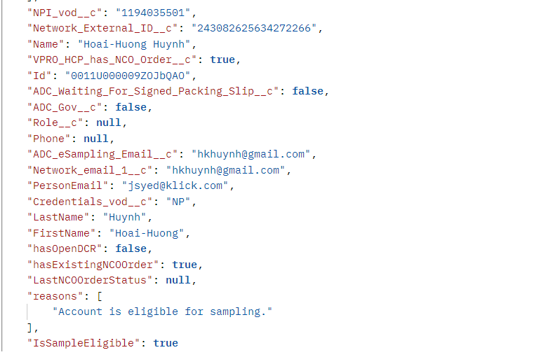

Network Payload :-

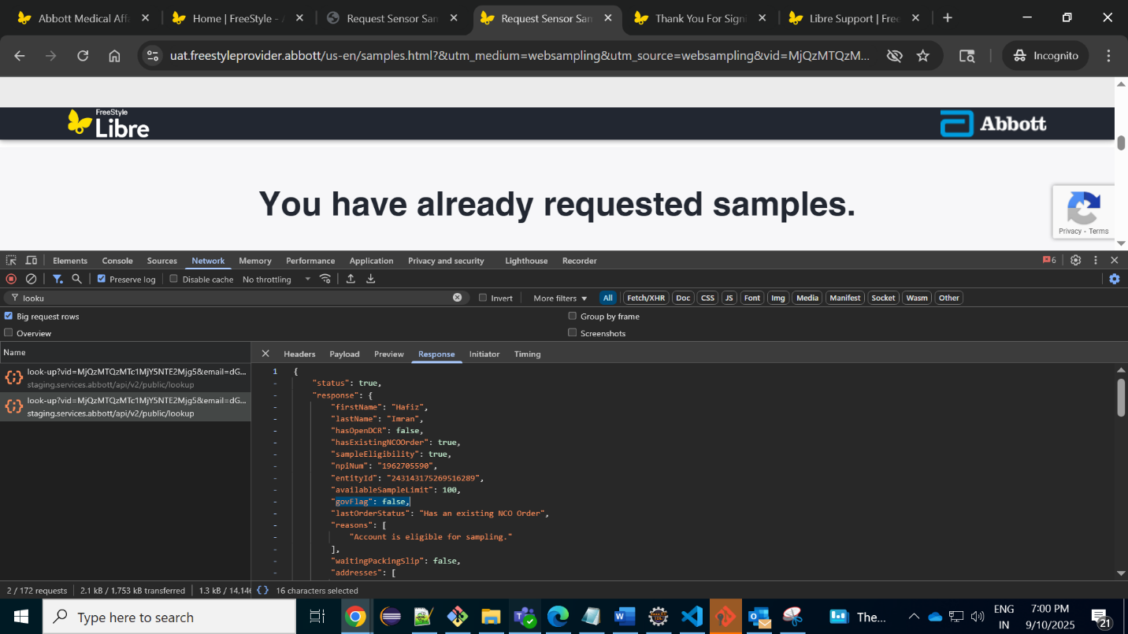

Kindly let me know if you need any additional details from my side.

Thanks ,
Prajitha J

