From: Gopalan, Kannan <kannan.gopalan@abbott.com>
Sent: Monday, September 29, 2025 12:58 PM
To: Madnani, Heena <heena.madnani@abbott.com>; Novodvorska, Kateryna <kateryna.novodvorska@abbott.com>; Sharma, Anirudh <anirudh.sharma1@abbott.com>
Cc: Gupta, Muneeshwar <muneeshwar.gupta@abbott.com>
Subject: RE: Request for 15-Min Discussion on Duplicate Orders Issue

- Veeva Team

Hi Heena, The duplicate compliance order fix was deployed in the Partial copy sandbox last week by Ani, and he has already validated it. Since the fix is confirmed and functioning as expected, no further changes are needed in Partial. We can proceed with deploying the Apex class code directly to Production by Raj after completing the SLC Document.

Thanks,
Kannan
From: Madnani, Heena <heena.madnani@abbott.com>
Sent: Monday, September 29, 2025 11:52 AM
To: Novodvorska, Kateryna <kateryna.novodvorska@abbott.com>; Sharma, Anirudh <anirudh.sharma1@abbott.com>; Gopalan, Kannan <kannan.gopalan@abbott.com>; Raj Bhattacharjee <raj.bhattacharjee@veeva.com>
Cc: Gupta, Muneeshwar <muneeshwar.gupta@abbott.com>; Pavithra Vishwanath <pavithra.vishwanath@veeva.com>; Kelley, Jamila M <jamila.kelley@abbott.com>
Subject: Re: Request for 15-Min Discussion on Duplicate Orders Issue

Hi @Raj Bhattacharjee

We have received the approval form Compliance to make necessary changes in Partial.

Please confirm once completed and share the configuration steps as requested by Kate.

Thanks,
Heena

From: Novodvorska, Kateryna <kateryna.novodvorska@abbott.com>
Sent: Monday, September 29, 2025 11:44 AM
To: Madnani, Heena <heena.madnani@abbott.com>; Sharma, Anirudh <anirudh.sharma1@abbott.com>; Gopalan, Kannan <kannan.gopalan@abbott.com>; Raj Bhattacharjee <raj.bhattacharjee@veeva.com>
Cc: Gupta, Muneeshwar <muneeshwar.gupta@abbott.com>; Pavithra Vishwanath <pavithra.vishwanath@veeva.com>; Kelley, Jamila M <jamila.kelley@abbott.com>
Subject: Re: Request for 15-Min Discussion on Duplicate Orders Issue

Hi @Raj Bhattacharjee,
Could you please share the configuration step(s) for the Installation Qualification (IQ) document to address the defect outlined below?
I've attached the IQ for your reference.

Best regards,
Kate

 | Kateryna Novodvorska  Abbott Diabetes Care  IT Business Analyst | Abbott Diabetes Care  1420 Harbor Bay Pkwy  Alameda, CA - 94502 | kateryna.novodvorska@abbott.com  M: +1 (669) 317-8458

From: Madnani, Heena <heena.madnani@abbott.com>
Sent: Friday, September 26, 2025 2:00 PM
To: Sharma, Anirudh <anirudh.sharma1@abbott.com>; Gopalan, Kannan <kannan.gopalan@abbott.com>; Raj Bhattacharjee <raj.bhattacharjee@veeva.com>; Novodvorska, Kateryna <kateryna.novodvorska@abbott.com>
Cc: Gupta, Muneeshwar <muneeshwar.gupta@abbott.com>; Pavithra Vishwanath <pavithra.vishwanath@veeva.com>; Kelley, Jamila M <jamila.kelley@abbott.com>
Subject: RE: Request for 15-Min Discussion on Duplicate Orders Issue

++ Kate

Hi @Raj Bhattacharjee,

We’ve aligned with the ADC Compliance team on the approach to resolve this issue. ADC IT has already initiated the SLC process. I’ll notify you once we receive the green light to proceed with the Production deployment.

In the meantime,
- Could you please implement the fix in Partial as the issue is still occurring there?
- Also, we will need the configuration steps to capture in IQ. Only then we get the approval to move to PROD.

@Novodvorska, Kateryna — kindly create a CIA to address this defect. A problem ticket has been logged under #PRB0049305.

 | Heena Madnani  Abbott Diabetes Care  IT Business Analyst | Abbott Diabetes Care  1420 Harbor Bay Pkwy  Alameda, CA - 94502 | heena.madnani@abbott.com  M: +1 (628) 255-6877

From: Sharma, Anirudh <anirudh.sharma1@abbott.com>
Sent: Friday, September 26, 2025 1:16 PM
To: Gopalan, Kannan <kannan.gopalan@abbott.com>; Raj Bhattacharjee <raj.bhattacharjee@veeva.com>; Madnani, Heena <heena.madnani@abbott.com>
Cc: Gupta, Muneeshwar <muneeshwar.gupta@abbott.com>; Pavithra Vishwanath <pavithra.vishwanath@veeva.com>; Kelley, Jamila M <jamila.kelley@abbott.com>
Subject: RE: Request for 15-Min Discussion on Duplicate Orders Issue

Thank you @Gopalan, Kannan,
@Raj Bhattacharjee We confirmed that the partial sandbox and production instances had identical code for VPRO_ComplianceOrderValidator. During testing this morning, we were able to create duplicate orders in the partial sandbox.

We then updated the full sandbox code, and it worked as expected. The attached Apex class update has now been deployed, and the system correctly restricts creating a new order when existing orders are present.

Before update:
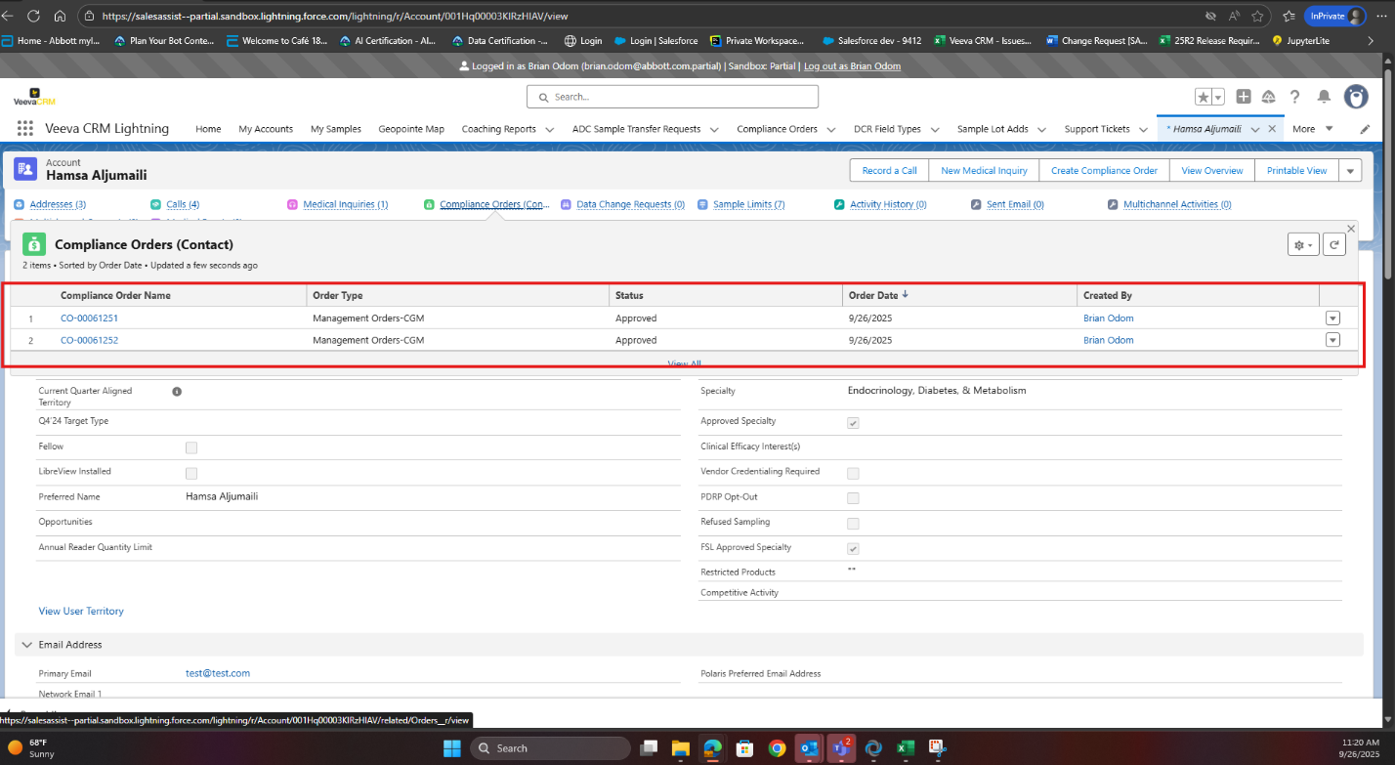

After update:

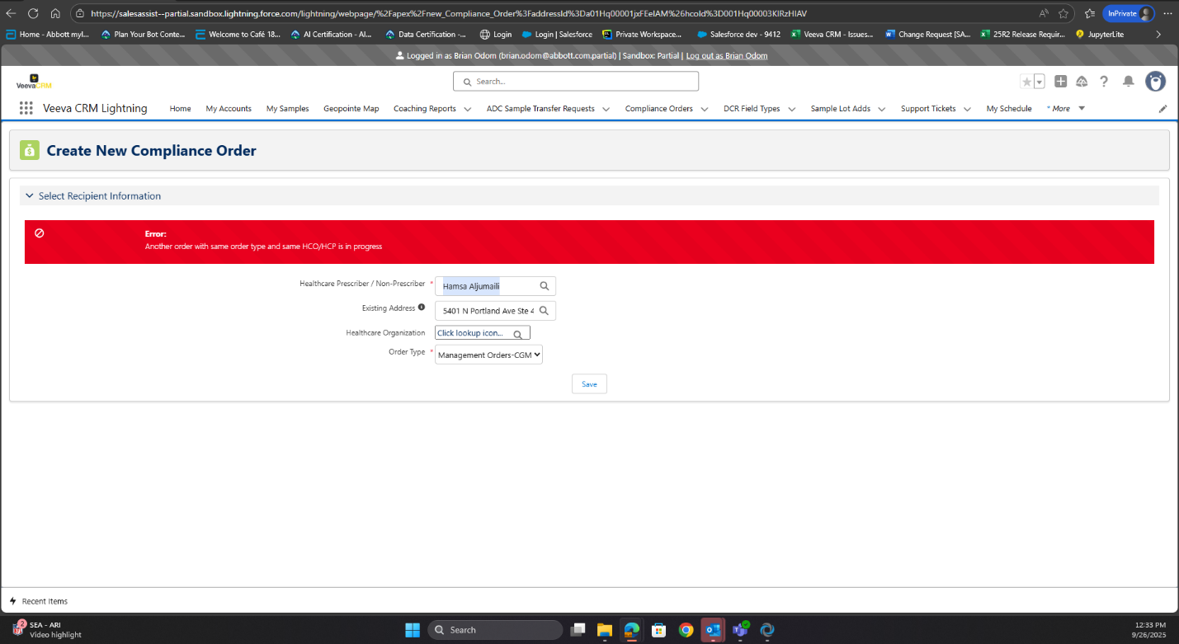

I also ran the following SOQL query to compare the Apex class across environments:

SELECT Name, ApiVersion, Status, LengthWithoutComments, BodyCrc,
LastModifiedBy.Name, LastModifiedDate
FROM ApexClass
WHERE Name = 'VPRO_ComplianceOrderValidator'

Findings:
- Production & Partial Sandbox: LengthWithoutComments matches → Code is identical.
- Full Sandbox: Last updated on 7/23/2025, whereas Production was last updated on 6/9/2025 → Version mismatch confirmed.
Environment Details:
- Production:
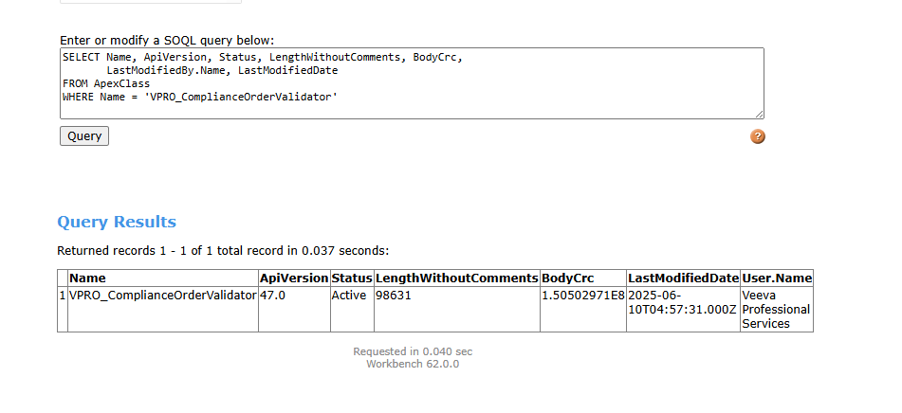
- Partial Sandbox:
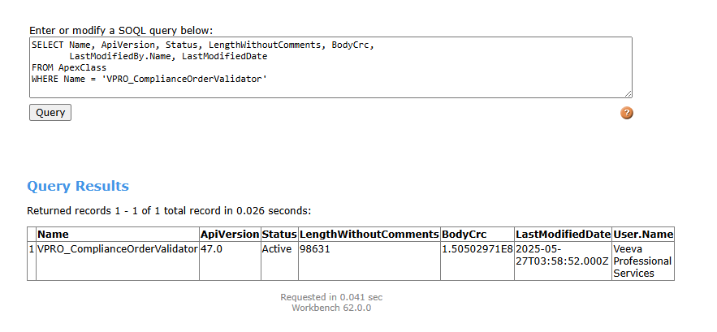
- Full Sandbox:
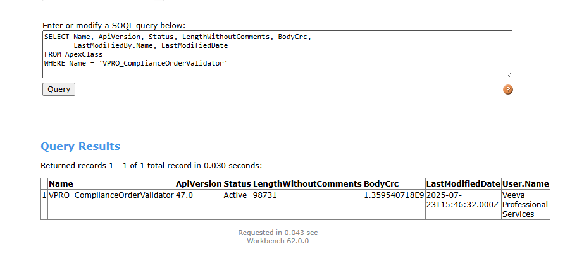

Best,
Anirudh

From: Gopalan, Kannan <kannan.gopalan@abbott.com>
Sent: Friday, September 26, 2025 1:09 PM
To: Raj Bhattacharjee <raj.bhattacharjee@veeva.com>; Madnani, Heena <heena.madnani@abbott.com>
Cc: Gupta, Muneeshwar <muneeshwar.gupta@abbott.com>; Sharma, Anirudh <anirudh.sharma1@abbott.com>; Pavithra Vishwanath <pavithra.vishwanath@veeva.com>; Kelley, Jamila M <jamila.kelley@abbott.com>
Subject: RE: Request for 15-Min Discussion on Duplicate Orders Issue

Hi Raj,

We have replicated the duplicate compliance order issue in the Partial copy sandbox by applying the relevant logic from the VPRO_ComplianceOrderValidator class (lines 752 and 761) from Full and we received the error message, confirming that the validation is working as expected.

We’ll proceed with creating the SLC documentation and will notify you once it’s ready. After that, we can move forward with promoting the updated code from Full à Production.

Thanks,
Kannan
From: Raj Bhattacharjee <raj.bhattacharjee@veeva.com>
Sent: Thursday, September 25, 2025 6:50 PM
To: Madnani, Heena <heena.madnani@abbott.com>
Cc: Gupta, Muneeshwar <muneeshwar.gupta@abbott.com>; Sharma, Anirudh <anirudh.sharma1@abbott.com>; Gopalan, Kannan <kannan.gopalan@abbott.com>; Pavithra Vishwanath <pavithra.vishwanath@veeva.com>; Kelley, Jamila M <jamila.kelley@abbott.com>; Mason Wenger <mason.wenger@veeva.com>; John Howard <john.howard@veeva.com>
Subject: Re: Request for 15-Min Discussion on Duplicate Orders Issue

Heena, Yes, I'm recommending copying over that specific Apex Class from Production to Full org so that we can properly replicate and troubleshoot the issue. -- Raj Bhattacharjee Veeva | Practice Manager, Commercial Technical Services On
ZjQcmQRYFpfptBannerStart
This Message is From an External Sender
Only click links or open attachments if you recognize the sender and know the content is safe.
Report Suspicious ‌

ZjQcmQRYFpfptBannerEnd
Heena,

Yes, I'm recommending copying over that specific Apex Class from Production to Full org so that we can properly replicate and troubleshoot the issue.

--
Raj Bhattacharjee
Veeva | Practice Manager, Commercial Technical Services

On Thu, Sep 25, 2025 at 8:04 PM Madnani, Heena <heena.madnani@abbott.com> wrote:
Hi Raj,

Thank you for providing the details regarding the potential root cause of the issue. Just to confirm my understanding—are you recommending that we replicate the production setup in the QA environment to identify the appropriate fix?

@Sharma, Anirudh Can you initiate a problem ticket in ServiceNow logging it as Production defect?

 | Heena Madnani  Abbott Diabetes Care  IT Business Analyst | Abbott Diabetes Care  1420 Harbor Bay Pkwy  Alameda, CA - 94502 | heena.madnani@abbott.com  M: +1 (628) 255-6877

From: Raj Bhattacharjee <raj.bhattacharjee@veeva.com>
Sent: Thursday, September 25, 2025 2:47 PM
To: Gupta, Muneeshwar <muneeshwar.gupta@abbott.com>
Cc: Madnani, Heena <heena.madnani@abbott.com>; Sharma, Anirudh <anirudh.sharma1@abbott.com>; Gopalan, Kannan <kannan.gopalan@abbott.com>; Pavithra Vishwanath <pavithra.vishwanath@veeva.com>; Kelley, Jamila M <jamila.kelley@abbott.com>; Mason Wenger <mason.wenger@veeva.com>; John Howard <john.howard@veeva.com>
Subject: Re: Request for 15-Min Discussion on Duplicate Orders Issue

Team: The root cause is not yet confirmed, though as I noted last Friday, Apex Class VPRO_ComplianceOrderValidator is a strong suspect. To replicate the issue, this class should be synced from production into the full org. Since the full org
Team:

The root cause is not yet confirmed, though as I noted last Friday, Apex Class VPRO_ComplianceOrderValidator is a strong suspect. To replicate the issue, this class should be synced from production into the full org. Since the full org is the closest to production, it must be aligned before troubleshooting can begin. Replicating in partial org is not feasible - the issue only occurs in production, partial lacks the necessary data, and October release items make it unsuitable. In addition, setting up data and syncing configuration in dev would require significant time and effort. While the final fix will be applied in dev, meaningful troubleshooting cannot happen until the full org is set up as requested.

If the full and production orgs are treated as GxP environments, it is imperative to keep them in sync to enable effective troubleshooting of production issues in the full org. The dev environment is a developer’s workspace and should not be used for analyzing production issues.

--
Raj Bhattacharjee
Veeva | Practice Manager, Commercial Technical Services

On Wed, Sep 24, 2025 at 3:29 PM Gupta, Muneeshwar <muneeshwar.gupta@abbott.com> wrote:
+John, Mason

@Veeva team, We are not getting any traction here. We are out of compliance and need your immediate attention here.

Thanks
Muneeshwar

 | Muneeshwar Gupta  Senior Manager  North America, LATAM Commercial IT | Abbott Diabetes Care  1420 Harbor Bay Parkway  Alameda, California  United States | M(Work): 415-535-3995  M(Personal): 510-847-4240  muneeshwar.gupta@abbott.com

From: Madnani, Heena <heena.madnani@abbott.com>
Sent: Wednesday, September 24, 2025 12:27 PM
To: Sharma, Anirudh <anirudh.sharma1@abbott.com>; Gopalan, Kannan <kannan.gopalan@abbott.com>; Raj Bhattacharjee <raj.bhattacharjee@veeva.com>; Gupta, Muneeshwar <muneeshwar.gupta@abbott.com>
Cc: Pavithra Vishwanath <pavithra.vishwanath@veeva.com>; Kelley, Jamila M <jamila.kelley@abbott.com>
Subject: RE: Request for 15-Min Discussion on Duplicate Orders Issue

++ Munee

 | Heena Madnani  Abbott Diabetes Care  IT Business Analyst | Abbott Diabetes Care  1420 Harbor Bay Pkwy  Alameda, CA - 94502 | heena.madnani@abbott.com  M: +1 (628) 255-6877

From: Sharma, Anirudh <anirudh.sharma1@abbott.com>
Sent: Monday, September 22, 2025 3:28 PM
To: Gopalan, Kannan <kannan.gopalan@abbott.com>; Raj Bhattacharjee <raj.bhattacharjee@veeva.com>
Cc: Pavithra Vishwanath <pavithra.vishwanath@veeva.com>; Madnani, Heena <heena.madnani@abbott.com>; Kelley, Jamila M <jamila.kelley@abbott.com>
Subject: RE: Request for 15-Min Discussion on Duplicate Orders Issue

Hi Raj,

Thanks for your note. Could you please elaborate on what exactly is causing the issue in production? Specifically:

- Are there any Apex classes or triggers that need to be updated?
- Is the custom label VPRO_ExistingOrderInProgressMsg being referenced in the handler logic? If yes, please share the handler class details.

Before making any changes, please confirm the exact modifications required. Once we review and provide a go-ahead, you can proceed with the updates.

Best regards,
Anirudh

From: Gopalan, Kannan <kannan.gopalan@abbott.com>
Sent: Friday, September 19, 2025 2:21 PM
To: Raj Bhattacharjee <raj.bhattacharjee@veeva.com>; Sharma, Anirudh <anirudh.sharma1@abbott.com>
Cc: Pavithra Vishwanath <pavithra.vishwanath@veeva.com>; Madnani, Heena <heena.madnani@abbott.com>; Kelley, Jamila M <jamila.kelley@abbott.com>
Subject: RE: Request for 15-Min Discussion on Duplicate Orders Issue

Raj,

Thanks for your initial assessment. As indicated by the error message when attempting to create a duplicate compliance order, this validation uses a custom label. When the compliance order record is saved, a handler is triggered to check for duplicate order scenarios. Can you please confirm is this label is being referenced in the code? Can you please provide the Handler class details?

VPRO_EXistingOrderInProgressMsg

Thanks,
Kannan
From: Raj Bhattacharjee <raj.bhattacharjee@veeva.com>
Sent: Friday, September 19, 2025 2:09 PM
To: Sharma, Anirudh <anirudh.sharma1@abbott.com>
Cc: Pavithra Vishwanath <pavithra.vishwanath@veeva.com>; Gopalan, Kannan <kannan.gopalan@abbott.com>; Madnani, Heena <heena.madnani@abbott.com>; Kelley, Jamila M <jamila.kelley@abbott.com>
Subject: Re: Request for 15-Min Discussion on Duplicate Orders Issue

I think I found the issue. . . what we should do is I can revert the code back from Prod and we test and confirm that the issue exists. . . then I deploy the code again and verify that the issue is fixed. LMK - I am working until 6PM ET -- Raj Bhattacharjee
I think I found the issue...what we should do is I can revert the code back from Prod and we test and confirm that the issue exists...then I deploy the code again and verify that the issue is fixed. LMK - I am working until 6PM ET

--
Raj Bhattacharjee
Veeva | Practice Manager, Commercial Technical Services

On Fri, Sep 19, 2025 at 3:34 PM Sharma, Anirudh <anirudh.sharma1@abbott.com> wrote:
++ Raj, Jamila.
@Raj Bhattacharjee, Can we use the call set up at 1 PM PST today to discuss the high-priority production bug below?
Best,
Anirudh

From: Sharma, Anirudh
Sent: Friday, September 19, 2025 9:54 AM
To: Pavithra Vishwanath <pavithra.vishwanath@veeva.com>
Cc: Gopalan, Kannan <kannan.gopalan@abbott.com>; Madnani, Heena <heena.madnani@abbott.com>
Subject: Request for 15-Min Discussion on Duplicate Orders Issue

Hello Pavithra,
Greetings!
During a short release in July, we had reported an issue with duplicate orders in the full sandbox, which you had kindly helped resolve (email attached).
Recently, a similar issue has been reported in the production environment, where duplicate orders are being placed for an HCP:
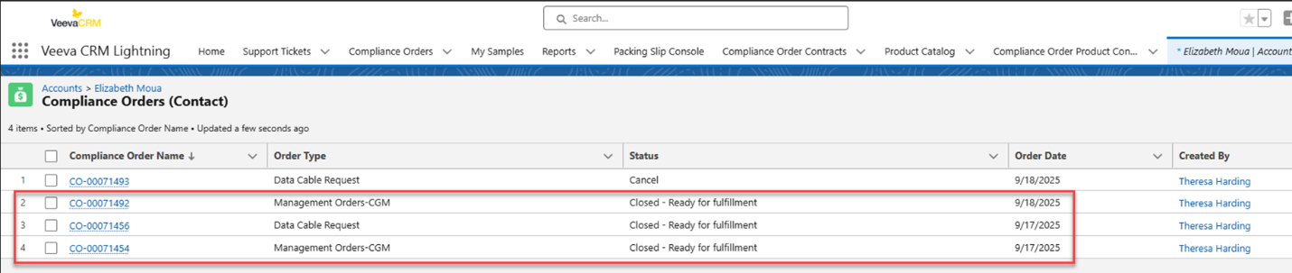
Would you be available for a 15-minute discussion today or Monday to help us understand what was fixed in the sandbox and what corrective actions we can take in production?
Thanks for the support.

Best regards,
Anirudh Sharma

