1538573217

Sharma, Anirudh
1538573217
DCR Approved

1730742214 - DCR rejected

LastNCOOrderStatus what are the list of value this field can hold, where in CRM is it stored

Sharma, Anirudh
LastNCOOrderStatus what are the list of value this field can hold, where in CRM is it stored
Please check it @Anirudh

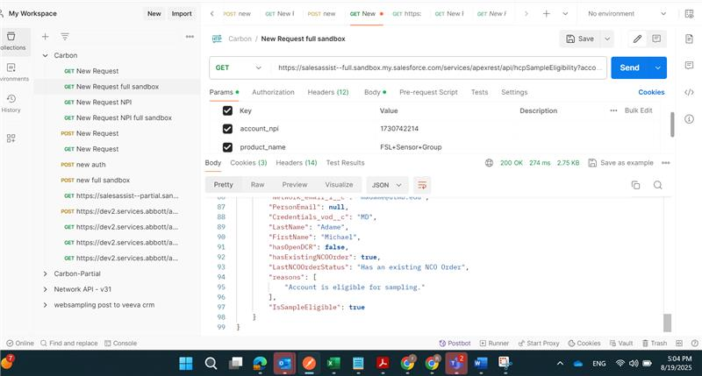

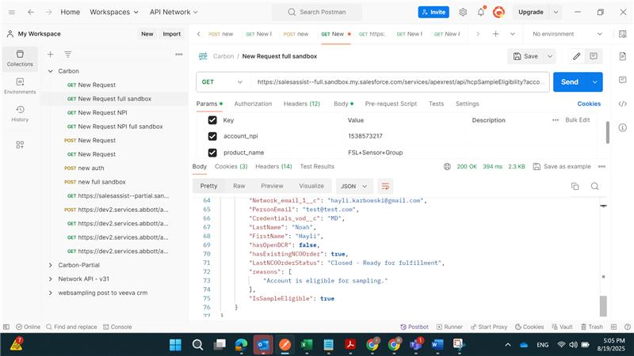

Once the order is placed, until 3 mins till the order is not in Closed - Ready for fullfillment, user can place a new order.

DCR with New Address logic same issue, what will be the statuses? what LastNCOOrderStatus values will be there?

Reordering is passing? check it is not

