Mapping TransformException to an External Format

This example demonstrates how the TransformException object thrown during exception can be mapped to an external format.

This sample cartridge consists of the following:
- External Message Nodes: AscDelMessage and AscDelExceptionMessage
- Mapping Node: TransformExceptionToAscDelExceptionMessage
- Message Flow Node: TransformExceptionMappingFlow

Shown below is the message flow ‘TransformExceptionMappingFlow’.

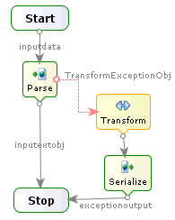

- Here, the Parse activity is used to parse the raw input message based on the ‘AscDelMessage’ format.

- The exception flow attached to the Parse activity is invoked if it results in error.

- The Transform activity is used to invoke ‘TransformExceptionToAscDelExceptionMessage’ mapping and thereby transforming the TransformException object thrown during error to ‘AscDelExceptionMessage’ format.

- It also generates the output message based on the ‘AscDelExceptionMessage’ format and writes it to exceptionoutput output variable.

