TECHNICAL PROJECT REPORT

Pharma-LM
Parameter-Efficient Domain Adaptation of Qwen2.5-7B for Pharmacological & Clinical Reasoning
Base Model | Qwen2.5-7B (4-bit, Unsloth)
Adaptation Method | LoRA / QLoRA (rank 16, ~0.53% trainable)
Domain / Dataset | Clinical medicine — medalpaca/medical_meadow_medical_flashcards (5,000 records)
Hardware | Google Colab — Tesla T4 (14.6 GB)

Prepared by Anirudh
Dual Degree — B.E. Computer Science (NGIT) · B.S. Data Science & Applications (IIT Madras)
Submitted as coursework for the LoRA Domain Fine-Tuning task, IIIT Hyderabad

1. Executive Summary
Pharma-LM is a parameter-efficient domain adaptation of Qwen2.5-7B, specialized for pharmacological and clinical reasoning using Low-Rank Adaptation (LoRA). Rather than updating the full 7-billion-parameter model, a compact set of rank-16 adapters was trained on top of a frozen, 4-bit-quantized base model — restricting the trainable footprint to roughly 0.53% of total parameters while still measurably shifting the model's behaviour toward structured clinical output.
The adapter was trained on 5,000 records from the medalpaca/medical_meadow_medical_flashcards dataset, reformatted around a custom system prompt ("MedTriage-LM") that instructs the model to identify a likely condition, explain the underlying biological reasoning, recommend standard clinical evaluation steps, and avoid inventing unsupported medical facts.
Training ran for 60 optimizer steps on a single Tesla T4 GPU in Google Colab and completed in 7.36 minutes, with training loss falling from 2.17 at step 1 to a stabilized band of roughly 0.45–0.55 from around step 10 onward. Post-training qualitative probes show the adapted model producing condition identification (e.g. aortic dissection from a classic presentation) and mechanism-level pharmacological explanation (e.g. CYP3A4 inhibition in a statin–grapefruit interaction) in a consistent, professional clinical register — a clear behavioural shift from an unadapted general-purpose model.
Scope note: Pharma-LM is a research prototype intended to demonstrate parameter-efficient domain adaptation. It is not a validated clinical decision-support tool, and its outputs should not be used for real patient care without expert medical review.

2. Motivation and Problem Statement
General-purpose language models can process medical text, but their responses tend to be conversational and inconsistent in structure — they do not reliably separate diagnosis, mechanism, and recommended action, and they are not tuned to the terse, evidence-grounded register expected of clinical documentation.
Full fine-tuning of a 7B-parameter model to correct this is computationally expensive and impractical on a single consumer-grade GPU. This project investigates whether Low-Rank Adaptation can close that gap cheaply: can updating under 1% of the parameters of Qwen2.5-7B be enough to teach it a consistent clinical-reasoning format, without the cost of full-model retraining?

Guiding question
Does LoRA-based adaptation on a focused medical instruction dataset shift Qwen2.5-7B from generic conversational answers toward structured, terminology-accurate clinical reasoning — while remaining trainable within the memory and time budget of a free-tier Colab GPU?

3. System Overview
The pipeline follows five stages: base-model loading, LoRA adapter configuration, dataset preparation, supervised fine-tuning, and qualitative evaluation. Each stage is isolated so that its effect on the final model can be reasoned about independently.
Stage | Description
Base model loading | Qwen2.5-7B loaded via Unsloth in 4-bit (NF4) precision
Adapter configuration | LoRA adapters attached to attention and MLP projections
Dataset preparation | 5,000 medical flashcard records mapped to a clinical prompt template
Supervised fine-tuning | TRL SFTTrainer, 60 optimizer steps, 8-bit AdamW
Qualitative evaluation | Held-out clinical prompts probed post-training

4. Base Model and Adaptation Method

4.1 Base model
Qwen2.5-7B was selected as the base model: it offers strong general-purpose reasoning capacity while remaining tractable for LoRA experimentation on a single GPU. The model was loaded through Unsloth with 4-bit quantization, which halves memory pressure relative to 16-bit loading and enabled the entire experiment to fit inside a free-tier Colab T4 instance.
Parameter | Value
Base model | Qwen2.5-7B
Quantization | 4-bit (NF4)
Maximum sequence length | 2,048 tokens
Training framework | Unsloth · Hugging Face Transformers · TRL

4.2 LoRA configuration
LoRA freezes the pretrained weight matrix W and learns a low-rank update ΔW, so that the adapted weight is W′ = W + ΔW, with ΔW expressed as the product of two much smaller matrices. This confines optimization to a compact set of new parameters instead of the full 7B-parameter model.
Parameter | Value
Rank (r) | 16
Alpha | 16
Dropout | 0
Target modules | q_proj, k_proj, v_proj, o_proj, gate_proj, up_proj, down_proj
Gradient checkpointing | Unsloth-optimized
Trainable parameters | 40,370,176
Total parameters | 7,655,986,688
Trainable fraction | ≈ 0.53%

5. Dataset and Prompt Design

5.1 Data source
The model was trained on the medalpaca/medical_meadow_medical_flashcards dataset (Hugging Face Hub), a public collection of instruction–input–output medical flashcard records. A fixed, reproducible slice of 5,000 records was selected from the full training split for the experiment.
Parameter | Value
Source dataset | medalpaca/medical_meadow_medical_flashcards
Records used | 5,000 (from a full split of 33,955)
Fields used | instruction, input, output
Split used for training | 100% of the selected 5,000 records

5.2 Prompt template
A custom clinical system prompt frames the model as “MedTriage-LM” and constrains the shape of every response. Each record is converted into a single supervised training sequence combining the instruction, the clinical context, and the target response, terminated with the tokenizer's EOS token.
System prompt: You are MedTriage-LM, a highly clinical and professional medical assistant. Analyze the provided medical inquiry carefully. Your response should: identify the likely medical condition or relevant biological mechanism; explain the underlying reasoning based on the provided context; recommend standard clinical evaluation steps; avoid inventing medical facts or unsafe treatments.

This prompt design is the primary mechanism by which the fine-tune shapes output structure: it explicitly forbids fabricated facts and directs the model toward a diagnose → explain → recommend response pattern, which the qualitative results in Section 8 show the model adopting.

6. Training Configuration
Parameter | Value
Training examples | 5,000
Per-device batch size | 2
Gradient accumulation steps | 4
Effective batch size | 8
Learning rate | 2 × 10⁻⁴
Warmup steps | 5
Optimizer | AdamW (8-bit)
LR scheduler | Linear
Max optimizer steps | 60 (≈ 0.1 epoch of the 5,000-record set)
Precision | FP16 / BF16, selected automatically by hardware support
Random seed | 3407

Training was capped at 60 optimizer steps to fit within a single free-tier Colab session; at an effective batch size of 8 this covers roughly 480 of the 5,000 training examples, i.e. a fraction of one full epoch. This was a deliberate choice to validate the pipeline end-to-end rather than to reach convergence — see Section 10 for how this bounds the conclusions that can be drawn.

7. Measured Training Results
The figures below are taken directly from the completed run and are reported as observed, without adjustment.
Parameter | Value
GPU | Tesla T4 (14.563 GB)
Memory reserved before training | 7.242 GB
Peak reserved memory during training | 8.764 GB
Additional memory used for training | 1.522 GB (≈ 10.45% of GPU capacity)
Training steps completed | 60 / 60
Training time | 441.74 seconds (≈ 7.36 minutes)
Initial training loss (step 1) | 2.1745
Final training loss (step 60) | 0.5654
Approximate stabilized loss (steps 40–60) | ≈ 0.47 – 0.55

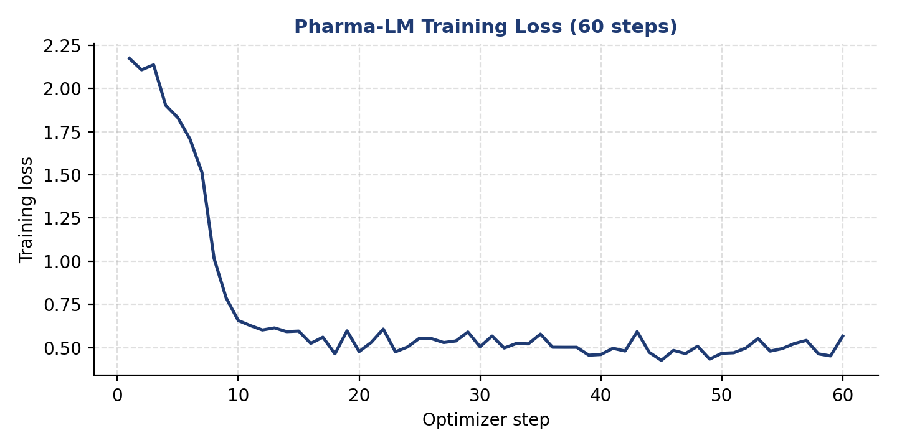
Figure 1 — Training loss per optimizer step, steps 1–60 (Pharma-LM run).
Loss drops sharply over the first eight steps (2.17 → 1.02) as the adapter absorbs the target response format, then falls further through step 10 before flattening into a noisy plateau around 0.45–0.55 for the remainder of the run. This shape is consistent with the adapter quickly learning surface-level formatting and terminology, with further gains past step ~20 being marginal at this learning rate and step budget.
Caveat: A falling training loss shows the adapter is fitting its training distribution — it does not by itself demonstrate improved medical accuracy or clinical safety. Those claims require a held-out comparison against the un-adapted base model, discussed in Section 10.

8. Qualitative Evaluation
After training, the model was switched to inference mode and probed with clinical prompts unseen during training, using the same MedTriage-LM prompt structure. Two representative probes are reported below.

8.1 Probe 1 — Acute presentation (diagnostic reasoning)
Field | Content
Instruction | Analyze this clinical presentation and identify the likely condition and recommended next steps.
Clinical context | A 45-year-old male presents with sudden onset of severe, tearing chest pain radiating to his back. Blood pressure is 180/110.

Result: Model response (excerpt): identifies the presentation as consistent with aortic dissection, describes the tearing of the aortic inner layer and the resulting risk of complications such as an absent or weak pulse in a limb, and recommends immediate evaluation and surgical management.

8.2 Probe 2 — Pharmacological mechanism (drug interaction)
Field | Content
Instruction | Explain the biological mechanism for the following drug interaction. Response must use Markdown, bold headings, and bullet points.
Clinical context | Patient was prescribed a statin and recently began consuming large amounts of grapefruit juice, leading to muscle pain.

Result: Model response (excerpt): correctly attributes the interaction to furanocoumarin compounds in grapefruit juice inhibiting hepatic CYP3A4, which impairs statin metabolism, raises circulating statin concentration, and produces the observed muscle pain — and advises avoiding grapefruit juice while on statin therapy.

Both probes show the model consistently following the diagnose → explain → recommend structure requested in the system prompt, using domain-accurate terminology (aortic dissection, furanocoumarin, CYP3A4) rather than generic conversational phrasing. These are illustrative examples, not a statistically powered evaluation — see Section 10.

9. Feature Highlights of the Adapted Model
- Domain-specific vocabulary — the model reliably surfaces precise anatomical and pharmacological terms (e.g. furanocoumarin, CYP3A4, aortic dissection) rather than lay paraphrases.
- Consistent clinical structure — responses follow a repeatable condition → mechanism → recommendation pattern rather than open-ended conversational text.
- Instruction-following under format constraints — the model correctly applies Markdown structuring (bold headings, bullet points) when explicitly instructed, as in Probe 2.
- Small, portable footprint — the specialization is stored as a ~40M-parameter LoRA adapter layered on the frozen base model, not a new 7B checkpoint, making it cheap to store, share, and swap.
- Low hardware requirement — the full adaptation cycle completes on a single free-tier Tesla T4 GPU in under 8 minutes.

10. Evaluation Strategy, Limitations, and Responsible Use

10.1 What has and hasn't been established
Training loss and the two qualitative probes in Section 8 demonstrate that the adapter changes the model's output style and terminology in the intended direction. They do not, on their own, establish that Pharma-LM is more medically accurate than the unadapted Qwen2.5-7B base model. A defensible accuracy claim requires presenting identical unseen clinical scenarios to both models and scoring the responses against consistent criteria.
Criterion | What to examine
Clinical relevance | Does the response correctly address the presented condition or mechanism?
Evidence grounding | Are conclusions supported only by the information given, with nothing invented?
Completeness | Does the response cover diagnosis, reasoning, and recommended next steps?
Terminology accuracy | Is medical/pharmacological terminology used correctly?
Format consistency | Does the response follow the requested structure and formatting?

10.2 Limitations
- The reported run covers 60 optimizer steps (~0.1 epoch of the 5,000-record set), not a full training pass — it is an initial adaptation run rather than a converged model.
- The two qualitative probes are illustrative demonstrations, not a statistically powered evaluation set.
- Like any generative model, Pharma-LM can produce incorrect or unsupported statements, especially outside the terminology and case types represented in medical_meadow_medical_flashcards.
- No comparison against the un-adapted Qwen2.5-7B baseline has yet been run; relative improvement is not yet quantified.
- The model has not been clinically validated and is not fit for autonomous use in patient care.

10.3 Responsible use
Intended scope: Pharma-LM is an analyst-support / educational prototype for demonstrating LoRA-based domain adaptation. It is not a medical device, has not undergone clinical validation, and all output must be reviewed by a qualified medical professional before informing any real clinical decision.

11. Reproducibility and Artifacts
The experiment was designed so that data selection, configuration, the trained adapter, and results can each be independently reproduced or re-used.
Artifact | Purpose
Pharma_LM.ipynb | Executable notebook containing the full data, training, and inference workflow
lora_model/ | Saved LoRA adapter and tokenizer representing the clinical specialization
Training configuration | Captured in-notebook (rank, alpha, learning rate, steps, seed = 3407)
Training loss log | Per-step loss for all 60 steps, captured from the SFTTrainer run
Qualitative probe outputs | Captured model generations for both evaluation prompts

12. Conclusion and Future Work
Pharma-LM demonstrates that a focused LoRA adapter — under 1% of the parameters of Qwen2.5-7B — is enough to visibly shift a general-purpose language model toward structured, terminology-accurate clinical reasoning, using only a free-tier Colab GPU and a 5,000-example instruction dataset. The strongest contribution of this project is the complete, reproducible pipeline: dataset selection and prompt design, 4-bit LoRA fine-tuning, resource measurement, and clinically-framed qualitative evaluation.
The clear next step is a controlled comparison between the base Qwen2.5-7B model and Pharma-LM on a shared, unseen set of clinical scenarios, scored against the criteria in Section 10.1 — this is required before any claim of improved medical accuracy can be made. Further extensions include training for a full epoch (or more) when additional compute is available, building a dedicated held-out test set, and comparing different LoRA ranks and target-module choices for their effect on response quality.

Summary: Pharma-LM should be read as a parameter-efficient clinical-domain specialization of Qwen2.5-7B, not a newly trained model. Its contribution is showing that a small, cheaply-trained adapter can meaningfully redirect a large base model's behaviour toward a target domain.

