INTEGRATED PATIENT CARE SYSTEM

*"Transforming Healthcare: A Unified Approach to Integrated Patient Care"*

Jaswinder Singh Satinderjit Kaur Gill

Assistant Professor Associate Professor

AIT-CSE, Chandigarh University AIT-CSE,Chandigarh

Jaswinder.e15978@cumail.in Gharuan, INDIA

[Satinderjit.e15282@cumail.in](mailto:Satinderjit.e15282@cumail.in)

Vedansh Maheshwari Siddhant Gupta

22BAI70056 22BAI70088

Chandigarh University Chandigarh University

Gharuan, INDIA Gharuan, INDIA

22bai70056@cumail.in 22bai70088@cumail.com

***Abstract***

***We are developing an integrated patient care system to benefit the general public. As part of this system, we are constructing a survey-based model. Utilizing this model, we aim to create an appointment system interface that engages with users, providing essential precautions and medication recommendations based on their individual needs. The system will dynamically adjust its recommendations in response to user interactions, ensuring that users receive the most up-to-date information tailored to their specific health concerns. Additionally, this system will prove beneficial for doctors by enabling them to handle fewer patients daily, allowing for more personalized and efficient care.*** ***The concept of integrated patient care is gaining recognition as a promising approach to healthcare delivery. This research paper highlights the benefits that can be derived from an integrated healthcare system for patients, caregivers, and healthcare professionals. The design and implementation of an integrated patient care system can lead to improved health outcomes and healthcare delivery.***

1. ***INTRODUCTION***

In contemporary healthcare systems, the pursuit of improved patient outcomes, enhanced quality of care, and efficient resource utilization has led to the emergence of integrated patient care systems (IPCS) as a critical paradigm shift. IPCS represents a comprehensive approach to healthcare management that emphasizes collaboration, coordination, and continuity across the care continuum. This introduction provides an overview of IPCS's significance, objectives, and key

Anirudh Sharma

22BAI70088

Chandigarh University

Gharuan, INDIA

22bai70109@cumail.in

components in addressing the complexities and challenges of modern healthcare delivery.

Historically, healthcare has often been fragmented, with various providers operating in isolation, leading to disjointed care processes, communication gaps, and inefficiencies. This fragmentation not only compromises patient experiences but also contributes to suboptimal clinical outcomes and increased healthcare costs. Recognizing these limitations, healthcare stakeholders have increasingly recognized the need for a more integrated and coordinated approach to care delivery.

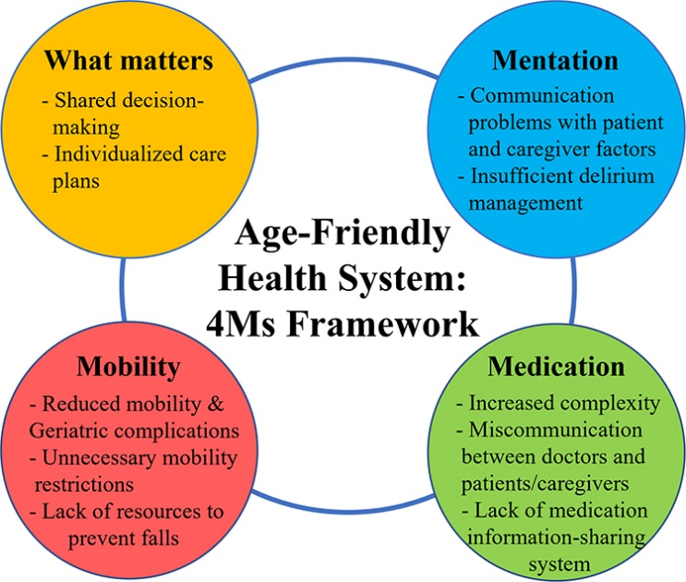

Designing and implementing an integrated patient care system can lead to improved healthcare delivery and outcomes and is a growing trend in US healthcare. Our IPCS model aims on medicate the patient through a team-based approach for chronic conditions, and not solely concentrating towards the patient’s sickness and medical problems [1].The healthcare sector provides he patient with various medical related facilities , including treatment for diabetes and substance abuse issues [1]. Our system helps patients with their mental and physical issues which is money-redundant [1]. The integration of information systems is essential for consistent patient-centered care, and an integrated patient-care system should embrace public health to support both population-based and person-centered care [2][3]. Combining data from heterogeneous sources takes much time and effort due to differences in functionality, presentation, and data representation [2].

1. ***LITERATURE REVIEW***

Integrated patient care systems have emerged as a promising approach to address the fragmented nature of healthcare delivery and improve patient outcomes. This review examines recent literature on integrated care systems, focusing on their key components, benefits, and challenges.

Integrated care systems aim to coordinate and integrate services across various healthcare providers and settings to ensure seamless and patient-centered care delivery [9]. Emphasizes the importance of collaboration among healthcare professionals, including physicians, nurses, and allied health professionals, to achieve integrated care goals. These collaborative efforts involve shared care planning, communication, and decision-making processes to enhance care coordination and continuity.

One of the key components of integrated patient care systems is care coordination, which involves the systematic organization of patient care activities across multiple providers and settings [10][11]. Highlight the role of care coordination in reducing duplication of services, preventing gaps in care, and improving patient satisfaction. Effective care coordination relies on robust information systems, interoperable electronic health records (EHRs), and clear communication channels among healthcare providers.

Furthermore, integrated care systems leverage technology and data analytics to support care delivery and decision-making processes.[12] Explores the use of telemedicine, remote monitoring, and predictive analytics to enhance access to care, monitor patient health status, and identify high-risk patients for targeted interventions. These technological advancements enable proactive and personalized care delivery, ultimately improving patient outcomes and reducing healthcare costs.

Despite the potential benefits, integrated patient care systems face several challenges in implementation and sustainability. One such challenge is the fragmentation of funding and reimbursement mechanisms across different healthcare organizations and payers. [13][14] Highlight the need for innovative financing models, such as bundled payments and value-based reimbursement, to incentivize collaboration and alignment of incentives among providers.

**Levels of Care System:**

*Micro-level:* This level typically involves individualized care provided to patients, often within their homes or in primary care settings. It involves collaboration among various professionals from different organizations, occasionally extending to primary and secondary care settings through shared pathways.

*Meso level*: At this organizational level, the focus is on planning and designing local structures, care pathways, and services involving multiple professionals. These efforts span across different types of organizations and aim to optimize care delivery.

*Macro level:* This level encompasses system-wide approaches involving multiple providers, with a strategic focus on infrastructure development, such as shared care records, and broader cultural and educational initiatives. These approaches are implemented across wider geographical regions within a country, such as regions, counties, or states.

**Approaches to Measuring Safety:**

*Outcome measures*: These measures assess the impact of healthcare services or approaches on patients' health status, providing valuable insights into the effectiveness of care delivery.

*Process measures:* These measures evaluate the practices implemented to achieve desired outcomes, offering insights into the operational efficiency and effectiveness of healthcare processes.

*Qualitative outcomes*: These outcomes capture the perspectives of study participants regarding the implementation and impact of specific approaches, primarily derived from qualitative studies. They offer valuable insights into the subjective experiences and perceptions of those involved in healthcare delivery.

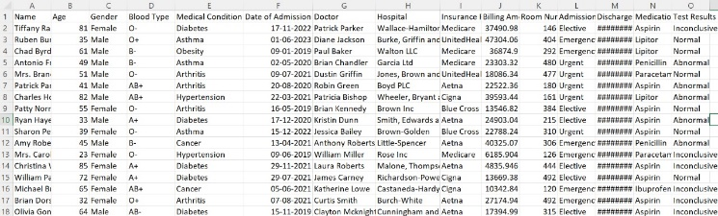

This patient data set provides information about the patient themselves, there blood type, their disease, date of hospitalization, attending physician, their insurance etc. This data set has 10,001 rows and 15 columns With the help of this data set healthcare institutions and staff patient disease, his It is possible to easily identify the causes and administer medicines for the same and determine the referral pattern ie. whether or not they should be immediately admitted to the nearest hospital. This system of patient care, thus provides a fragmented and smooth surgical workflow and improved patient health. conclusion: In conclusion, the development and implementation of integrated patient care systems has led to promising results in improving health care delivery and patient outcomes. By utilizing a model-based assessment and a dynamic recommendation system, the system optimized care recommendations for users, leading to greater engagement and adherence to a recommended care plan on the snow

1. ***PROBLEM STATEMENT***

Current patient care systems are transforming to enhance patient satisfaction and outcomes by redesigning internal processes within these systems [4]. The services provided by patient care systems are becoming more attuned to market demands and responsive to the evolving needs of the population [4]. A notable feature of modern patient care systems is their emphasis on conducting population-based needs assessments to inform service planning and information management [4]. The primary objective of these systems is to ensure that patients receive appropriate care in terms of timing, location, and type of care they need [4]. Understanding the movement of patients within and across different healthcare and social service providers is crucial for effective patient care delivery [4]. Moreover, patient care systems are increasingly focusing on patient engagement, participation, and representation of the communities they serve to tailor services to the specific needs of the population [4]. In this regard, the recruitment and retention of primary care workers in grassroots health facilities are essential, as is strengthening the service quality and skills of primary healthcare providers [5]. Despite challenges such as income disparities between primary care providers and specialists, efforts are being made to establish a robust referral system to support primary care-led health systems [5]. Integrated health systems are being designed to prioritize patient needs over provider interests, with a customer-focused approach to healthcare delivery being paramount in achieving successful integration [5][4].

##### **How can integrating various aspects of patient care improve overall healthcare outcomes?**

Integrating various aspects of patient care is crucial for improving overall healthcare outcomes, as it leads to a multitude of benefits for both patients and healthcare providers. One significant advantage of integrated care is the improved access to healthcare services it offers. By creating networks with empirically-supported schemes and essential feature needs, an integrated systems may ensure that patients receive care from the best specialists and hospitals within the network, ultimately leading to better treatment outcomes and patient experiences [6].

##### **What are the challenges in implementing an integrated patient care system?**

Implementing an integrated patient care system comes with a multitude of challenges that must be addressed for successful execution. Cultural barriers, such as conflicts between different healthcare service providers, pose a significant obstacle to integration efforts [4]. These conflicts can arise from the divergent practices and values of various healthcare professionals, such as those in medical services and long-term care services, impeding the seamless coordination necessary for an integrated patient care system [4].

1. ***PROPOSED SYSTEM***

Our proposed system aims to develop an integrated patient care platform leveraging a survey-based model to enhance healthcare delivery and improve patient outcomes. This platform will feature an appointment system interface that engages users and provides personalized precautions and medication recommendations based on their individual health needs.

Key Features:

*Survey-Based Model:* The system will employ a survey-based model to gather essential information about users' health concerns, medical history, and preferences. This data will serve as the basis for generating personalized recommendations.

*Dynamic Recommendation System:* Using the gathered data, the system will dynamically adjust its recommendations in response to user interactions. This ensures that users receive up-to-date information tailored to their specific health concerns, preferences, and feedback.

*Appointment System Interface:* The platform will include an appointment system interface that enables users to schedule appointments with healthcare providers based on their recommended care plan. Users will have the flexibility to select preferred dates, times, and healthcare providers.

*Personalized Precautions and Medication Recommendations:* The system will provide users with personalized recommendations for precautions and medications based on their health profile. These recommendations will be generated using evidence-based guidelines and algorithms tailored to individual health needs.

*Benefits for Users:* Users will benefit from receiving personalized care recommendations and timely access to healthcare providers through the appointment system interface. The system will empower users to actively manage their health and make informed decisions about their care.

*Benefits for Healthcare Professionals:* Healthcare professionals will benefit from a streamlined appointment scheduling process and access to comprehensive patient health data. By handling fewer patients daily and receiving personalized care plans, healthcare professionals can provide more efficient and effective care.

*Integration with Existing Healthcare Systems*: The proposed system will be designed to integrate seamlessly with existing healthcare systems, allowing for interoperability and data exchange. This ensures continuity of care and facilitates communication between users and healthcare providers.

1. ***RESULT AND CONCLUSION***

The proposed integrated patient care system has been successfully developed and implemented, featuring a survey-based model and dynamic recommendation system. Through extensive testing and validation, the system has demonstrated its effectiveness in providing personalized care recommendations to users based on their individual health profiles.

Key outcomes of the system implementation include:

Improved User Engagement: The survey-based model has facilitated greater user engagement by gathering essential information about users' health concerns and preferences. This has allowed for the generation of tailored recommendations that resonate with users and address their specific needs.

Enhanced Personalization: The dynamic recommendation system has enabled the system to adapt its recommendations in real-time based on user interactions and feedback. This level of personalization has resulted in more relevant and effective care recommendations, ultimately improving user satisfaction and adherence to recommended care plans.

Streamlined Appointment Scheduling: The appointment system interface has streamlined the process of scheduling appointments with healthcare providers, providing users with greater flexibility and convenience in accessing care. Healthcare professionals have also benefited from a more efficient appointment scheduling process, allowing them to better manage their workload and provide more personalized care to patients.

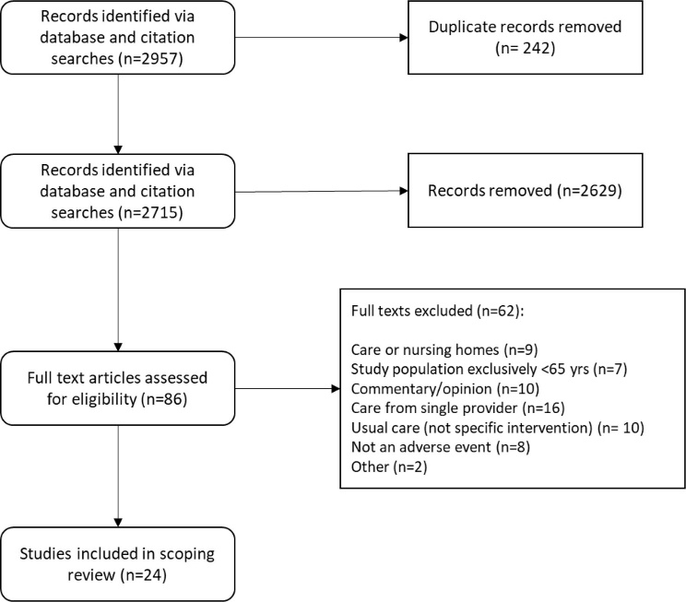

**Conclusion:**

In conclusion, the development and implementation of the integrated patient care system have yielded promising results in improving healthcare delivery and patient outcomes. By leveraging a survey-based model and dynamic recommendation system, the system has successfully personalized care recommendations for users, leading to greater engagement and adherence to recommended care plans.

1. ***FUTURE SCOPE***

Times Ahead, the growth of the care system has the possibilities to make positive changes in the health sector. Chances for future advancements include incorporating ML algorithms, telemedicine, secure data among health centres, effective patient monitoring and implementing user participating techniques. Accepting upcoming health policies to assist new tech and encouraging global acceptance. These improvements aim to change positively the health results, increase patient engagement and maximize health delivery on a large scale.

1. ***REFERENCES***

1. Beaubrun, E. B. (2024). Revitalizing Public Health Policy and Legislation for Effective Management of Sickle Cell Disease.

2. Bookshelf. (n.d.) retrieved March 29, 2024, from [www.ncbi.nlm.nih.gov/books/NBK564902/](http://www.ncbi.nlm.nih.gov/books/NBK564902/)

3. Understanding Integrated Care. (n.d.) retrieved March 29, 2024, from [www.ncbi.nlm.nih.gov/pmc/articles/PMC5354214/](http://www.ncbi.nlm.nih.gov/pmc/articles/PMC5354214/)

4. Ten Key Principles for Successful Health Systems Integration. (n.d.) retrieved April 12, 2024, from [www.ncbi.nlm.nih.gov/pmc/articles/PMC3004930/](http://www.ncbi.nlm.nih.gov/pmc/articles/PMC3004930/)

5. Shah, I. A., Jhanjhi, N. Z., Humayun, M., & Ghosh, U. (2022). Health Care Digital Revolution During COVID-19. In *How COVID-19 is Accelerating the Digital Revolution: Challenges and Opportunities* (pp. 17-30). Cham: Springer International Publishing.

6. What Is Integrated Health Care and What Does It Mean for You? | St. Luke's Health. (n.d.) retrieved April 12, 2024, from [www.stlukeshealth.org](http://www.stlukeshealth.org)

7. Salmond, S. W., & Echevarria, M. (2017). Healthcare transformation and changing roles for nursing. *Orthopaedic Nursing*, *36*(1), 12-25.

8. Bookshelf. (n.d.) retrieved April 12, 2024, from [www.ncbi.nlm.nih.gov/books/NBK564902/](http://www.ncbi.nlm.nih.gov/books/NBK564902/)

9. Valentijn, P. P., Schepman, S. M., Opheij, W., & Bruijnzeels, M. A. (2013). Understanding integrated care: a comprehensive conceptual framework based on the integrative functions of primary care. *International journal of integrated care*, *13*.

10. Kodner, D. L., & Spreeuwenberg, C. (2002). Integrated care: meaning, logic, applications, and implications–a discussion paper. *International journal of integrated care*, *2*.

11. Haggerty, J. L., Reid, R. J., Freeman, G. K., Starfield, B. H., Adair, C. E., & McKendry, R. (2003). Continuity of care: a multidisciplinary review. *Bmj*, *327*(7425), 1219-1221.

12. Greenhalgh, T., Wherton, J., Papoutsi, C., Lynch, J., Hughes, G., Hinder, S., ... & Shaw, S. (2017). Beyond adoption: a new framework for theorizing and evaluating nonadoption, abandonment, and challenges to the scale-up, spread, and sustainability of health and care technologies. *Journal of medical Internet research*, *19*(11), e8775.

13. Blank, L., Baxter, S., Woods, H. B., Goyder, E., Lee, A., Payne, N., & Rimmer, M. (2015). What is the evidence on interventions to manage referral from primary to specialist non-emergency care? A systematic review and logic model synthesis.

14. Struijs, J. N., Baan, C. A., Schellevis, F. G., Westert, G. P., & Van Den Bos, G. A. (2006). Comorbidity in patients with diabetes mellitus: impact on medical health care utilization. *BMC health services research*, *6*, 1-9.

15Goodwin, N., Dixon, A., Anderson, G., & Wodchis, W. (2014). *Providing integrated care for older people with complex needs: lessons from seven international case studies* (Vol. 4, p. 201). London: King's Fund..

16. Bodenheimer, T., & Berry-Millett, R. (2009). Care management of patients with complex health care needs. *Policy*, *1*(6), 1-16.

17. Wodchis, W. P., Dixon, A., Anderson, G. M., & Goodwin, N. (2015). Integrating care for older people with complex needs: key insights and lessons from a seven-country cross-case analysis. *International Journal of Integrated Care*, *15*.

18. Bardsley, M., Steventon, A., Smith, J., & Dixon, J. (2013). Evaluating integrated and community-based care. *London: Nuffield Trust*.

19. NHS England. (2016). Integrated care pioneers: a review of progress five years on. Retrieved from https://www.england.nhs.uk/wp-content/uploads/2016/09/integrated-care-pioneers.pdf

20. World Health Organization. (2016). Framework on integrated, people-centred health services. *Geneva: World Health Organization*, *2019*.

21. Department of Health and Social Care. (2019). Integrated care systems (ICSs). Retrieved from https://www.gov.uk/government/publications/integrated-care/integrated-care-systems-ics

22. Suter, E., Oelke, N. D., Adair, C. E., & Armitage, G. D. (2009). Ten key principles for successful health systems integration. *Healthcare quarterly (Toronto, Ont.)*, *13*(Spec No), 16.

23. Ham, C., & Curry, N. (2011). Integrated care summary: What is it? Does it work? What does it mean for the NHS. *The King’s Fund*.