## horizontal line



Futures and Options of Diesel Prices

05-10-2015

George mason university

Volgenau School of Engineering

Department of Computer science

*A project report on*

**F & O for Diesel Prices**

*Prepared by*

Anirudh Arora (G00894977)

Saurabh Patil (G00907573)

**Table of Contents**

|  |  |
| --- | --- |
| **Introduction** | **Page No 3** |
| **Need for Current Project** | **Page No 3** |
| **Data** | **Page No 4** |
| **Measure and the Probability Distribution of Return** | **Page No 4** |
| **Program Execution** | **Page No 8** |
| **Code Analysis Input from the User** | **Page No 9** |
| **Different Functions** | **Page No 10** |
| **Future Enhancement** | **Page No 14** |
| **Conclusion** | **Page No 16** |

# 

# Introduction:

Futures and Options contract are very important concepts in economics. In this Project we explore these concepts particularly in regards Trucking Companies. This project will help the company decide on whether it needs to buys futures or options. A correct decision will help boost the company's profits. Since 38% of the entire cost of a trucking company is fuel related.

# Need for the Current Project:

In late 2008, the American Transportation Research Institute (ATRI) published an Analysis of the Operational Costs of Trucking in an effort to provide more accurate marginal cost data for motor carrier operations. The goal of the research was to identify current and accurate operational costs based on data provided directly from motor carriers. The resulting dataset could then be used by both motor carriers as a high-level benchmarking tool and by government agencies for transportation improvement analyses. The conclusion of this published report was Motor carriers operate in an extremely competitive market, with very thin profit margins and must therefore be particularly attentive to fuel expenses.

The rise in average operating cost that was experienced between 2009 and 2011 is expected to continue given the current economic conditions and industry trends. Fuel costs continue to constitute the majority of costs for motor carriers.

Given the rise in fuel prices that was experienced in 2010 and again in 2012, motor carrier fuel costs are almost certain to continue to be the first or second largest cost center for fleets.

# 

**Data:**

Our data consists of time series of monthly Diesel Prices from the year 1994 to present from the Website [www.eia.gov](http://www.eia.gov/) which is also known as U.S. energy information, a site operated by the U.S. department of energy. Since we were more interested in the very recent trend of diesel price changes we filtered this data and used the diesel prices from January 2008 to April 2016.

We would now use this data to calculate the Mean and Standard Deviation of the change in diesel prices which would be an input parameter to the Gaussian function which would add stochastically add randomness to our predicted diesel prices.

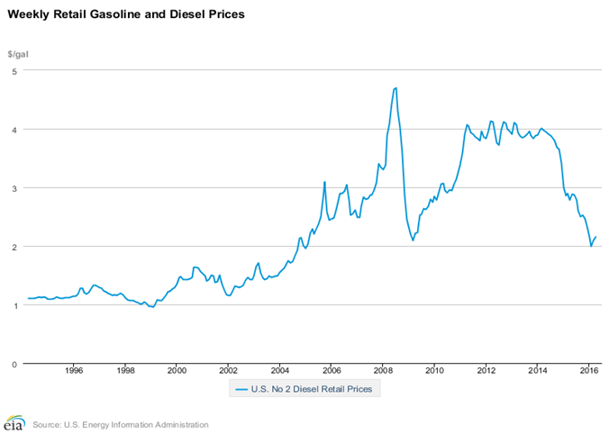

Fig.1 Weekly Diesel Trends from year 1994 to 2016

# Measure Return and the Probability Distribution of Return:

To explicitly display the distribution of Monthly return, this section builds the probability distributions corresponding to the entire trading time of Monthly return.

A number of studies investigated the time series of returns on varying time scales in order to probe the nature of the stochastic process underlying it. To construct the time series of returns using the time series of the monthly diesel price, the price change R(T) is defined as the change in the logarithm of the monthly diesel price,

**R(T)= ln Z(T+dT)-ln Z(T)**

where dT denotes the time interval of sampling with dT = 1 month in the data.

The time series of daily returns for Diesel market shown in Figure 2 below

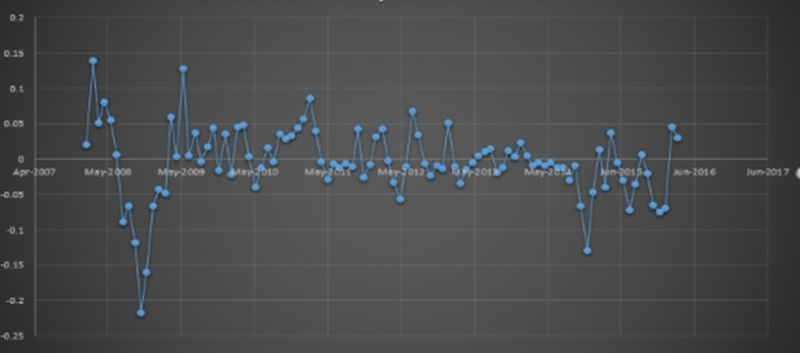

The Above time series is based on the calculations been done in the figure below.

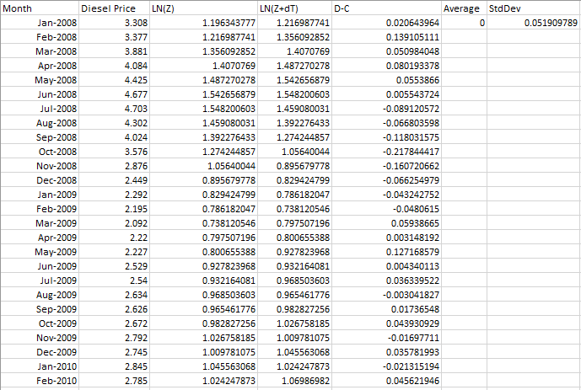

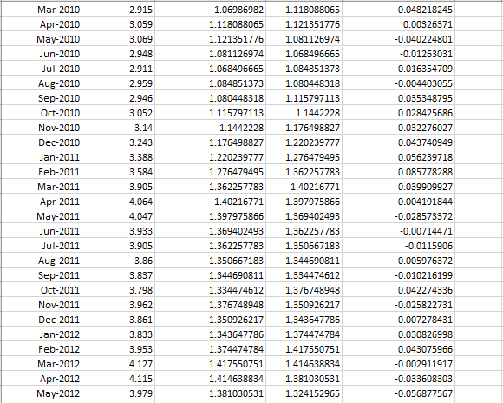

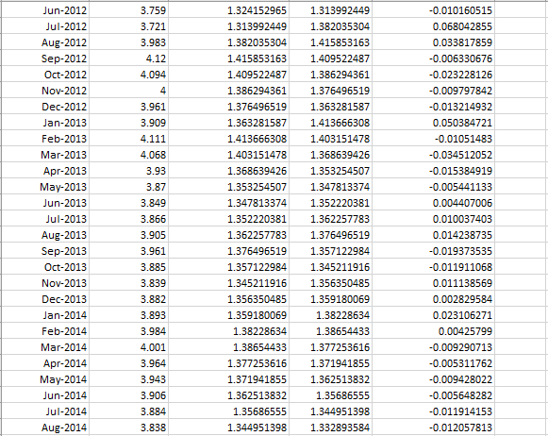

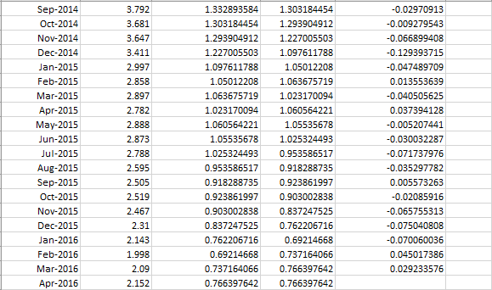

To display the probability distribution of monthly returns more clearly, we will construct the probability distribution for the time series of daily returns.

To construct the probability distribution, we adopt the histogram method and group the total samples into 100 intervals. Then, we count the number of monthly return ranging between each interval. The Figure below shows the probability distribution of monthly returns for the sampling market.

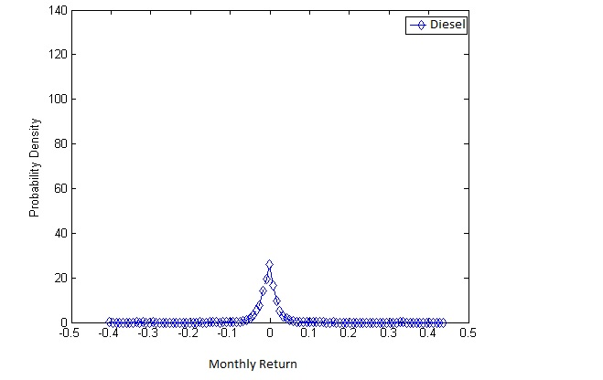

# Program Execution:

After the Data has been taken from the user, the Gaussian function is called on the diesel price. For Diesel price computation for future, a random value drawn from the Gaussian distribution is used. When this is done, the variable diesel price on the left of the assignment statement represents the future cost with some randomness in it.

A snippet of the code where the call takes place is shown below:

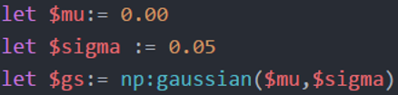



The details of the Gaussian function implemented in order to stochastically calculate the future prices on the diesel is been show below:

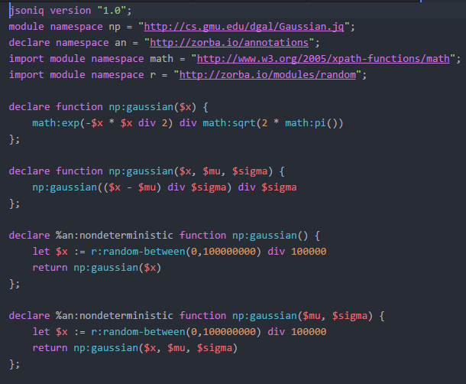

# Code Analysis: Input from the User:

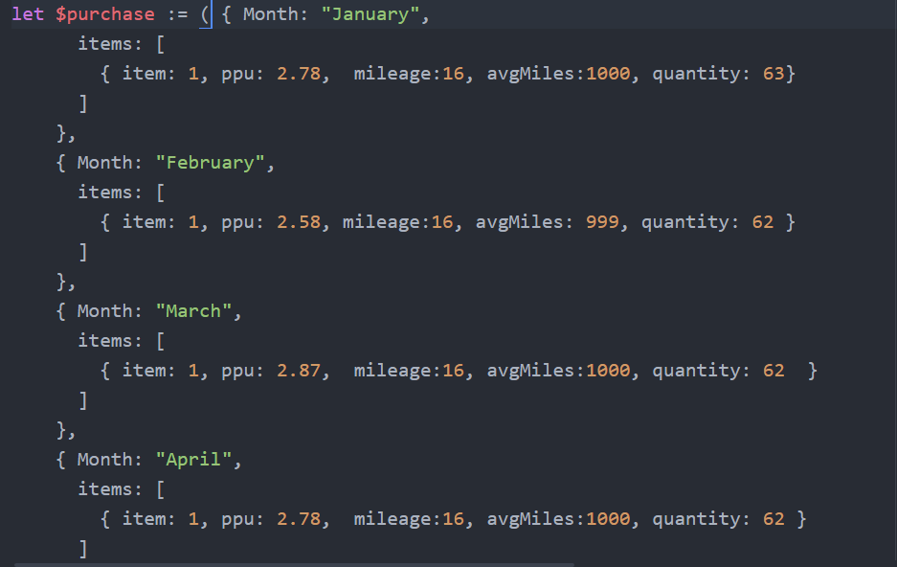

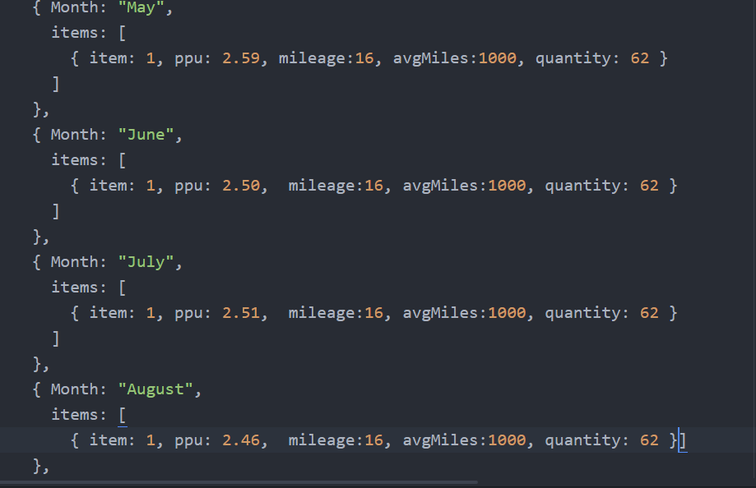

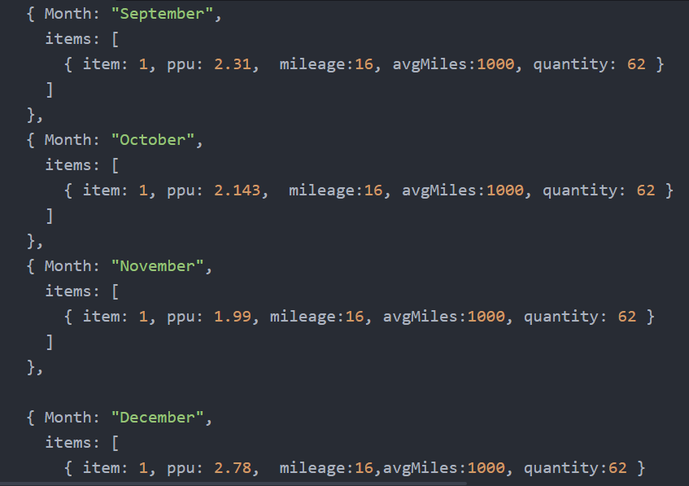

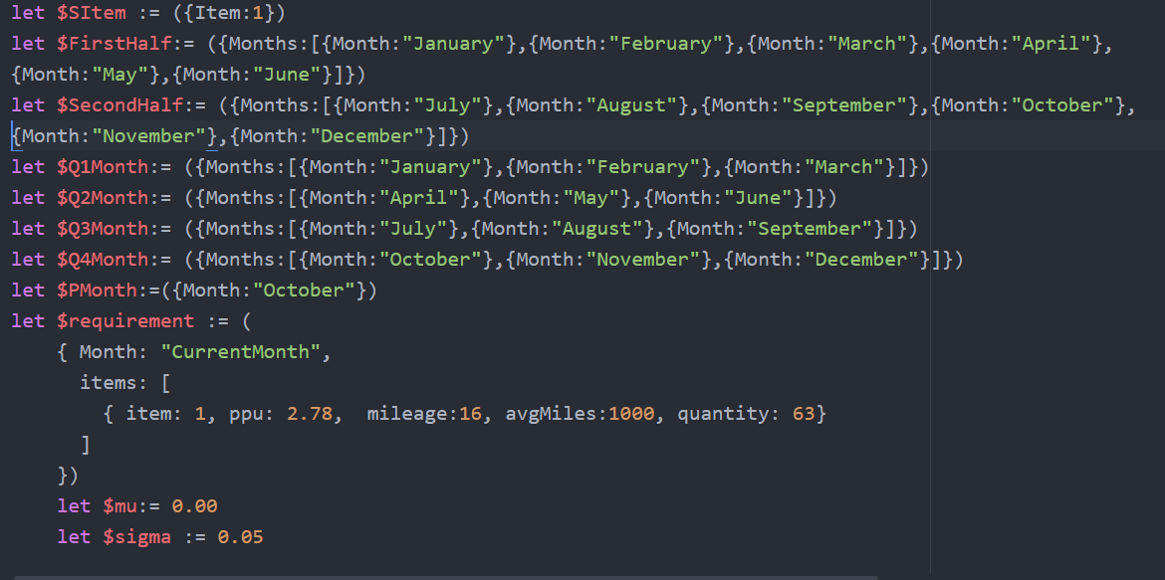

**Different functions:**

**1 - Yearly:** 

**Output:**

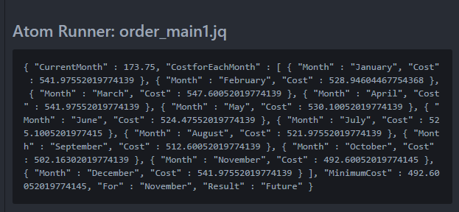

**2.a -Half Year (Jan - June)**



**Output:**

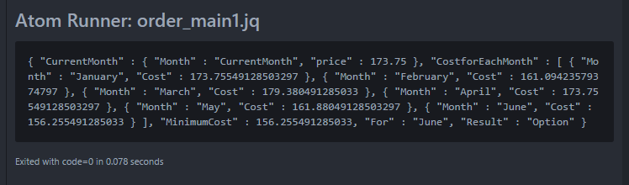

**2.b -Half Year (July-Dec)**



**Output:**

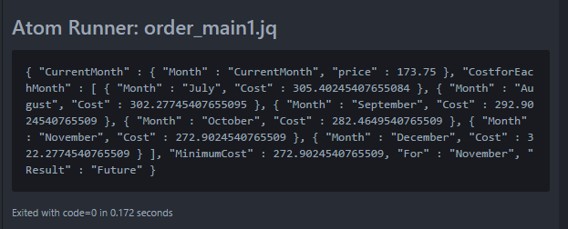

**3.a - Quarter 1 (Jan- March)**



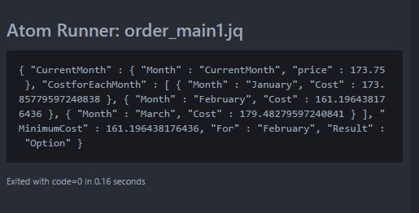

**3.b - Quarter 2 (April- June)**



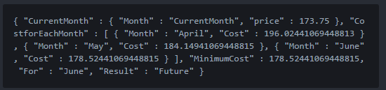

**3 c - Quarter 3 (July-Sept)**



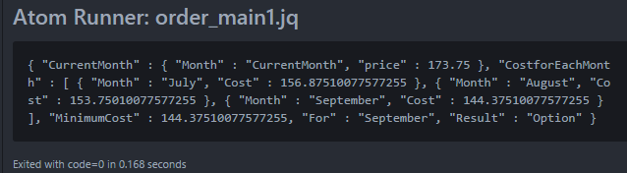

**3 d - Quarter 4 (Oct-Dec)**

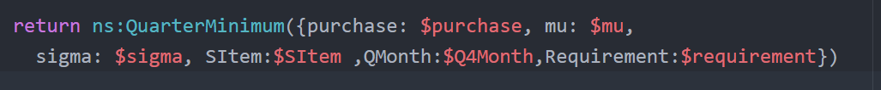

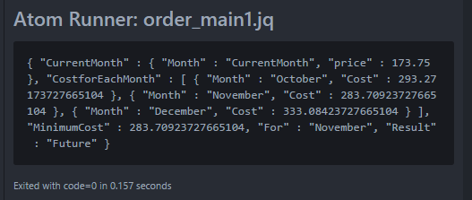

**4 - Monthly**



**Output for the above function:**

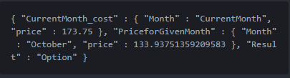

# Future Enhancements:

We can calculate the optimal cost of fuel if we use DGAL and run over code through the DGAL Argmin function. It could be subject to a budget constraint which could be the maximum/ minimum cost on fuel for the previous year.

The input to the DGAL will be

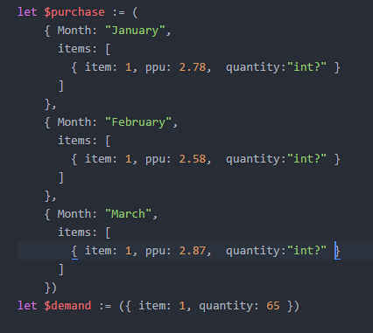

The Argmin Function will be used on this data

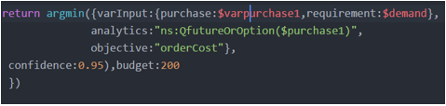

The Gaussian Function will be used to add randomness to the prediction of diesel prices. The Gaussian function will be used would be something like this.



We have implemented this project for Trucking companies. In the future we propose to expand it to cover Airlines and Shipping Companies too.

# Conclusion:

Our project will help mitigate the expenses spent on fuel by the trucking Companies. Since they operate in an extremely competitive market, with very thin profit margins this project will help them minimize the expenses spent on fuel by allowing them to get the fuel in minimal cost. There is rise in average operating cost of trucking Companies and it is expected to continue given the current economic conditions and industry trends. As Fuel costs continue to constitute the majority of costs for motor carriers, saving on the fuel cost will lead to overall profits for these Companies.