CARGOPULSE
Point-in-Time LNG Operational Pressure Intelligence
Alternative-data engineering for terminal congestion, throughput and asset-level operational diligence
CargoPulse converts continuous maritime telemetry (AIS) into validated LNG terminal events and point-in-time indicators of capacity utilisation, berth saturation, abnormal operational delay, persistence and vessel-flow pressure. The system is designed as an analytical platform rather than a visualisation layer: source evidence, geospatial reconstruction, transformations, orchestration, serving and presentation are separated so every derived signal can be reproduced, tested and challenged.
34  confirmed LNG terminal calls | 30  daily point-in-time pressure observations | 22  dbt analytical models
161  dbt data tests | 183 / 183  validated dbt build passes | 36 / 36  Python test-suite passes

Validated scope
Sabine Pass LNG terminal, January 2023. The report treats the resulting index as an operational-pressure measure, not a measure of capital exposure, a probability of disruption or a trading signal.

1. Problem statement and research objective
Raw AIS is a movement record, not a decision product. It cannot by itself distinguish a busy terminal from a constrained one, an unusually long berth stay from normal turnaround, or a temporary utilisation spike from persistent congestion. Those distinctions require identity validation, geospatial context, historical comparison and explicit data-quality controls.
CargoPulse therefore treats every downstream metric as a derived claim that must remain traceable to source evidence. The analytical chain is: telemetry -> validated vessel identity -> terminal/berth event -> operational metric -> point-in-time historical baseline -> pressure component -> explainable index.
Central research question
Can continuous maritime telemetry be transformed into auditable point-in-time indicators of LNG terminal congestion and saturation without look-ahead bias, forced imputation or loss of data provenance?

1.1 Physical variables being measured
Variable | Operational interpretation
Capacity utilisation | Share of modeled berth capacity consumed over the day. High utilisation reduces operational headroom.
Berth saturation | Peak simultaneous berth occupancy relative to the three-berth terminal model.
Abnormal operational delay | Observed active-call duration above the applicable historical expectation. It is not contractual demurrage; it is a screening signal for demurrage-relevant investigation.
Persistence | Trailing three-day utilisation distinguishes a one-day spike from sustained pressure.
Vessel balance | Short-horizon arrivals versus departures identifies whether vessel pressure is accumulating or clearing.

2. Engineering architecture
The application is deliberately decoupled. Streamlit does not own analytical logic and does not query PostgreSQL directly. Analytical state is produced upstream, served through FastAPI and validated independently of the presentation layer.
Layer | Responsibility | Control / design rationale
Python ingestion | Cleaning, type normalisation, timestamp handling, duplicate control, staging. | Produces trusted source records before database loading.
PostgreSQL + PostGIS | Durable relational state, geography points, spatial indexes, terminal/berth geometry. | Preserves geospatial evidence and supports reproducible spatial joins.
Vessel enrichment | USCG PSIX evidence and queue-based classification. | Separates confirmed LNG carriers from ambiguous/unknown identities.
dbt Core | Staging, intermediate, operations, baselines, features, pressure calculations, tests. | Owns analytical lineage and testable SQL transformations.
Apache Airflow | Ingest -> validate -> load -> enrich -> dbt -> export -> quality gate. | Controls task ordering, retries and execution visibility.
FastAPI + SQLAlchemy | Read-only analytical service boundary. | Decouples consumers from physical database schema.
Docker + GitHub Actions | Reproducible multi-service runtime and automated validation. | Keeps environment and integration behaviour testable.

3. Point-in-time correctness and research controls
Point-in-time (PIT) correctness is treated as a model requirement. A duration baseline for date t may use only calls whose berth departure occurred before t. Future operating information is therefore structurally excluded from earlier pressure estimates, reducing look-ahead bias.
Control | Implementation principle
PIT historical baselines | Only eligible calls completed before each metric date enter that date's duration history.
Berth-first hierarchy | A berth-specific history is used when sufficient prior observations exist; otherwise the model falls back to terminal-wide history.
No forced imputation | If history is insufficient, the system records insufficient evidence rather than fabricating an expected duration.
Censoring preserved | Calls intersecting dataset boundaries remain censored and are not silently treated as complete observations.
Review states preserved | Continuity or detection concerns remain explicit review states.
Confidence separated | Evidence quality is reported separately from operational-pressure magnitude.

Research discipline
The framework records when it does not know enough. Missing history, censoring and review states reduce usable evidence rather than being converted into clean-looking observations.

4. Operational-pressure index methodology
The daily index is an explainable weighted aggregation of seven normalized operational components. The score is capped at 100 and is used to compare terminal operating regimes through time; it is not a probability model.
Component | Max pts | Interpretation
Capacity pressure | 20 | Daily terminal utilisation.
Berth saturation | 10 | Peak occupied berths relative to terminal capacity.
Active-delay share | 20 | Share of scoreable active calls exceeding historical duration expectations.
Severe-delay share | 15 | Share of active calls exhibiting more extreme duration pressure.
Delay intensity | 10 | Magnitude of abnormal operational delay among scoreable active calls.
3-day utilisation | 15 | Persistence of capacity consumption over the trailing window.
Vessel-balance pressure | 10 | Positive short-horizon arrivals-minus-departures pressure.

Weighting methodology
The current weights are heuristic baseline coefficients chosen for transparency and diagnostic usefulness; they are not statistically estimated and should not be interpreted as calibrated economic sensitivities. A subsequent research stage would estimate or optimize weights against explicitly defined out-of-sample operational or market targets, with the present heuristic index retained as the benchmark.

Commercial interpretation boundary
Abnormal operational delay is not contractual demurrage. It identifies operating conditions that may warrant demurrage-relevant investigation; actual demurrage depends on contractual laytime terms and independent commercial evidence.

5. Current-state finding: capacity-led pressure
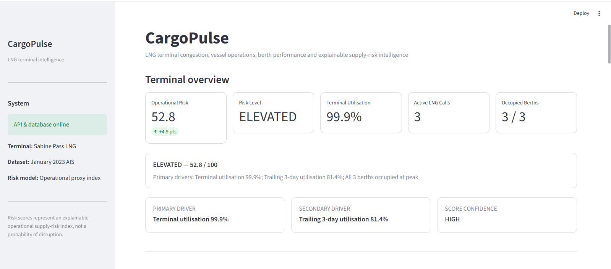
Figure 1. Current application overview. The report uses operational-pressure terminology because the index measures congestion and saturation rather than capital exposure.
The latest validated state is 52.8 / 100 with high confidence. Terminal utilisation is 99.9%, all three modeled berths are occupied at peak, and trailing three-day utilisation is 81.4%. The composition is therefore capacity-led and persistent rather than backlog-led.
This distinction is material. Two days can produce similar headline values while representing different physical mechanisms: full berth capacity, abnormal vessel duration, or accumulating vessel balance. The decomposition is designed to preserve those differences rather than collapse them into a single unexplained number.

5.1 Time-series regime analysis
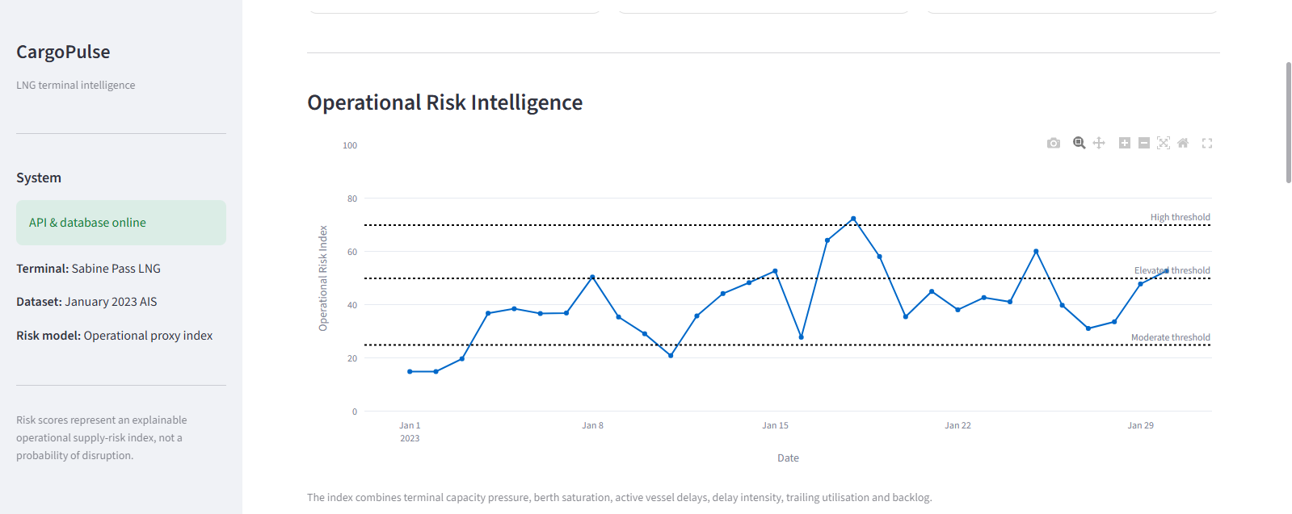
Figure 2. Daily operational-pressure series with regime thresholds.
The series is episodic rather than monotonic. It moves through Low, Moderate, Elevated and High regimes, reaches a validated peak of 72.5 around 18 January, then eases before returning to Elevated territory at month-end. The trajectory provides context for the latest reading: 52.8 is part of a recurring pattern of terminal pressure, not an isolated outlier.

6. Physical-flow analysis
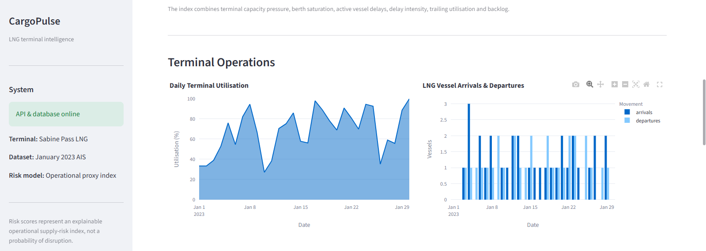
Figure 3. Daily utilisation and LNG vessel arrivals / departures.
Daily utilisation repeatedly reaches high levels and finishes near full capacity. The arrivals/departures series adds a separate flow dimension: a heavily utilised terminal can still clear vessels efficiently, whereas repeated arrival surplus can create short-horizon accumulation. Capacity consumption and vessel balance are therefore modeled separately.
The distinction connects the statistical representation to a physical mechanism. The features measure how infrastructure is being consumed and how quickly vessel pressure is entering or leaving the system.

7. Asset-Level Operational Diligence
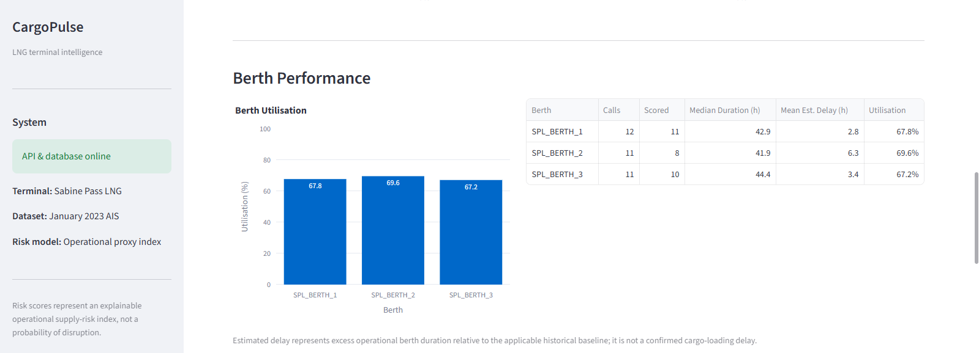
Figure 4. Berth-level utilisation and operating metrics.
Berth utilisation is balanced at 67.8%, 69.6% and 67.2%, but estimated abnormal operational delay differs. Berth 2 records the highest mean estimate at 6.3 hours versus 2.8 and 3.4 hours at berths 1 and 3. The result does not establish a causal fault at berth 2; it localises where further operating diligence should concentrate.
At asset level, this drill-down separates terminal-wide throughput pressure from localized performance variation. The same analytical pattern is relevant to capacity planning and infrastructure diligence: identify the aggregate constraint, localise the bottleneck, then determine whether the source is operational, structural or data-related before drawing a capex conclusion.

8. Auditability and call-level evidence
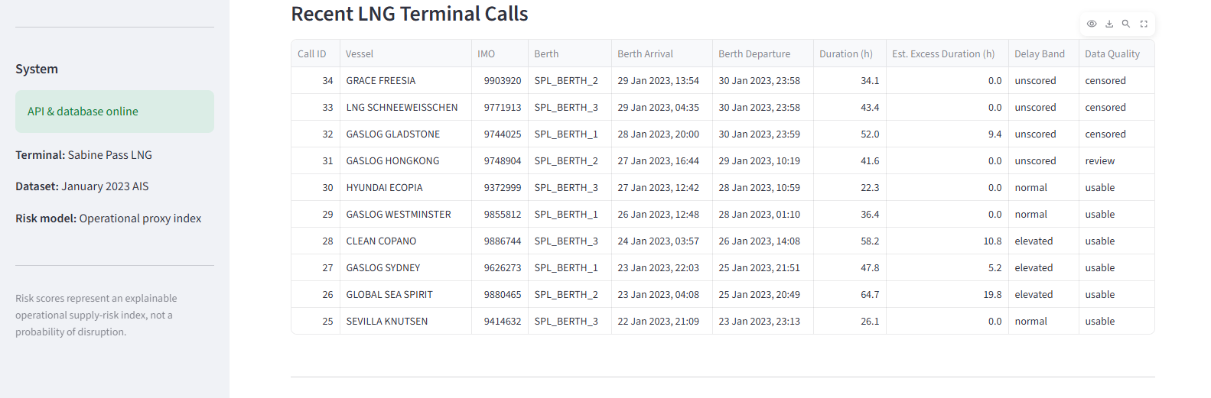
Figure 5. Recent validated LNG calls, abnormal-delay estimates and data-quality states.
The call table is the evidence layer beneath the aggregate series. It preserves vessel identity, berth, arrival/departure times, observed duration, abnormal-delay estimate, severity band and data-quality state. GLOBAL SEA SPIRIT, for example, records 19.8 hours of estimated abnormal operational delay and CLEAN COPANO 10.8 hours, both on usable records.
Censored and review rows remain visible. They are not presentation exceptions; they are part of the model state. An observation that cannot support a defensible historical comparison remains unscored rather than being imputed into the index.

8.1 Latest pressure decomposition
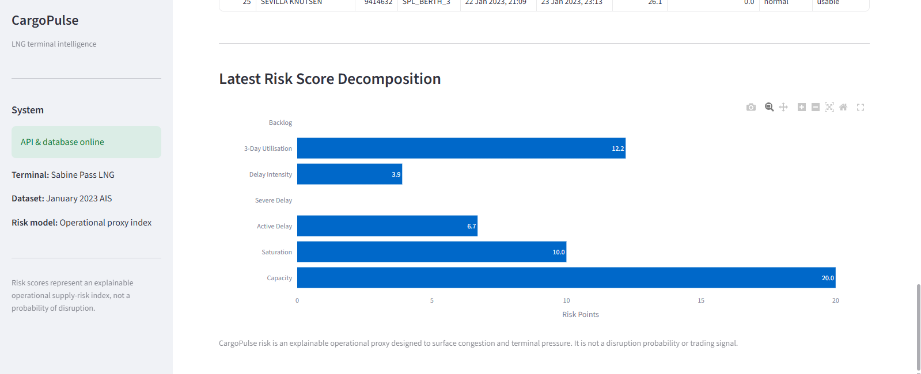
Figure 6. Component contribution to the latest 52.8 operational-pressure index.
The latest composition is 20.0 capacity points, 10.0 saturation points, 12.2 trailing-utilisation points, 6.7 active-delay points and 3.9 delay-intensity points, with zero severe-delay and vessel-balance contribution. The reading is therefore dominated by current capacity use and persistence, with secondary abnormal-duration pressure.
Because the coefficients are explicit, the result is reproducible and contestable. A reviewer can inspect the physical evidence, challenge individual weights and compare the heuristic baseline against a later statistically calibrated specification.

9. Validation, reproducibility and CI
Analytical outputs are generated through a validated pipeline rather than manually edited chart data. The project contains 22 dbt models and 161 dbt data tests. The validated dbt build records 183 passes and zero errors; the Python suite records 36 passes and zero failures.
Validation layer | What it protects
Raw validation | Checks source schema, cleaning expectations and early data-quality failures.
Database validation | Checks populated AIS evidence, generated PostGIS locations and enrichment state.
dbt tests | Validate not-null, uniqueness, accepted values and cross-model relationships across the analytics graph.
Final quality gate | Requires critical analytical outputs to be non-empty and index values to remain within [0,100].
Regression tests | Preserve exact validated historical outputs, including the known peak-pressure day.
CI integration | Runs lint/unit validation, dbt parsing, Docker Compose checks, Airflow DAG import checks and an isolated PostGIS integration smoke test.

10. Interpretation boundaries and research agenda
- Validated scope is Sabine Pass and January 2023; no global LNG-market claim is made.
- The pressure index is not a probability of supply disruption, a price forecast, an investment recommendation or a demonstrated trading signal.
- Abnormal operational delay is not confirmed cargo-loading delay or contractual demurrage without independent operating and contractual evidence.
- AIS gaps, vessel-identity ambiguity and geofence assumptions can affect reconstructed operating timelines.
- The current coefficient set is heuristic. Future work should compare the baseline against statistically estimated alternatives using explicit training, validation and out-of-sample test periods.
- A research extension would test whether point-in-time terminal features contain incremental information for defined targets such as throughput outcomes, LNG regional spreads, shipping rates or exposed assets, without presuming such a relationship exists.
- An engineering extension would move ingestion toward near-real-time telemetry and alerting while retaining the same PIT, data-quality and provenance controls.

Conclusion
CargoPulse establishes a controlled evidence chain from continuous maritime telemetry to geospatially validated LNG terminal events, point-in-time historical comparisons and an explainable operational-pressure index. The analytical output remains traceable to berth and call-level evidence, including explicit uncertainty states.
The principal engineering result is the separation of concerns around that evidence chain: PostGIS-backed spatial state, dbt-owned transformations and tests, Airflow orchestration, FastAPI serving, reproducible containerisation and CI validation. The principal research result is equally narrow: terminal congestion, saturation and abnormal operational delay can be represented as point-in-time, auditable features without treating uncertain observations as clean data or allowing future calls to contaminate historical baselines.

