General Instructions:

* Follow the instructions given in each section.
* Do not write anything on the question paper, except your roll no.
* Make sure that you attempt the questions in order.

**Section - A**

**(Q 1 to 10: Each question carries 1 mark)**

**Q.1**. What will be file permission after the command chmod 555 file1.txt?

1. **-r-xr-xr-x**
2. r-xr-xr-xxr-
3. xr-xr-x
4. -rxxr-xr-x

**Q.2** Which command will list down files in a directory along with its user and mode details?

1. list
2. **ls -l**
3. ls
4. None of the above

**Q.3** Which command will show all mp4 format files?

1. ls *
2. ls mp4
3. ls .mp4
4. **ls *.mp4**

Q.4. What will be output of following command id -un ?

1. urid number
2. **uid name**
3. all ids including groups, sudo etc
4. create new id

**Q.5 .**What does factor command do?

1. give factors of a number
2. **give factors in sorted order**
3. give uniq factors of a number
4. give uniq factors in sorted order

**Q.6** .How will you assign read-write permissions for a file f1.txt to the owner/user?

1. chmod a+r f1.txt
2. **chmod u=rw f1.txt**
3. chmod g=rwx f1.txt
4. chmod o+r f1.txt

**Q.7.** How can you grant execute permission only for the owner of the file f1.txt?

1. chmod ++x f1.txt
2. chmod o+x f1.txt
3. chmod +x f1.txt
4. **chmod u+x f1.txt**

Q.8. What does free command do?

1. **summary of RAM usage**
2. summary of disk usage
3. summary of both ram and disk usage
4. kill a task

**Q.9** What will be user permission if the case where permissions are "---x-w--w-"?

1. read write
2. read write and execute
3. **execute only**
4. write only

Q.10. Which of the following umask setting doesn't allow execute permission to be set by default on directory files?

1. 222
2. 111
3. **000**
4. 444

**Section - B**

**(Q 11 to 15 : Each question carries 2 marks)**

Q.11. Vijay is new to linux environment. He has to refer to the manual for some commands on terminal. Which command will help him to get the manual for specified command?

1. vi
2. **man**
3. ls
4. nano

**Q.12.** What is the command to set the execute permissions to all the files and subdirectories within the directory?

/home/user1/direct

1. chmod –r +x /home/user1/direct
2. **chmod –R +x /home/user1/direct**
3. chmod –f –r +x /home/user1/direct
4. chmod –F +x /home/user1/direct

Q.13 For creating empty files, what command do we use?

1. cp
2. cat
3. **touch**
4. create

Q.14 Recursive deletion is performed by _____?

1. -r
2. -R
3. %æ
4. **-r and –R**

Q.15. With rm command for interactive deletion, what option do we use?

1. **-i**
2. -f
3. -r
4. -R

**Section – C**

**(Q 16 to 19: Each question carries 5 marks)**

**Q.16**. Following files and directories as mentioned below are already

created .

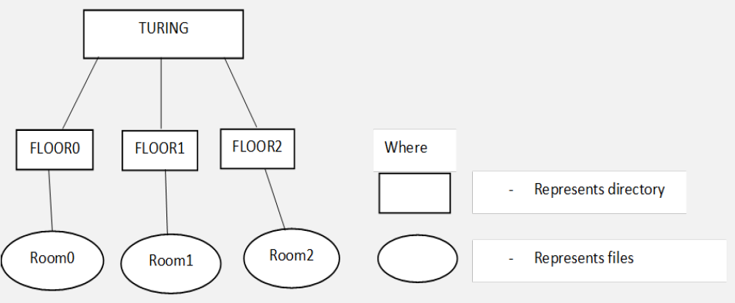

mkdir -p TURING/FLOOR0

mkdir TURING/FLOOR1

mkdir TURING/FLOOR2

touch TURING/FLOOR0/Room0

touch TURING/FLOOR1/Room1

touch TURING/FLOOR2/Room2

**Perform the below mentioned tasks**

1. Create a “MANAGEMENT ” directory in “FLOOR1” directory withread,write,execute permissions only for the owner. (2 Marks)
2. Create a new group “manager” with a custom GID(group id) “12345”. (2 Marks)
3. change the group of the “MANAGEMENT ” directory to “manager ” group. (1 mark)

**Q.17.** Write the steps and appropriate commands for the following

scenerio :

Scenerio : Astha noted down her password on a piece of paper but unfortunately she lost it, help her to generate a new password .

Q.18. Write the commands to perform following task.

1. How would you find all instances of the word "error" in a file "filelist.txt". Filelist.txt is present inside your current directory. (2marks)
2. How would you sort the contents of a file "filelist.txt" in ascendingorder, and save the output to a new file "sorted_filelist .txt"? (2 marks)
3. Display the last 10 lines of a file "filelist.txt"?

(1 mark)

Q.19. Suppose there are following files in the current working directory

art

part

part1

part2

mozart

tart

Which of the above files would qualify for the following searches:

* 1. ls p*
  2. ls [!abc]art
  3. ls
  4. ls p*[12]
  5. ls [!ap]