General Instructions:

* Follow the instructions given in each section.
* Do not write anything on the question paper, except your roll no.
* Make sure that you attempt the questions in order.

**Section - A**

**(Q 1 to 10: Each question carries 1 mark)**

Q.1. How do you rename file “new” to file “old”?

1. **mv new old**
2. move new old
3. cp new old
4. rn new old

Q.2The login shell is __________.

1. **the shell program that runs when the user logs in**
2. the shell program that authenticates the user while logging in
3. common shell for all the users that belong to the same group
4. None of the above

.Q3. To back up over typing errors in vi which of the following is used?

1. $
2. @
3. !

Q.4 Choose the incorrect communication command

1. mail
2. mesg
3. **grep**
4. write

Q5. Choose the TCP/IP Protocol which is used for remote terminal connection service?

1. FTP
2. UDP
3. RARP
4. **TELNET**

**Q.6.** To search a particular pattern in a file we use ______.

1. touch
2. **grep**
3. find
4. ls

Q.7 Choose the correct command to Display the file ‘sample.txt’ one page at a time.

1. man sample.txt>more
2. cat sample.txt<more
3. **cat sample.txt|more**
4. None of the mentioned

Q.8 **.**What will happen if I will type cd.. in the root directory?

1. Error message indicating the user can’t access beyond the root level
2. Behavior is unix-flavor dependent
3. Results in changing to the ‘home’ directory
4. **Nothing happens**

Q.9**.** Select the most appropriate option for RPM in Linux

1. assigns a dynamic IP address
2. is used to keep track of the users
3. **stands for Red Hat Package Manager**
4. None of the above

Q.10. Choose the following statement is true or false: Directory is a type of file.

1. **true**
2. false

**Section - B**

**(Q 11 to 15 : Each question carries 2 marks)**

Q.11. Which of the following represents read,write and execute permissions for owner and read execute permissions for group and others?

1. 575
2. 22
3. **755**
4. 544

**Q.12.** What will the following command do?

1. **Copy the content of f1.txt in f2.txt**
2. Move the content of f1.txt into f2.txt
3. Invalid Command
4. Undefined Behaviour

Q.13. Command to move content of a folder1 into folder2, both folders are in current working

directory?

1. **mv folder1/* folder2**
2. mv folder1 folder2
3. mv folder1/ folder2
4. mv folder1/* folder2/*

Q.14. Command to remove all files which start with j and have exactly 3 characters in them?

1. j**
2. j?*
3. **j??**
4. j*

Q.15. Which of the following command is used to change the group associated with a file as root?

1. chown root file.txt
2. **chgrp root file.txt**
3. chgrp file.txt root
4. chown file.txt root

**Section – C**

**(Q 16 to 19: Each question carries 5 marks)**

Q.16. Following files and directories as mentioned below are alreadycreated . Perform the below mentioned tasks

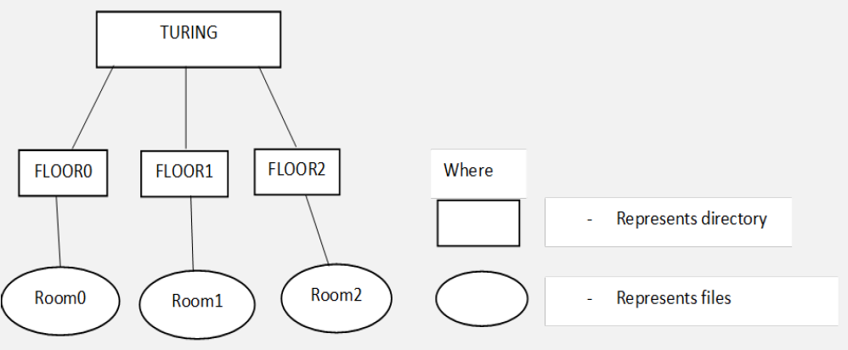

mkdir -p TURING/FLOOR0

mkdir TURING/FLOOR1

mkdir TURING/FLOOR2

touch TURING/FLOOR0/Room0

touch TURING/FLOOR1/Room1

touch TURING/FLOOR2/Room2

Perform the below mentioned tasks

* 1. Change the permissions of “FLOOR0” directory to have read,write and execute permissions only for the owner. (1 Mark)
  2. Create a “Faculty ” file in the “FLOOR0” directory. (1 Mark)
  3. Write “000 111 222 333 444 555” into “Faculty ” file using cat command and also exit text insertion prompt when done with write operation . (2 mark)
  4. Remove “Room0” file from the “FLOOR0” directory. (1 Mark)

Q.17 Create a file “alpha_zone .txt” and write “Students are 40, Teachers are Unknown - 23”. Next compress this file to “alpha_zone .txt.tar.gz” and write the commands to output the content of the file stored in the Narchive without extracting or decompressing the file.

Q.18 Explain following commands with examples (1 mark each)

1. banner
2. reboot
3. man
4. cp -r
5. tac

Q.19. You have given a system having the following scenario . “_test” is present inside the /home/user directory



Perform the following task on the given system.

1. Create a file name containing your name and the last four digitsof your roll number.(Example : “chitrang_9011 ”) . The file should be present inside the “_test” directory. (1 mark)
2. You are currently in the /home/user directory. The difference between less and more commands is present insidequestion19_ii .txt. How can you print the content of this file? (2marks)
3. You are currently in question19_ii directory which should be the output of the following command: ls question19_ii .txt. (2 marks)