General Instructions:

* Follow the instructions given in each section.
* Do not write anything on the question paper, except your roll no.
* Make sure that you attempt the questions in order.

**Section - A**

**(Q 1 to 10: Each question carries 1 mark)**

Q.1. A file has a permission set as 777 ie rwxrwxrwx but the directory permissions are 400. If the user tries to delete the file, will he be able to do it?

a) Yes

**b) No**

**Q.2.** A file has a permission set as 000 i.e. - - - can the file be deleted?

**a) Yes**

b) No

Q.3. A file named file01 should be readable, writable and executable only by the user (owner). Which one of the following set of command will be used?

**a) chmod 700 file01**

b) chmod 000 file01

c) chmod 477 file01

d) chmod 777 file01

Q.4. Which of the following umask setting allow execute permission to be set by default on regular files?

a) 222

b)111

c) 000

**d) None of the mentioned**

**Q.5.** Under which license is the Linux kernel registered which makes it open-source?

a) General Processed License

**b) GNU General Public License**

c) GNU License

d) General Possessed License

Q.6. What is the full form of GNU?

a) Greatest Not Unix

**b) GNU’s Not Unix**

c) Grand Number Unix

d) Group’s Not Unix

**Q.7.** Like chmod, chown and chgrp can also use _______ option.

**a) -R**

b) -r

c) -x

d) -i

Q.8. Which command is used to set terminal IO characteristic?

a) tty

b) ctty

c) ptty

**d) sty**

**Q.9.** Which of the following command is used to summarize the disk usage?

a) chkdsk

**b) du**

c) fdisk

d) disk

Q.10. The location of some system configuration and system administrator executable files is?

a) /home

b) /proc

c) /var

**d) /sbin**

**Section - B**

**(Q 11 to 15 : Each question carries 2 marks)**

Q.11. To print the lines in which 2nd word starts with letter “A” from the file names.txt,the command will be?

a) cat names.txt | grep \s+A

b) cut -d “ “ 2 names.txt | grep A

c) cat names.txt | grep ^A

**d) cut -d “ “ -f 2 names.txt | grep ^A**

**Q.12.** Consider the commands for some user named “rajat”

1. mkdir testdir

2. chmod 0444 testdir

3. cd testdir

4. touch abc.txt

Which line will give error ?

1. Line 1 : wrong command syntax
2. Line 2 : can not change the permissions of the directory
3. **Line 3 : Can not change directory : permission denied**
4. Line 4 : can not create file : permission denied

Q.13. Consider the commands

touch myfile.c

cat>myfile.c

#include<stdio.h>

int main()

{

printf(“Vi Editor”);

return 0;

}

Control + Z

vi myfile.c

yy

p

:wq

After this the file will be:

1. Same as after cat command
2. **First line will be duplicated #include<stdio.h> #include<stdio.h>**
3. First line of the file will be : yyp#include<stdio.h>
4. First line will be deleted

Q.14. Consider the following commands entered and then what will be the output

cat>names.txt

Sumit

Rajan

Suresh

Anita

Control + Z

cp names.txt names2.txt

cat>>names2.txt

Anamika

Control + Z

diff names.txt names2.txt

1. **4a5**

**Anamika**

1. 4a0

Anamika

1. 0d5 < Anamika
2. 4c5 < Anamika

Q.15. Consider the commands executed with present working directory empty :

1. mkdir fol1

2. touch fol1/abc.txt

3. cat>fol1/abc.txt

4. this is the content.

5. Control + Z

6. cp fol1/abc.txt fol2/abc.txt

Which of these command will give error :

1. Line 2 : Can not create file in some other folder
2. Line 3 : can not write to a file in some other folder
3. Line 6 : can not copy to some other folder
4. **Line 6 : Directory “fol2” does not exist. Hence Error**

**Section – C**

**(Q 16 to 19: Each question carries 5 marks)**

Q.16. We have one partition of 50gb, delete it and make partition according (25gb, 25gb), in this partition1 will be of primary partition, and partition2 will be of swap space.

**Solution:**

* fdisk /dev/sda (to enter in partition)
* d (press enter to delete partition)
* n (to create partition)
* p (for creating primary partition)
* 1 (partition number)
* keep first sector it blank press enter (First sector will be set by default)
* type last sector (divide number by 2 which shown on your screen)
* n (to create partition2)
* p (for primary partition)
* 2 (partition number)
* keep first sector blank press enter (last sector will be set by default)
* keep last sector blank press enter (last sector will be set by default)
* t (to change partition type)
* 2 (select 2nd partition )
* 82 (hex code for swap space)
* p (to check created partition)
* w (write table to disk and exit)

Q.17. a) What are the different file permissions there in Linux?       (2.5 marks)

b) How to set file permissions in Linux?                                 (2.5 marks)

**Solution:**

a. Read, write, execute and –

The ‘r’ means you can “read” the file’s contents.   
The ‘w’ means you can “write”, or modify, the file’s contents.   
The ‘x’ means you can “execute” the file. This permission is given only if the file is a program.

b. You can set file permissions in Linux using the "chmod" command. The basic syntax for the chmod command is "chmod [options] [mode] [file]". The mode is a three-digit number representing the permissions for the owner, group, and others, respectively. For example, to set the permissions of a file to allow the owner to read, write, and execute, and to allow others to only read and execute, you would use the following chmod command: "chmod 755 [file]".

Q.18. Perform the following task

i. Check the default runlevel of your system. (1mark)

ii. Also check all target files available.   (2 marks)

iii. Change the default runlevel to runlevel3. (2marks)

Solution: -

1. systemctl get-default
2. systemctl list-units --type=target
3. systemctl set-default runlevel3.target

Q.19. Write commands to perform following operations as per below diagram

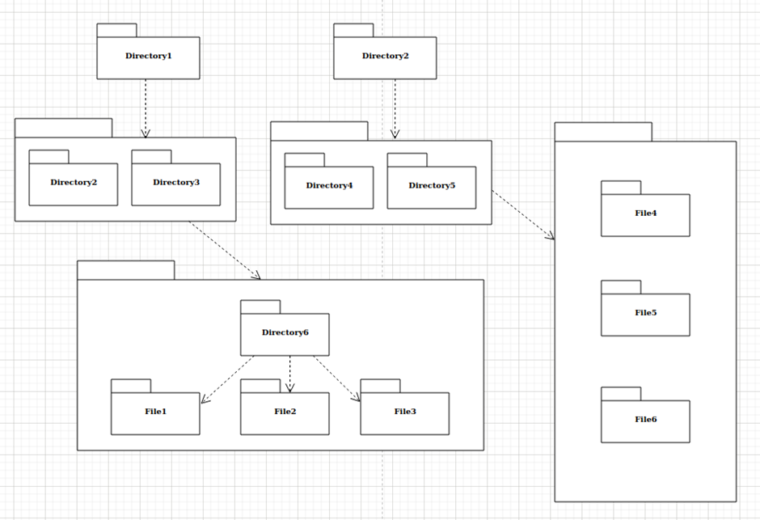

* Create files and directory as per diagram (4 mark)
* Merge File1 and File4 content in File3 (1 mark)

Cosnsider NOTE: Directory 6 is in Directory 3 and File 4, 5, 6 are in Directory 5

Solution: -

1. mkdir Direcotry1 Directory2

cd Directory1

mkdir -p Directory2 Directory3/Directory6

cd Directory3/Directory6

touch File{1..3}

cd ../../../

cd Directory2

touch File{4..6}

1. cat ~/Directory1/Directory3/Directory6/File1 File4 > ~/Directory1/Directory3/Directory6/File3